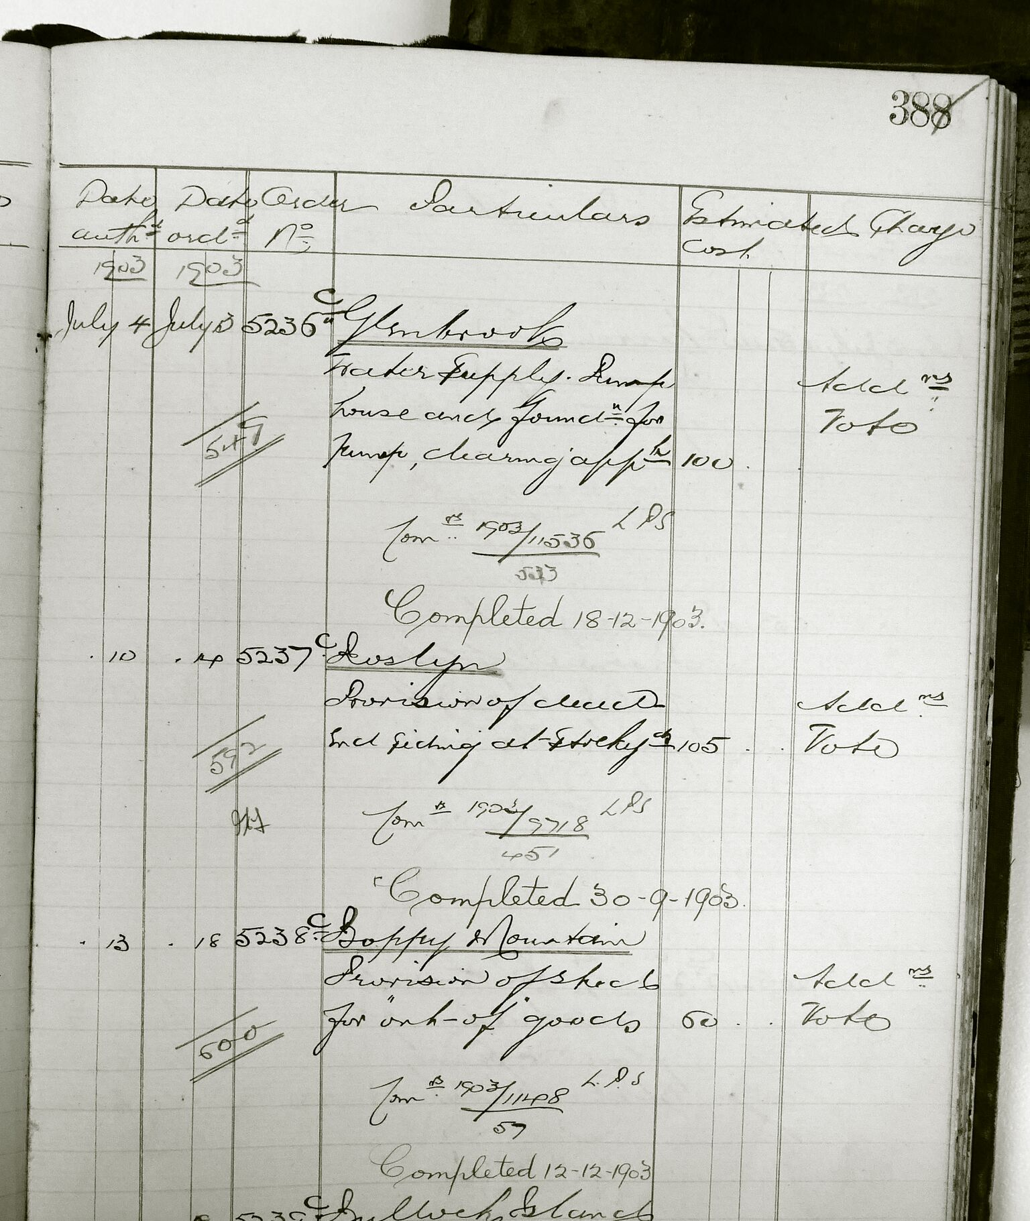

Extract from Register of Shop Orders Mechanical Branch, 11/20291, 254/ NRS 259/1/4. Image: John Fox.

Glenbrook DH -2 Extract from Register of Shop Orders Mechanical Branch- MK