Private Walk / investigation

Blue Mountains National Park – The Duck Hole at Glenbrook and more–Monday 1st May 2017- Track Notes

Title | The Duck Hole and more
Date | Monday 1st May 2017
Leader | Bruce Cameron.
Maps, etc. | Department of Lands topographic map, Penrith 9030-3N 1:25,000, third edition GPS setting WGS 84.
Activity  /description and route | 1 With Bruce Cameron in charge, try to locate the site of a building that may have been the caretakers cottage for the pump installation at the Duck Hole. To quote Bruce, “I am more than happy to wander around and show you the old gate keepers, Duck Hole Supervisors hut…as long as I can find  it following all the regrowth in recent years.”  A copy of a very poor mud map shows a building named ‘Wood’s Cottage’ W.S.W. of Glenbrook Station. It may or may not be the same building  2 Revisit an area around the Duck Hole track head John Fox recorded 23rd February 2017, “In the bush about 20 metres from the track that goes to the Duck Hole I located a hole that is probably the trench that was used for the “holding tank”. It’s located on the highest part of that section of the ridge. GR 278651E 6261271 N elevation 217 m (see map where I’ve put a dot) (Note: as the highest point on that section of the map is 200 metres it shows that the GPS is slightly inaccurate for measuring altitudes).The hole is about 2 metres long in a north-south orientation. It is about 0.5m wide and about 1.5m deep. There was no infrastructure found – not even iron. But there were 10 beer bottles in the hole. In further searching I located a pile of rocks that looked like they’d been placed in position many years ago.GR 278738E 6261256 N elevation 203 m.  3 Revisit the Duck Hole and the former pump house site walking the site of all known previous infrastructure searching for any evidence.  4 Other related sites to be discussed, including possibly a visit to The Bunker, a cave that has evidence of European occupation around WWII.
Gear issues | Water 2 litres, electrolytes, maps, compass, block out, sunglasses and hat.
Meeting point | 0830 at 2773 Coffee Shop, Ross Street, Glenbrook
Transport | Private vehicles
Comments | This is a day of investigative exploring. Some historic archaeological sites will be visited.

The Party
Bruce Cameron, leader and author of the book ‘The Blue Labyrinth’, Brian Fox, John Fox, Michael Keats, John Cooper, Scott Marshall, (members of the Bush Club) and Doug Knowles and Denis Bainbridge (Glenbrook & District Historical Society). 8.
The Weather
A glorious warm and sunny autumn day. Some minor cloud in the morning but otherwise clear. Temperature range 18 to 23 degrees.
Background Notes
Michael Keats and John Fox have a developing interest in understanding the old infrastructure (a steam pump in the Duck Hole) that was created to provide a reliable water source for steam trains at Water Tank, then, Wascoes, etc., (now Glenbrook) after climbing Lapstone Hill. The capital investment for this project was found by the NSW Railway Commissioners when Glenbrook Lagoon failed as a water source during the drought 1877 -1884 and the cost of running water trains from Penrith became excessive. The whole installation was made redundant when the new alignment of the Great Western Railway was completed in 1913.
A paper or a small book is planned documenting the history of water supply to steam trains at Water Tank (Glenbrook).
Visits by the authors.

On 10th February 2006 in company with bushwalking legend, the late Wilf Hilder a visit was made to Glenbrook to visit the Duck Hole. An extract of the track notes of that walk based on statements by Hilder are set out below.
“Heading west again along Station Street we picked up a fire trail for 50m before heading north and west along the remnants of a long forgotten trail that joined with an historic ‘coal road’.
Although this ‘coal road’ is long forgotten it is well graded with some significant but crude dry stonewalls up to 3m in height. It is a road redolent with history – railway history. It was constructed as a result of the prolonged drought in the late 19th century that dried up the natural lake (Glenbrook Lagoon) water source for replenishing water for the steam trains at Glenbrook.
The road and associate timber chute enabled the delivery of coal to service a steam pump on Glenbrook Creek at the Duck Hole. This installation lifted water from the Glenbrook Creek through some 90m to the plateau top. On the day evidence was found of one of the rock cuttings made to allow the inlet suction pipe to fit snug into the cliff line. Hilder reported that he had collected a piece of coal from the track on a previous visit.”
Ten years on, 24th October 2016, in the company of co- author John Fox, we retraced some of this journey,
“The built track down Pumphouse Gully to Glenbrook Creek is 2m+ wide and apart from several washaways and trail bike rider’s random shortcuts it is still in reasonable condition. Checking for artefacts, a square headed forged bolt was located fixed into the rock about 5m back from the river bank. Here also there is a concrete slab with four embedded bolts and nearby a hand forged loop bolt secured into the rock by molten lead. A deeply cut trench in the sandstone could have been used to secure the inlet water pipe line.”
On 23rd February 2017, John Fox, acting on advice from Doug Knowles, Glenbrook Historical Society, visited a site about 20 metres from the track head to the Duck Hole where he located a shaped depression that is probably the trench that was used for a “holding tank”. It is positioned on the highest part of that section of the ridge GR 278651E 6261271 N. elevation 217 m.
John documented, “The depression is about 2m long in a north-south orientation. It is about 0.5m wide and about 1.5m deep. There was no other infrastructure found – not even iron. In further searching I located a pile of rocks that looked as though they had been placed in position many years ago, GR 278738E 6261256 N, elevation 203 m.”
Place Names
Glenbrook Creek. Named by Sir John Jamison, 15th November 1818 and shown on Plan of Emu Plains and Lines of Road up Lapstone by Surveyor Rusden, 29th July 1831.
The Duck Hole, a natural water hole on Glenbrook Creek was named after the native Wood Ducks which used to frequent the location. The water hole was also used to provide water for steam engines, via Glenbrook Lagoon, from the late 1870s.
Pumphouse Gully is a small non perennial gully located on the eastern side of the Duck Hole on Glenbrook Creek, Glenbrook. The name derives from the installation of a steam pump at the junction of this gully with Glenbrook Creek. The pump and pipe network delivered water to a storage at Glenbrook station to replenish steam train boilers after they had climbed Lapstone Hill. Ref: The Nepean Times, Saturday 3rd October 1903, page 6, record, “The Commissioners are now having a pumping plant put down in Glenbrook Creek over a mile from the station and over 400feet below the rail level, which, when completed, will give them a never failing supply of beautiful water. This work will be completed in about a fortnight’s time.” P 781 612.
Track Notes
Outside the coffee house meeting point the group met and after an outline of proposed activities drove in convoy to the end of Station Street where vehicles were parked, GR 793 609. Walking commenced at 0845.
A network of tracks starts from the end of Station Street. We headed west then north across a shallow unnamed gully through a delightful Angophora dominated forest. The understorey featured many fine specimens of the Grass Tree, Xanthorrhoea aborea. We had only progressed a very short distance when attention was drawn to a modified cave, immediately south of the track at GR 790 610. Use of this cave like many others probably dates from the WWII period and features a significant 2m high dry stone wall to extend the entry area and a much more recent addition of a protective wall against the wind. No artefacts were seen.
Below the cave in the bed of an unnamed creek we inspected several sets of grinding grooves, very much hidden by recent moss and algal growth, GR 790 610. Returning to the track we climbed for some distance before connecting with the so called ‘coal road’, purpose built road that was used to haul coal by horse and a one axel dray from Water Tank (Glenbrook) to the top of the chute above the steam pump installation at the Duck Hole. Prior to the construction of the current railway deviation in 1911-1913 this road would have followed a direct route on the north eastern side of the current railway cutting. As Doug explained while construction was under way, coal supplies to the steam pump had to be maintained so a deviation was made for the road to cross the new railway line as a level crossing at approximately GR 789 612. It is believed that the road started near the present junction of Lennox Street and the current Great Western Highway. The current topographic map shows a link between Reading Street and Fletcher Street that would have been cut off when the railway cutting was built, approximately GR 787 613.
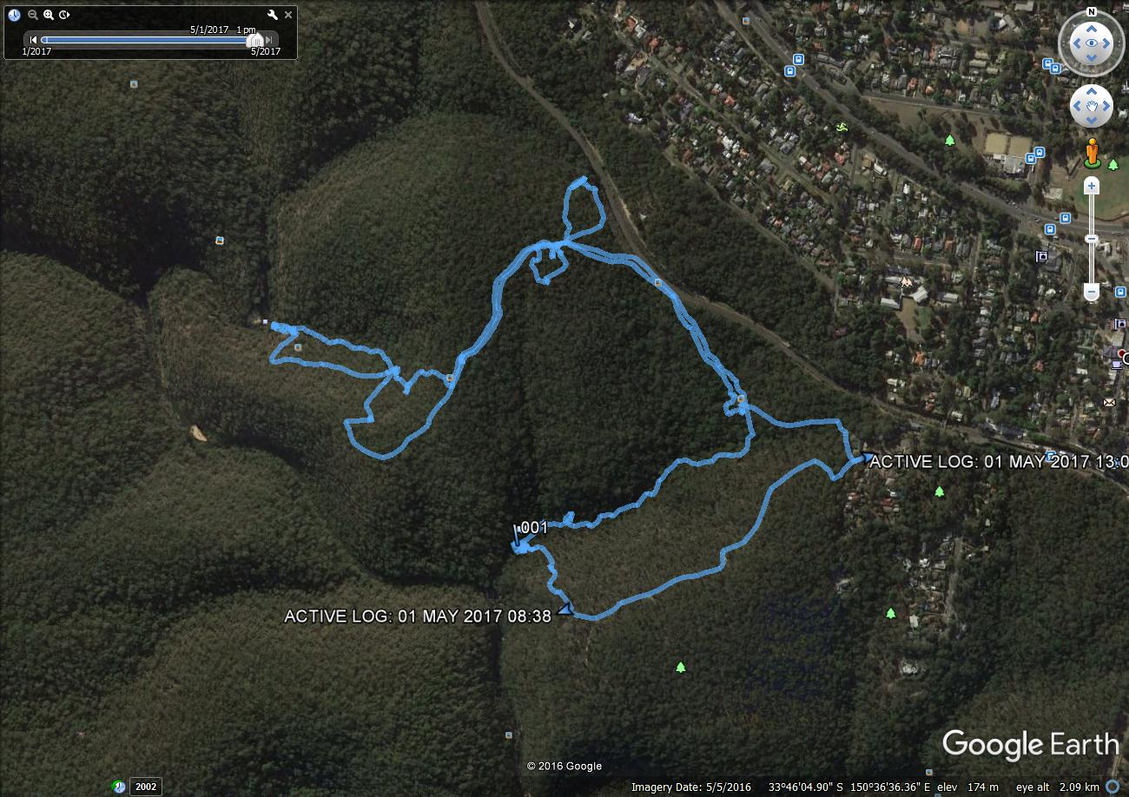
Plot of the walk overlaid on an aerial photograph. Recorded and prepared by Brian Fox.
We moved on noting some more recent industrial history in the form of three old railway drop signal stanchions that had been left abandoned in the bush when electric signalling was installed.
Walking above and on the edge of the railway cutting Bruce led us to a series of sites that showed evidence of constructed stone pedestals which very likely supported the gravity water pipe line from the high point above the Duck Hole to Water Tank. Further corroborative evidence was noted in the form of a cutting in the rock at GR 787 614 for a pit. This pit and several others nearby are consistent with the findings documented by John Fox, 23rd February
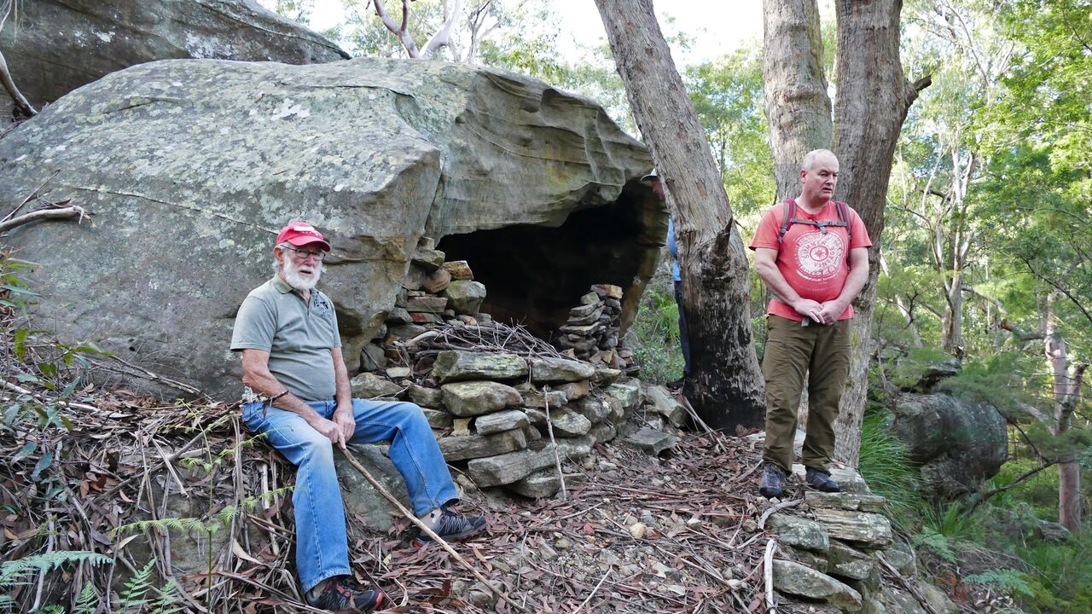

Doug and Bruce at the cave at GR 790 610. Photo: John Fox.

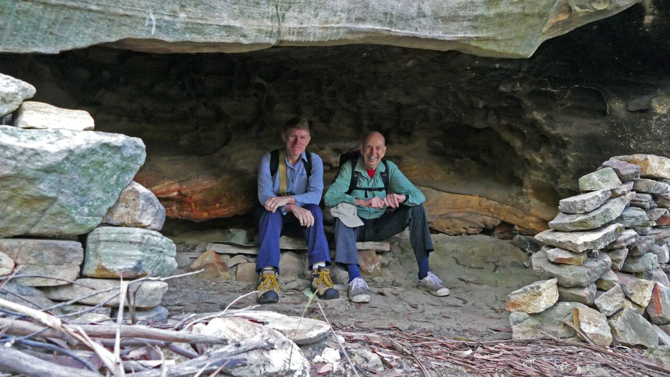
Scot and Michael in the cave at GR 790 61. Photo: John Fox.
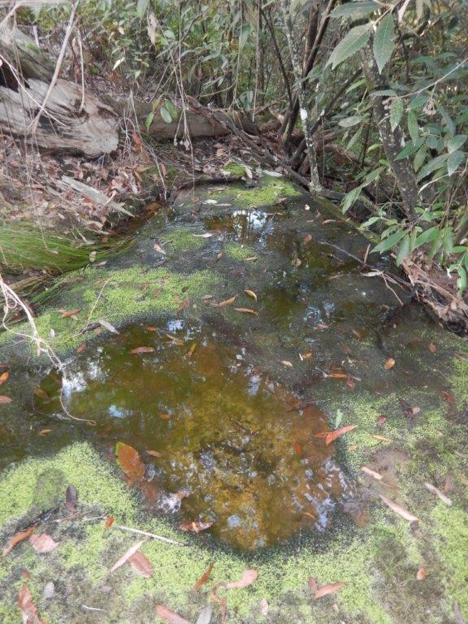
Grinding grooves in an unnamed creek. Photo: Michael Keats.
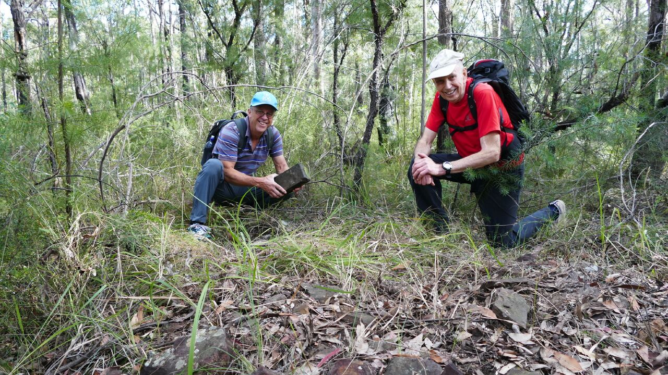
Michael and Brian (with brick) at the site of a former building above the Duck Hole. Photo: John Fox.
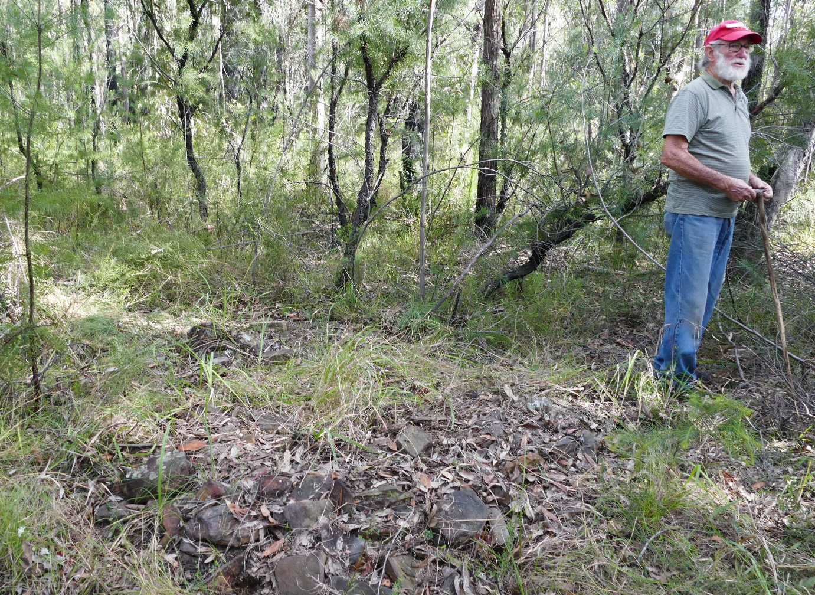
Doug at the site of a former building above the Duck Hole. Photo: John Fox.
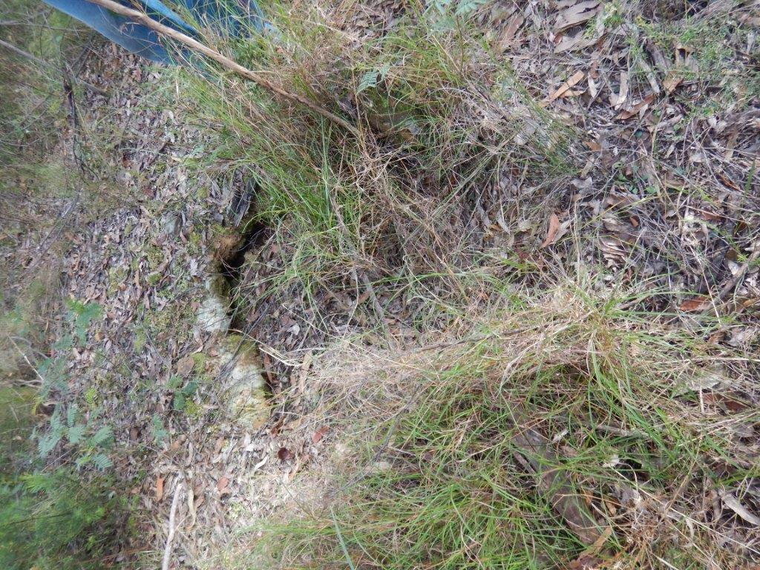
One of several pits possibly associated with the water pipeline above the Duck Hole. Photo: Michael Keats.
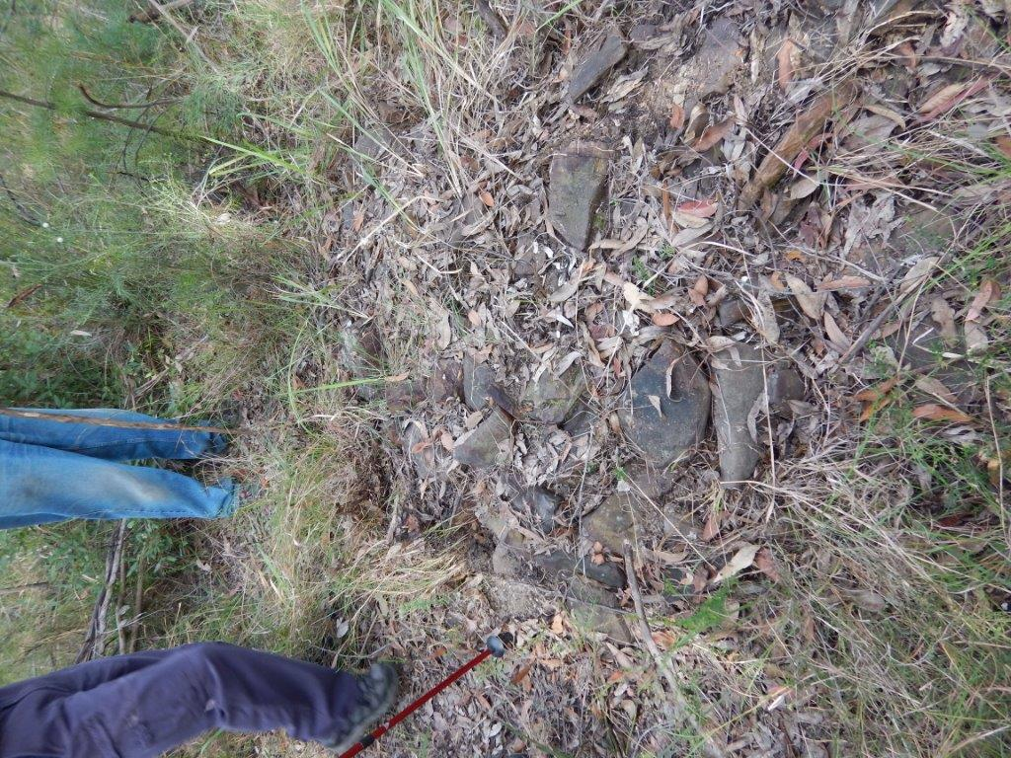
Remains of a chimney/hearth from a building associated with the water pipeline from the Duck Hole to Water Tank. Photo: Michael Keats.
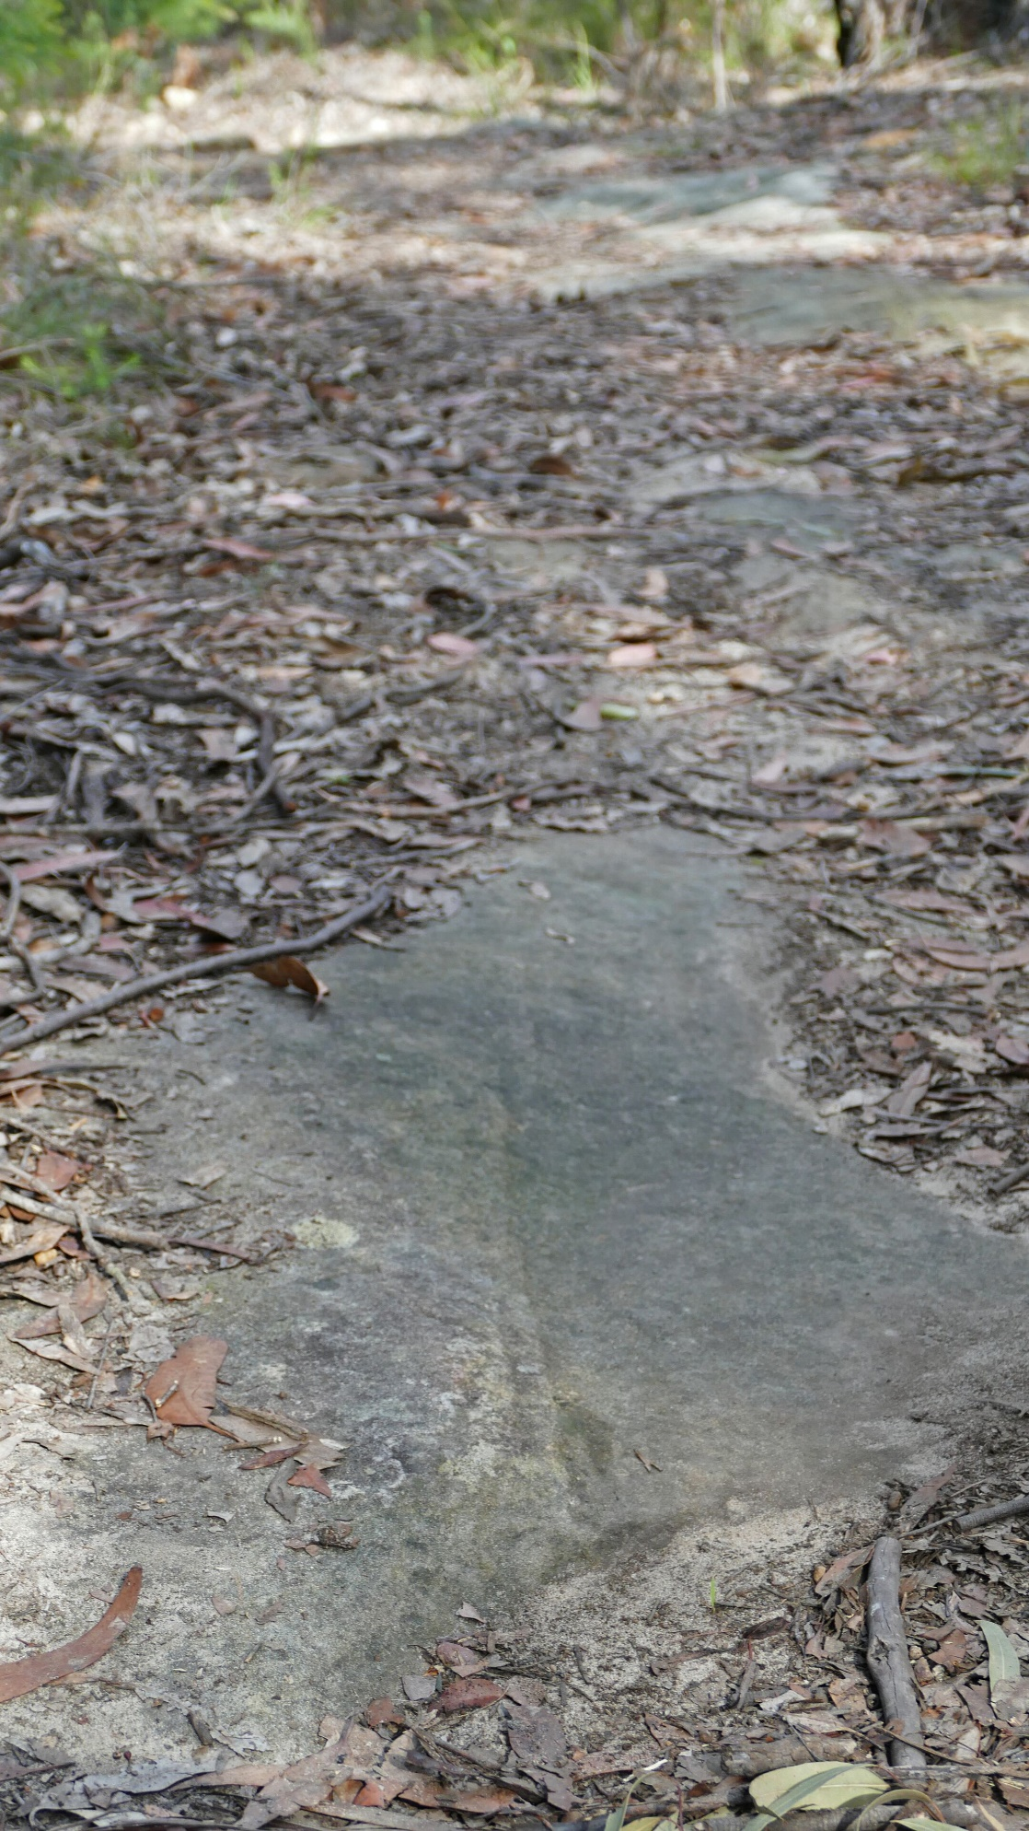
Dray wheel ruts on the coal road. Photo: John Fox.

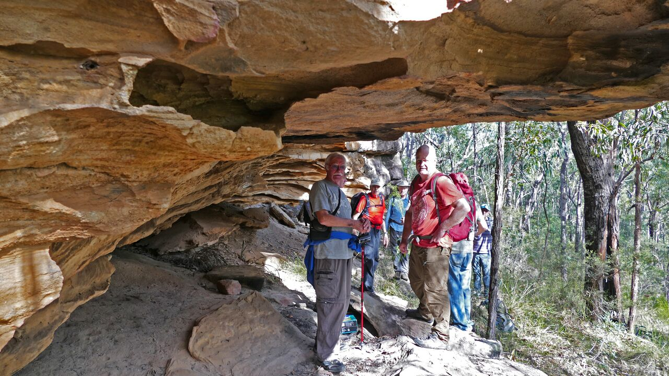

Denis, Michael, Scott and Bruce at an overhang, GR 783 610. Photo: John Fox.

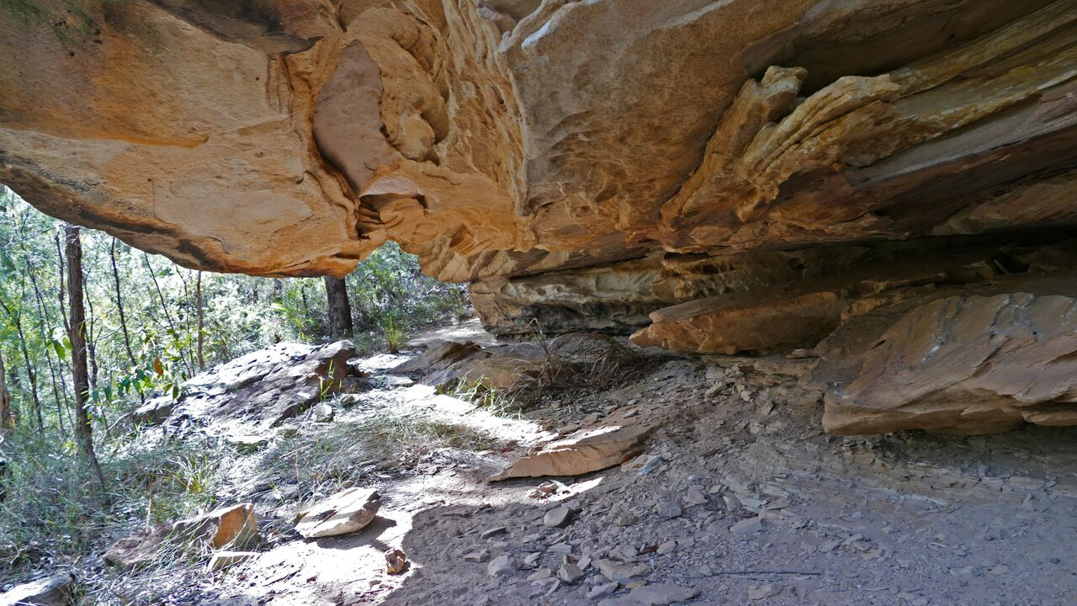

The overhang at GR 783 610. Photo: John Fox.
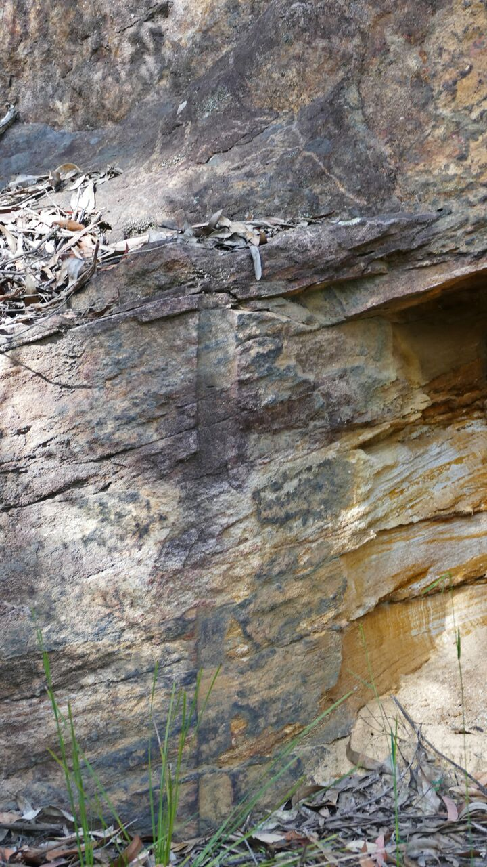
Blasting hole drill marks, top or first zigzag, on the coal road. Photo: John Fox.
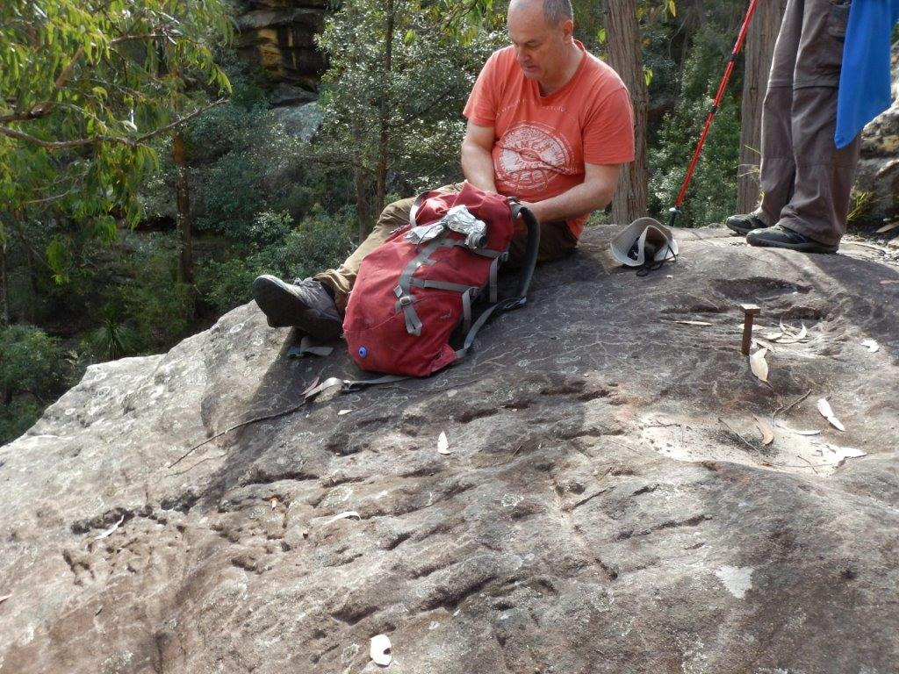
Bruce sitting on a rock near the top of site of the coal chute into the Duck Hole. Note the anchor bolt and chipped sandstone rock face. Photo: Michael Keats
2017. From this point an attempt was made to follow the alignment of the former water line to the high point. The regrowth from the last fire made this exercise difficult. Coupled with the complication of natural rock groupings we are uncertain as to how valid our walk really was. By 0931 we had reached GR 789 613, back on the ‘coal road.’
A few metres on we started searching south of the coal road looking for evidence of former infrastructure. A square cut hole about 80 x80mm was found at GR 786 612 and at GR 278646 6261271 there were groupings of stones that could have been for a chimney/hearth of a building. There is much speculation as to what this building may have been for. Hypothesises range from a caretakers cottage to a toll station to check that coal deliveries from Water Tank arrived and were not diverted for personal gain. Another theory is that the building could have housed one of the workers required to maintain the operation of the steam pump installation. The general view was that the Duck Hole was so close to superior comforts at Water Tank that this was unlikely. A brisk 20 minute walk and workers could be on the job.
Walking along the coal road, ruts caused by the steel rims of the loaded drays were a common sight, (examples at GR 785 612 and GR 784 610) as were many pieces of coal that had fallen off the drays. According to Doug the drays were single axel affairs and carried about half an imperial ton.
An occupation cave at 10121 GR 783 610 was visited. There was a fireplace but little else.
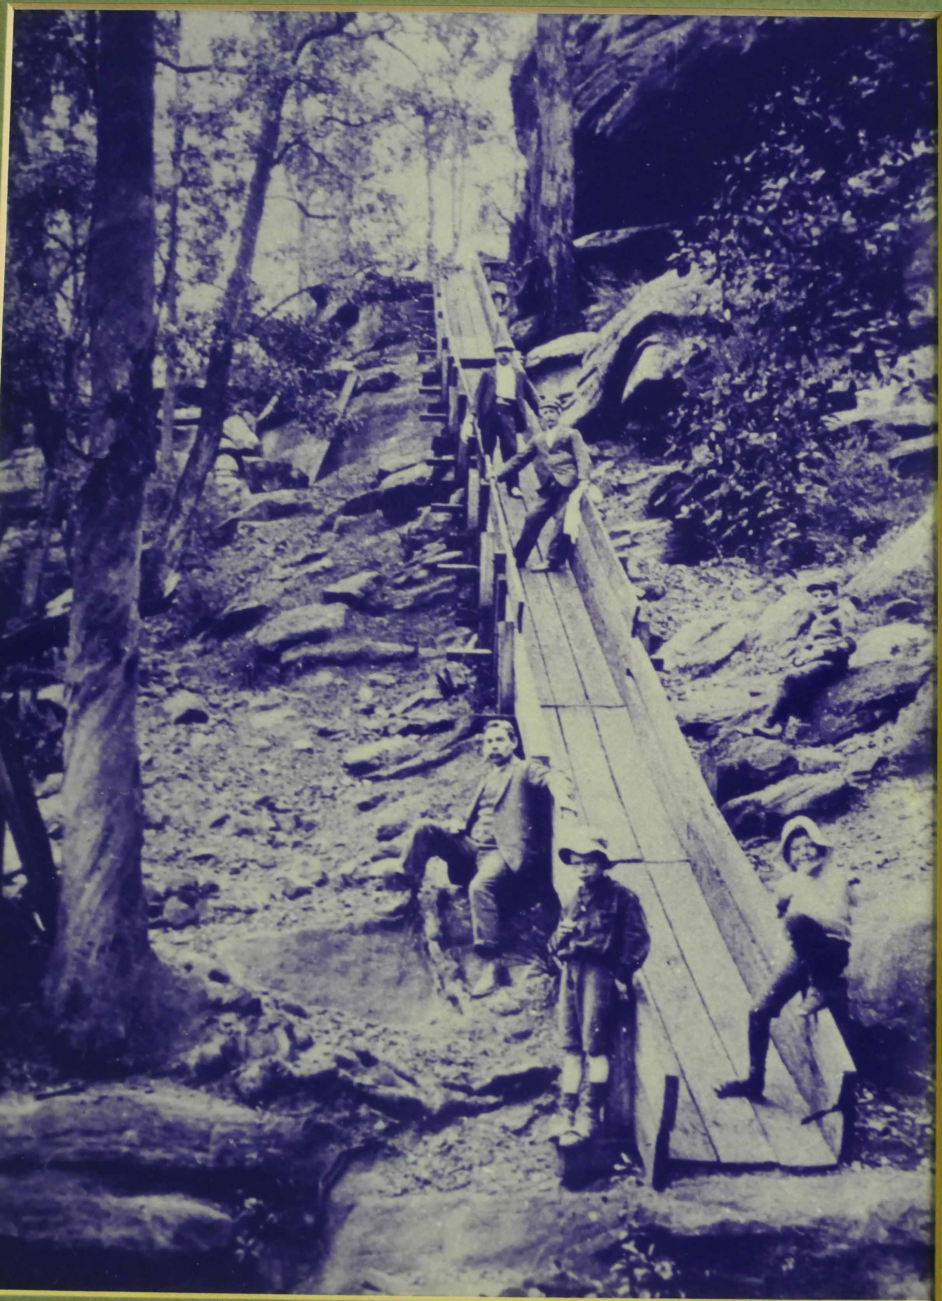
‘Coal chute into Glenbrook Creek used for steam engine to pump water up to Glenbrook Lagoon which was then gravity fed to Glenbrook Station for steam trains. Bottom of chute, Ted Nolan and Will Lawson, son of Henry Lawson’. Image by John Fox from a photo in the Glenbrook Bowling Club. Caption from the picture. The structure was built in Pumphouse Gully, east of the Duck Hole.
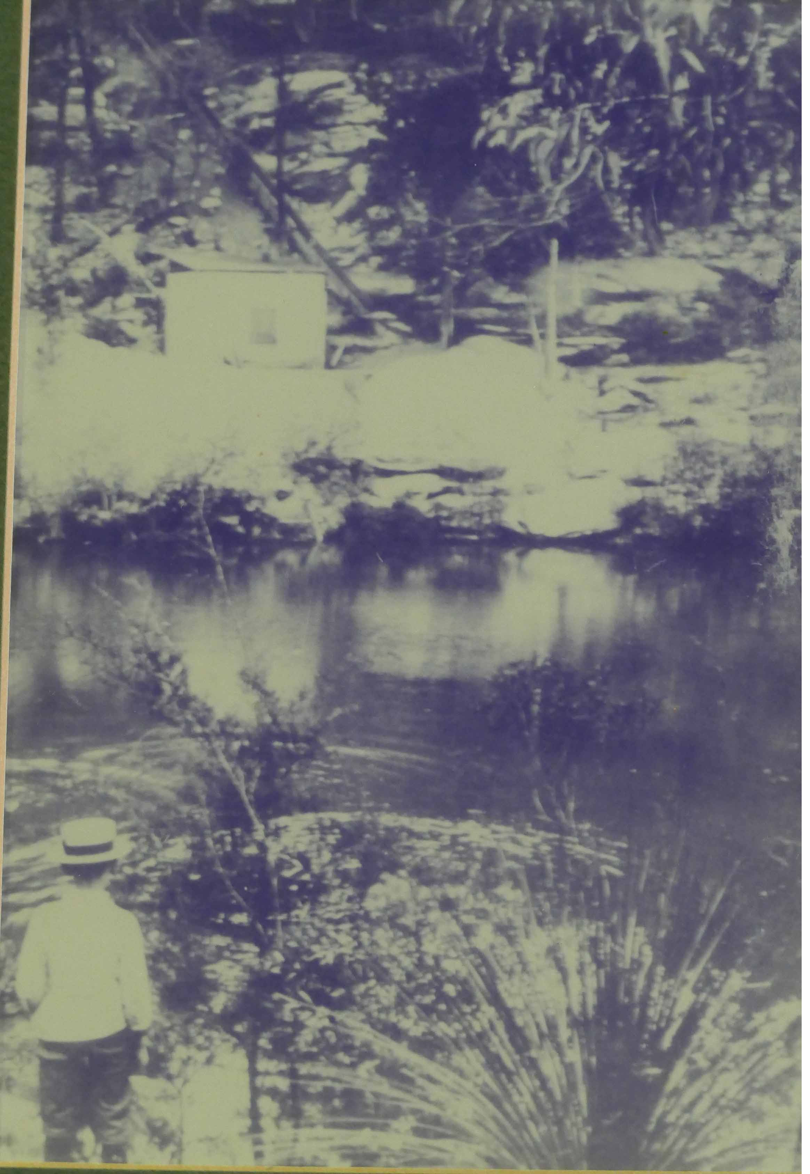
The Pumphouse and pipeline at the Duck Hole. Image by John Fox of a photo hanging in the Glenbrook Bowling Club.
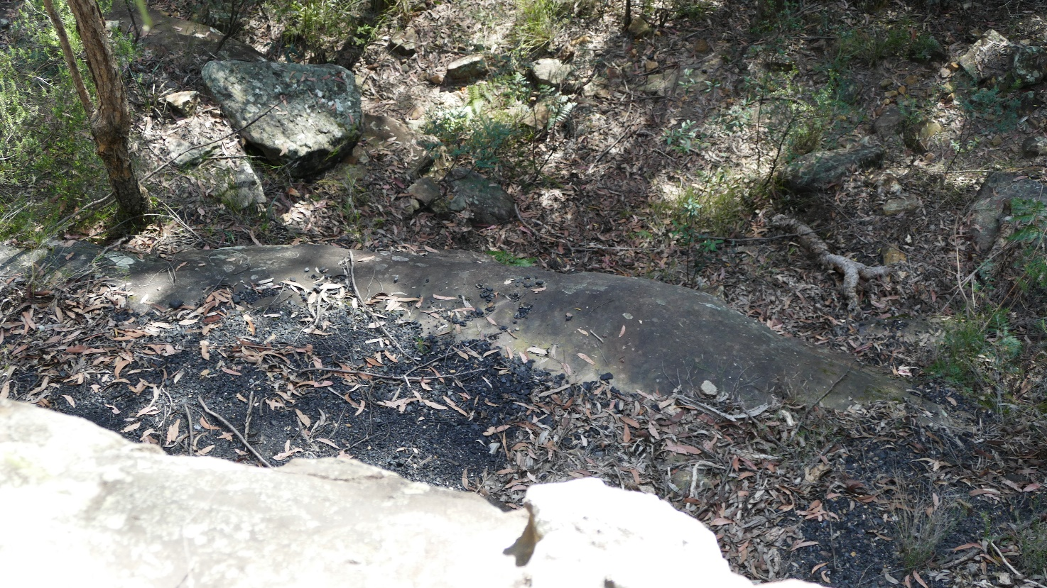
Spilt coal, from the dump at the top of the former coal chute above the Duck Hole. Photo: John Fox.
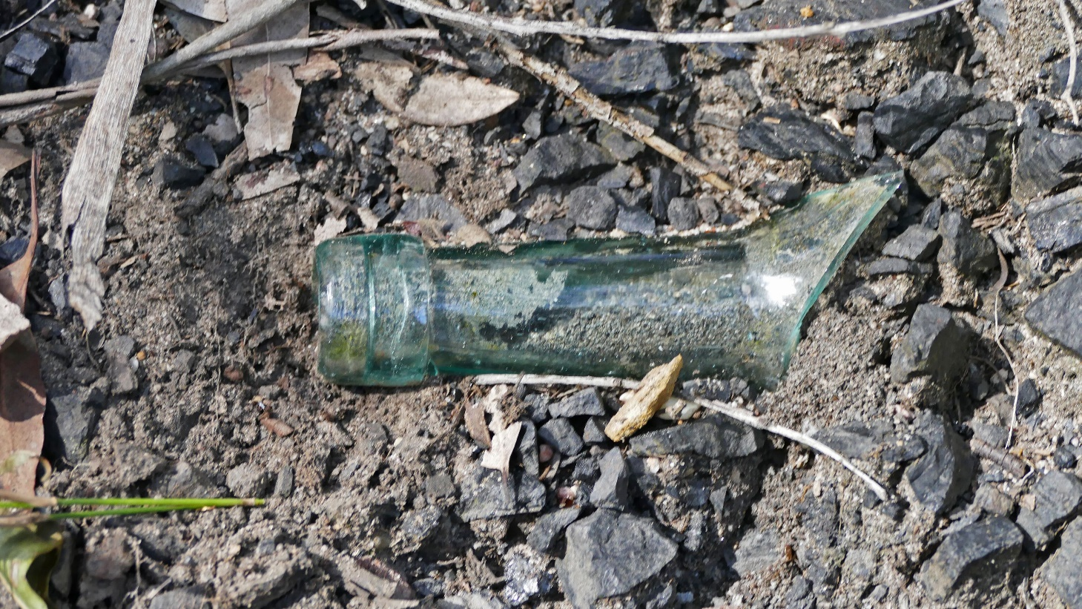
Bottle fragment found in the ash heap, site of the steam pump, The Duck Hole. Note that the bottle top has been added as a separate item Photo: John Fox.
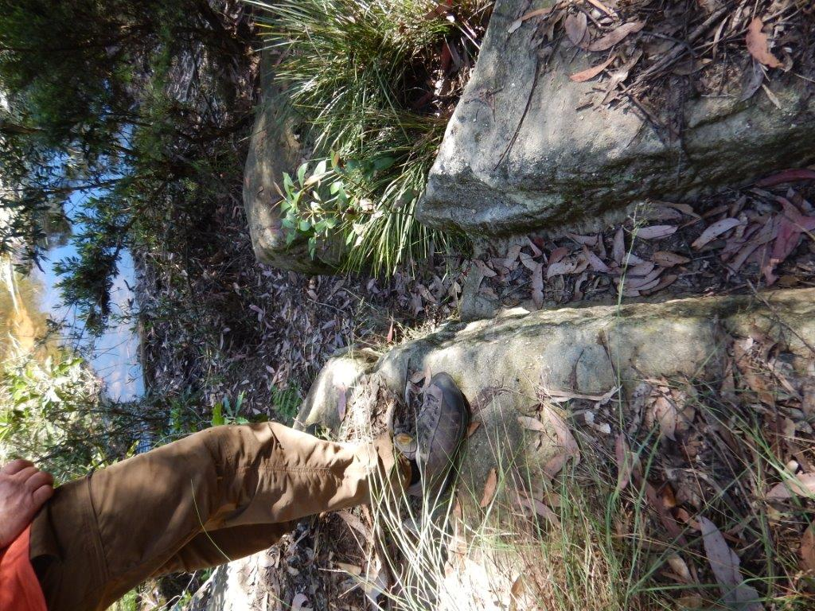
Cut trench for the inlet line for the steam pump installation at the Duck Hole. Photo: Michael Keats.
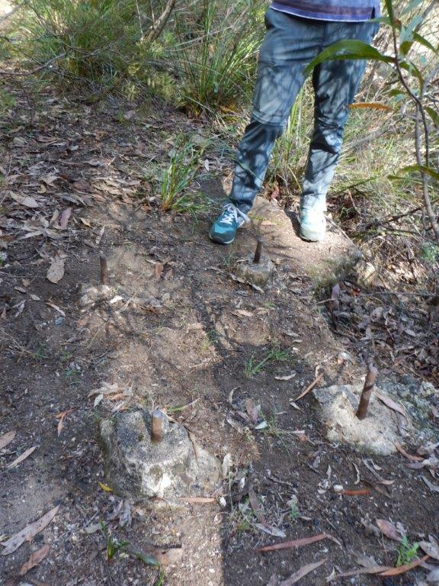
Mounting bolts for the Duplex Worthington steam pump at the Duck Hole. Photo: Michael Keats.

Moving down the coal road there was increasing evidence of blasting holes, where to gain sufficient width (about 12 feet), the road makers had blasted and then used a ‘cut and fill’ approach to creating the road. Many examples were found at GR 783 610 and at two of the three hairpin bends, both recorded as being at GR 781 611, but at different elevations.
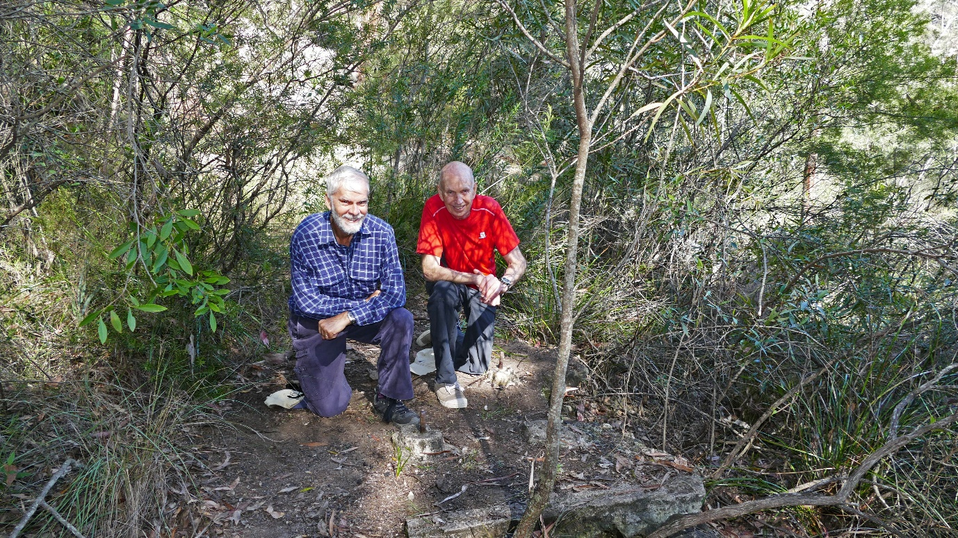
John Fox and Michael at the site of the Duplex Worthington steam pump at the Duck Hole. Photo: Brian Fox.
At 1047, GR 781 611 we reached the top of the site of the former coal chute. Bruce recalled when visiting this area as a 5year old there was still a substantial dump of coal. Little remains on top these days. However, looking over the cliff edge there is still a large quantity of coal (several hundredweights) that never made it to the steam boiler. We decided to have morning tea here. This was a good idea as it allowed opportunity to search the area for more clues. Brian identified the stump of a substantial pole that probably due to its position hard against the cliff face was a key support for the top of the chute.
Morning tea over, we left our packs and made our way down the alignment of the chute to the site of the pump house and associated infrastructure. The concrete slab with four securing bolts was cleared of debris for a photo. Brian did some measuring and the bolts are in a rectangle approximately 20” x 27”. Slightly to the east of this slab there are remains of what was once a substantial pile of ash. We know from press reports of major floods over the years that much of this pile has been washed downstream.
John Cooper indicated that he probably had sufficient information now to undertake a calculation of the minimum size that the Worthington pump would need to be in order to lift the water from Glenbrook Creek to the top of the plateau. Using the trace from the walk today, the plans obtained from the Australian Railways Historical Society, and noting various key sites, it could also be possible to plot the actual alignment of the water lines.
After photographs and generally searching the area we made our way back up the chute alignment to collect packs. A conscious decision was made to walk up the creek bed of Pumphouse Gully in an attempt to find evidence of the position of the pipeline. Whilst there are plenty of likely sites we could find nothing definitive. By 1134 we had reached the top at GR 783 610.
Walking back I recorded our position at 1149 as GR 785 610 and at 1153 at GR 785 611. Bruce had offered to take us to The Bunker, a natural cave used by less fortunate people during and post WWII. This was taken up by all of the party except Denis who proceeded home. Doug had already left the party at the top of the first zigzag in the coal road.
To visit The Bunker, Bruce recalled memories of nearly 30 years ago. We started from the cave at GR 790 610 and then proceeded down an unnamed creek that flows into Glenbrook Creek. It was a delightful creek that soon developed canyon like features. The vegetation was lush and the creek progressively opened out has we pushed further south. At GR 788 603 more grinding grooves were discovered in the creek bed with some very attractive small natural water pots. A tributary creek from the west was crossed at GR 786 607.
We followed a false lead near here up a steep slope, but quickly returned to the creek bed and continued south. At 1242 we entered The Bunker, GR 278606 6260701. It is a place little frequented and there are still many artefacts from the last use, probably in the late 1940’s. Dating was relatively easy with impressed dates on several broken bottles. Of real interest was the remains of a pair of women’s shoes with two soles and one upper well preserved. The timber poles of a rough camp bed were neatly stacked and by some Herculean effort someone had carried in a full length railway line sleeper which had been propped up with rocks to form a stable seat.
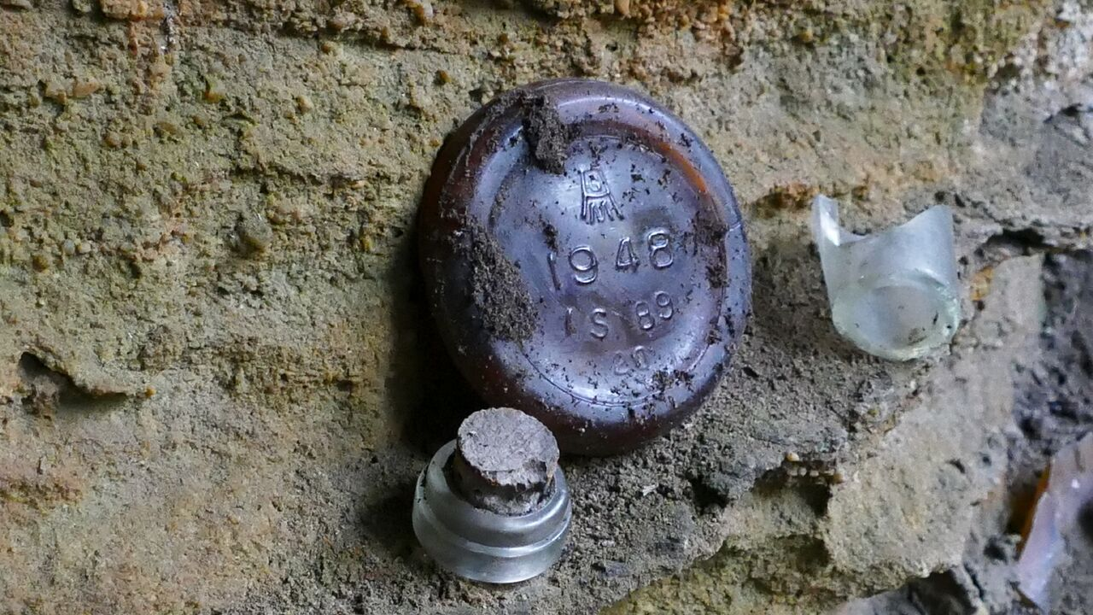
Bottle fragments helping to date occupation of The Bunker. Photo: John Fox.
At 1255 it was time to leave. From The Bunker we headed south east up a reasonably steep slope, negotiating two small cliff lines on the way. 1307 saw us seated on a commanding rock platform with views west over Glenbrook Creek, GR 787 606. The Bunker is about 200m from the junction of the unnamed creek and Glenbrook Creek. Lunch was overdue so with good appetite we enjoyed the break. Bruce needed to get away for an appointment and left well before the rest of us.
At 1324 we set off walking back towards the vehicles. The locally named Loop Track was encountered at 1326, GR 789 606. The vehicles were reached at 1335. Total distance walked 6.7km, total ascents 302m.
Table of Times, Locations and Grid References
Times | Location | Grid Reference
0845 | Park vehicles in Station Street | GR 793 609
0852 | Side track to habitation cave | GR 790 610
0859 | Habitation cave | GR 790 610
0959 | Grinding grooves in creek bed | GR 790 610
0905 | Above railway cutting | GR 789 612
0914 | Old signal stanchion | GR 788 612
0919 | 1911 track deviation across new railway line | GR 787 613
0925 | Rock cutting for the gravity feed pipeline | GR 787 614
0931 | Re-join the coal road | GR 787 613
0942 | Side track to old building site | GR 787 615
0944 | Square cut hole in rock | GR 786 612
0957 | Site of old building + bricks | GR 786 613
1002 | Collapsed chimney | GR 786 613
1007 | Dray wheel ruts in road surface | GR 785 612
1011 | Dray wheel ruts in road surface | GR 784 610
1017 | Spilt coal+ side search | GR 782 609
1021 | Return to coal road | GR 783 610
1030 | Blasting holes | GR 783 610
1037 | Blasting holes | GR 783 610
1039 | Extensive evidence of blasting on first zigzag | GR 782 611
1045 | Second zigzag | GR 781 611
1047 | Top of Coal chute and end of coal road+ am tea + explore area | GR 781 611
1102 | Descend alignment of coal chute | GR 781 611
1104 | In the pump area, ash pile and bottle fragment | GR 781 611
1106 | Measure steam pump mounting bolts in concrete block | GR 781 611
1120 | Walk up Pumphouse Gully searching for evidence | GR 782 611
1134 | Re-join the coal road | GR 783 610
1149 | On the coal road | GR 785 610
1153 | Example of crude stone walling + blast hole marks in loose rock | GR 785 611
1225 | On side track + descent into unnamed creek + grinding grooves | GR 788 603
1239 | Visit to cave (not The Bunker) | GR 786 607
1242 | At The Bunker, 11 minutes + climb out | GR 786 607
1307 | Above Glenbrook Creek on plateau + lunch 17 minutes | GR 787 606
1326 | On Loop Track | GR 787 606
1335 | Return to vehicles | GR 793 609

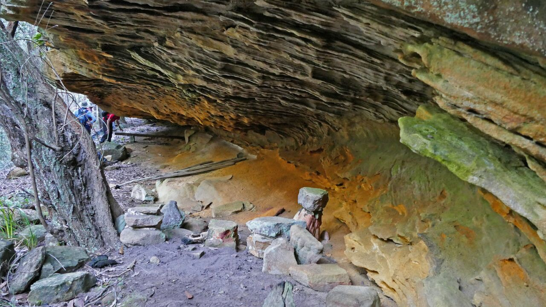

View of The Bunker looking downstream (south west). Photo: John Fox.

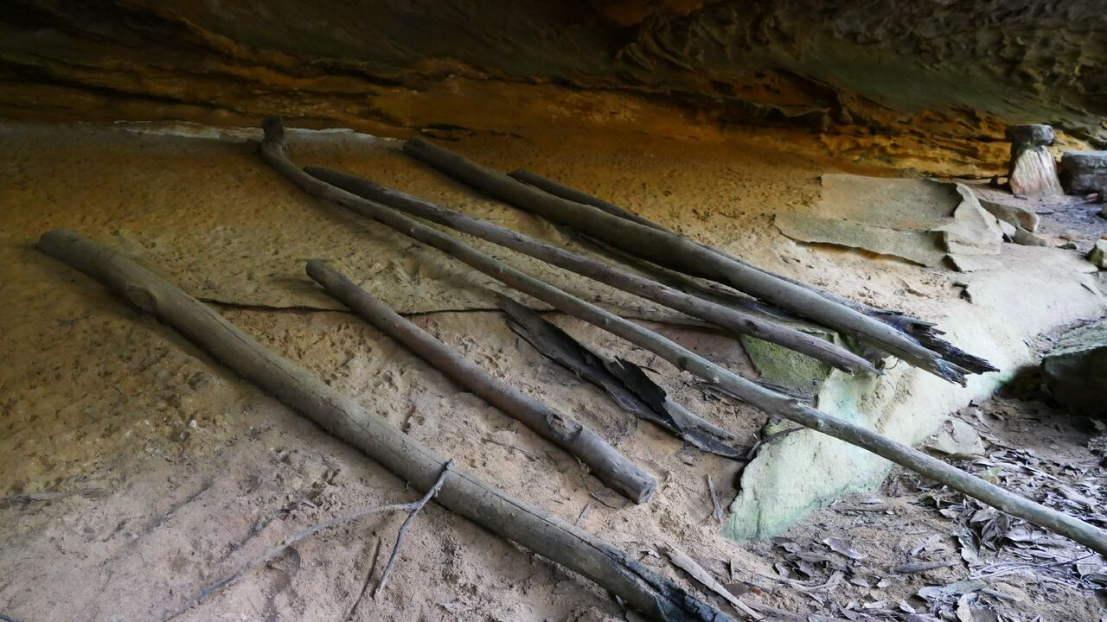

Disassembled camp bed in the The Bunker. Photo: John Fox.
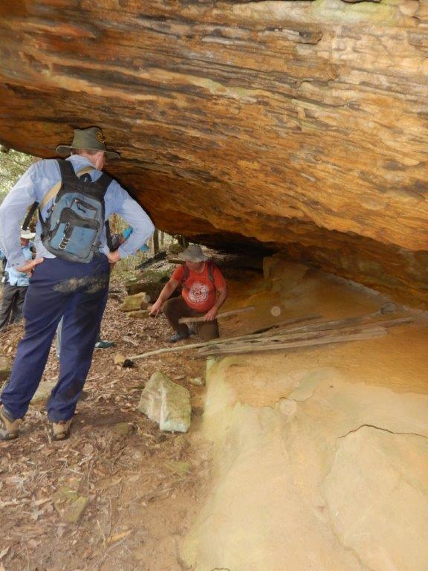
Scott and Bruce in The Bunker. Photo: Michael Keats
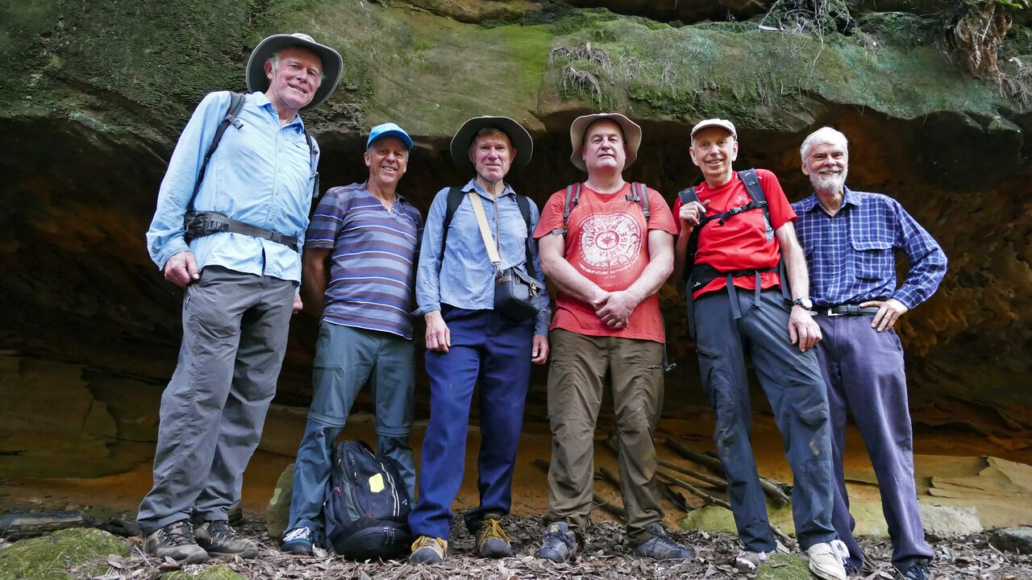
Some of the party at The Bunker. Left to right, John Cooper, Brian, Scott, Bruce, Michael and John Fox. Time exposure, John Fox.

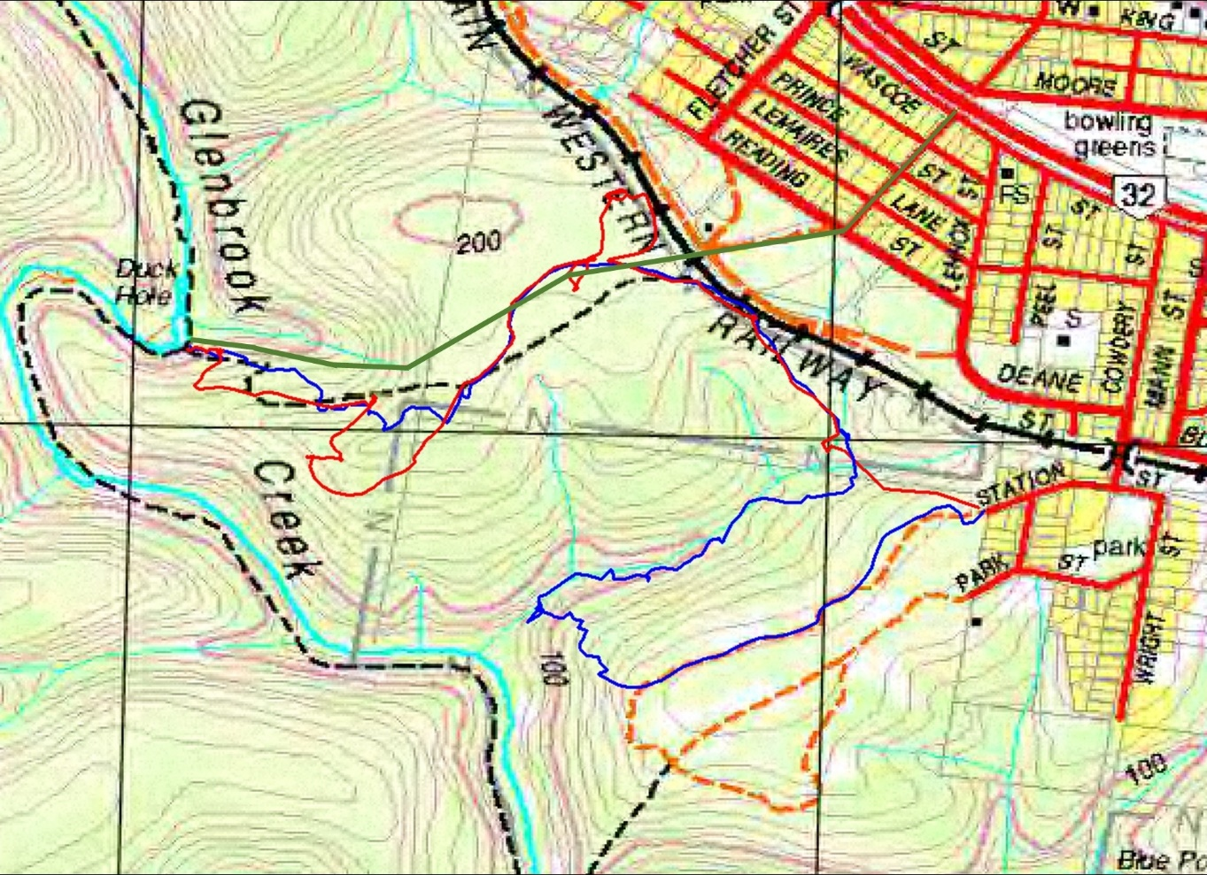
Map drawn by John Cooper.

Private Walk – The Duck Hole and more 010517 – Track Notes /MK

The first time the Duck Hole was used as a water resource for the railways was in 1877. Ref Aston, Nell, Rails Roads and Ridges, 1988, pp 14-15

