Private Walk

Greater Blue Mountains National Park –Blue Mountains National Park – Glenbrook Creek and a bit of detective work- Exploratory- Monday 19th February 2018- Track Notes

Short title | Glenbrook Creek and a bit of detective work
Date | Monday 19th February 2018
Leader | John Fox
Maps, etc. | NSW Department of Lands topographic Map, 1:25000, Penrith 9030-3N, Third edition, GPS setting WGS 84.
Walk description and route | The purpose of this walk is to satisfy that the proposition advanced by researcher Bayley that the steam pumping station at the Duck Hole was not located about 800m further upstream. We will descend to the site of the former pump house at the Duck Hole via the old access track and then make our way upstream to approximately GR 782 620. The plan is to take photographs here to show that no installation ever existed at this location. We may elect to climb the cliffs here to the top or alternatively return to the Duck Hole area and search the cliff line one more time to see whether we can find any evidence of attachment points for the former pipeline.
Rating | 4 (has to be a 4 as it is off track).
Gear issues | 3 litres of water at least, first aid kit, GPS, PLB, appropriate head and footwear, electrolytes, maps, compass.
Numbers | By invitation.
Meeting point | Pymble 0600, Blaxland (John Fox home) 0800, at 2773 Coffee Shop, Ross Street, Glenbrook 0830.
Transport | Club cars.
Comments | This walk has exploratory elements and may or may not involve exposure. We may get wet
Close of Bookings | ASAP
Enquiries | Michael Keats mjmkeats@easy.com.au or Tel 9144 2096

The Party

John Fox, leader, Brian Fox, Michael Keats, Daryl Watson, Dave Dash, Freda Moxom, Emanuel Conomos, members of the Bush Club and Noel Cather and Jeff Moonie, members of the Glenbrook and District Historical Society, 9.

The Weather

A warm to very warm day with high humidity and variable cloud cover.

Background Notes

On 10th February 2006 in company with bushwalking legend, the late Wilf Hilder a visit was made to Glenbrook to visit the Duck Hole. An extract of the authors notes of that walk based on statements by Hilder are set out below.
“Heading west again along Station Street we picked up a fire trail for 50m before heading north and west along the remnants of a long forgotten trail that joined with an historic ‘coal road’.

Although this ‘coal road’ is long forgotten it is well graded with some significant but crude dry stonewalls up to 3m in height. It is a road redolent with history – railway history. It was constructed as a result of the prolonged drought in the late 19th century that dried up the natural lake (Glenbrook Lagoon) water source for replenishing water for the steam trains at Glenbrook.

The road and associated timber chute enabled the delivery of coal to service a steam pump on Glenbrook Creek at the Duck Hole. This installation lifted water from the Glenbrook Creek through some 90m to the plateau top. On the day evidence was found of one of the rock cuttings made to allow the inlet suction pipe to fit snug into the cliff line. Hilder reported that he had collected a piece of coal from the track on a previous visit.”

Ten years on, 24th October 2016, in the company of co- author John Fox, we retraced some of this journey,

“The built track down Pump house Gully to Glenbrook Creek is 2m+ wide and apart from several washaways and trail bike rider’s random shortcuts it is still in reasonable condition. Checking for artefacts, a square headed forged bolt was located fixed into the rock about 5m back from the river bank. Here also there is a concrete slab with four embedded bolts and nearby a hand forged loop bolt secured into the rock by molten lead. A deeply cut trench in the sandstone could have been used to secure the inlet water pipe line.”

On 1st May 2017 another visit was made to the area, principally to search for evidence of structures associated with the operation of the steam pump at the Duck Hole. Immediately off the coal road to the south near the crest of the hill, there are several groups of stones, manufactured bricks and dug pits that could have been related to dwellings (a caretaker cottage?) and or infra structure for the operation of the steam pump. It is possible that a person was permanently stationed to monitor coal deliveries, prevent theft of coal or interference with the works.

An operational steam pump almost by definition requires a full time attendant, and given the demand for water it was most likely a 24 hour, 7 day a week operation. Supplies of lubricants and other maintenance items would need to be on hand and also be protected. Even if the attendants walked in from Glenbrook each shift there would still need to be a caretaker/security person controlling the pump site.

On 25th May 2017, Bruce Cameron, bushwalker explorer and author reported that he had rediscovered a cave just downstream from the old bunker. (Cameron had visited this location 30 years earlier). As he reported,

“What I did not see last time was there are big chunks of coal in the cave, Buckets loads!! I am thinking the cave was used by staff at the Duck Hole and the coal is as big as a slice of bread and 2 inches thick. The coal would almost certainly be from the Duck Hole works. I think it may well be a Duck Hole related site.”
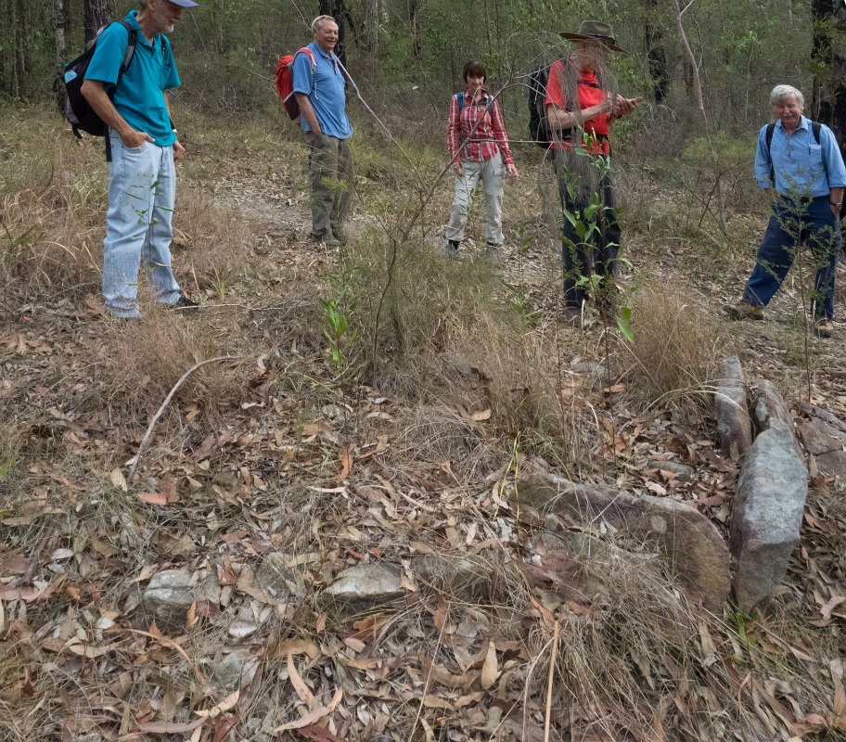

Some of the party examine placed stones that could have been for a building related to the water pipeline, GR 790 610. Photo: Emanuel Conomos.

William A Bayley a railways historian published a map in his book Lapstone Zig Zag Railway, 1972. The map shows the steam pump installation at GR 782 620, a similar bend in Glenbrook Creek to the Duck Hole GR 781 612, but some 800m due north.

Now the map Bayley drew for his book, (copy below) was more than likely based on drawings from the ARHS historical records, of which we have copies. There are two separate and distinct sets of plans. What we do not know any more than Bayley knew was whether the drawings were merely ideas for consideration or whether they were adopted with the intention to be built. I suspect that Bayley never visited either of the two sites and chose to use the drawings which showed the pump installation closest to Glenbrook Lagoon.

Bayley failed to recognise the basic engineering principles his assumptions violated; viz. why pump water up 100m, then over a ridge, then by a tunnel under the railway line only to disgorge this now costly water into a vast evaporation basin (the lagoon) so that what remained in turn could flow by gravity all the way to the tank at the railway station. I believe Bayley’s pipeline never existed. Copies of scaled plans and cross section drawings obtained from the Australian Railways Historical Society (NSW) branch and attributed to ‘GWR –Water Supply at Glenbrook’ show that considerable engineering would have been involved in ensuring water supply from the Duck Hole.

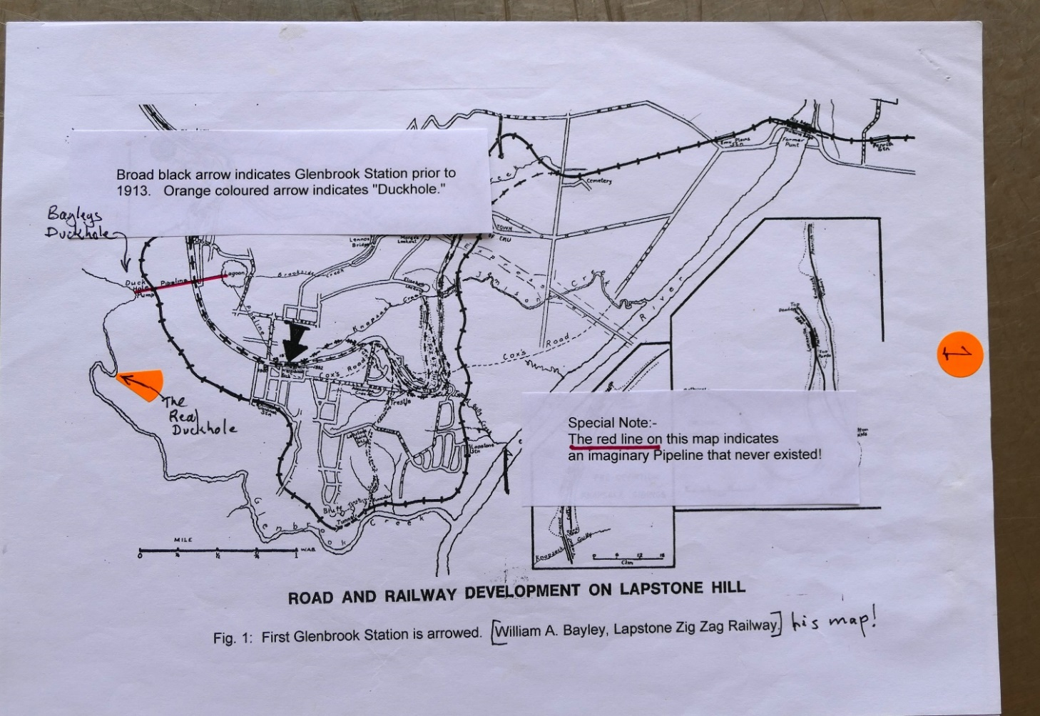

The map by William A Bayley showing the mistaken location of the Duck Hole as published in Lapstone Zig Zag Railway, fig 1. Image thanks to Glenbrook and District Historical Society, 16th January 2017.

Prior to the walk today, John Fox carried out a recce walk to make sure that we could reach the site of Bayley’s supposititious pump site. John did more, he scrambled up the cliff face to the top of the ridge to satisfy himself that there was no old infrastructure hiding in the bush.

Track Notes

Before the walk started we meet with Doug Knowles (Glenbrook and District Historical Society) who was unable to come on the walk. He also brought a CD video from Denis Bainbridge, also of the G&DHS, of our Duck Hole investigation 1st May 2017.

Doug had not been idle. Concerned about evaporation rates at Glenbrook Lagoon after pumping water from Glenbrook Creek at considerable expense; he handed me a copy of his calculations showing that in the month of January 2018, some 5,677 gallons per acre per day were lost to evaporation. With losses of this magnitude pumping water to an evaporation basin makes no sense.

Vehicles were parked at the end of Station Street at 0839 and walking was under way a few minutes later. All noted the extreme dry conditions which have left many native species struggling for survival.
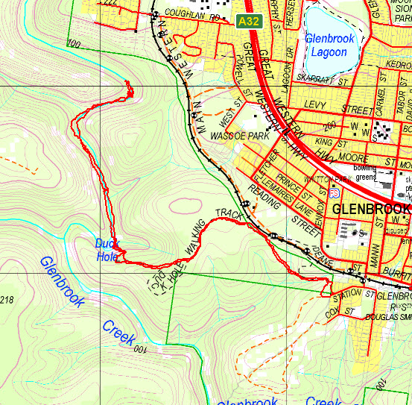

Plot of the walk overlaid on a topographic map -recorded by Brian Fox and prepared by Yuri Bolotin.

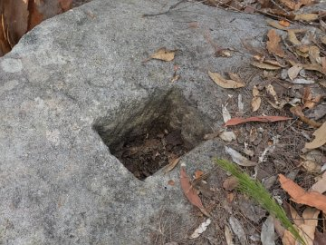
Cut hole in sandstone located below the current access/ service road parallel to the current railway, possibly used to support a strainer post for signalling equipment. Photo: Emanuel Conomos.

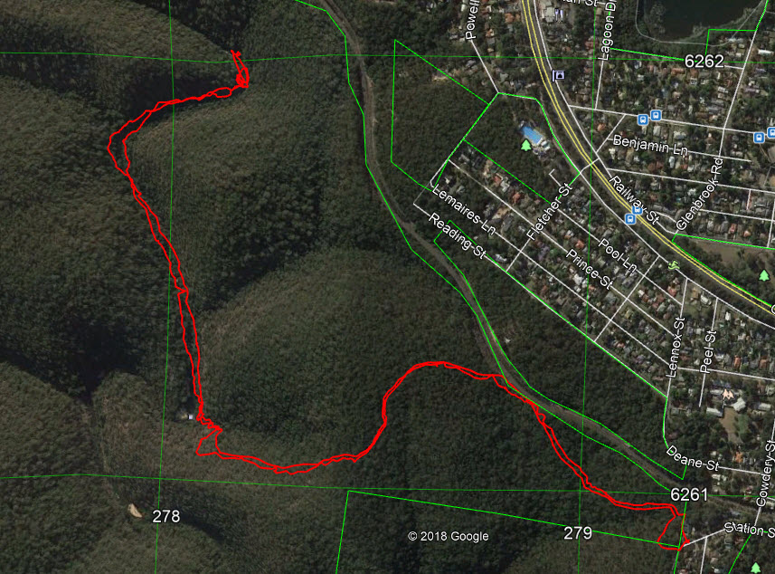

Plot of the walk overlaid on an aerial photograph -recorded by Brian Fox and prepared by Yuri Bolotin.
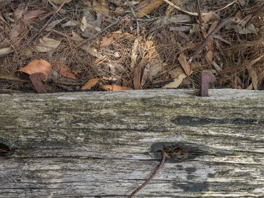

Square strainer post laying near the square hole shown above. It is uncertain what the two steel pins were used for Photo: Emanuel Conomos

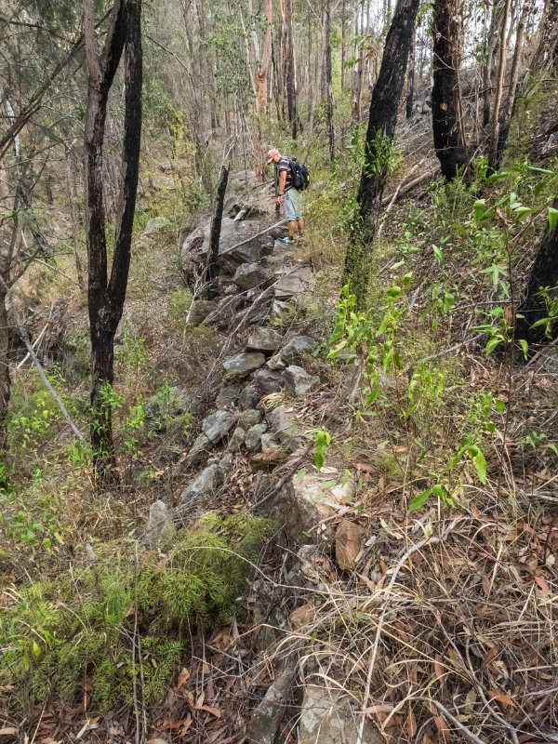

Brian above a dry stone wall south side of the current railway cutting. Two square cut holes were found in large boulders in this wall alignment. Photo: Emanuel Conomos
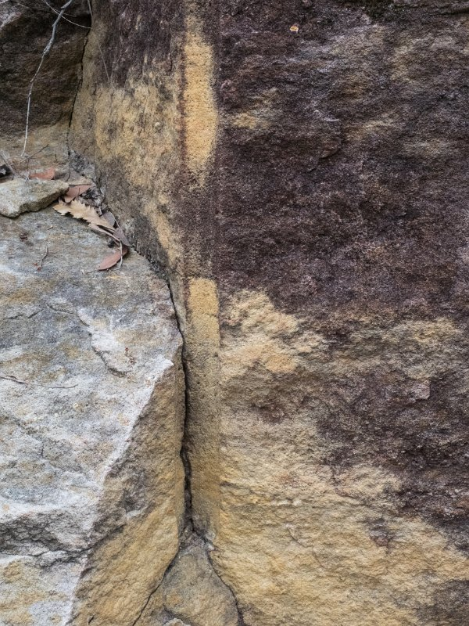

Blasting drill hole located on the route down to the Duck Hole. The evenness of the drill hole suggests that it was machine cut. Photo: Emanuel Conomos
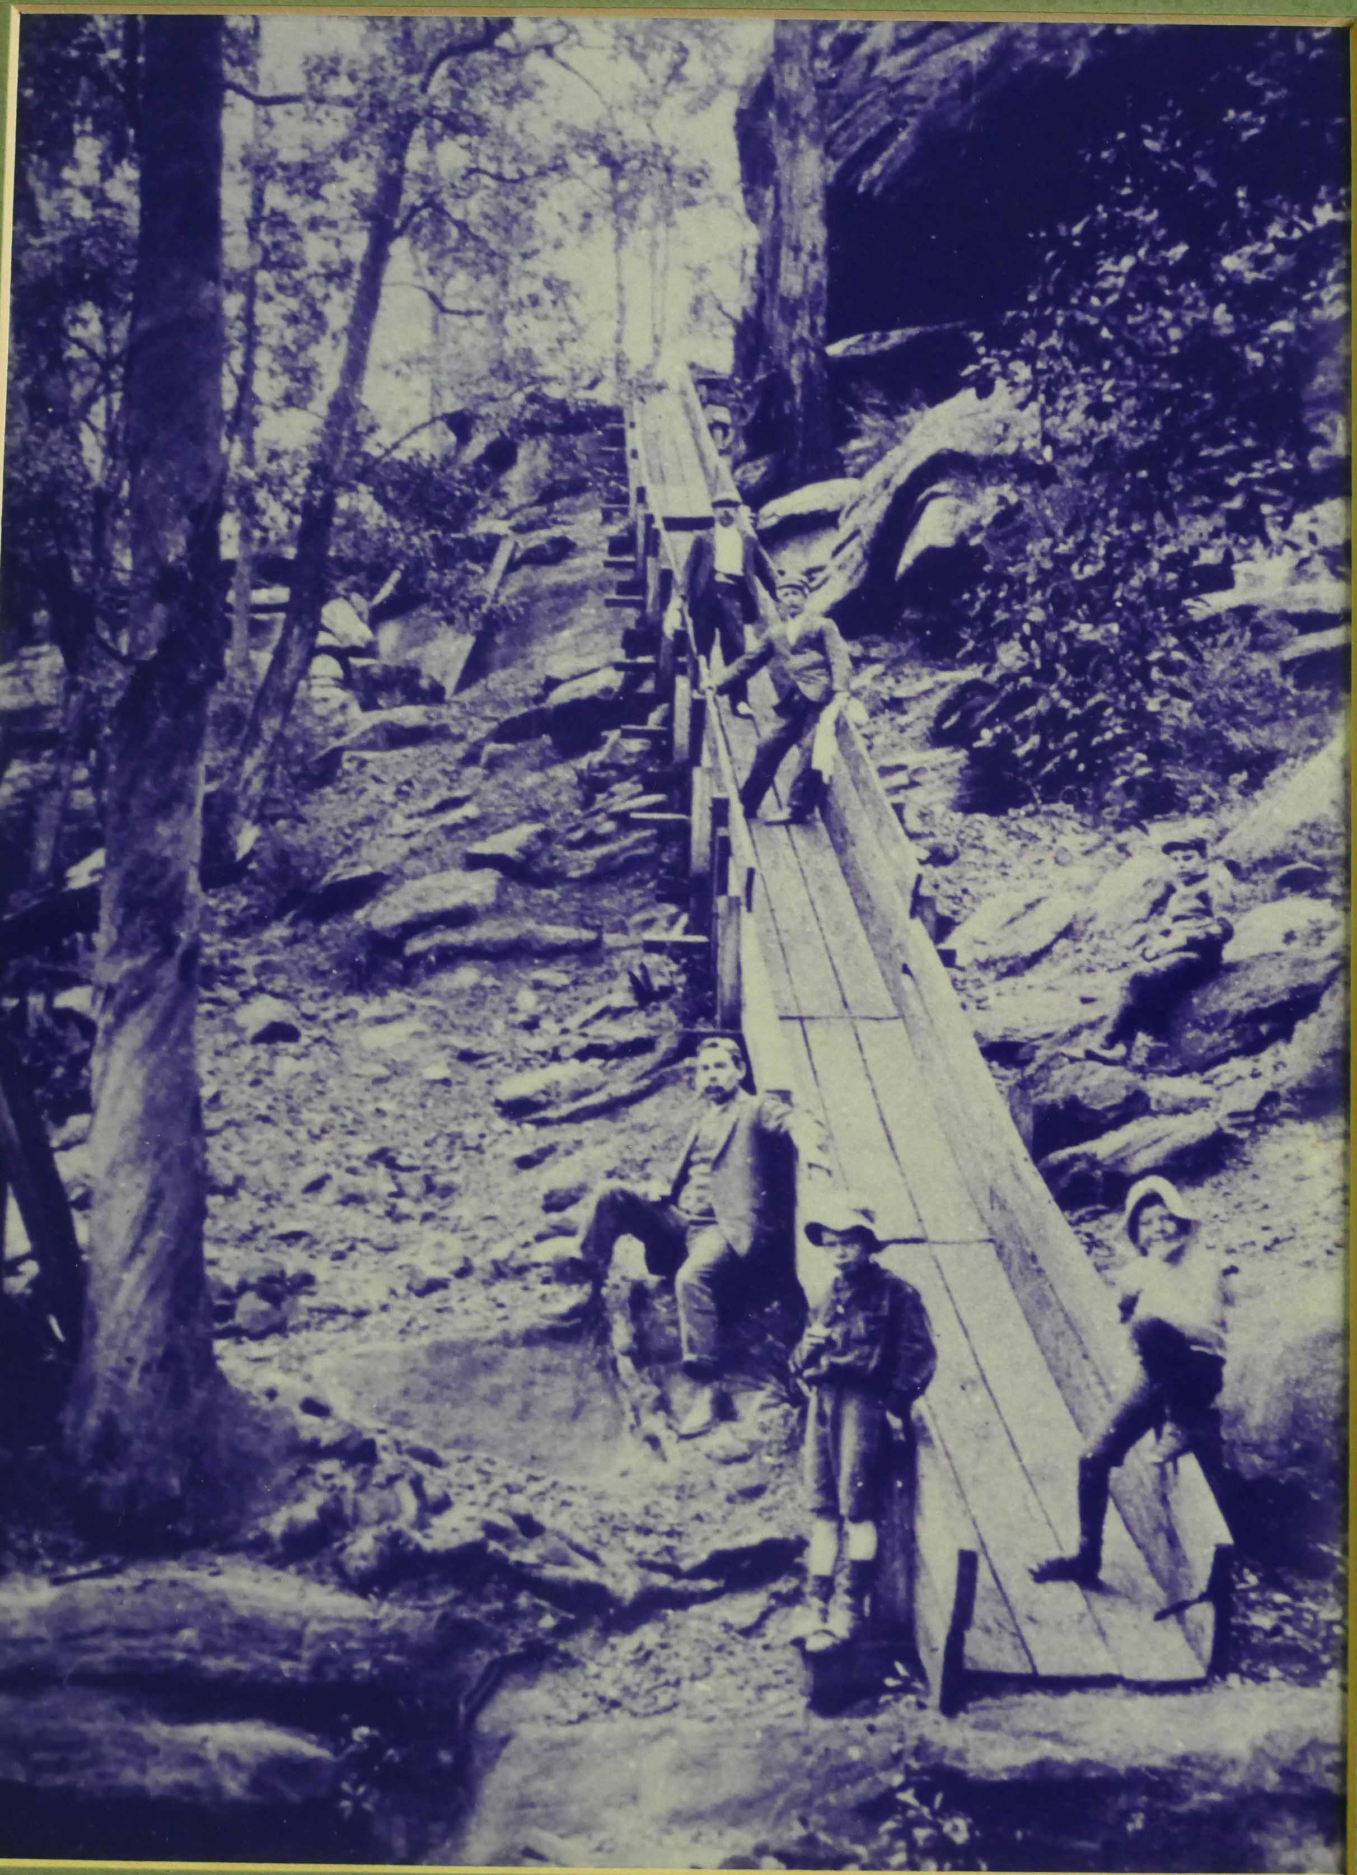

The coal chute above Glenbrook Creek used to deliver coal for the steam pump installed to lift water up to the cliff top and then either to Glenbrook Lagoon or Glenbrook Station water tanks. It is known that the water was gravity fed to Glenbrook Station for steam train boilers. Whether there was another direct line is conjecture. Note re the above picture. There is no coal visible in the chute or at the bottom end of it which raises the question, was this picture taken on completion of the chute and before it was commissioned. Bottom of chute, Ted Nolan and Will Lawson, son of Henry Lawson’. Image by John Fox from a photo in the Glenbrook Bowling Club. Caption from the picture. The structure was built in Pump house Gully, above the Duck Hole.
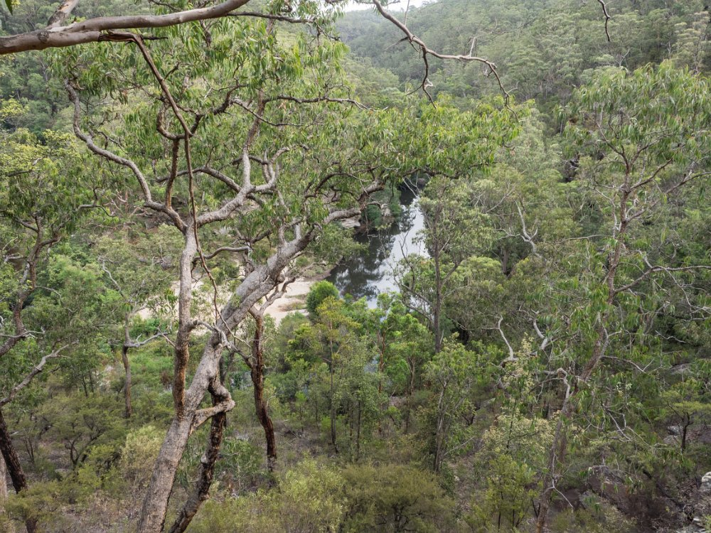

Glenbrook Creek taken from above the Duck Hole. Photo: Emanuel Conomos.

Our first stop was at GR 790 610 where there is evidence of placed stones forming the base of a hearth. This immediately begs the question as to whether it was the site of a former building connected with the steam pump operation. Whilst it is some distance from the so called coal road it could be associated with the delivery pipeline or accommodation for a linesman.

Nearby, GR 789 612 and below the current service road there is a section some 50m long of dry stone walling, in places 6 course s of stone blocks high, two square cut mortise holes that could have supported squared timber posts. General thought were that these works related to the current railway and possibly date from 1912.

At 0910, GR 787 613 we left the network of tracks and newer roads and joined the alignment of the coal road, c 1903. This road has evidence of deep ruts caused by the steel rimmed wheels of the drays hauling coal to the top of the delivery chute. To try and give the walk context I am quoting here some researched material, thanks to John Fox.

The Nepean Times, June 3, 1903, ran the following article “GLENBROOKS WATER SUPPLY- Owing to the alteration of arrangements for watering trains at Glenbrook, and pending further improvements there, Mr. Charles Towle, who has been employed there for the last 18 months in attending to the watering of trains, has come back to Penrith, and Mr. J. Ensor, of Lawson, is now in charge. During the severe drought, and while the duplication was going on, Mr. Towle's duties were of the hardest, but, by his obliging manner, he had endeared himself to, not only the employees, but the townspeople as well, all of whom regret his leaving”. I am curious about the section, “the alteration of arrangements for watering trains at Glenbrook, and pending further improvements there …Mr. Towle's duties were of the hardest...” Was Towle down at the Duck Hole or was he at the station? He could not have done both duties. What were the changes?

An extract from p 388, Shop Orders Mechanical Branch, NSW Railways has the following entry,
“4th July 1903, dated authorised, 13th July 1903, date ordered, Order Number 5236, Glenbrook Water Supply. Pump House and foundations for pump, clearing approaches, £100. Completed 18-12-1903.”

What is not certain is that this approved work was at the Duck Hole. Given that it took six (6) months to complete and is the equivalent in 2017 money to $14,000 it was very likely at the Duck Hole and not at the Glenbrook Lagoon.

Here in the available historical record there is an apparent conflict of information about when the first pumping of water from the Duck Hole commenced. The Nepean Times, Saturday 3rd October 1903, page 6, records, “The Commissioners are now having a pumping plant put down in Glenbrook Creek over a mile from the station and over 400feet below the rail level, which, when completed, will give them a never failing supply of beautiful water. This work will be completed in about a fortnight’s time.”

… and also of Nepean Times Saturday 14th November 1903, page 6, “The new pumping plant to supply the Railway Department with water from Glenbrook Creek, a mile and a quarter from the station, and something over 400 feet below the rail level, was put into operation over a week ago, and has done away with the necessity of running a water train from Penrith which has been going on for nearly two years at great expense to the Commissioners. The pump, a very powerful duplex Worthington is working well and keeping up the supply satisfactory.”

The Nepean Times, Saturday 7th May 1904, page 6, records, “The Railway Department are also calling for tenders for the carting of coal from the station out to the new pumping station for the year ended 30th June 1905.” [We didn’t get that advertisement- Ed, N.T.]

The foregoing information was borne in mind as we left the old coal road, GR 785 611 to take a steep short cut. The horses or oxen used for delivering the coal would have to use the more gradual incline of the coal road. We linked up with the coal road again lower down. At GR 783 610 there is a significant hairpin bend that must have been a challenge to the drivers and animals alike.

Further down the cut bank side of the coal road has been widened by blasting out sections of the sandstone. Good examples of machine drilled blast holes are to be seen at GR 783 610. The writer is of the opinion that this is part of the works described in order number 5236 above that refers to ‘clearing approaches.’

At 0941, GR 781 611, we stood on a natural viewing platform looking over the Duck Hole and a section of Glenbrook Creek. From this point the coal road heads north to the top of the coal chute.
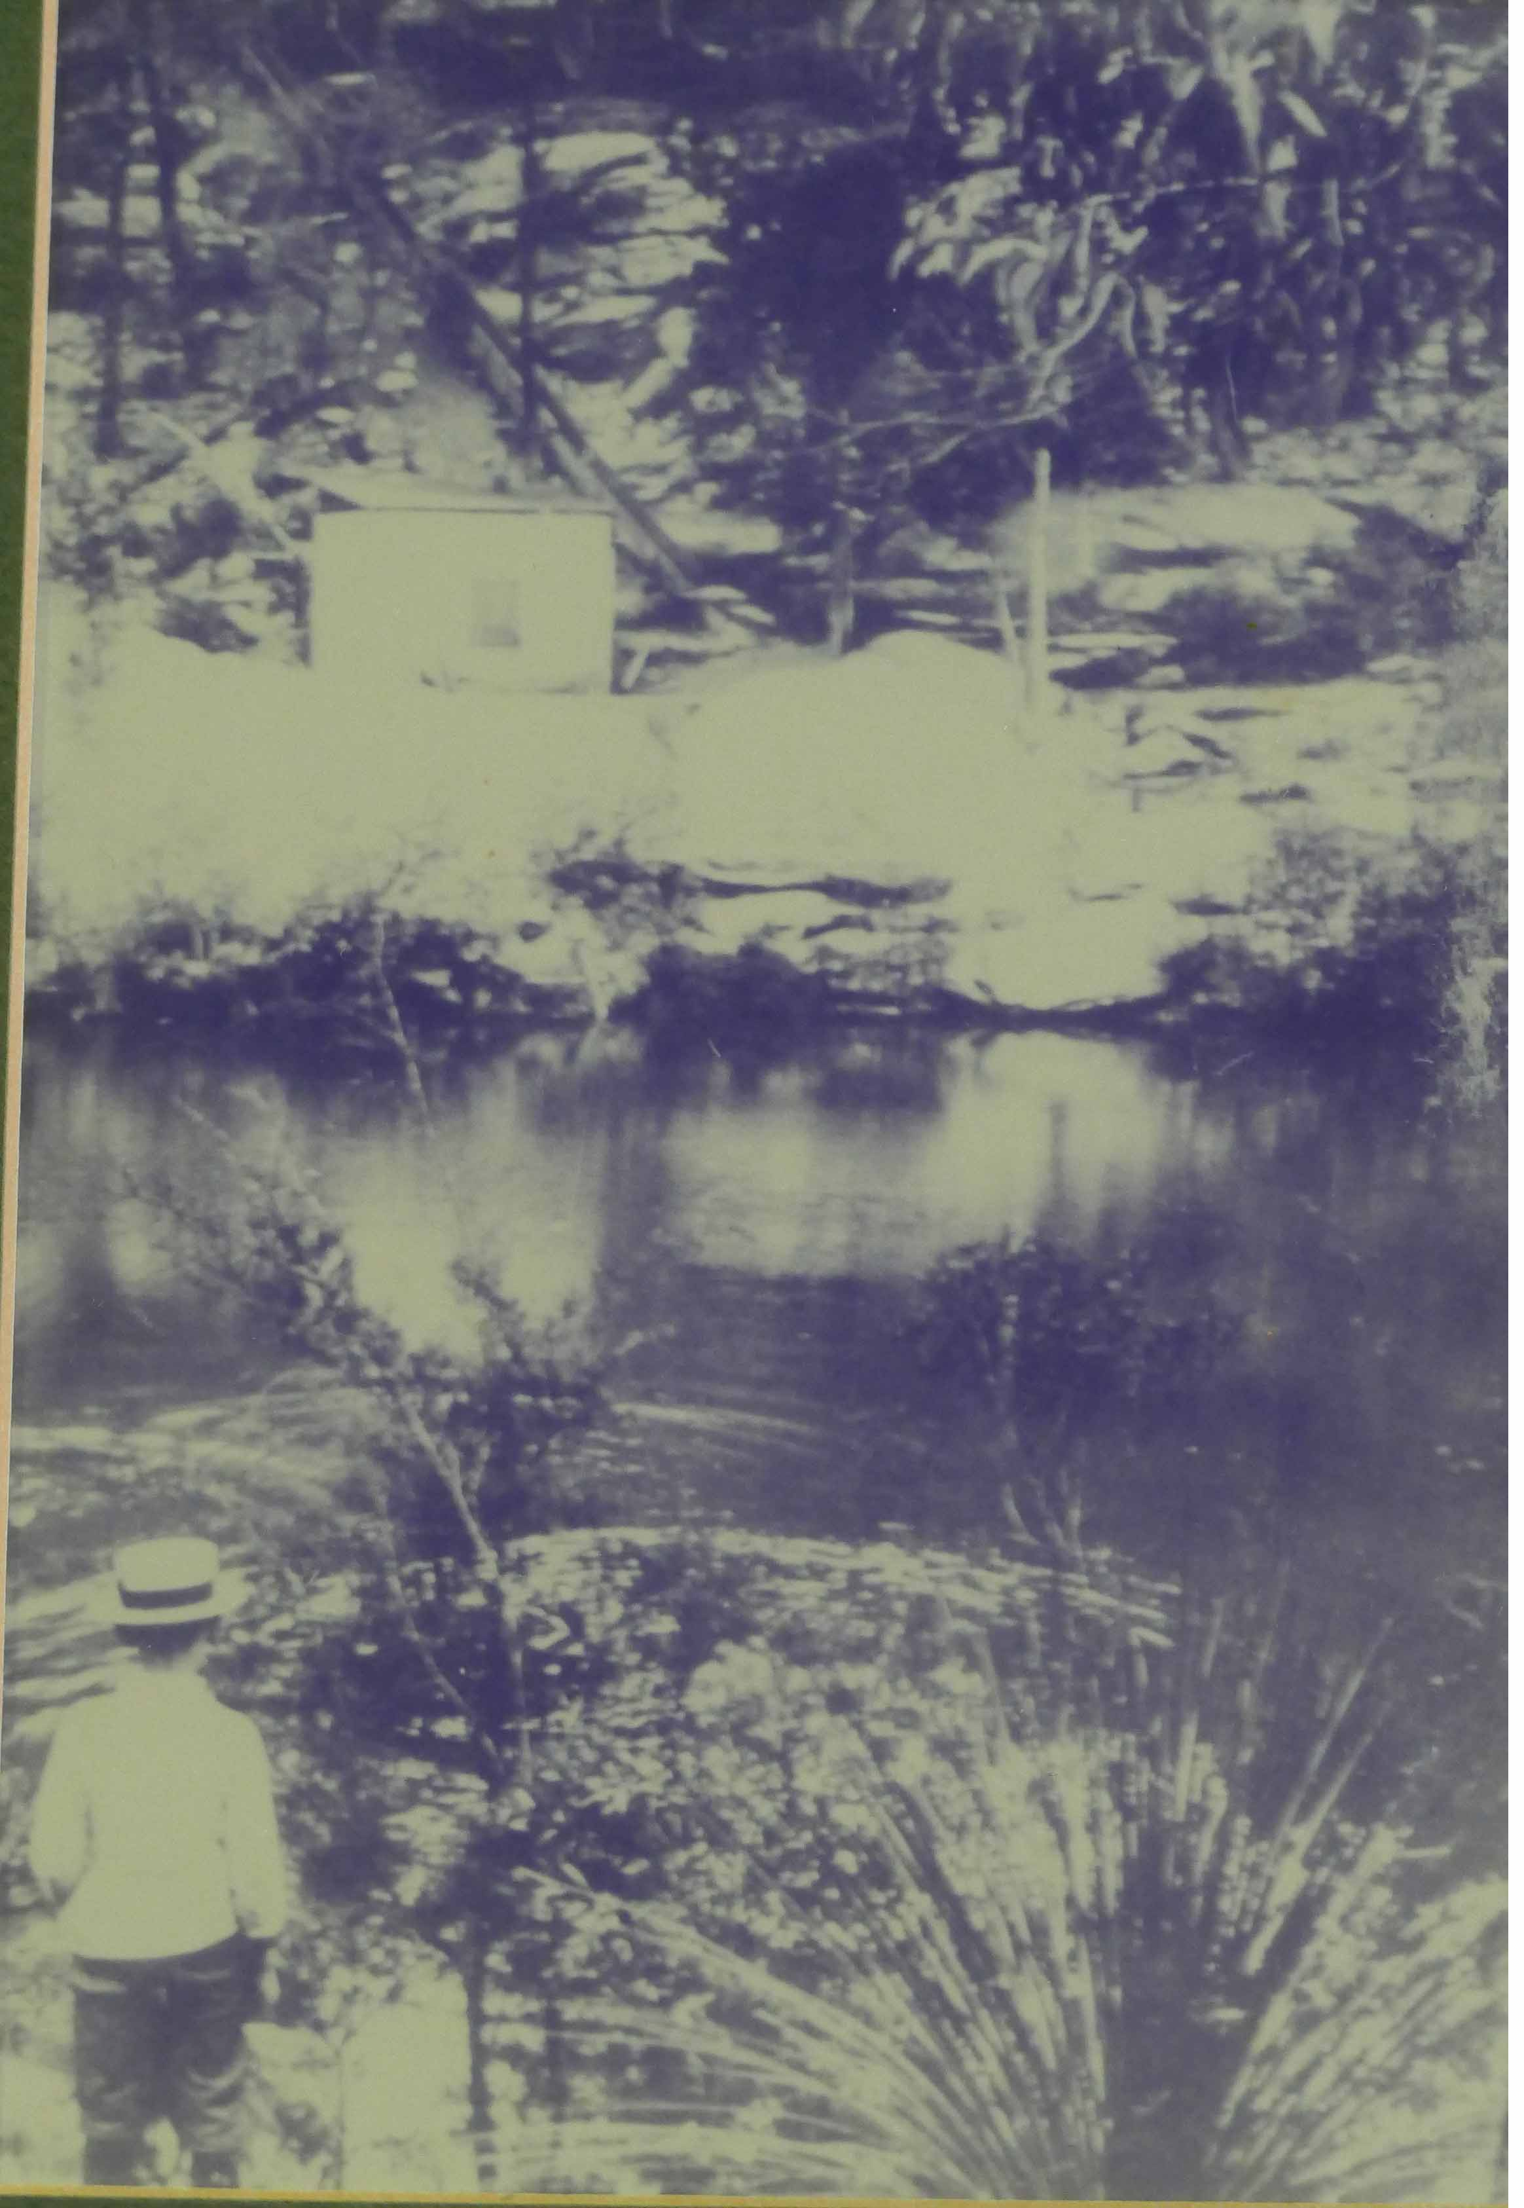
The Pump house, coal chute and pipeline at the Duck Hole. Image by John Fox of a photo hanging in the Glenbrook Bowling Club.

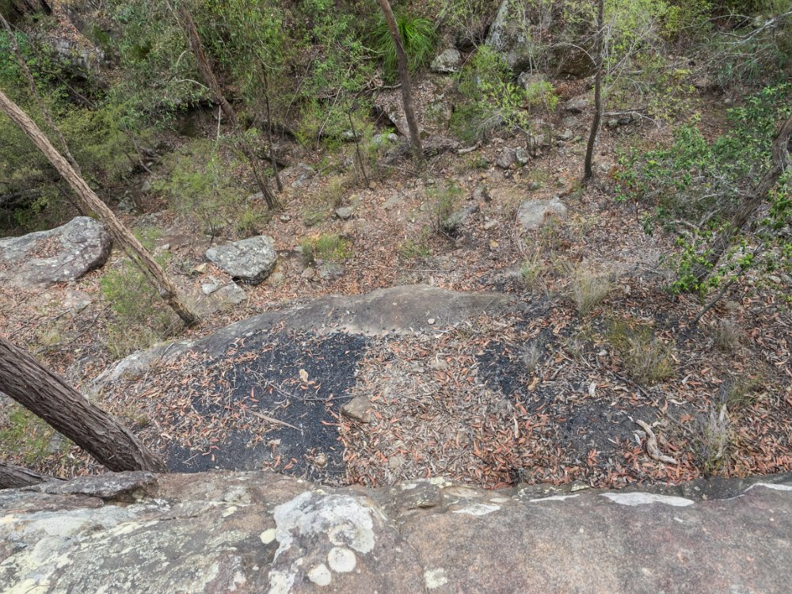
Not all coal made it to the chute. Photo: Emanuel Conomos.

Standing above the chute Dave had a good look around to see what evidence remained of a loading stathe or transfer mechanism to unload the dray (or similar) and then send the coal down the chute. We could find nothing. What was easy to find is evidence of spillage where coal had missed the mark and gone over the edge of a small cliff onto a rock shelf.

Although there is a graded path from the top of the coal chute to the bottom where the pump was located, we elected to scramble down and note carefully any remaining artefacts. There were several locations where 7/8th diameter, square topped and possibly hand forged bolts indicated points of attachment for the coal chute.

Almost down at the creek bank is a slab of concrete with 4 threaded bolts set out at roughly 750cm x 900cm from each other. These bolts possibly secured the steam pump or the boiler. Given the relative disposition of the remains of ash dump, I would suggest that the bolts were for the pump as the fire box would have been closer to the ash dump.

A really conspicuous item is the cut trench to house the water intake pipe from the Duck Hole. A photograph shows an eyelet secured into the rock by molten lead. This was most likely an anchor point to secure the pipe and reduce movement caused by the water flow.

We had plenty of time to speculate on all these issues over a ten minute morning tea break.
Then it was packs on as we headed up stream to the reputed alternate site for the steam pump.

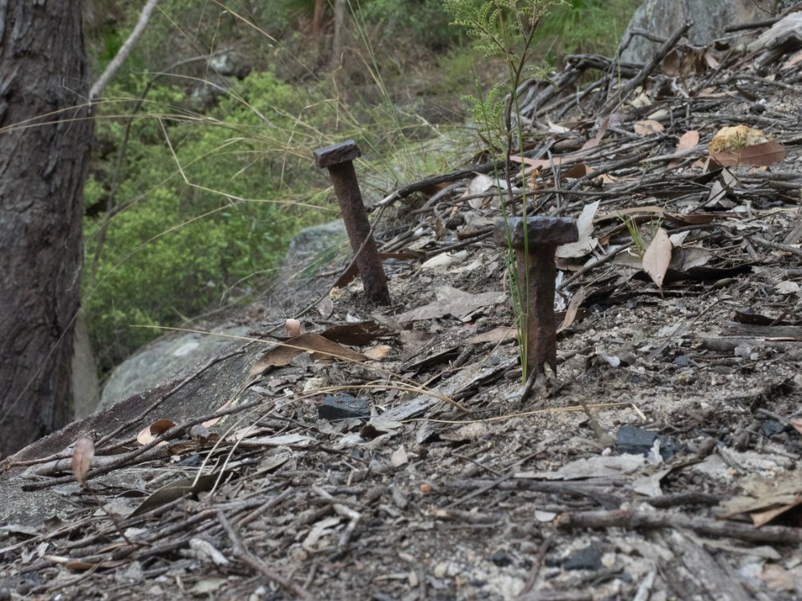

Two of several securing bolts for the coal chute to the Duck Hole. Photo: Emanuel Conomos.

The walk upstream is on a rough track that is used by keen bushwalkers. It goes all the way to Martins Lookout some 6km from the Duck Hole. At 1046, GR 779 818, an unnamed tributary joins Glenbrook Creek from the west. John advised that normally this is a babbling brook of crystal clear water. Today it was bone dry and dusty. No need to worry about wet feet.

We kept pushing on along our rough path for another five minutes and arrived at the bend in the creek, the site of the Bayley map Duck Hole, GR 782 620. It is an unlikely site with the banks revealing no sign of any man- made structures. Excursions were made further upstream but nothing was found except a small waterfall in a side gully, so small it does not register. Daryl did some quick calculations about the location. It is about 300m as the Kookaburra flies from the bend to the present day railway line, a further 400m to the Great Western Highway and 900m to the nearest access to Glenbrook Lagoon. John Fox reiterated that he had climbed to the top of the gully on the eastern side of the bend and found nothing to indicate any structures or works at all.

There was general agreement by all present that no construction of any kind had happened at this site. At 1123 we began the return journey to the Duck Hole where we had lunch before climbing back to the coal road and then to the vehicles. Total distance walked 6.6km, Total ascents 214m.

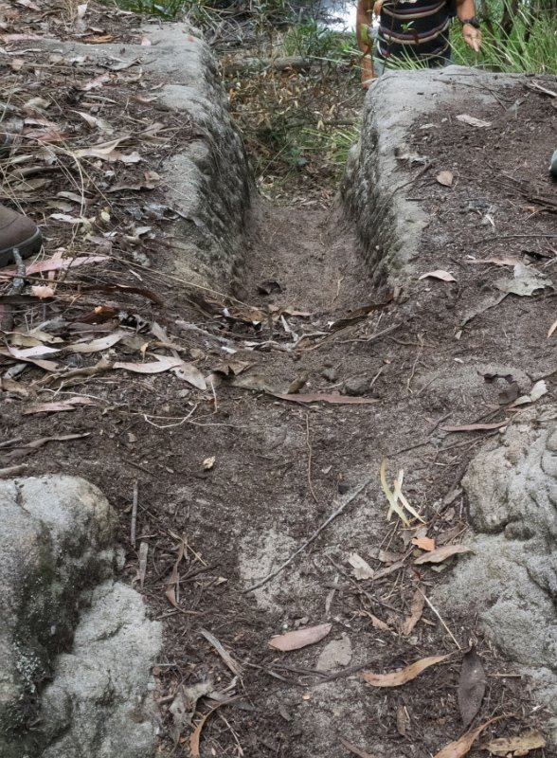

The cut trench for the water intake line at the Duck Hole. Photo: Emanuel Conomos

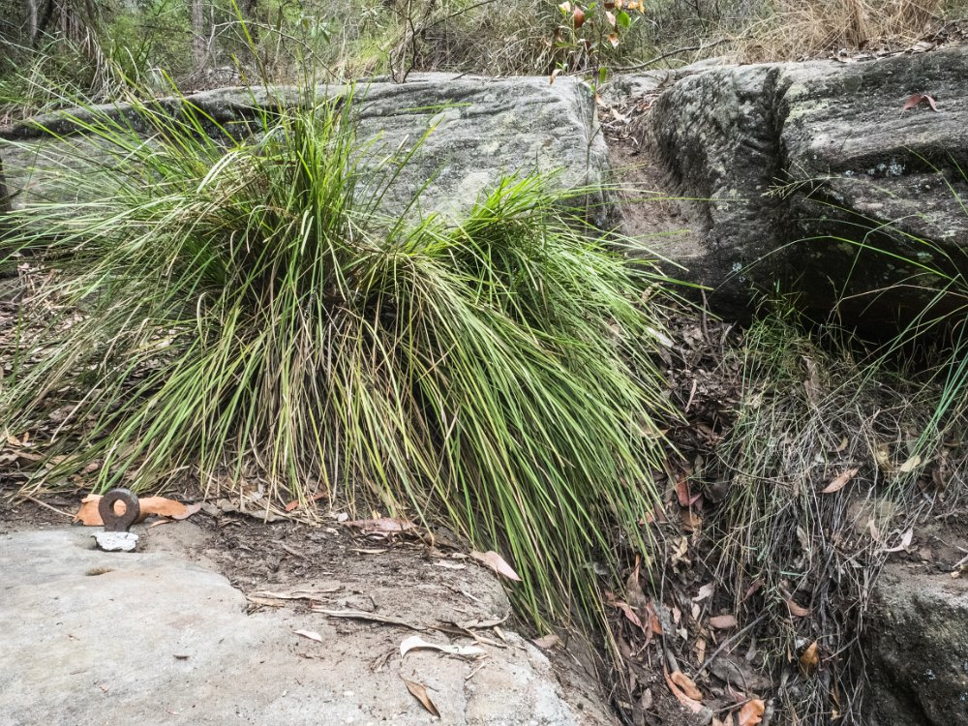

Details of the cut trench for the water intake line and securing eyelet embedded in the rock. Photo: Emanuel Conomos

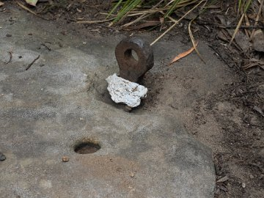

Details or the securing eyelet at the water intake point, the Duck Hole. Photo: Emanuel Conomos
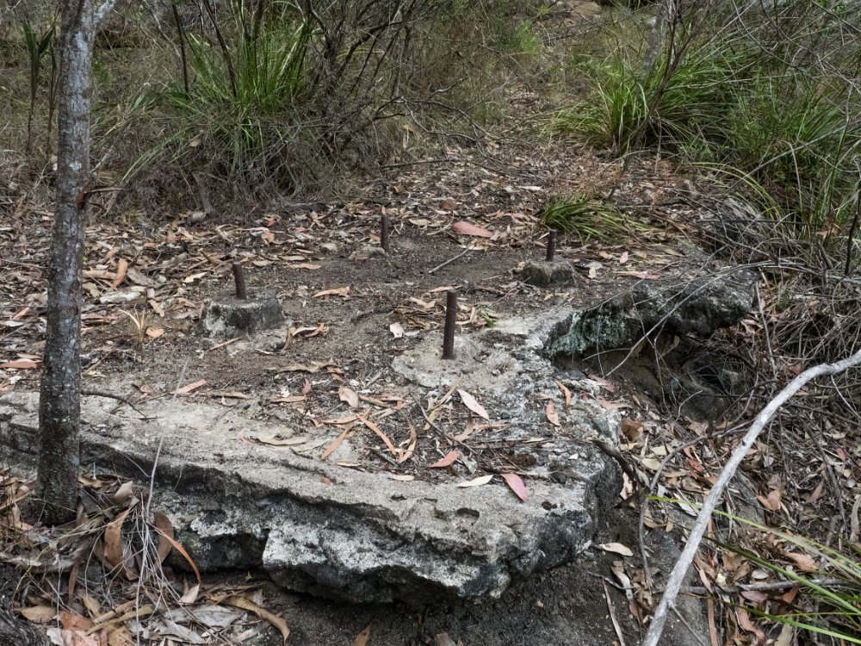

Remains of the mounting block for the steam pump at the Duck Hole. Photo: Emanuel Conomos

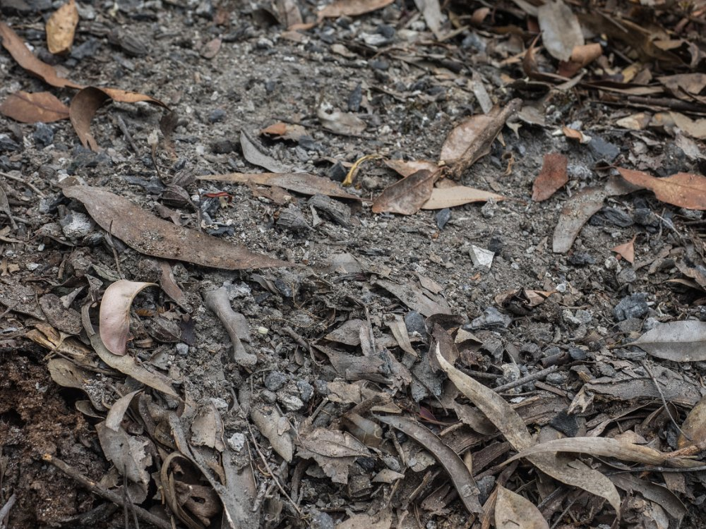

Remains of the ash dump at the Duck Hole. Photo: Emanuel Conomos

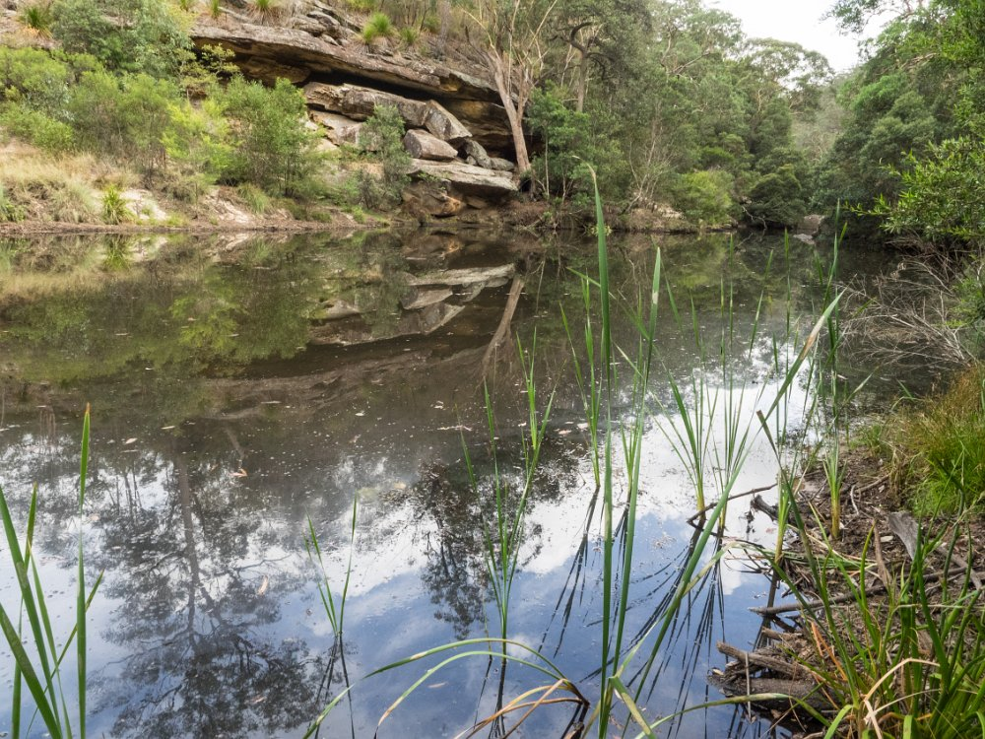

Glenbrook Creek – view upstream from the Duck Hole, Photo: Emanuel Conomos

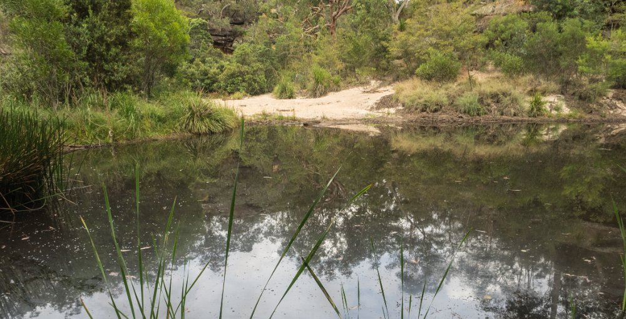

Glenbrook Creek – view downstream from the Duck Hole Photo: Emanuel Conomos

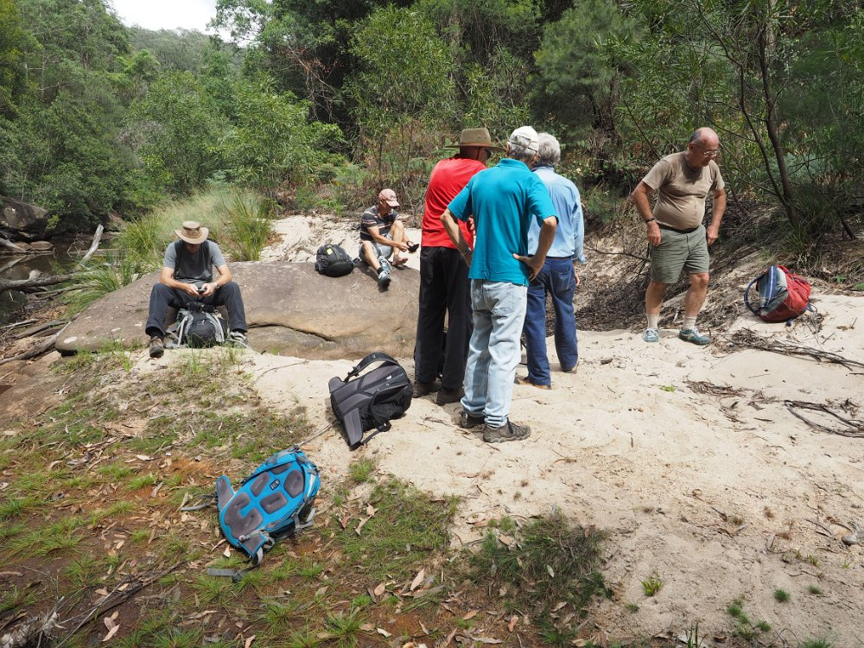

At the Bayley map Duck Hole site. Photo: Emanuel Conomos

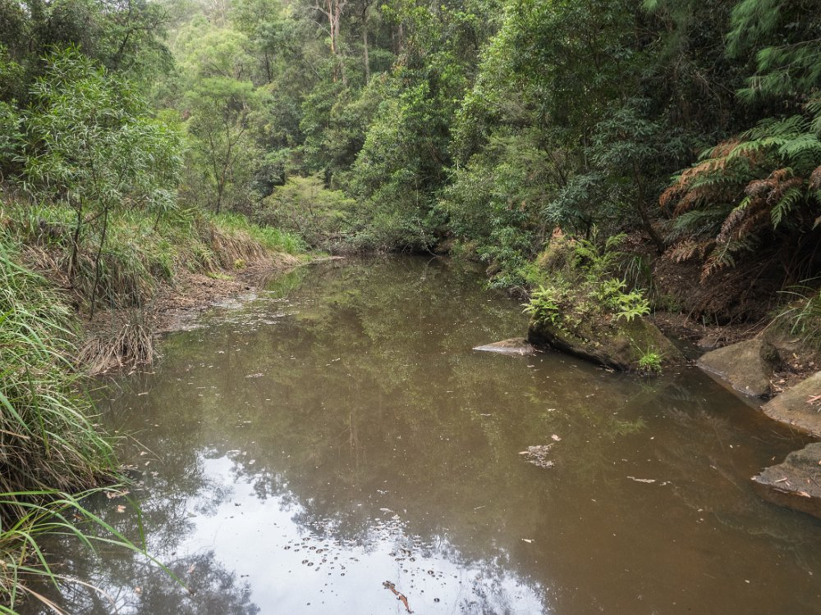

At the Bayley map Duck Hole site. Photo: Emanuel Conomos
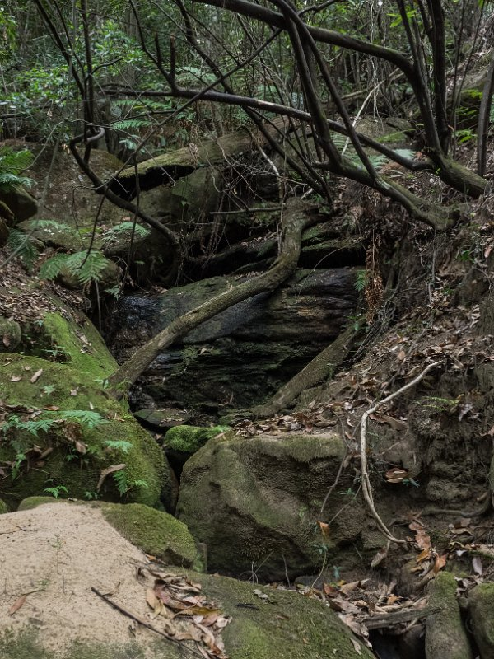

A nearly dry waterfall upstream from the Bayley map Duck Hole. Photo: Emanuel Conomos
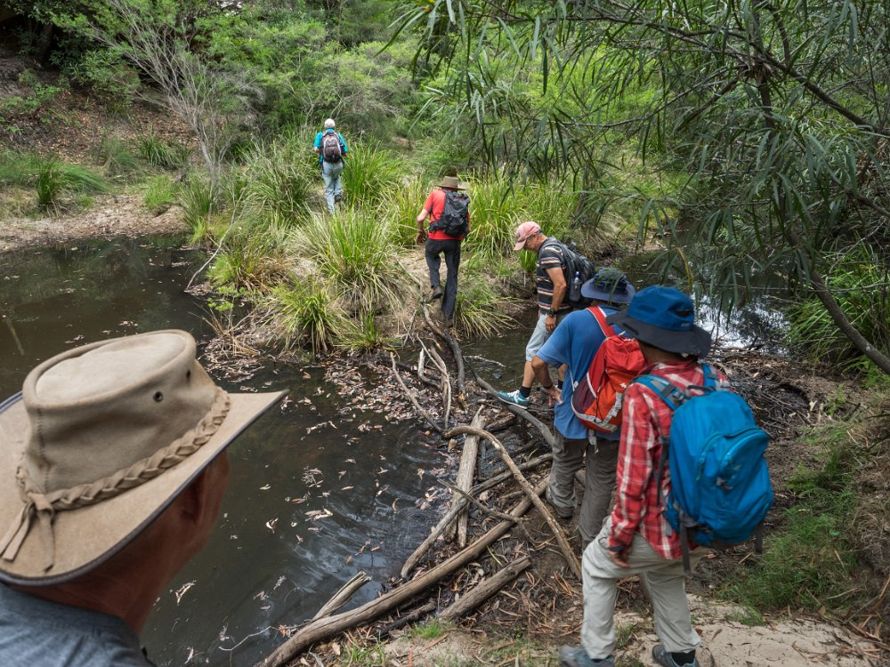

Crossing Glenbrook Creek. Photo: Emanuel Conomos

Feedback from Jeff Moonie

“On arriving home I couldn’t resist doing a bit of searching through my files and studying the two known photographs of the Duck Hole.

Now after visiting the site the photographs make more sense in regards to the position of the coal chute, pump shed and the internal machinery.

The pump shed appears to be a basic structure. I can now see where the boiler was by its chimney, right rear, and the exit pipe leaving the shed on the left. By the image it must have been 6 inches, or more in diameter, especially when you compare it to the inlet pipe coming out of the pond. It still doesn’t give us a positive position for the pump and its engine in the shed. There was a large amount of ash piled around the shed.

I was wrong about my theory that the pipe may have followed the coal chute. I will most certainly have to revisit the site with the photographs to see what else can be discovered.”

Supplementary Walk to Glenbrook (Lapstone Tunnel) thanks to Jeff Moonie.

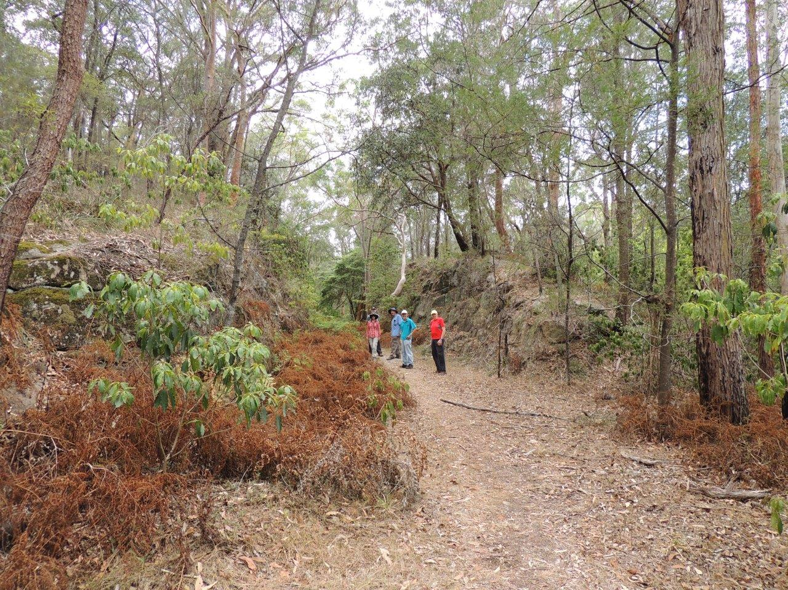

On the old railway track alignment. Photo: Brian Fox.

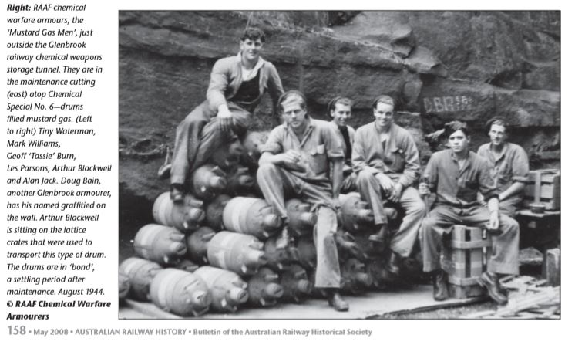
Photo thanks to Brian Fox.
A note re the above picture

Thanks for copying this item. You will note that Doug Bain has written his name on the rock above where his head appears in the picture. I knew Doug very well. In the 1970’s He was a successful master plumber and also a Simmental cattle breeder. He also told me that every day he had to apply a special cream to his face to control mustard gas burns. They never ever healed up.

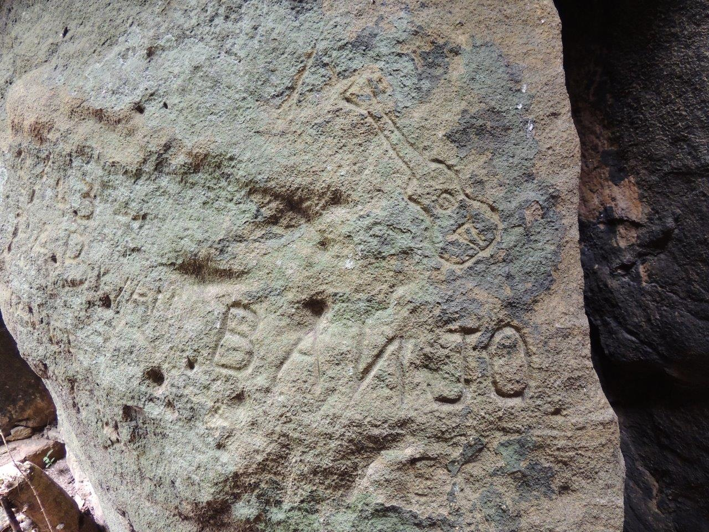

The age of this graffiti is unknown. It very likely refers to one of the Mustard Gas Men. Photo: Brian Fox.

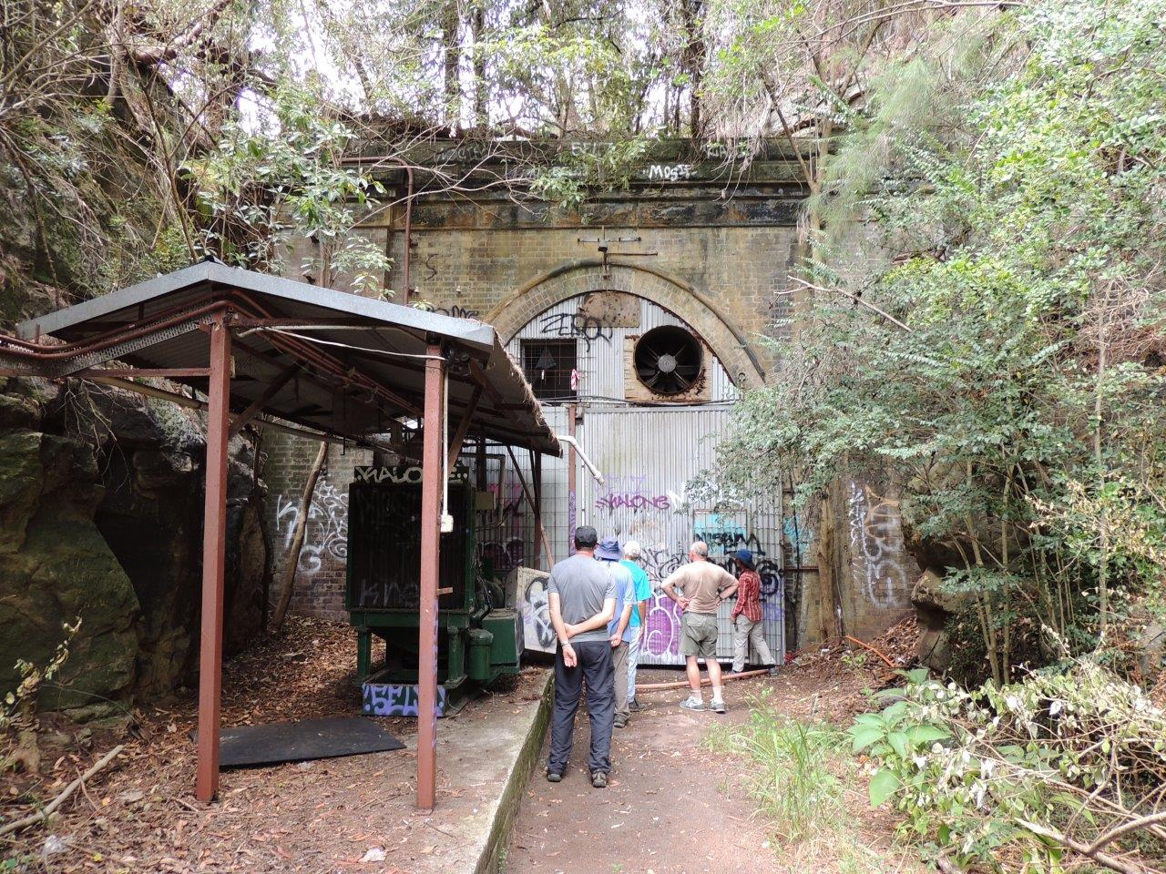

The blocked entrance to the tunnel. Photo: Brian Fox.

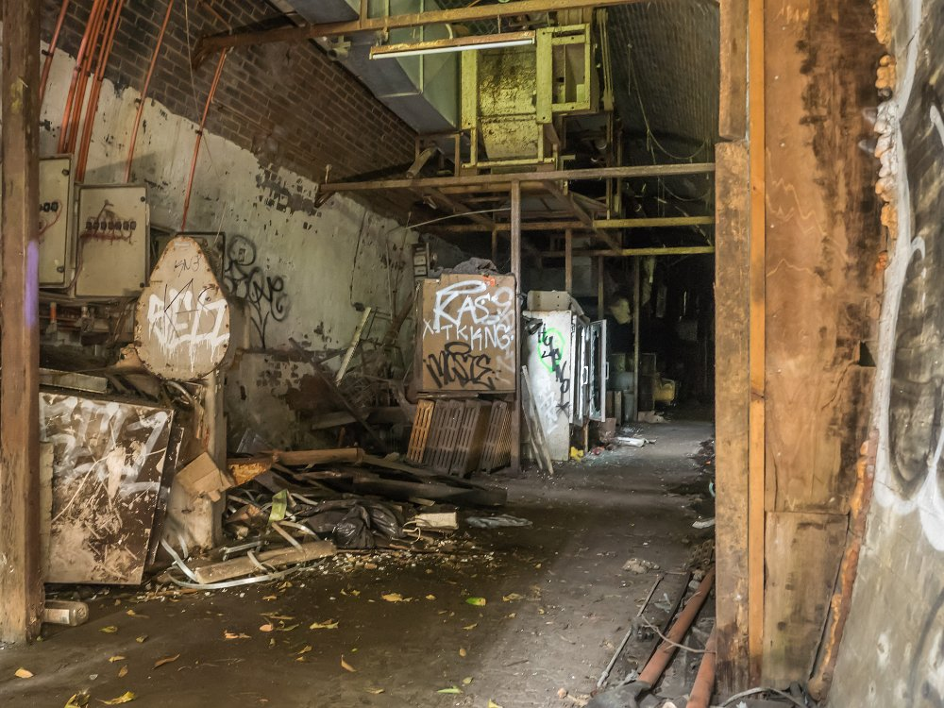

A view inside the tunnel. Photo: Emanuel Conomos

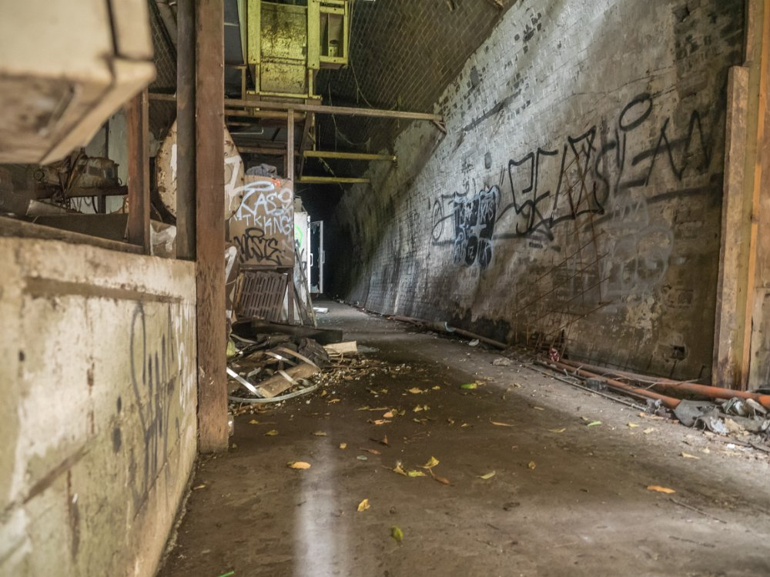

Another view inside the tunnel. Photo: Emanuel Conomos

Michael Keats
20th February 2018

Private walk to the Duck Hole 190218- Track Notes /MK

Shorthand for duplication of the Western Railway line.

