STEAM LOCOMOTIVES USED IN THE BLUE MOUNTAINS
Compiled by Denis Bainbridge
Rev 5/16
Probably the first locomotive to work on the Blue Mountain line was No. 5. It was punted across the Nepean River near Penrith in May 1866 before the Victoria Bridge was completed to assist in the new rail construction.
1855 Class 5 0-4-2 Mixed Traffic "The Governor General" 2 in Class
This locomotive built by Hawthorn and Company in England and was imported by William Randle who was the contractor for the Parramatta to Liverpool rail extension in 1856. It was purchased by NSW Railways in November 1856 and given the number 5.
It worked the Western line and was reported to be working material trains between Mount Victoria and the Clarence Tunnel in June 1869. It was reported to be in a poor state with a cracked boiler. It was transferred to passenger train duties working Parramatta suburban trains in the 1870's. It was then used with No. 75 in test runs to develop a suburban locomotive design. It finished its life at The Bombo Quarry suppling steam to the crushers before being scrapped in 1893.
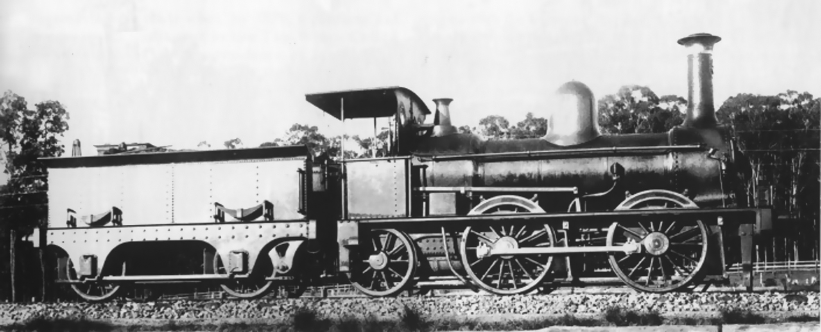
Class 5 0-4-2 "The Governor General" SRA

Passenger Locomotives

1865. G(23) Class 2-4-0 Beyer Peacock Manchester. 13 in Class
The G23 class was the first passenger locomotive to use the Lapstone Zig Zag in June 1867 after the completion of the Victoria Bridge over the Nepean River at Penrith. The first nine locomotives in the class had a driving wheel diameter of 69.5 inches which proved to be unsuccessful for Blue Mountains work so the final four in the class were manufactured with wheel diameter of 66 inches. These final models had a tractive effort of 11,310 lbs against 10,740 for the early models. The latter four units Numbers 32 to 35 which served from 1870 to 1874 working the Penrith to Mount Victoria "Daily Mixed".
Never popular they suffered from hot axle boxes on their heavily loaded two wheel Bissel Truck. They were replaced by the 79 class.
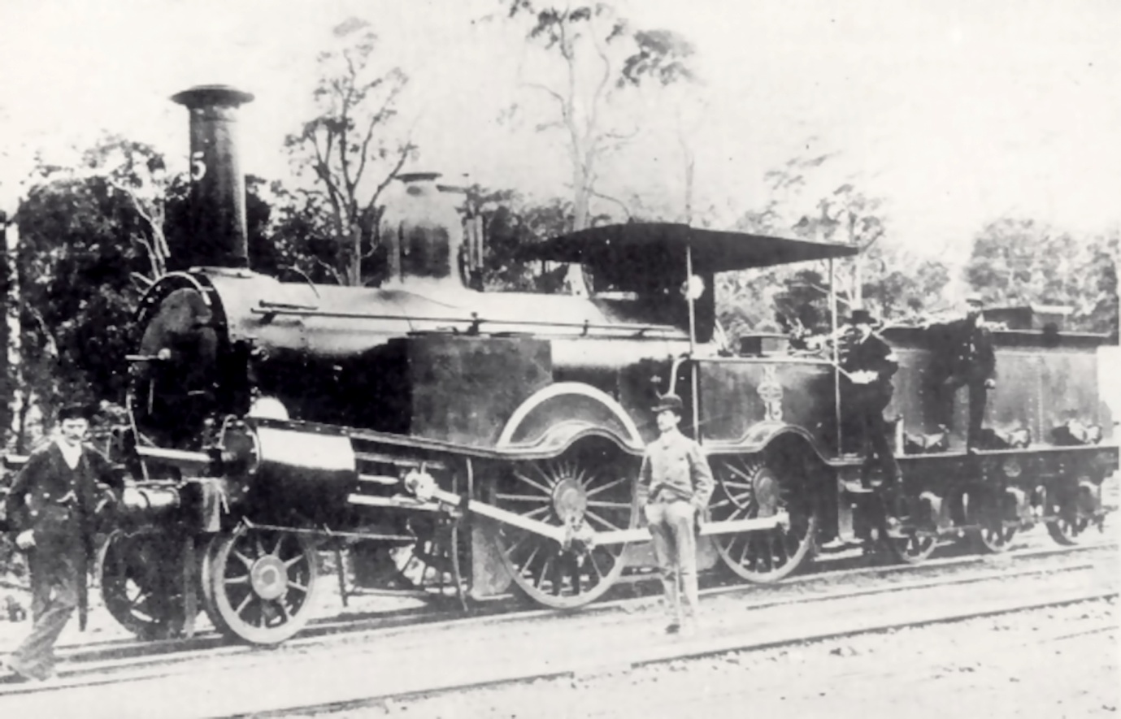
1865 Class G(23) 2-4-0 with 5' 9" Driving Wheels. SRA

1865 E(17) Class 23 in Class
Although basically a goods engine they were pressed into passenger service over the Blue Mountains. Orders were placed for nine C(23) 2-4-0 Class and nine 0-6-0 E(17) Class the latter to be built by Robert Stephenson & Company with their long boiler design. They were fitted with engine and tender hand brakes with shoes of timber on main and trailing driving wheels. Later brakes were added to the leading wheels. Large sand boxes were supplied on each side of the smoke box. They had a tractive effort of 15,550 lbs. Many more were built and assembled in Sydney by Vale & Lucy of Druitt Street & Mort & Company who sourced them from Stephenson.
They were employed on the Penrith to Mount Victoria passenger run during the 1868 - 1870 period. One No. 17 suffered a boiler explosion at Wentworth Falls on December 23, 1881

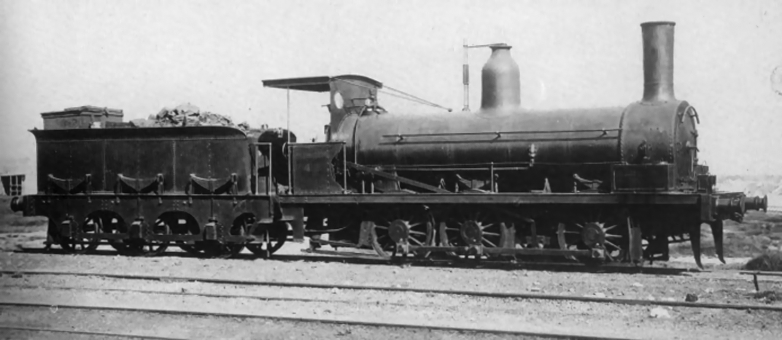
1865 Class E(17) 0-6-0 SRA

1874 O(60) Class 0-6-0 6 in Class
The light loads pulled by 4 wheel engines in the mountains resulted in an experiment with 6 wheel engines for passenger trains. The problem not considered was the sharp curves some of 8 chains radius being a problem for a rigid long wheel base engine without a leading track for guidance. designed and constructed by Robert Stephenson & Company and erected by Mort & Company in Sydney and placed into service between October 1874 and January 1875. They were a classic Stephenson long boiler design with steeply inclined cylinders driving the middle wheels. With a wheel diameter of 5 feet and a tractive effort of 16,5170 lbs they were the most powerful engines used so far for passenger traffic.
In the mountains they could lift 93 tons over the 1 in 30 grades at 15 mph an improvement of 65 tons for the 2-4-0 G(23) Class and 81 tons for the 0-6-0 17 Class. In 1875 the schedule for the run from Emu Plains to Blue Mountains (now Lawson) was 88 minutes including two reverses on the Zig Zag and 4 stops.
In 1877 the 79 Class took over most passenger traffic, however, heavier trains still used the 60 Class as main locomotive or pusher. They were finally taken off the mountains by 1885 replaced by the Baldwin 304 class.
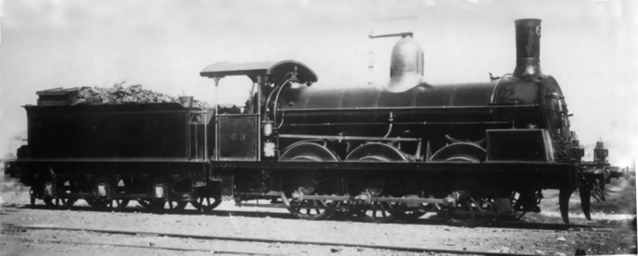
Class O(60) 0-6-0 SRA

1877 C(79) Class 4-4-0 68 in Class
A further development of the Beyer Peacock 23 class. They had a four wheel leading Bissel bogie and 20 percent more power with a tractive effort of 13,000 lbs. They took over passenger and mail services for 20, years. They were the first locomotives to be fitted with Westinghouse air brakes from the factory. Beyer Peacock designed and built the first batch of 30 and were in service between 1877 to 1879. The next batch of 26 units were built in Scotland by Dubs and Company and entered service between 1880-1881. The next batch of four were built by Beyer Peacock in 1881 while the final eight engines were built in Sydney by Atlas Engineering Works at Haymarket and were delivered between 1881 to 1882.
The run to Mount Victoria took 4 hours and 30 minutes climbing the Zig Zag and stopping at all stations beyond Parramatta. These locomotives operated the "Western Mail" from Penrith to Bathurst from 1877, "The Fish" from Sydney to Penrith 1885 - 1895 in 55 minutes with a stop at Parramatta and Penrith to Mount Victoria from 1880 to 1885.
They were replaced on the former trip by D (261) class and the latter by the L(304) class. They had a life in other areas some being converted into tank engines in 1896. They were later converted to Belpaire boilers and worked many areas.
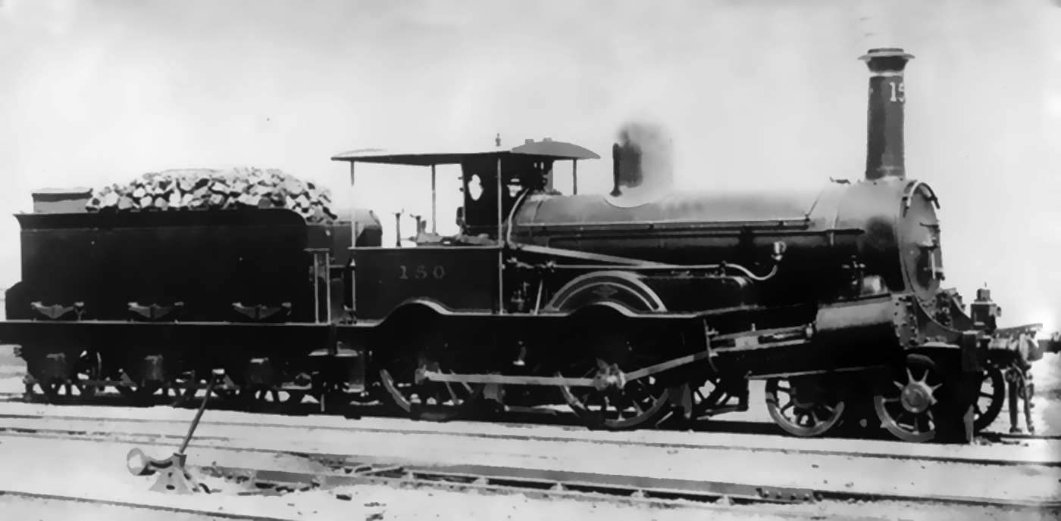
1877 Class C(79) 4-4-0 SRA

1877 C(105) Class 4-4-0 2 in Class
In order to compare the performance of American locomotives with the British C(79) Class then on order for country train services an order was placed with Baldwin Locomotive Works in 1876.
It was a typical American locomotive down to its smokestack, large oil burning headlamp and bell. It had a better four wheel bogie than the Bissell truck fitted to the C(79) with its restricted movement. The reversing gear was hand operated through an American version of Stephenson's valve gear. Westinghouse air brakes were supplied, however, could only be supplied to the train pipe chimney first. It had a tractive effort of 12,840 lbs. The tender was a six wheel type instead of the american bogie type. This allowed the engine to be turned on a 45 foot diameter turntable.
in December 1877 it was run to Lithgow hauling a small three car train of new American Jackson & Sharp two suburban and one sleeping carriages weighing in at 52 tons. The train had stops at Parramatta, Penrith then all stations to Lithgow and completed the trip in 5 hours 45 minutes less than any earlier trip. As there was no turntable at Lithgow large enough to turn the engine it travelled to Mount Victoria tender first, turned and continued back to Sydney in a total of 4 hours 30 minutes. the last 34 miles from Penrith in 55 minutes.
Its brakes proved to be unsuitable and caused some concerning situations. It was removed to go working to Picton and Penrith until improved brakes were fitted and it then worked to Goulburn. A second unit was ordered in 1879, however, they were regulated to easier runs until scrapped in 1904.

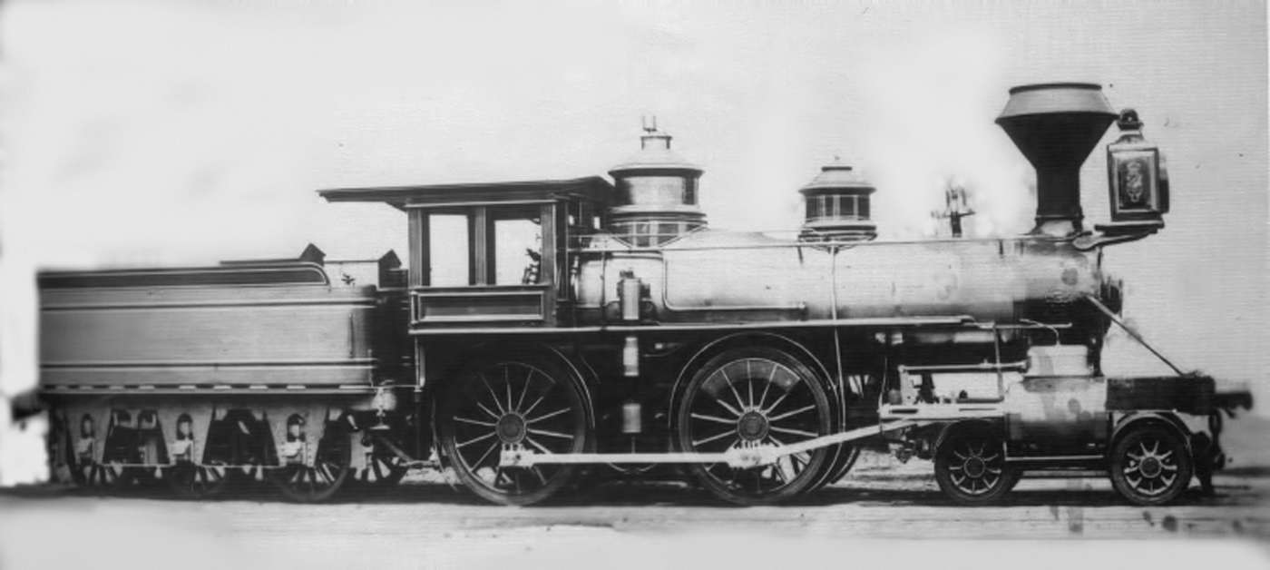
1877 Class U(105) 4-4-0 First American L Poole

1885 Class 304 2-6-0 Baldwin 10 in Class
This locomotive was designed by Thomas Midelton, NSW Locomotive Overseer. They were different from the usual American style of locomotive in that they were missing the steam dome, sandbox and cow catcher. The steam was captured by a long copper dry pipe running the full length of the boiler which was perforated on the upper side for 8 feet in the middle. The pipe terminated at the rear in a brass steam box in which were attached pipes to the auxiliaries while the front end was attached to a smokebox regulator thus reducing the number of steam pipe connections. A small dome over the firebox contained the safety valves and whistle. Westinghouse air brakes were fitted to the drive wheels only. They had a tractive effort of 15,470 lbs
The first locomotive was completed by Baldwin in September 1884 and was test run with good results. They entered NSW service between March and September 1885. when run on the Western Line they showed a large improvement over the 79 Class on the Blue Mountain section. They remained on this task until replaced by the 261 Class.

It is now than an interesting period occurred when competition between the British and American style locomotives came to a head in the winter of 1887. Thomas Midelton was of the opinion that the new British 373 class were useless on steep grades required for the Blue Mountains and that more of the American 304 Class should be purchased. William Scott, Locomotive Engineer was of the opinion that the 304 was overrated and that the British 373 would beat them over the mountains every time. The question of a contest was set in motion.
Midelton had paid a key role in the 304 with its 5 foot driving wheels and unusual steam piping design. he liked the long smoke box , large grate area and bar frames and compensated springing for light tracks. Baldwin had built the 2-6-0 Moguls and tested them on the Philadelphia and Reading Railway in September 1884 delivering 10 engines on the sailing vessel "Iceberg". The first unit steamed on St Patrick's Day 1885.
The 373 Class 12 engines were built by Vulcan Foundry of Lancashire and was a typical British design with 5 foot 6 inch driving wheels, cutaway cab and a six wheel tender. They seemed a good locomotive for British passenger work. The first engine only entered service in May 1887 one month before the contest. Scott who had been involved with locomotives since the first 0-4-0 Stephenson unit to arrive in NSW. He liked the British large wheels and elegant shape. he thought the 373 4-4-0 bogie was ideal for the curves and that the 304 was too long.
The commissioner set the rules as the two engineers couldn't agree to terms of the contest. The rules were, steam pressure to not exceed 140 PSI, no sand to be used except in emergency situation and only the Westinghouse air brake to be used. The trains had to pull a 130 ton train from Sydney to Bathurst in daylight. The trial commenced on June 15 with interstate referees. The route was change to end at Eskbank (Lithgow).
The results are lost in history, however, the 373 ran into trouble on the Down leg after Wentworth Falls when it had to stop for 2 minutes when its steam pressure fell to 105 psi and it couldn't climb to Katoomba until pressure was increased. Scott disputed some of the time results.
The Baldwin 304 set off three days later after a tender derailment caused a delay and with speeds of 45 mph a high speed for a small wheel engine with a lot of 8 chain curves it gained 68 minutes on the down trip to Eskbank. It was obvious that the 304 was the best engine for the grades. The 304's were used on "The Fish" until replaced by larger engines.
The 373 were not considered a good engine and were disliked by drivers for their hard riding and track maintenance for their high axle load. They would slip easily on a wet track. (it is strange that the 304's were scrapped while a 373 was restored at Thirlmere).
William Throw in a 1889 report was critical of the 373 and Vulcan Foundry stating that unless you had tight specifications that must be adhered to then you would suffer the results.
1890 Class 436 2-6-0 10 in Class
Due to the growth in traffic and shortage of powerful passenger engines tenders were requested from Scotch Dubs and Company who promised quick delivery. The order was for 10 locomotives based on the Baldwin 304 class with modifications. It had a wider running board curved over the driving wheels and outside hand rails. The Baldwin safety valve cover was replaced by an British type. They were called "Scotch Yankees". They had a tractive effort of 15,470 lbs
When in service in 1890 they suffered from hot axle boxes which required the fitting of larger axles and fitting a handbrake. They operated on Blue Mountain passenger trains until replaced by the P(6) class. For 10 years Number 440 worked out of Penrith on the Orange day train to Sydney each afternoon returning on a local passenger service. In the morning it assisted passenger trains to Katoomba if required.

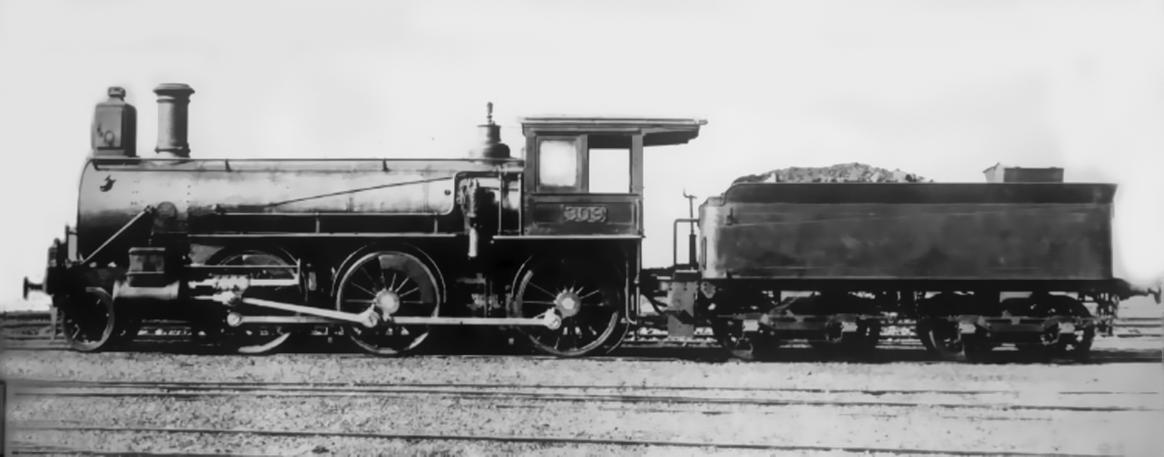
1885 Class 304 2-6-0 Second American. SRA

1891 Class O (446) 4-6-0 12 in Class
There was an extreme shortage of locomotives and worries about moving the 1890-91 wool clip made the purchase of additional locomotives critical. Throw was in England so decision was made without him. The engines were ordered from Baldwin in 1890 and were similar to the engines supplied to the Baltimore and Ohio Railroad except for changes of omission of sand dome and bell, fitting of buffers and draw hooks instead of American couplers, screw reversing gear, copper stay bolts, brass tubes and lagging on the cylinders cut back to fit the NSW loading gauge. The axle load was reduced to 14.5 tons. because of this Baldwin refused to guarantee that the engine would maintain a speed of 22 mph while hauling a load of 176 tons on grades of 130 ft per mile (1 in 40).
In 1891 they were placed in service on the Blue Mountains passenger services with the cow catchers removed. They were a striking looking engine with long smoke boxes to allow continuous hard steaming on steep grades. The large wooden cab place astride the firebox. the driver's seat on the right side along side the screw reverse. The fire man had a seat on the other side where he could rest on downhill runs.
Before the O (446) "The Fish" was usually double headed by various D classes from Penrith to Katoomba. The new engines worked unassisted and cut the running time by 15 minutes with a load of 132 tons increasing to 140 tons in fine weather.
The engines had some teething problems. The screw reversing components were weak. The draw hooks were undersized and the brakes needed work. Some wheels and tyres were made from defective materials and caused a derailment. These faults were quickly made good by Baldwin.
These problems resulted in a three month Royal Commission which was actually a political vendetta against Commissioner Eddy. Apart from findings against the axles and tyres no fault was found with the locomotives. By the time the faults were rectified the P (6) locomotives were coming on line for express traffic the 446 engines were put on to goods use. They were much modified over the years with the last one scrapped in 1949.

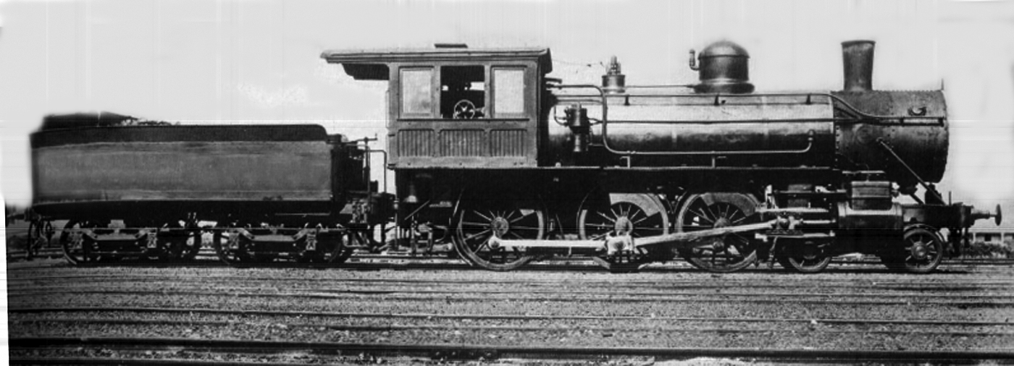
1891 Class O(446) 4-6-0 Third American SRA

1892 Class P(6) 4-6-0 Later called C32 Class "Manchester Engines" 191 in Class
This locomotive is one of the success stories of locomotives in NSW. The battle between American and British locomotive builders had been in the formers favour. Our unique patterns of traffic including severe grades did not suit many British locomotives which were designed for high speed travel over flat country.
The continuing shortage of locomotives meant that action had to be taken urgently. Commissioner Eddy was keen to setup a locomotive manufacturing capability in NSW. Tenders were issued, however, due to many circumstances led to nothing concrete occurring. Eddy then sent William Throw to England to negotiate with the final tenderer without result. Throw was then ordered to complete a design to be tendered. Beyer Peacock were given the task to finalize the design. There has been a lot of discussion on the ideas that led to the final P(6) design. Many of its features were similar to Throw's earlier locomotives beginning in 1879 with the South Australian K Class. His assistant in the design was J Scouler who worked at SA Railways before joining Beyer Peacock. The design was similar to the S.A. K, Q and R Classes in many features. The R Class was a combination of Throw's thoughts and best features of the Baldwin "N". Beyer Peacock built 50 engines which entered service between February 1892 and July 1893. They had a tractive effort of 22,190 lbs and were the first units to be built with Belpaire boilers and Allan straight link motion. They had an unusual feature with the sand box mounted over the leading drive wheel splasher. They originally had a bogie tender
Four builders were involved in supplying the P(6):

Beyer Peacock and Company 106
Baldwin Locomotive Works 20
Clyde Engineering Company NSW 45
Eveleigh Workshops NSW 20
They entered all main line services until the introduction of the "NN" 35 Class in 1914.
As our interest is The Blue Mountains we know that tests in 1907 with "The Fish" between Sydney and Penrith pulling a 240 ton train in 46 minutes requiring speeds of 65 mph The highest speed recorded for the class was on March 11, 1939 with seven carriages weighing 165 tons with a speed of 73 mph at Doonside with an average for the journey of 20 miles being 57.7 mph. The engines became the work horses on the Blue Mountains
The motor car was making inroads into the slower train times so efforts were made to improve train travel times. Fitting super heaters gave new life to the P(6). The fastest time to Mount Victoria was 3 hours 21 minutes, rising 3,424 feet in 77.8 miles with 3,245 feet occurring in 32 miles. On September 5, 1929 locomotive 3307 pulling five cars of 125 tons reaching Katoomba in 2 hours 2 minutes with four stops and Mount Victoria in 2 hours 24 minutes with seven stops which opened the way for "The Caves Express" which commenced operations on November 11, 1929. The engines were painted black with a star on the smoke box, polished buffers and motion work.

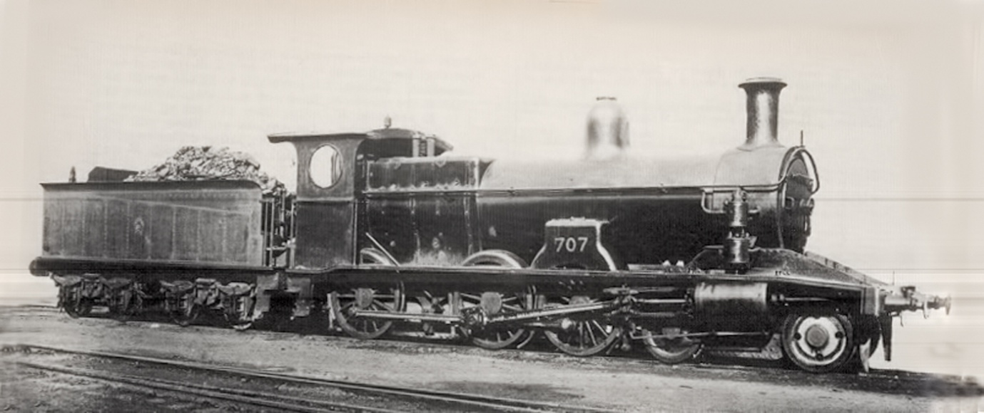
1892 Class P(6) C32 4-6-0 191 in Class
1892 Z26 Class 2-6-2ST 20 in Class
These unusual saddle tank engines for NSW built by Dubs & Co for use pulling coal and blue metal trains on the steep Illawarra run. They were also used as push up engines from Penrith usually running tender first which helped with the smoke problem in the tunnel and after disconnecting at Katoomba could return to Penrith head first. They were not successful due to low water capacity and inability to handle tight turns.
Several were used in the Glenbrook Gorge deviation in 1912-13.

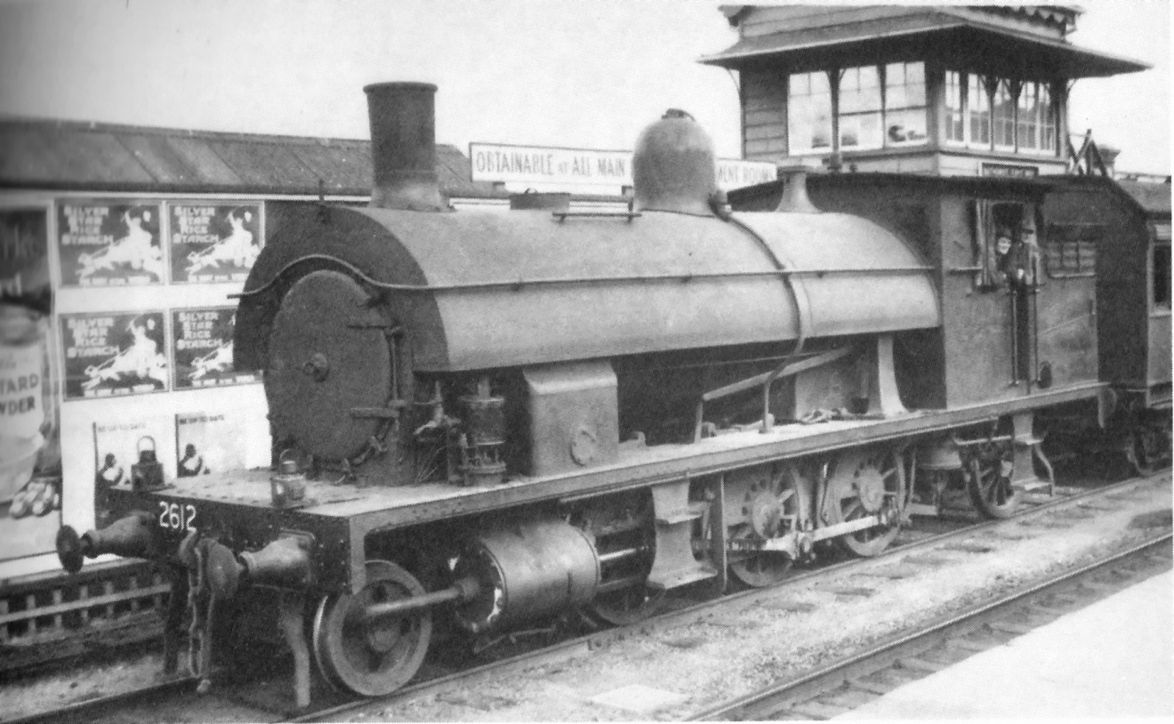

1914 (C)35 NN Class 4-6-0 35 in Class
Developed under Lucy and to overcome double heading with the (P6) C32 class due to introduction of heaver corridor cars. Built at Eveleigh workshop from 1914 (first five) to 30 units by 1917. Five were added in 1923. All units were superheated, fitted with Allan straight link motion gear and exhaust steam injectors. They were often called "Naughty Nannies". They were troublesome at first and poor steaming performers, however, with time they proved to be good express engines. They had a tractive effort of 29,150 lbs.
They took over "The Fish" in June 1918. Their time to Penrith 54 minutes was an additional three minutes and 3 hours 17 minutes to Mount Victoria which didn't include a new stop at Warrimoo. The Glenbrook Deviation and extra stops the running time was 17 minutes longer than the run to Penrith with a D Class engine and switching to a P (6) Class for the run to Mount Victoria. With the need to compete with motor traffic the 17 minutes was reduced to 10 minutes.
They took over the Caves Express in 1932. A test run on may 26, 1933 with a new "CUB" set a C35 hauled 148 ton train to Penrith in 40 minutes 49 seconds. The highest speed recorded for this class was 71 mph. They were replaced on this service by the (C)36 Class in 1935.
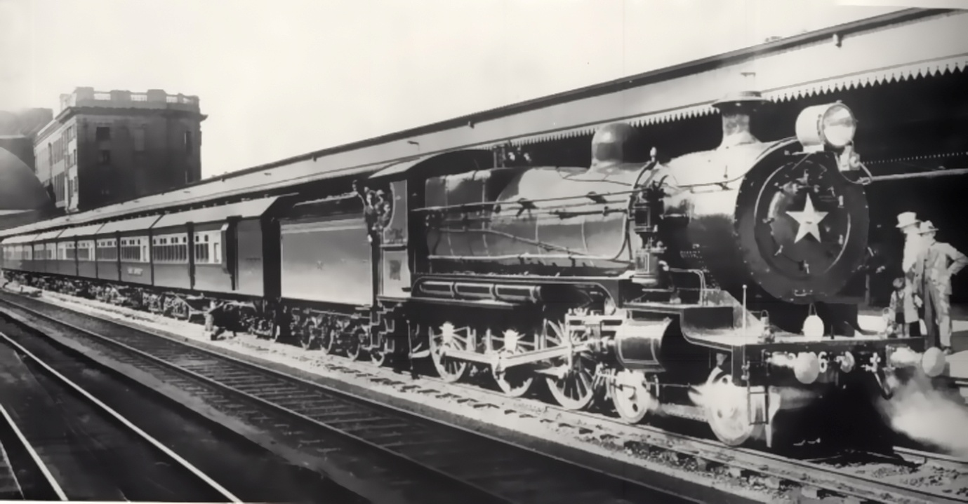
1914 Class NN C(35) 4-6-0 C35 on "Caves Express" 35 in Class D O'Brien

1925 C(36) 4-6-0 Express Passenger 75 in Class
Eveleigh Workshop 10 First Jan 1925 Clyde Engineering 65 Last Nov 1928
25 tenders were built at Walsh Island Dockyard Newcastle. Thee tenders were for the first time in NSW turret tenders which gave a large water and coal capacity with a good view along the train.
These express locomotives were designed for non stop runs up to 100 miles. They had Walschaert's valve gear operating outside piston valves, self cleaning fire box, round top tapered three course boiler (Belpaire boilers were fitted later), exhaust steam ejectors and air operated butterfly fire doors. They had a traditional British long narrow fire box which was the blight of many firemen. They were called "Pigs" mainly due to their stubby shape.
They took over the long run work from the C(32) and C(35) engines cutting schedule time due to less water stops. In their early days they proved difficult to work. Firebox faults developed by 1934 which required retrofit work as well as changes to the blast pipe design which reduced the fire lifting problem and allowed the use of lower quality coal. The class colour was changed to green.
On the western line on August 9, 1934 pulling a load of 160 tons from Central to Mount Victoria then 190 tons to Orange. For the first time there was no water stop at Lawson which now was at Wallerawang 106 miles into the trip. On the non stop run from Parramatta to Katoomba the train reached 70 mph near St Marys, with the 75 mile sprint taking 90 minutes 57 seconds with an average of 36.5 mph. This was an improvement of 55 minutes over the Orange day train.
Another run on September 20, 1935 with the "Caves Express" six cars of 150 tons, it reached Penrith in 39 minutes for 34.2 miles with an average speed of 52.6 mph. The first stop at Hazelbrook was reached in 82 minutes at an average speed of 42.5 mph. There were three more stops on the route the time to Katoomba was 109.5 minutes. These times were repeated with other C(36) locomotives.
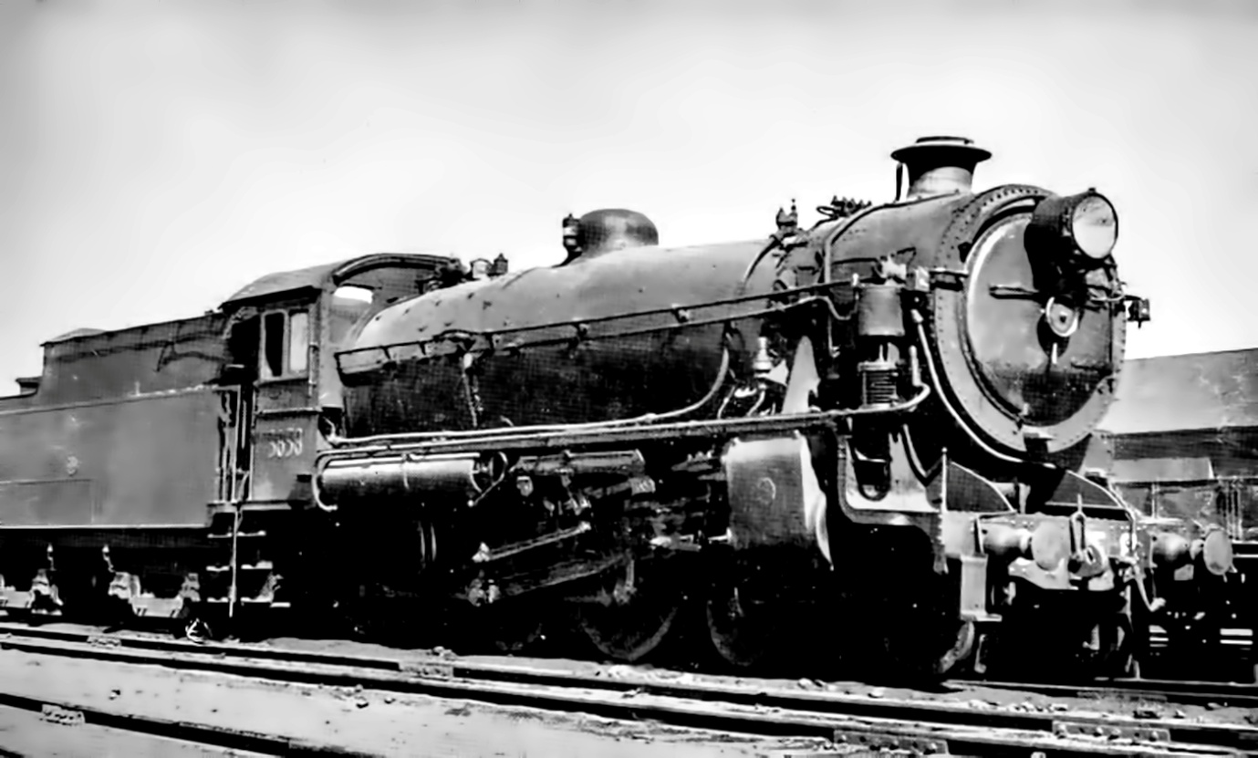
1925 Class C(36) 4-6-0 Express Passenger 75 in Class

The Tractive effort was 30,500 lbs. The longest non stop run ever recorded for this class was 130.2 miles.
From 1953 73 units were converted to Belpaire Boilers with steel inner fire boxes, arch tubes and regulator valves in the superheater header. New cabs were fitted with bucket seats.
As C(38) Class came on line they replaced the C(35) on heavy express runs. It was interesting that the C(36) units began replacing the standard goods engines on fast freight services.
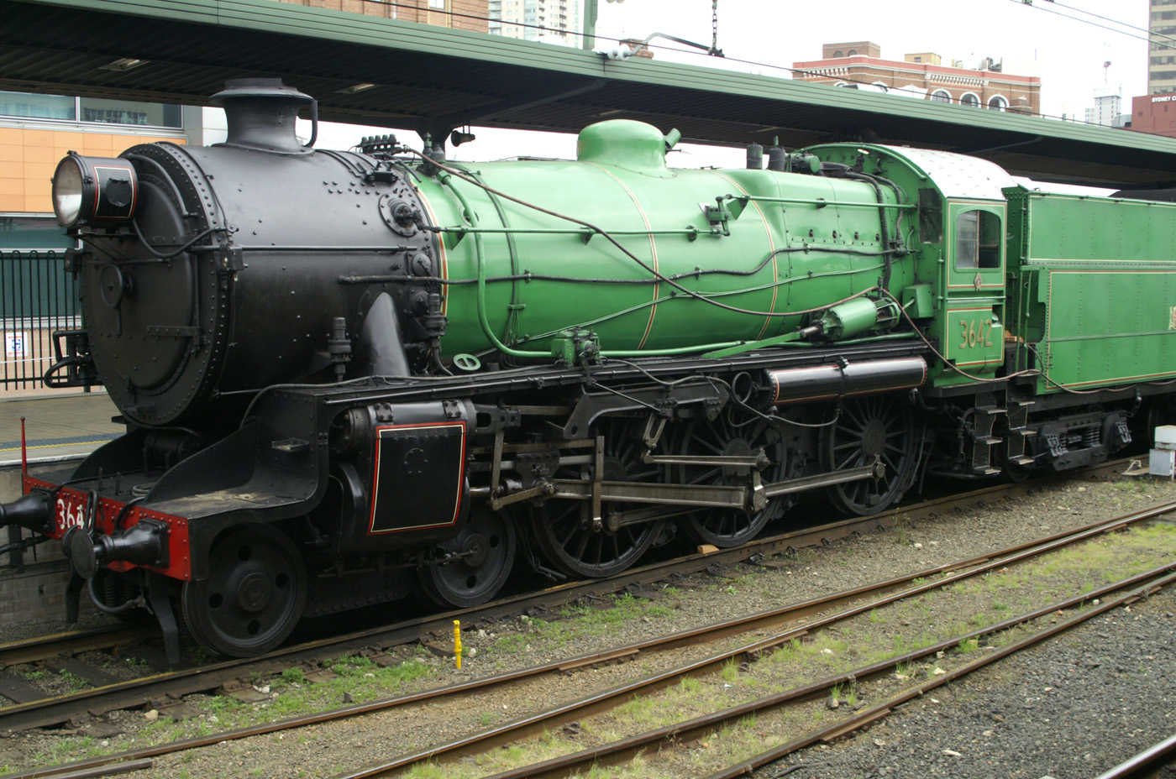
Restored 3642 with Belpaire Boiler. D Bainbridge

1943 C38 Class 4.6.2 Pacific 30 in Class
This class of locomotives is considered the best design ever in Australia with a tractive effort of 36,273 lbs at 245 PSI boiler pressure. Designed in the late 1930’s by Harold Young. They used a cast steel frame, cast Boxpok coupled wheels with roller bearings and a delta trailing truck. The first five were built by Clyde Engineering and were partially streamlined. The total number were built by 1949.
The 25 units were built by Everleigh Workshops (even numbers) and Cardiff Railway Workshops (odd numbers). Due to maintenance problems the streamlining was dropped on these later units.
There was a major problem with 3801 as it was proving difficult to fire and maintain steam pressure. Two top rated firemen were tried without any result. Finally a top Bathurst fireman was invited to have a look and he found the blast pipe had a major design problem with reduced firebox vacuum. Once fixed 3801 found her true potential as a main line locomotive. The high 22.5 ton axle load restricted its area of operations. One of these main routes was the Sydney to Dubbo mail.
As diesels were coming by 1962 C38’s were gradually removed from service. 3801 was due for scrapping. There was a diesel fuel scare with tensions between USA and Cuba so the remaining C38’s were overhauled. As the situation eased no further overhauls were carried out. They were also used on fast goods trains pulling amazing loads on some of the States steepest grades.
The last operating C38 locomotive was 3820 which operated the Newcastle Flyer to Central on December 29, 1970.

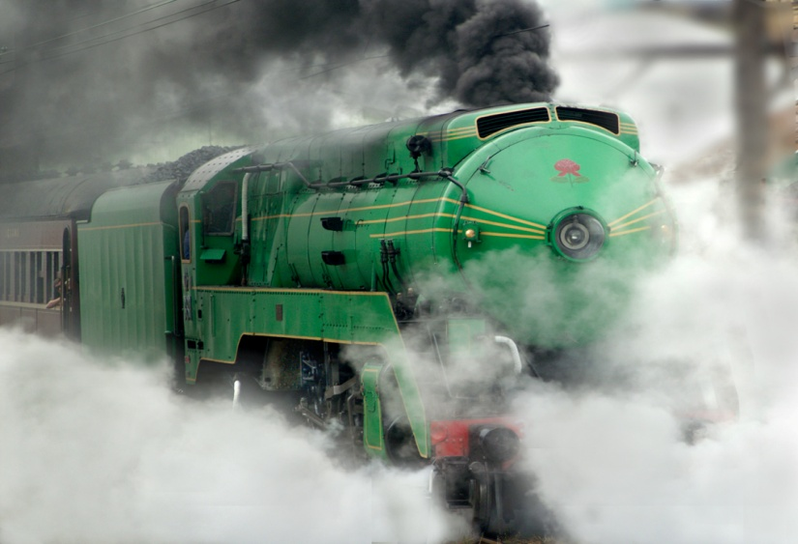
3801 Leaving Central D Bainbridge
Two of the class were restored 3801 and 3830 and are used to haul enthusiast trains. The boiler on 3801 gradually failed and it was withdrawn from service. The replacement boiler built in Germany was useless as it was the wrong size. A replacement boiler was installed and it should resume operations in 2016.

Goods Locomotives.

1865 E17 Class 0-6-0
Basically a goods engine that was also used for passenger traffic. See passenger section.
1874 I(48) 0-6-0 12 in Class
Designed for use in the Blue Mountains with 20% more tractive effort than the E17. Designed and built by Robert Stephensonand erected in Sydney by Mort & Company and went into service between 1874 and 1875. There boilers couldn’t maintain steam to the large 19” cylinders. They were replaced on the mountains by the 131 2-8-0 class in 1879. Number 52 was destroyed in the Emu Plains accident with 103 in 1878.
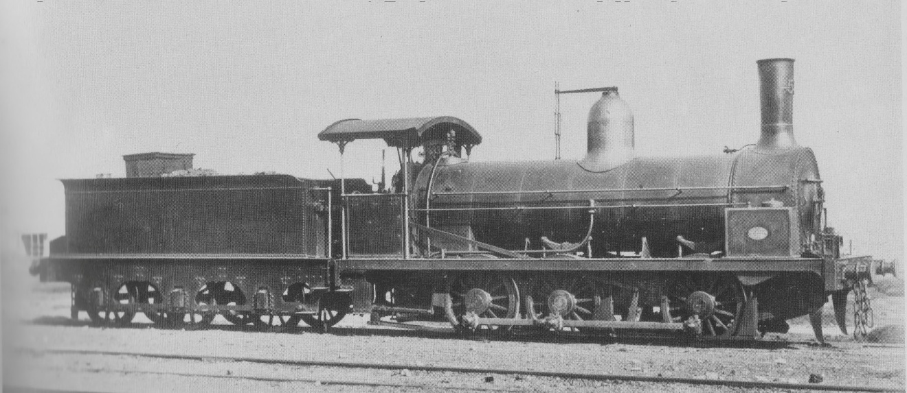
Class 48 (Second) I(48)
1877 (Z)19 Class 0-6-0 77 in Class
As the network grew there was an urgent need for more powerful locomotives. An order for 50 locomotives was placed with Beyer Peacock based on the E17 long boiler design. Additional units were built by Henry Vale to bring the total to 77. They had a tractive effort of 19,450 lbs. They had a large hand brake coupled with a spray of water to cool the willow brake shoes. Their Blue Mountains load was 126 tons. They were modified in 1891 with new boilers with increased pressure, Westinghouse brakes, compensating beams on leading two axles suspension, conversion to LH drive and new steel cabs. Due to their short wheel base and no leading truck they were easy to derail so their speed was restricted due to several fatal accidents. Restricted to 25 mph they were removed from mainline service.
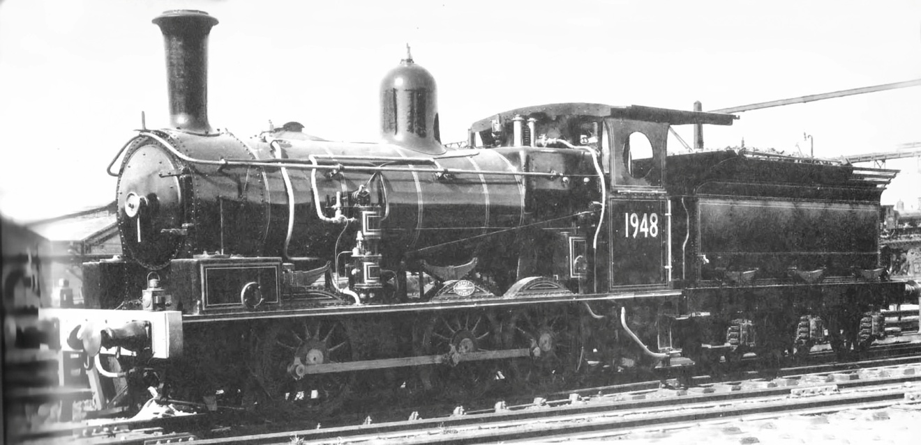
Class 93 Z(19)

1879 (Z)28 J(131) 2-8-0 11 in Class
Baldwin supplied the first consolidation locomotives on the NSW System. They were the most powerful locomotives in Australia and were needed for the Blue Mountains. Typical American features including canister steam and sand domes, ballon stacks and large wooden cabs.
They were confined to operate between Penrith and Eskbank (Lithgow) working tender first on the return as there was no turntable at Eskbank and Mt Victoria being too short. They could pull 140 tons over the mountains needing two firemen. Their brakes were poor and had to be reworked. They could pull 137-142 tons up the mountains
In 1891 they were replaced by the larger J(483) Class on the mountains.
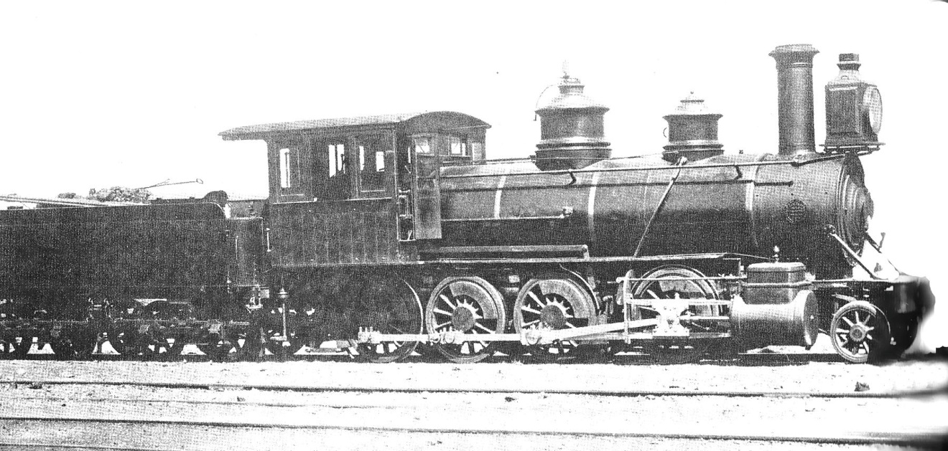
J(131) Z(28)
1881 B(205) (Z)25 2-6-0 Mougal 70 in Class
Fitted with a leading pony truck for handling tight bends they were an extension of (Z) 19 0-6-0 class of 1877 with a tractive effort of 19,400 lbs. Bayer Peacock delivered them between 1881 and 1885. They were considered ahead of contemporary design of this period. Some adjustments were required the weight on the driving wheels because of slippage.
As the turntables at Mt Victoria and Katoomba were too short they had to return tender first a max load of 117 tons being the maximum load for the hand brake. It was decided to build 50 ft turntables at Sydney, Bathurst and Goulburn.
In the 1880’s they were used in all the difficult areas in the state. In the 1890’s they were mostly the only push-up engines used in the Blue Mountains. Some were still working in the 1960’s.They were re-boilered in 1911 with Belpaire design.
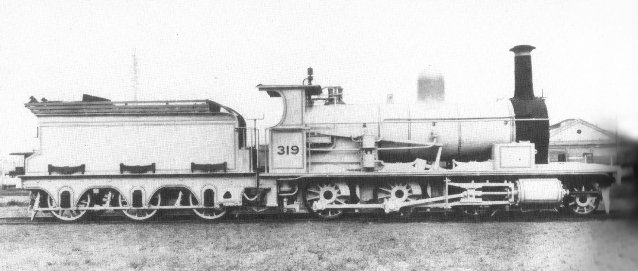
B9205) Z(25)
1891 (Z)29 (J) 483 2-8-0 20 in Class
These additional 20 engines of a larger design than (z) 28 with two being compounds were supplied by Beyer Peacock. Four more were completed by Everleigh Workshop for a total of 35. The compounds were converted to single drive after poor performance. They were also used on the Western mail trains going unassisted between Penrith and Katoomba.
Between 1916 and 1920 six were retrofitted with superheaters, piston valves and larger cylinders and returned to main line services. They were replaced by the new D50 locomotives.
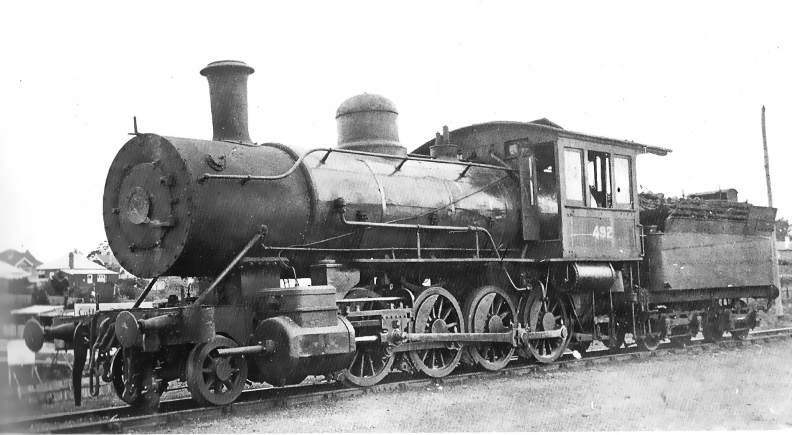
Z(29) J(483)

1896 D50 2-8-0 T(524) Standard Goods 280 in Class
In conjunction with Beyer Peacock who delivered the first five of these new consolidation heavy goods locomotives in 1896. The design influenced by W Throw CME were equipped with Belpaire boilers, Allan valve gear and flangeless second and third coupled wheels. They had a tractive effort of 28,800 lbs.
The builders were:
Beyer and Peacock & Company 151, Dibbs & Company 5, Neilson & Company 10, North British Locomotive Company 84, Clyde Engineering 30.
These locomotives were very reliable similar to their passenger cousins the P6.
In 1913 Clyde Engineering supplied the new D53 Class which were similar to the earlier class except for a larger firebox, flanged on all driving wheels and superheaters. They had a tractive effort of 33,600 lbs. 190 were built with Clyde Engineering suppling 160 and the Everleigh Workshops 30.
In the period 1918 and 1925 120 new D55 class were where built by Clyde Engineering. They had a tapered superheated boiler and had the complicated Southern valve gear. Also supplied were rocking firebars, drop grates and ashpan dampers. They had a tractive effort of 33,600 lbs.
In the 1930’s when boilers needed replacing they were fitted with the standard non tapered D50 boilers. During the coal field industrial problems in the late 1940’s 70 were converted to oil burning. When the strikes finished 15 were converted back to coal while the rest were stored in case the trouble reappeared.
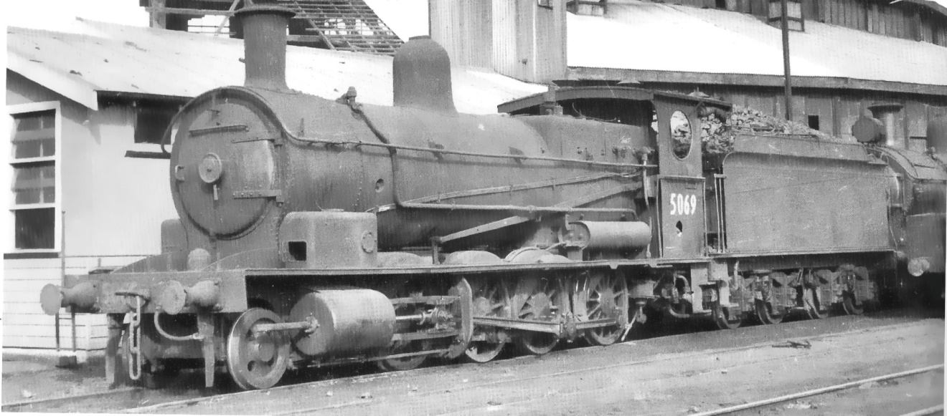
D5069 with Saturated Boiler
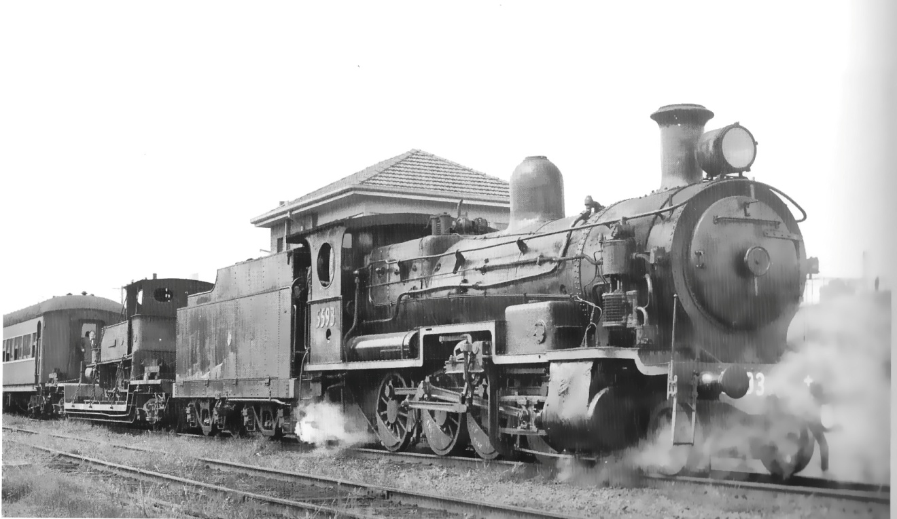
D5593 with Southern valve gear

1929 D57 4-8-2 25 in Class
These Mountain Class locomotives designed by E Lucy CME and they were controversial due to many early problems. Lucy’s quest for super power to move heavier trains resulted in a design developed over many years. There was a lot of interest in these locomotives and Clyde Engineering won the contract to build 25 units. The tenders were built by Mort’s Dock & Engineering Company.
They were the first locomotives in NSW to have cast steel frames, three cylinders with the two outside using Walschaert valve gear and the inside cylinder using Gresley conjugating gear. They had power reversing gear, mechanical stocker and cast steel frame for trailing truck. They had a tractive effort of 64,327 lbs.
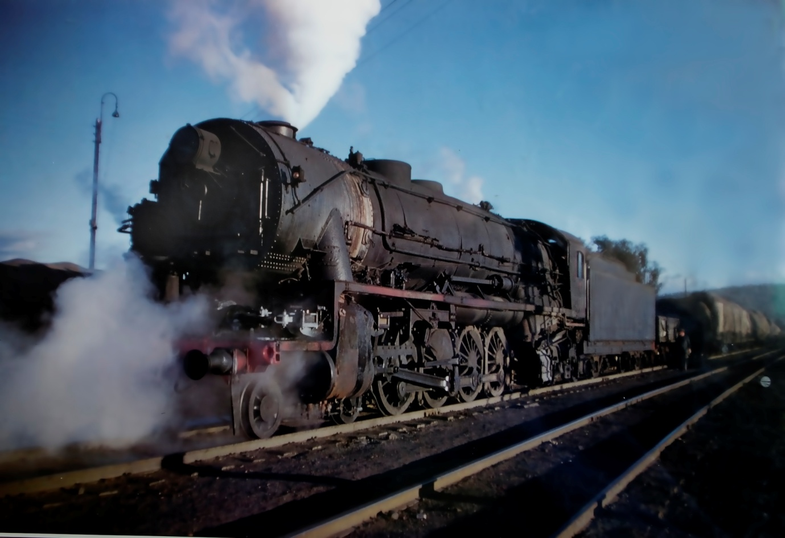
D57 with revised air compressor fitting adjacent to smokebox
By 1930 they were working the Blue Mountains line pulling loads of 630 tons using a Standard Goods pusher between Valley Heights and Katoomba. The record of bringing 2000 tons down the mountains was made by 5917 in 1934.
1950 D58 4-8-2 13 in Class
These modified 57 class locomotives gained approval in 1943 to build 25 units, however, due to other pressures only 13 were built 11 at Everleigh and 2 at Cardiff. 5801 entered service in March 1950. They were not a good performer with many problems.
The major differences with the 57 Class were the use of rack and pinion valve gear in place of the Gresley conjugated valve gear for the middle cylinder. The Gresley gear had many problems which reduced performance to an effective 2 ½ cylinders and resulted in an off-beat exhaust sound. Smaller cylinders were used to allow running to Newcastle, however, it wasn’t used on this route. There was also a change in coupling rods between the second and third driving wheels to correct slip common in three cylinder locomotives, however, this caused more wear on driving wheel bearings.
The rack and pinion valve gear drive for the third cylinder proved to be high maintenance and lubrication demand. If not maintained perfectly its performance was worse than the Gresley system in suppling steam to the third cylinder. The smaller cylinders were less efficient using more steam and water over the 57 Class. They were all withdrawn from service by 1957.

1952 D59 2-8-2 20 in Class
Due to locomotive shortages pre diesel resulted in 20 America light Mikados from Baldwin-Lima-Hamilton of a USA War Department design. Shipments were delayed as NSWR required shorter tenders to fit available turntables. They were oil fired initially and later converted to coal firing.
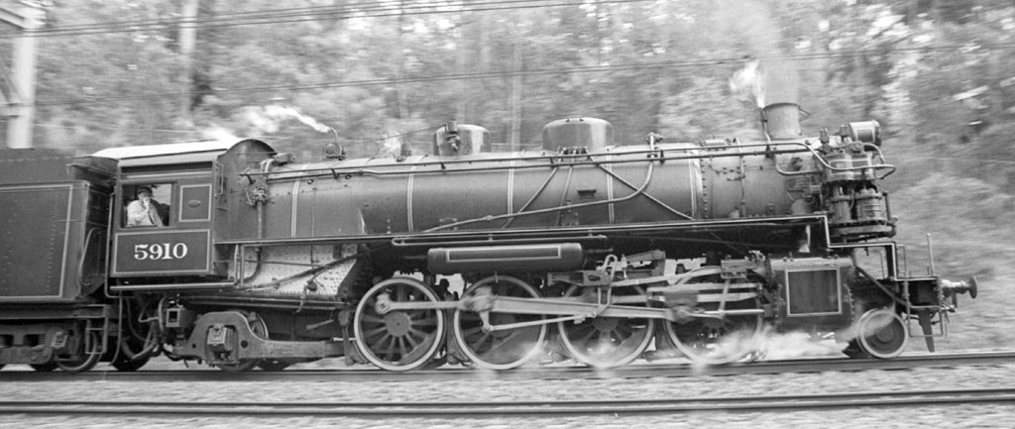
5910 at Pennant Hills D Bainbridge
They had a tractive effort of 35,000 lbs so were unsuited to Blue Mountains work, however, in their late period were used as pushers at Bathurst.

AD60 4-8-4 + 4-8-4 42 in Class.
The last steam locomotives purchased by NSWR and the first Beyer Garratts used in NSW. With a tractive effort of 63,000 lbs they were amongst the largest Garratts operated in the world and the first with cast steel frames and integral cast cylinders. They weighed 264 tons with a boiler pressure of 200 PSI.
Intended for the Blue Mountains they soon were used in heavy freight all over the system. Their light axle loading made them suitable for wheat traffic and other general traffic. Many modifications were carried out to improve their operation. Some were converted to dual operation where turning wasn’t available
Their power was legendary and in one case a double diesel 1220 tonne freight train stalled on the 1 in 66 Wingello Bank. An AD60 was bought in and it lifted the load including the diesels without effort.
The last steam locomotive withdrawn in NSW was 6042 (actually 6010) in March 1973.
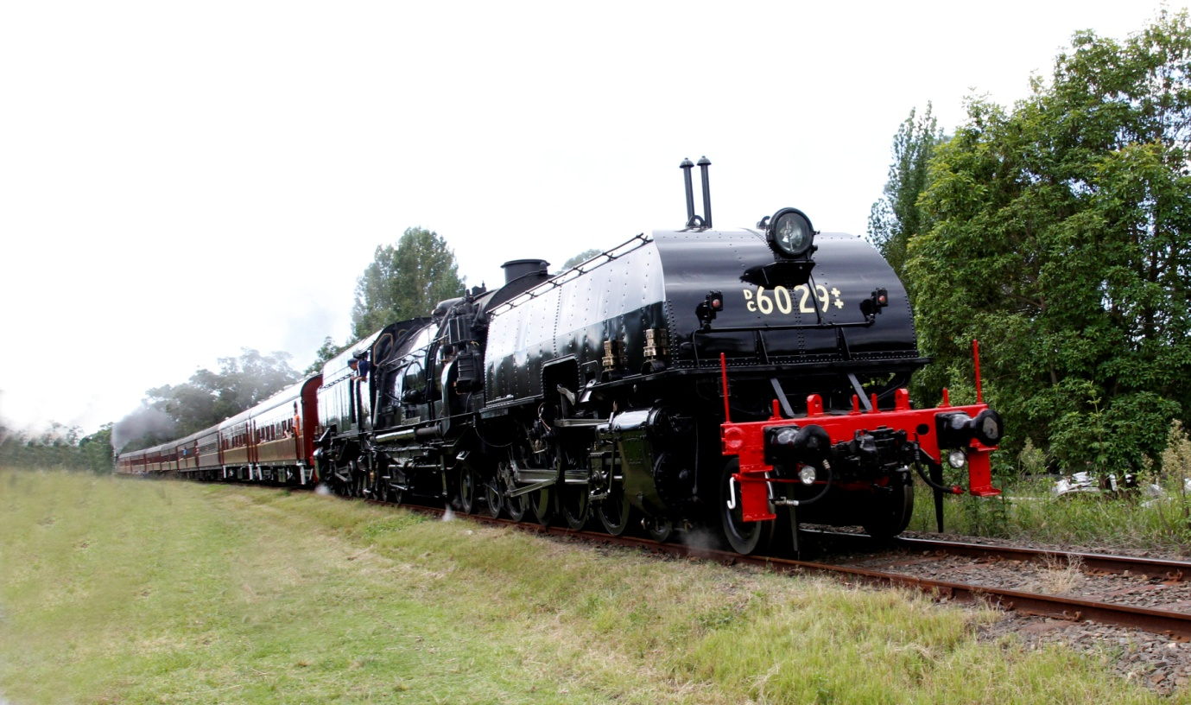
Restored 6029 at Thirlmere D Bainbridge

