STEAM LOCOMOTIVES USED IN THE BLUE MOUNTAINS

Compiled by Denis Bainbridge

Rev 5/14

Probably the first locomotive to work on the Blue Mountain line was No. 5. It was punted across the Nepean River near Penrith in May 1866 before the Victoria Bridge was completed to assist in the new rail construction.

1855 Class 5 0-4-2 Mixed Traffic "The Governor General" 2 in Class

This locomotive built by Hawthorn and Company in England and was imported by William Randle who was the contractor for the Parramatta to Liverpool rail extension in 1856. It was purchased by NSW Railways in November 1856 and given the number 5.

It worked the western line and was reported to be working material trains between Mount Victoria and the Clarence Tunnel in June 1869. It was reported to be in a poor state with a cracked boiler. It was transferred to passenger train duties working Parramatta suburban trains in the 1870's. It was then used with No. 75 in test runs to develop a suburban locomotive design. It finished its life at The Bombo Quarry suppling steam to the crushers before being scrapped in 1893.

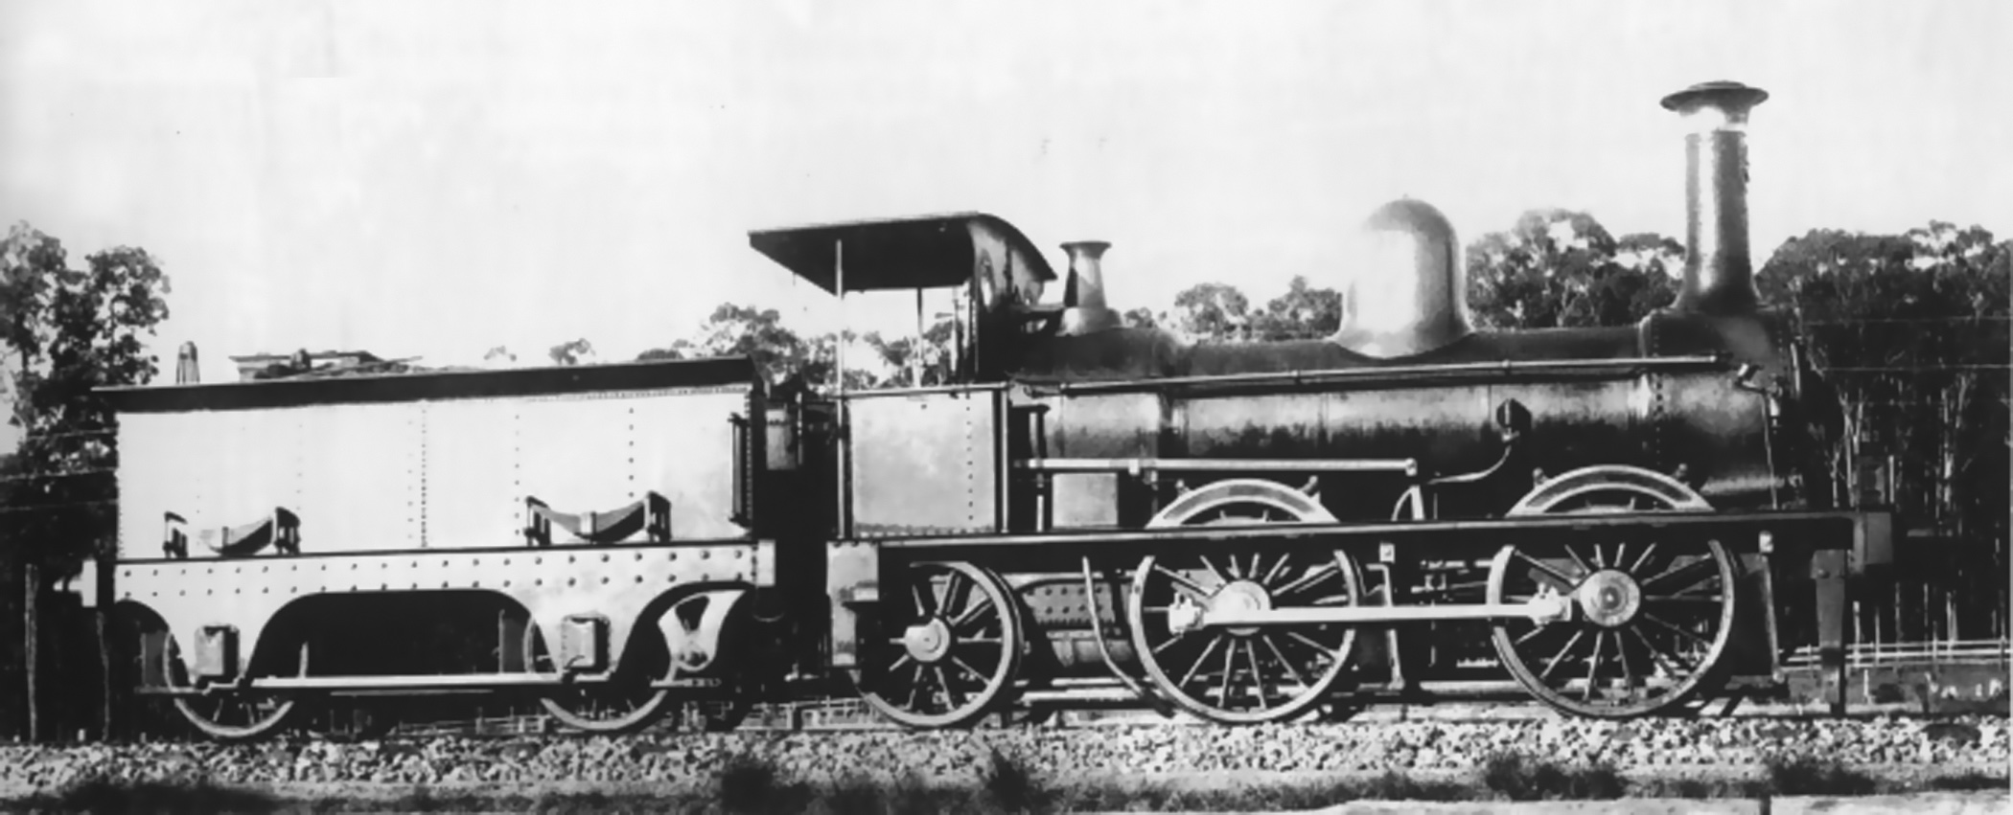

Class 5 0-4-2 "The Governor General" SRA

Passenger Locomotives

1865. G(23) Class 2-4-0 Beyer Peacock Manchester. 13 in Class

The G23 class was the first passenger locomotive to use the Lapstone Zig Zag in June 1867 after the completion of the Victoria Bridge over the Nepean River at Penrith. The first nine locomotives in the class had a driving wheel diameter of 69.5 inches which proved to be unsuccessful for Blue Mountains work so the final four in the class were manufactured with wheel diameter of 66 inches. These final models had a tractive effort of 11,310 lbs against 10,740 for the early models. The latter four units Numbers 32 to 35 which served from 1870to 1874 working the Penrith to Mount Victoria "Daily Mixed".

Never popular they suffered from hot axle boxes on their heavily loaded two wheel Bissel Truck. They were replaced by the 79 class.

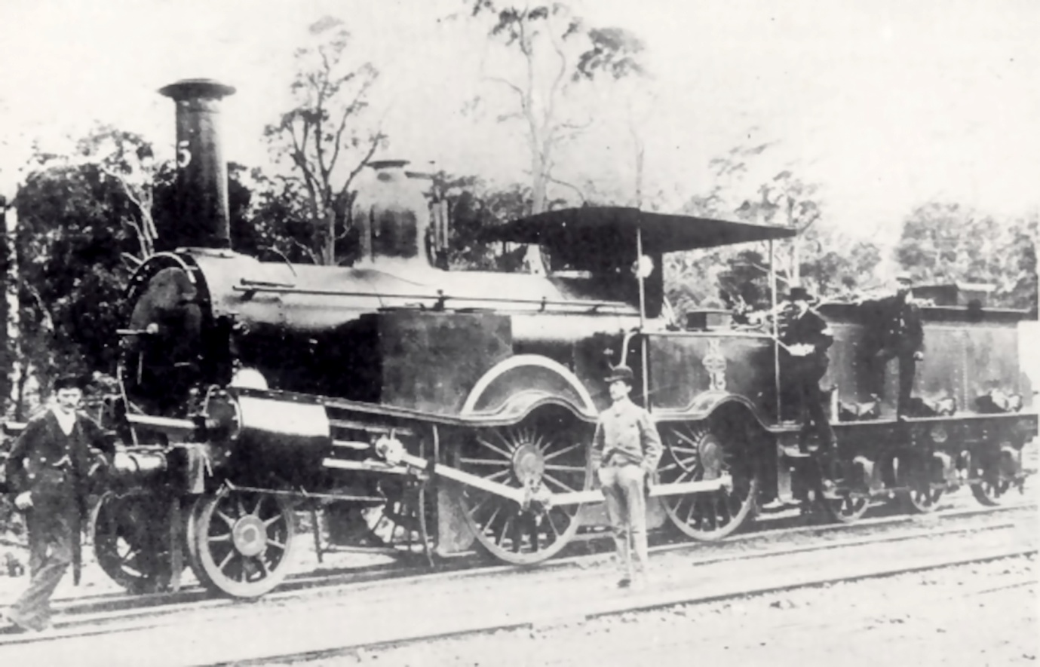

1865 Class G(23) 2-4-0 with 5' 9" Driving Wheels. SRA

1865 E(17) Class 23 in Class

Although basically a goods engine they were pressed into passenger service over the Blue Mountains. Orders were placed for nine C(23) 2-4-0 Class and nine 0-6-0 E(17) Class the latter to be built by Robert Stephenson & Company with their long boiler design. They were fitted with engine and tender hand brakes with shoes of timber on main and trailing driving wheels. Later brakes were added to the leading wheels. Large sand boxes were supplied on each side of the smokebox. They had a tractive effort of 15,550 lbs. Many more were built and assembled in Sydney by Vale & Lucy of Druitt Street & Mort & Company who sourced them from Stephenson.

They were employed on the Penrith to Mount Victoria passenger run during the 1868 - 1870 period. One No. 17 suffered a boiler explosion at Wentworth Falls on December 23, 1881

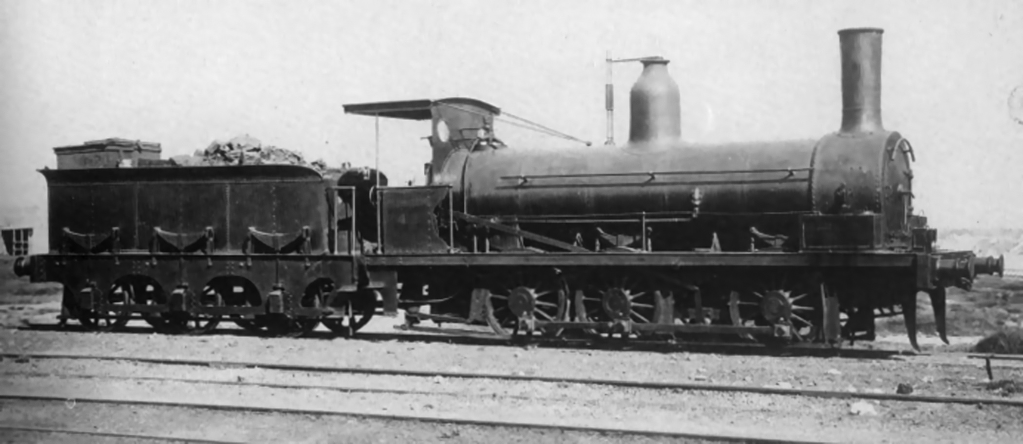

1865 Class E(17) 0-6-0 SRA

1874 O(60) Class 0-6-0 6 in Class

The light loads pulled by 4 wheel engines in the mountains resulted in an experiment with 6 wheel engines for passenger trains. The problem not considered was the sharp curves some of 8 chains radius being a problem for a rigid long wheel base engine without a leading track for guidance. designed and constructed by Robert Stephenson & Company and erected by Mort & Company in Sydney and placed into service between October 1874 and January 1875. They were a classic Stephenson long boiler design with steeply inclined cylinders driving the middle wheels. With a wheel diameter of 5 feet and a tractive effort of 16,5170 lbs they were the most powerful engines used so far for passenger traffic.

In the mountains they could lift 93 tons over the 1 in 30 grades at 15 mph an improvement of 65 tons for the 2-4-0 G(23) Class and 81 tons for the 0-6-0 17 Class. In 1875 the schedule for the run from Emu Plains to Blue Mountains (now Lawson) was 88 minutes including two reverses on the Zig Zag and 4 stops.

In 1877 the 79 Class took over most passenger traffic, however, heavier trains still used the 60 Class as main locomotive or pusher. They were finally taken off the mountains by 1885 replaced by the Baldwin 304 class.

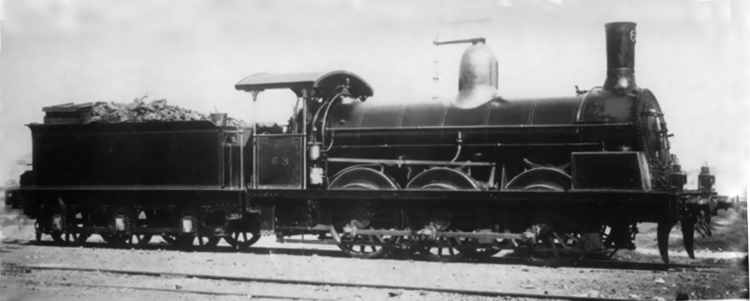

Class O(60) 0-6-0 SRA

1877 C(79) Class 4-4-0 68 in Class

A further development of the Beyer Peacock 23 class. They had a four wheel leading Bissel bogie and 20 percent more power with a tractive effort of 13,000 lbs. They took over passenger and mail services for 20, years. They were the first locomotives to be fitted with Westinghouse air brakes from the factory. Beyer Peacock designed and built the first batch of 30 and were in service between 1877 to 1879. The next batch of 26 units were built in Scotland by Dubs and Company and entered service between 1880-1881. The next batch of four were built by Beyer Peacock in 1881 while the final eight engines were built in Sydney by Atlas Engineering Works at Haymarket and were delivered between 1881 to 1882.

The run to Mount Victoria took 4 hours and 30 minutes climbing the Zig Zag and stopping at all stations beyond Parramatta. These locomotives operated the "Western Mail" from Penrith to Bathurst from 1877, "The Fish" from Sydney to Penrith 1885 - 1895 in 55 minutes with a stop at Parramatta and Penrith to Mount Victoria from 1880 to 1885.

They were replaced on the former trip by D (261) class and the latter by the L(304) class. They had a life in other areas some being converted into tank engines in 1896. They were later converted to Belpaire boilers and worked many areas.

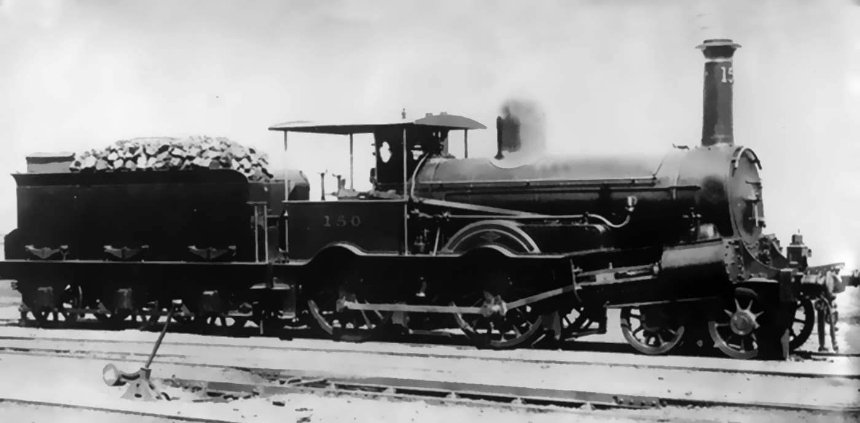

1877 Class C(79) 4-4-0 SRA

1877 C(105) Class 4-4-0 2 in Class

In order to compare the performance of American locomotives with the British C(79) Class then on order for country train services an order was placed with Baldwin Locomotive Works in 1876.

It was a typical American locomotive down to its smokestack, large oil burning headlamp and bell. It had a better four wheel bogie than the Bissell truck fitted to the C(79) with its restricted movement. The reversing gear was hand operated through an American version of Stephenson's valve gear. Westinghouse air brakes were supplied, however, could only be supplied to the train pipe chimney first. It had a tractive effort of 12,840 lbs. The tender was a six wheel type instead of the american bogie type. This allowed the engine to be turned on a 45 foot diameter turntable.

in December 1877 it was run to Lithgow hauling a small three car train of new American Jackson & Sharp two suburban and one sleeping carriages weighing in at 52 tons. The train had stops at Parramatta, Penrith then all stations to Lithgow and completed the trip in 5 hours 45 minutes less than any earlier trip. As there was no turntable at Lithgow large enough to turn the engine it travelled to Mount Victoria tender first, turned and continued back to Sydney in a total of 4 hours 30 minutes. the last 34 miles from Penrith in 55 minutes.

Its brakes proved to be unsuitable and caused some concerning situations. It was removed to go working to Picton and Penrith until improved brakes were fitted and it then worked to Goulburn. A second unit was ordered in 1879, however, they were regulated to easier runs until scrapped in 1904.

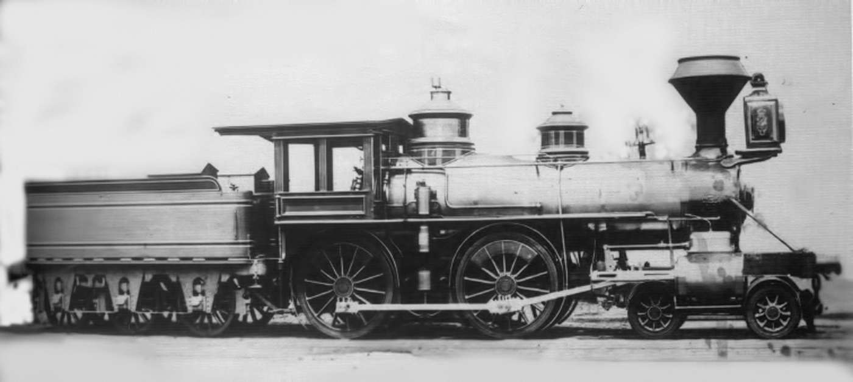

1877 Class U(105) 4-4-0 First American L Poole

1885 Class 304 2-6-0 Baldwin 10 in Class

This locomotive was designed by Thomas Midelton, NSW Locomotive Overseer. They were different from the usual American style of locomotive in that they were missing the steam dome, sandbox and cow catcher. The steam was captured by a long copper dry pipe running the full length of the boiler which was perforated on the upper side for 8 feet in the middle. The pipe terminated at the rear in a brass steam box in which were attached pipes to the auxiliaries while the front end was attached to a smokebox regulator thus reducing the number of steam pipe connections. A small dome over the firebox contained the safety valves and whistle. Westinghouse air brakes were fitted to the drive wheels only. They had a tractive effort of 15,470 lbs

The first locomotive was completed by Baldwin in September 1884 and was test run with good results. They entered NSW service between March and September 1885. when run on the Western Line they showed a large improvement over the 79 Class on the Blue Mountain section. They remained on this task until replaced by the 261 Class.

It is now than an interesting period occurred when competition between the British and American style locomotives came to a head in the winter of 1887. Thomas Midelton was of the opinion that the new British 373 class were useless on steep grades required for the Blue Mountains and that more of the American 304 Class should be purchased. William Scott, Locomotive Engineer was of the opinion that the 304 was overrated and that the British 373 would beat them over the mountains every time. The question of a contest was set in motion.

Midelton had paid a key role in the 304 with its 5 foot driving wheels and unusual steam piping design. he liked the long smoke box , large grate area and bar frames and compensated springing for light tracks. Baldwin had built the 2-6-0 Moguls and tested them on the Philadelphia and Reading Railway in September 1884 delivering 10 engines on the sailing vessel "Iceberg". The first unit steamed on St Patrick's Day 1885.

The 373 Class 12 engines were built by Vulcan Foundry of Lancashire and was a typical British design with 5 foot 6 inch driving wheels, cutaway cab and a six wheel tender. They seemed a good locomotive for British passenger work. The first engine only entered service in May 1887 one month before the contest. Scott who had been involved with locomotives since the first 0-4-0 Stephenson unit to arrive in NSW. He liked the British large wheels and elegant shape. he thought the 373 4-4-0 bogie was ideal for the curves and that the 304 was too long.

The commissioner set the rules as the two engineers couldn't agree to terms of the contest. The rules were, steam pressure to not exceed 140 PSI, no sand to be used except in emergency situation and only the Westinghouse air brake to be used. The trains had to pull a 130 ton train from Sydney to Bathurst in daylight. The trial commenced on June 15 with interstate referees. The route was change to end at Eskbank (Lithgow).

The results are lost in history, however, the 373 ran into trouble on the Down leg after Wentworth Falls when it had to stop for 2 minutes when its steam pressure fell to 105 psi and it couldn't climb to Katoomba until pressure was increased. Scott disputed some of the time results.

The Baldwin 304 set off three days later after a tender derailment caused a delay and with speeds of 45 mph a high speed for a small wheel engine with a lot of 8 chain curves it gained 68 minutes on the down trip to Eskbank. It was obvious that the 304 was the best engine for the grades. The 304's were used on "The Fish" until replaced by larger engines.

The 373 were not considered a good engine and were disliked by drivers for their hard riding and track maintenance for their high axle load. They would slip easily on a wet track. (it is strange that the 304's were scrapped while a 373 was restored at Thirlmere).

William Throw in a 1889 report was critical of the 373 and Vulcan Foundry stating that unless you had tight specifications that must be adhered to then you would suffer the results.

1890 Class 436 2-6-0 10 in Class

Due to the growth in traffic and shortage of powerful passenger engines tenders were requested from Scotch Dubs and Company who promised quick delivery. The order was for 10 locomotives based on the Baldwin 304 class with modifications. It had a wider running board curved over the driving wheels and outside hand rails. The Baldwin safety valve cover was replaced by an British type. They were called "Scotch Yankees". They had a tractive effort of 15,470 lbs

When in service in 1890 they suffered from hot axle boxes which required the fitting of larger axles and fitting a handbrake. They operated on Blue Mountain passenger trains until replaced by the P(6) class. For 10 years Number 440 worked out of Penrith on the Orange day train to Sydney each afternoon returning on a local passenger service. In the morning it assisted passenger trains to Katoomba if required.

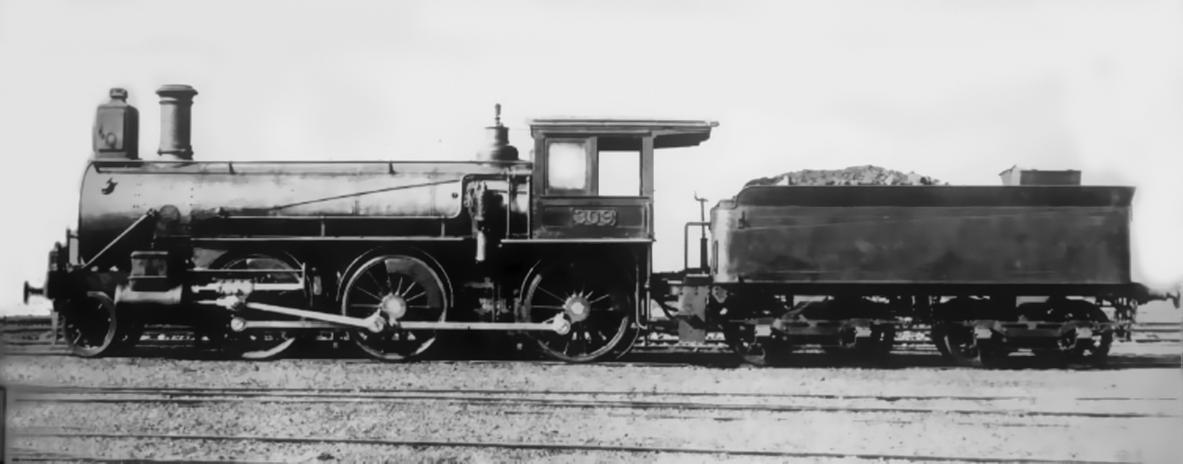

1885 Class 304 2-6-0 Second American. SRA

1891 Class O (446) 4-6-0 12 in Class

There was an extreme shortage of locomotives and worries about moving the 1890-91 wool clip made the purchase of additional locomotives critical. Throw was in England so decision was made without him. The engines were ordered from Baldwin in 1890 and were similar to the engines supplied to the Baltimore and Ohio Railroad except for changes of omission of sand dome and bell, fitting of buffers and draw hooks instead of American couplers, screw reversing gear, copper stay bolts, brass tubes and lagging on the cylinders cut back to fit the NSW loading gauge. The axle load was reduced to 14.5 tons. because of this Baldwin refused to guarantee that the engine would maintain a speed of 22 mph while hauling a load of 176 tons on grades of 130 ft per mile (1 in 40).

In 1891 they were placed in service on the Blue Mountains passenger services with the cow catchers removed. They were a striking looking engine with long smoke boxes to allow continuous hard steaming on steep grades. The large wooden cab place astride the firebox. the driver's seat on the right side along side the screw reverse. The fire man had a seat on the other side where he could rest on downhill runs.

Before the O (446) "The Fish" was usually double headed by various D classes from Penrith to Katoomba. The new engines worked unassisted and cut the running time by 15 minutes with a load of 132 tons increasing to 140 tons in fine weather.

The engines had some teething problems. The screw reversing components were weak. The drawhooks were undersized and the brakes needed work. Some wheels and tyres were made from defective materials and caused a derailment. These faults were quickly made good by Baldwin.

These problems resulted in a three month Royal Commission which was actually a political vendetta against Commissioner Eddy. Apart from findings against the axles and tyres no fault was found with the locomotives. By the time the faults were rectified the P (6) locomotives were coming on line for express traffic the 446 engines were put on to goods use. They were much modified over the years with the last one scrapped in 1949.

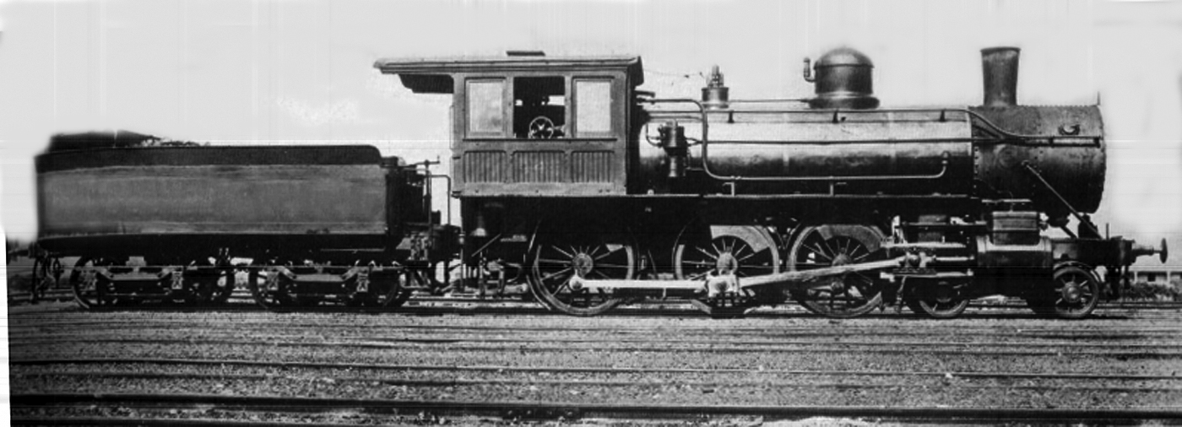

1891 Class O(446) 4-6-0 Third American SRA

1892 Class P(6) 4-6-0 Later called C32 Class "Manchester Engines" 191 in Class

This locomotive is one of the success stories of locomotives in NSW. The battle between American and British locomotive builders had been in the formers favour. Our unique patterns of traffic including severe grades did not suit many British locomotives which were designed for high speed travel over flat country.

The continuing shortage of locomotives meant that action had to be taken urgently. Commissioner Eddy was keen to setup a locomotive manufacturing capability in NSW. Tenders were issued, however, due to many circumstances led to nothing concrete occurring. Eddy then sent William Throw to England to negotiate with the final tenderer without result. Throw was then ordered to complete a design to be tendered. Beyer Peacock were given the task to finalize the design. There has been a lot of discussion on the ideas that led to the final P(6) design. Many of its features were similar to Throw's earlier locomotives beginning in 1879 with the South Australian K Class. His assistant in the design was J Scouler who worked at SA Railways before joining Beyer Peacock. The design was similar to the S.A. K, Q and R Classes in many features. The R Class was a combination of Throw's thoughts and best features of the Baldwin "N". Beyer Peacock built 50 engines which entered service between February 1892 and July 1893. They had a tractive effort of 22,190 lbs and were the first units to be built with Belpaire boilers and Allan straight link motion. They had an unusual feature with the sand box mounted over the leading drive wheel splasher. They originally had a bogie tender

Four builders were involved in supplying the P(6):

Beyer Peacock and Company 106

Baldwin Locomotive Works 20

Clyde Engineering Company NSW 45

Eveleigh Workshops NSW 20

They entered all main line services until the introduction of the "NN" 35 Class in 1914.

As our interest is The Blue Mountains we know that tests in 1907 with "The Fish" between Sydney and Penrith pulling a 240 ton train in 46 minutes requiring speeds of 65 mph The highest speed recorded for the class was on March 11, 1939 with seven carriages weighing 165 tons with a speed of 73 mph at Doonside with an average for the journey of 20 miles being 57.7 mph. The engines became the work horses on the Blue Mountains

The motor car was making inroads into the slower train times so efforts were made to improve train travel times. Fitting super heaters gave new life to the P(6). The fastest time to Mount Victoria was 3 hours 21 minutes, rising 3,424 feet in 77.8 miles with 3,245 feet occurring in 32 miles. On September 5, 1929 locomotive 3307 pulling five cars of 125 tons reaching Katoomba in 2 hours 2 minutes with four stops and Mount Victoria in 2 hours 24 minutes with seven stops which opened the way for "The Caves Express" which commenced operations on November 11, 1929. The engines were painted black with a star on the smoke box, polished buffers and motion work.

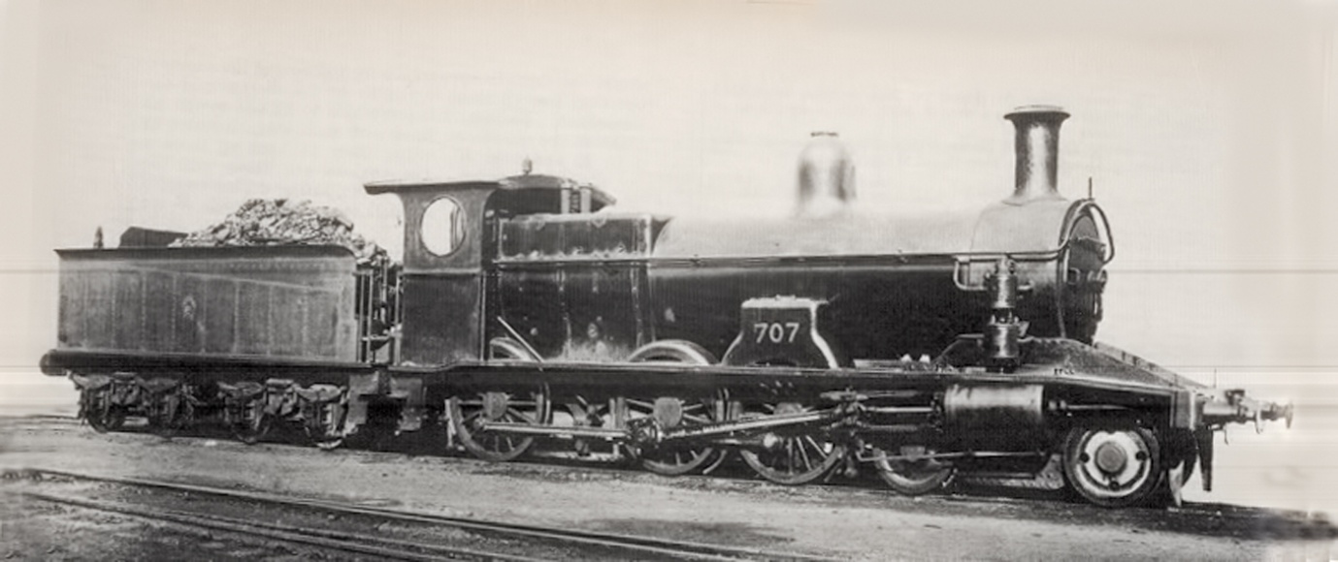

1892 Class P(6) C32 4-6-0 191 in Class

1914 (C)35 NN Class 4-6-0 35 in Class

Developed under Lucy and to overcome double heading with the (P6) C32 class due to introduction of heaver corridor cars. Built at Eveleigh workshop from 1914 (first five) to 30 units by 1917. Five were added in 1923. All units were superheated, fitted with Allan straight link motion gear and exhaust steam injectors. They were often called "Naughty Nannies". They were troublesome at first and poor steaming performers, however, with time they proved to be good express engines. They had a tractive effort of 29,150 lbs.

They took over "The Fish" in June 1918. Their time to Penrith 54 minutes was an additional three minutes and 3 hours 17 minutes to Mount Victoria which didn't include a new stop at Warrimoo. The Glenbrook Deviation and extra stops the running time was 17 minutes longer than the run to Penrith with a D Class engine and switching to a P (6) Class for the run to Mount Victoria. With the need to compete with motor traffic the 17 minutes was reduced to 10 minutes.

They took over the Caves Express in 1932. A test run on may 26, 1933 with a new "CUB" set a C35 hauled 148 ton train to Penrith in 40 minutes 49 seconds. The highest speed recorded for this class was 71 mph. They were replaced on this service by the (C)36 Class in 1935.

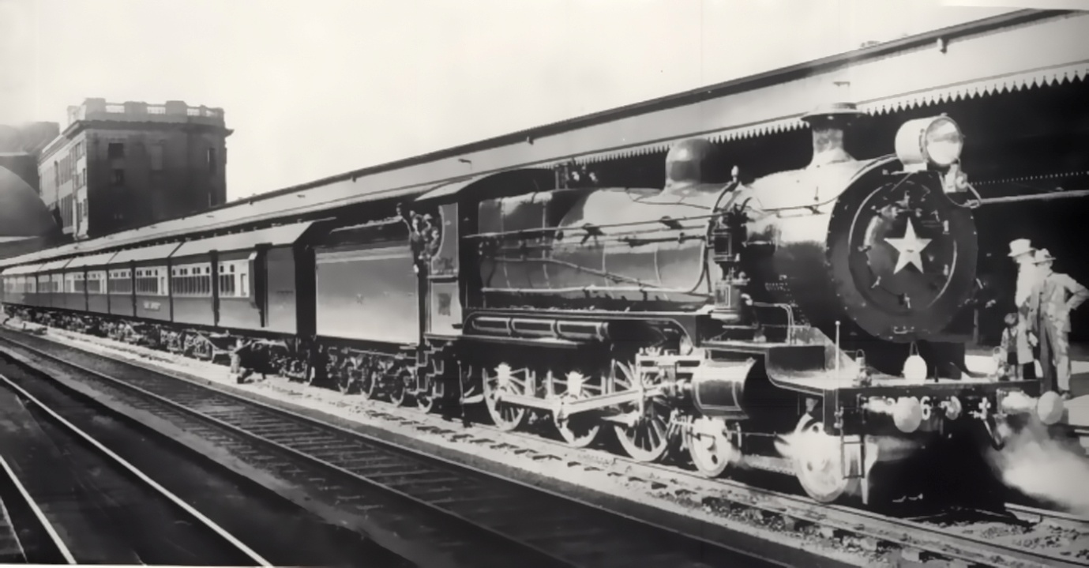

1914 Class NN C(35) 4-6-0 C35 on "Caves Express" 35 in Class D O'Brien

1925 C(36) 4-6-0 Express Passenger 75 in Class

Eveleigh Workshop 10 First Jan 1925 Clyde Engineering 65 Last Nov 1928

25 tenders were built at Walsh Island Dockyard Newcastle. Thee tenders were for the first time in NSW turret tenders which gave a large water and coal capacity with a good view along the train.

These express locomotives were designed for non stop runs up to 100 miles. They had Walschaert's valve gear operating outside piston valves, self cleaning fire box, round top tapered three course boiler (Belpaire boilers were fitted later), exhaust steam ejectors and air operated butterfly fire doors. They had a traditional British long narrow fire box which was the blight of many firemen. They were called "Pigs" mainly due to their stubby shape.

They took over the long run work from the C(32) and C(35) engines cutting schedule time due to less water stops. In their early days they proved difficult to work. Firebox faults developed by 1934 which required retrofit work as well as changes to the blast pipe design which reduced the fire lifting problem and allowed the use of lower quality coal. The class colour was changed to green.

On the western line on August 9, 1934 pulling a load of 160 tons from Central to Mount Victoria then 190 tons to Orange. For the first time there was no water stop at Lawson which now was at Wallerawang 106 miles into the trip. On the non stop run from Parramatta to Katoomba the train reached 70 mph near St Marys, with the 75 mile sprint taking 90 minutes 57 seconds with an average of 36.5 mph. This was an improvement of 55 minutes over the Orange day train.

Another run on September 20, 1935 with the "Caves Express" six cars of 150 tons, it reached Penrith in 39 minutes for 34.2 miles with an average speed of 52.6 mph. The first stop at Hazelbrook was reached in 82 minutes at an average speed of 42.5 mph. There were three more stops on the route the time to Katoomba was 109.5 minutes. These times were repeated with other C(36) locomotives.

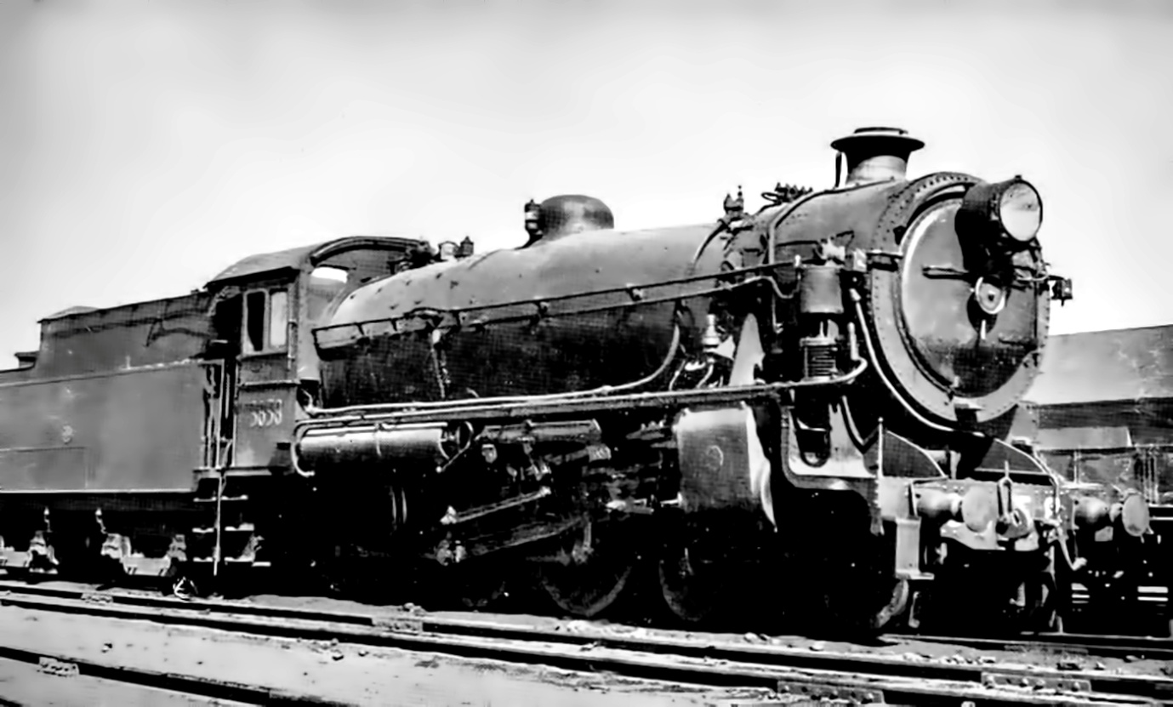

1925 Class C(36) 4-6-0 Express Passenger 75 in Class

The Tractive effort was 30,500 lbs. The longest non stop run ever recorded for this class was 130.2 miles.

From 1953 73 units were converted to Belpaire Boilers with steel inner fire boxes, arch tubes and regulator valves in the superheater header. New cabs were fitted with bucket seats.

As C(38) Class came on line they replaced the C935) on heavy express runs. It was interesting that the C(36) units began replacing the standard goods engines on fast freight services.

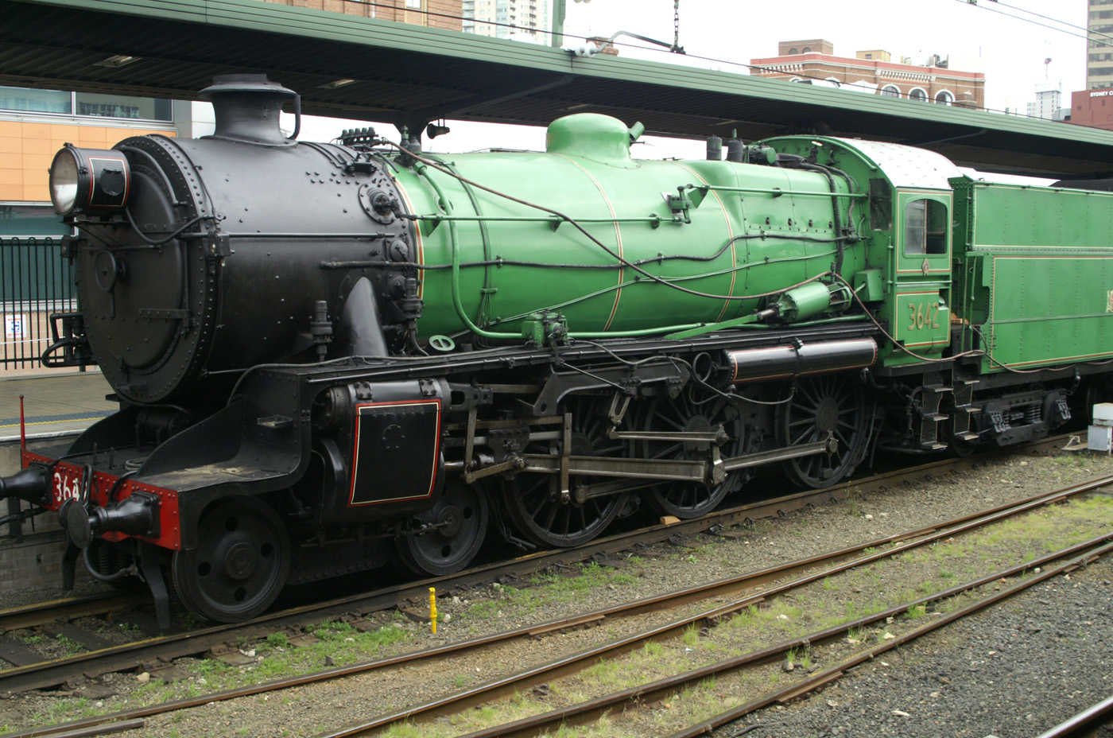

Restored 3642 with Belpaire Boiler. D Bainbridge