**Our History**

BEFORE THE SCHOOL       -      by Nell Aston

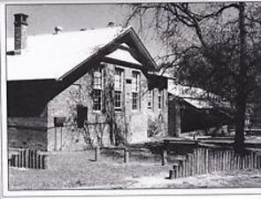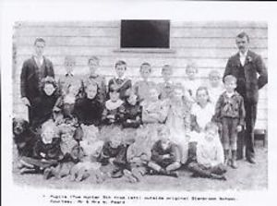

 Glenbrook was not even called Glenbrook when the railway line opened in 1867. It was a tiny watering stop for locomotives, at first known appropriately as Water Tank, then Wascoe's Siding and for one year, Brookdale. It was not even on the main road.

The very few children at this isolated place either grew up without schooling or caught the train to Wentworth Falls - as the Hamment children did. The train guards looked after them on the way but it was such an exhausting day from 5-30 am to evening, winter and summer, that the children could only attend school on three days per week.

Springwood and Emu Plains Schools opened in 1878 so the children went to Springwood, being easier to reach with trains at convenient times and without the slow changing of points to forward reverse-forward that was necessary on the Lapstone Zig Zag. Springwood School, now demolished, was quite close to the station so children and parents were happy with this arrangement for a couple of years - until the Public Instruction Act was passed in 1880.

This Act required all children to go to school and provided free rail passes to get them there. However, they must go to the NEAREST school and both the Department of Public Instruction and The Commissioner for Railways insisted that the nearest school to Glenbrook was Emu Plains.

When the passes were issued in1881" the parents wrote many letters, as did Mr Showe, Principal of Springwood, protesting that the train times were inconvenient and the school was a mile from the station, so the children would be "up to their knees in mud" in wet weather. Mr Showe also hinted at "another teacher's conduct," as a reason for not sending children to Emu Plains. But then he did admit that his own small school was in danger of closing if the Glenbrook children transferred away from Springwood

The Glenbrook parents who wrote were Thomas Miles, J.M. Wood and Mrs Am Willis.

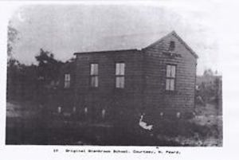

Finally, the Department and the Railway Commissioner decided that Springwood was closer, "in the spirit of the Act," and new Passes were issued.

In 1890 the parents petitioned for a provisional school at Glenbrook but this was refused.

The petition was repeated when the Navvies' children were actually' camped along the line with their parents for the building of the First Deviation but the Chief Inspector remarked that these railway children were only "birds of passage," not to be counted in the need for a school. Yet it was the Navvies' children who filled the school to overflowing in its first year and during later periods of railway building.

The beginnings of Glenbrook School owed a great deal to the Railways. Apart from navvies, most of the population were permanent railway workers or in some way connected with them.  The original Zig Zag was a great engineering feat for its day and the trains had been puffing, forward and reverse, up Lapstone Hill by this line for twenty five years before any school was built.  The stopping place for engine water from Glenbrook lagoon had grown into the village of Glenbrook 1892.

Finally the Zig Zag, too slow for the increased rail traffic and too short for the longer trains, was to be replaced by a tunnel.  This was the First deviation, The Lapstone Tunnel, now called the Old Tunnel.  The Deviation should have been finished by the end of 1891 and the children would have moved away with their parents before the school even began but the sudden death of the railway contractor, David Proudfoot, caused the work to go for another year.  So the Navvies' children were still there to crowd into the little school when it opened in May, 1892.

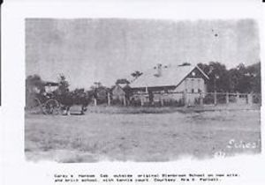

Early in 1892, a Provisional school was granted- if the parents would supply the school building. This they did, with a second hand weatherboard shack which cost them 80 pounds. It was about half the size of a modern class-room – and most uncomfortable. It had a fireplace and a water tank on one side and two windows in the opposite wall but no window blinds at first.

 The enclosed verandah at one end was not added until after it was moved to a new site. The iron roof was unlined until 1896, causing summer temperatures to reach 120 Degrees Farenheight.

 In this heat Miss Hall worked for most of two exceptionally hot summers-wearing her long skirt and' of course her whalebone corsets.

The tank beside the school must have remained almost empty in the dry conditions and the small iron roof would not catch much water anyway. So water must have been brought to the school. Glenbrook Lagoon water was used for the locomotives and this was sometimes filtered through earth for drinking.

The people did not wait for official inspection of the site. Mr J Lucas of "Lucasville", MLA and Minister for Mines- and a man not easily opposed – was one of the parents.  He decided the best site for the school was in the north east corner of Glenbrook Park and that was where it was put. When Mr Inspector Kevin came along to view the site, the building was almost finished and he could only write an indignant letter to his Chief Inspector, complaining that it was illegally placed in a public park, "as suitable as if it stood in Hyde Park."  It should be moved to the site he had selected when opportunity arose.  For this reason the Inspector refused to recommend that the Department provide toilets for the school. So boys and girls managed as best they could for more than a month until Mr Lucas used his influence to get "WC's" built, "for decency's sake"

Miss Hall had trained as a pupil teacher and was only twenty when she was appointed to Glenbrook on 26th April 1892.  It was a tough, new school with the local pupils outnumbered by children from the Railway Camps, some of whom had not even been to school before.  She arrived to open the school on 9th May but, finding no furniture, she merely enrolled the 28 who were present and reported the situation in a letter to the Department.

She wrote her letter under the letterheads of Major Shallard who ran "The largest Bee Farming Concern in Australia," in Brooklands Road.  She probably boarded with this family for there were Shallard children at the school and, in those days, it was not "proper" for a lady to live alone.  There were boarding houses in the village but even these would not be quite "proper" as they catered mainly for railway employees, usually single men who shared a bathroom.

When the school furniture arrived it was not enough so, in June the Inspector, Mr Kevin, prodded by John Lucas, was requesting:

**Glenbrook, Additional Furniture** –

In order to complete the organisation of the school, the following additional articles of furniture are needed:-

3 desks each 9 feet long

1 form 9 feet long

1 small table

There are 66 children on the roll and two blocks of desks are necessary, besides the two forms for the infants.

The furniture came by train to the station and someone must have carried it across the Park to the school.  Other sources tell us that the regulation forms had no back rests but children must learn to "sit up straight"; and the regulation space was 18 inches of desk per child. That meant six children at each desk. They must not bump each other or cause ink to be spilled on other children's books.

**GLENBROOK PROVISIONAL SCHOOL**

**BECAME GLENBROOK PUBLIC SCHOOL IN OCTOBER, 1892.**

**Glenbrook Infants site and Glenbrook Primary site were brought together as one school in 2013 on the Woodville Street Site.**