GLENBROOK POINTS

Newsletter of Glenbrook & District
Historical Society Inc.

Feb Mar '14
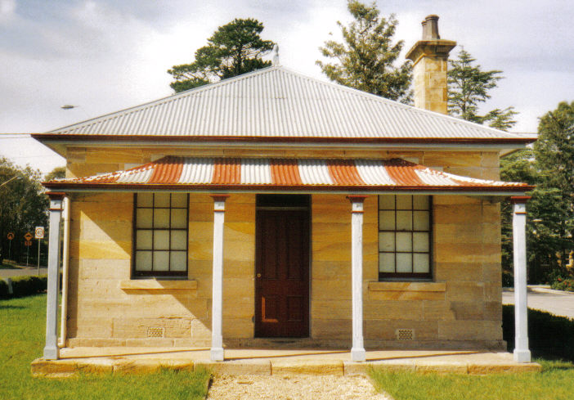
Postal address P.O. Box 38 Glenbrook NSW 2773

Contacts: Tim Miers 4739 2384
Doug Knowles 4751 3275
Meetings 3rd Wednesday monthly at 1.30 pm
(except Dec-Jan) Glenbook Guides Hall
cnr Hare & Moore Sts Glenbook

"Walks & Talks" 2014 Programme
March: Sat. 8th 9.30am "Lapstone Construction" Railway 1910 and East Portal of Lapstone Tunnel 1892.
April: Sat. 5th 9.00am "The Descent to the West." Mt. York. Short return walks on 3 historic routes--Cox's Pass 1815, Lawson's Road 1822 & Berghofer's Pass 1909. This is a special walk--Adults $10.00
Sat. 26th 1.30pm "Eastern Zig Zag Railway 1866, Knapsack Viaduct and Old mine shaft.
Adults: $8.00ea. Children under 16yrs. free, but must be accompanied by a parent or guardian. (No dogs please.) Bookings are essential: phone Doug. on 4751 3275 (Please allow the phone to ring long), or Tim on 4739 2384 for details

