GLENBROOK POINTS

Newsletter of Glenbrook & District
Historical Society Inc.

Aug – Sept 2012
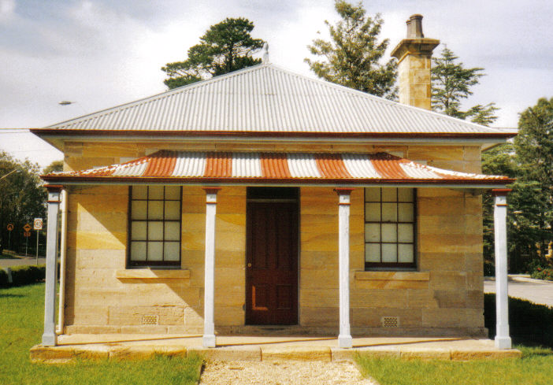
Postal address P.O. Box 38 Glenbrook NSW 2773

Contacts: Tim Miers 4739 2384
Doug Knowles 4751 3275

Meetings 3rd Wednesday monthly at 1.30 pm
(except Dec-Jan) Glenbrook Guides Hall
cnr Hare & Moore Streets Glenbrook

WALKS & TALKS: From Aug 2012.
AUGUST: Saturday 25th: 1.30pm Lapstone Construction Railway 1910 and East Portal of Lapstone Tunnel 1892.
SEPTEMBER: Saturday 8th: 1.30pm Dunn's Sawmill site and earth dam. Brookside Creek, Lennox Bridge and old Stone Quarry. : Saturday 29th: 9.30am Glenbrook Lagoon Precinct. Early campsite and railway dam construction 1880

