GLENBROOK POINTS

Newsletter of Glenbrook & District
Historical Society Inc.

June – July 2012
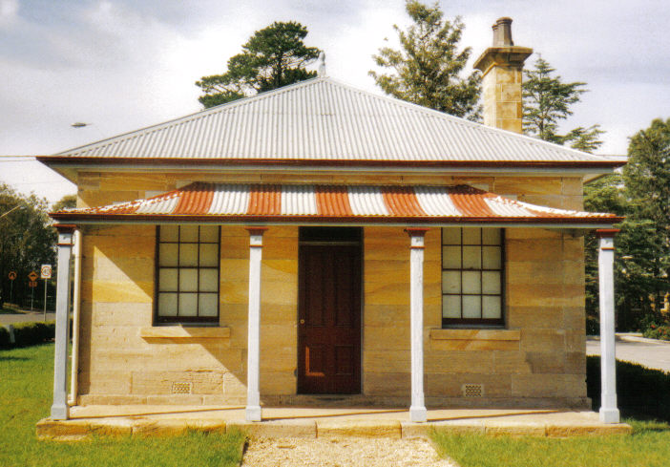
Postal address P.O. Box 38 Glenbrook NSW 2773

Contacts: Tim Miers 4739 2384
Doug Knowles 4751 3275

Meetings 3rd Wednesday monthly at 1.30 pm
(except Dec-Jan) Glenbrook Guides Hall
cnr Hare & Moore Streets Glenbrook
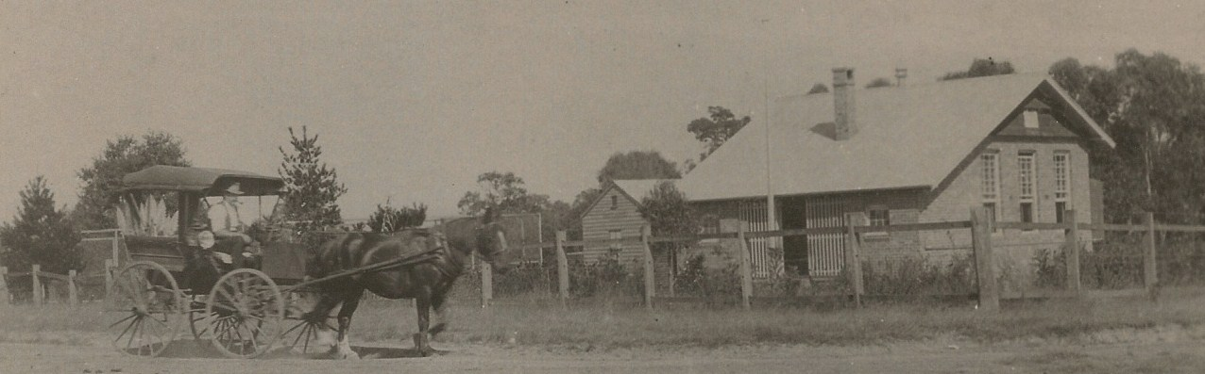
CAN ANYONE NAME THIS SCENE... Place date etc.

