GLENBROOK POINTS

Newsletter of Glenbrook & District
Historical Society Inc.

Aug Sept. ‘13
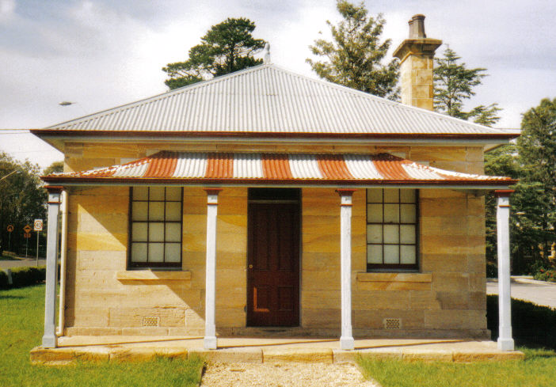
Postal address P.O. Box 38 Glenbrook NSW 2773

Contacts: Tim Miers 4739 2384
Doug Knowles 4751 3275

Society meets on 3rd Wed. Each month 1.30pm
(except Dec-Jan) Glenbrook Guides Hall
cnr Hare & Moore Streets Glenbrook

WALKS & TALKS: From Aug 31st
August, Saturday 31st at 1.30pm: Lapstone Construction Railway 1910 and East Portal of Lapstone Tunnel 1892.
September, Saturday 21st at 9.30am: "Dunn's Sawmill Site" and earth dam, Brookside Creek, Lennox Bridge and old Stone Quarry
October, Saturday 19th at 9.30am: "Glenbrook Discovery--Heritage Walk." (Last walk for this season.)
Adults: $5.00ea. Children under 16yrs. free, but must be accompanied by a parent or guardian. (No dogs please.) Bookings are essential: phone Doug. on 4751 3275 (Please allow the phone to ring long), or Tim on 4739 2384 for details

