GLENBROOK POINTS

Newsletter of Glenbrook & District
Historical Society Inc.

Feb Mar '14
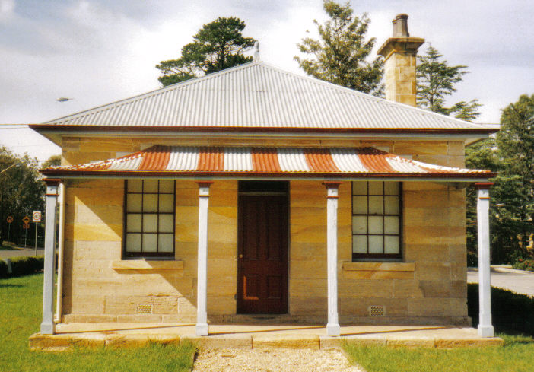
Postal address P.O. Box 38 Glenbrook NSW 2773

Contacts: Tim Miers 4739 2384
Doug Knowles 4751 3275
Meetings 3rd Wednesday monthly at 1.30 pm
(except Dec-Jan) Glenbook Guides Hall
cnr Hare & Moore Sts Glenbook

"Walks & Talks" 2014 Programme
March: Sat. 8th 9.30am "Lapstone Construction" Railway 1910 and East Portal of Lapstone Tunnel 1892.
April: Sat. 5th 9.00am "The Descent to the West." Mt. York. Short return walks on 3 historic routes--Cox's Pass 1815, Lawson's Road 1822 & Berghofer's Pass 1909. This is a special walk--Adults $10.00
Sat. 26th 1.30pm "Eastern Zig Zag Railway 1866, Knapsack Viaduct and Old mine shaft.
Adults: $8.00ea. Children under 16yrs. free, but must be accompanied by a parent or guardian. (No dogs please.) Bookings are essential: phone Doug. on 4751 3275 (Please allow the phone to ring long), or Tim on 4739 2384 for details

pge 1

Pam’s Page

In the early 1920's, a Captain Charles Smith, who lived in Darlinghurst, decided he would like a mountain residence. He bought land on top of Lapstone Hill with a partly built house on it: finished it, and called it "Logie." Over the years "Logie" altered and extended. It became the Lapstone Hotel in the late 1920's and in turn, was purchased in the1940's to become the R.A.A.F. Base.
The early history of the R.A.A.F. began with the formation of Eastern Area Headquarters at Edgecliff in Sydney in 1942. At the end of the war, the Headquarters were re-located to Bradfield Park. However, it proved to be unsuitable for a permanent location for an Area Headquarters. In 1949, the Lapstone Hotel was purchased by the R.A.A.F. for use as Eastern Area Headquarters. It was a 2 storied 'U' shaped building of 57 bedrooms together with a dining-room and kitchen, ballrooms and several reception rooms. Also, there were a number of outbuildings, a swimming pool, small golf course and an extensive garden. The property was considered suitable and the premises were occupied by the R.A.A.F. in 1950. Between 1949 and 1954, additional land was purchased nearby to allow Married Quarters to be built for Officers and other ranks.
1953, Eastern Area Headquarters was re-formed as 'Headquarters Home Command' and later on became 'Operational Command.' Three separate elements were based at R.A.A.F. Glenbrook. Many R.A.A.F. members and their families lived in the Lower Blue Mountains. The Officers lived and had their dining-room and Mess in the main building. Snr. N.C.O.s and Airmen lived in a R.A.A.F. camp in Penrith roughly where the Westfield Plaza and the Joan Sutherland Centre is to-day. They were bussed to Glenbrook each morning for work: returned to Penrith for lunch: taken back to Glenbrook for the afternoon and then back to Penrith at the end of the day.
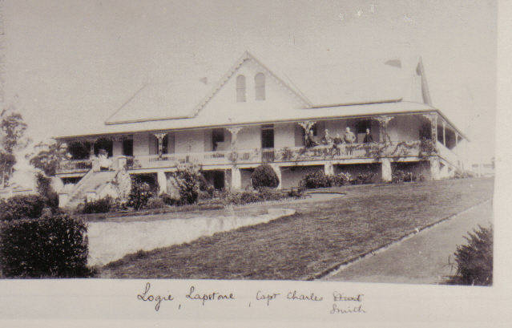
Sometime later quarters were m built for the other ranks " Briarcliffe", a large s sandstone cottage adjacent to t the Base, was purchased in 1 1953. It is the official home o of the Air Officer C Commanding Operational C Command.
"B Briarcliffe" was built in 1 1923 by Mr. John. C. Dunn o of Glenbrook. It is built f from sandstone quarried on t „LOGIE“ c 1920 the property.
These are my memories of the Base in the 1950's and 1960's: also in 1970 when my family returned to Glenbrook from a posting in Washington D.C U.S.A.
There are no married quarters anymore: Personnel either purchase their own homes or live in rental properties.There doesn't seem to be the contact between the service personnel and the local community which was really enjoyed in years gone by.

Pge 2

GLENBROOK & DISTRICT HISTORICAL soc.

Walks & Talks" led by Doug. Knowles and Tim Miers
2014 Programme

March: Sat. 8th 9.30am "Lapstone Construction" Railway 1910 and East Portal of Lapstone Tunnel 1892.
April: Sat. 5th 9.00am "The Descent to the West." Mt. York. Short return walks on 3 historic routes--Cox's Pass 1815, Lawson's Road 1822 & Berghofer's Pass 1909. This is a special walk--Adults $10.00
Sat. 26th 1.30pm "Eastern Zig Zag Railway 1866, Knapsack Viaduct and Old mine shaft.

May: Sat. 10th 1.30pm "Bull's Creek," Stone dam and old Railway Pump site.
Sat. 31st 1.30pm "Glenbrook Lagoon Precinct." Early campsite and railway dam construction1880.

June: Sat. 21st 1.30pm "The Mountain Murders." Lee Weller's grave site and rock inscriptions.

July: Sat. 12th 1.30pm :"Dunn's Sawmill Site" and earth dam, Brookside Creek, Lennox Bridge and old Stone Quarry.

Aug: Sat. 2nd 1.30pm "Cox's Road." Walk along a section of this historic road following the ridge-top from Linden to Woodford Trig.
Sat. 23rd 1.30pm "Duck Hole-Glenbrook Creek.” Old Roadway Construction and Railway Pump site.

Sept. Sat. 13th. 1.30am "Cattle Rustler's Yard." Campsite and caves.

Oct.: Sat. 4th 9.30am: "Glenbrook Discovery"--Heritage Walk. (Last walk for this season.)
ADULTS: $8.00ea. Children under 16yrs. Free: but must be accompanied by a parent or guardian. (No dogs please.) BOOKINGS are ESSENTIAL: Phone Doug. on 4751 3275. (Please allow the phone to ring more than usual), or Tim on 4739 2384 for details re meeting place, time and grade of walk. Good walking shoes are essential. Please bring a hat and drinking water.

SPECIAL BOOKINGS: Social Clubs, School Groups etc. Times and days to suit your organisation can be arranged for a standard fee of $40.00 for a Glenbrook Historical Society tour guide.
pge 3

GLENBROOK BUS SHELTER

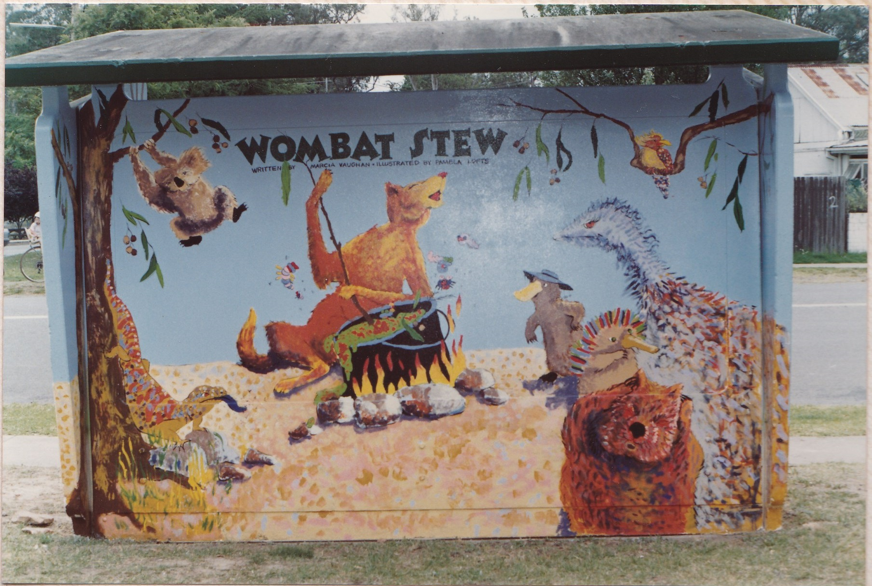
Recently a car ran off the road and collided with a bus shelter, severely damaging the car, but with minor damage to the concrete bus shelter. On removing the car the shed was further
damaged. Within a few days the Council
removed the damaged shed simply by
crushing the concrete and carting the
rubble to the tip. Not an exiting story, but
the shed in question was of historic value
to Glenbrook, situated in Ross St at the
Community centre. The shelter shed was
painted by students from Glenbrook MURAL REAR
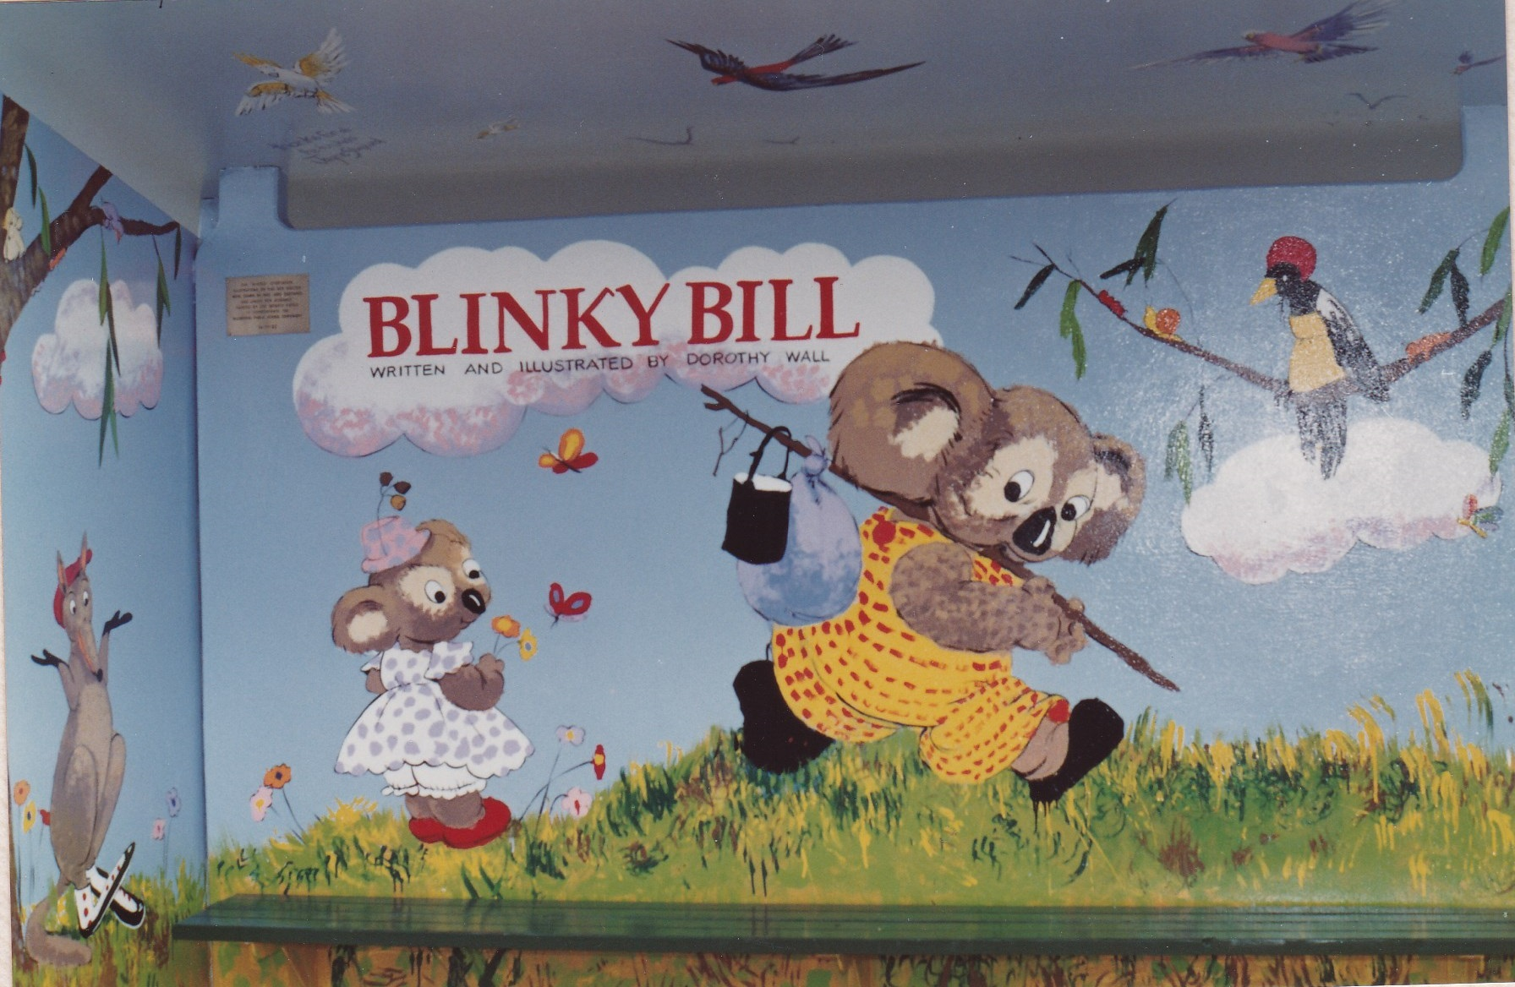
Primary School as part of their 100 years
school celebration 1992. The artist was
Sue Gasser .
Joan Peard and others considered this
to be an act of vandalism and Joan
contacted Mayor Mark Greenhill.
The Mayor was unaware of this event
and promised to "look into it and ring you
back". Within a few days the Mayor said
he wouild recommend to Council that the MURAL FRONT
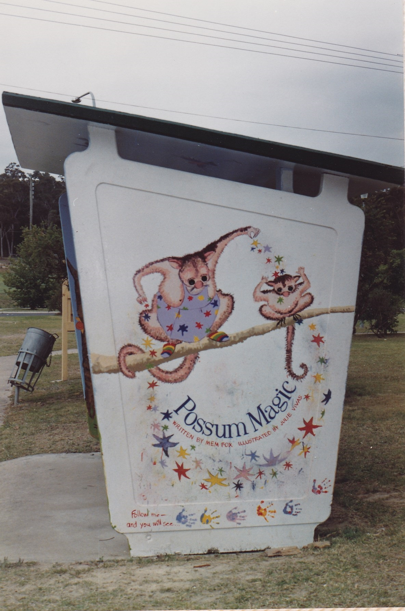
shelter shed be replaced and restored to it's
former glory. More recently the Mayor contacted
Joan to report that a similar concrete shed was
available and the murals restored. Fortunatley our
Mayor has an interest in local history, which is
more to be said than those who authorised the sheds
removal, and he is always available & listens.
We have 3 photographs of the original, but the
outside mural of the northern wall and inside of
southern wall are still missing. If any member can
help, please e-mail me copies of their photos. We
cannot rest on our laurels until the shed is replaced SOUTH WALL
and restored. Nothing short of this is satisfactory.
EDITOR e-mail jpe13704@gmail.com

pge 4

