GLENBROOK POINTS

Newsletter of Glenbrook & District
Historical Society Inc.

OCT/NOV. '14
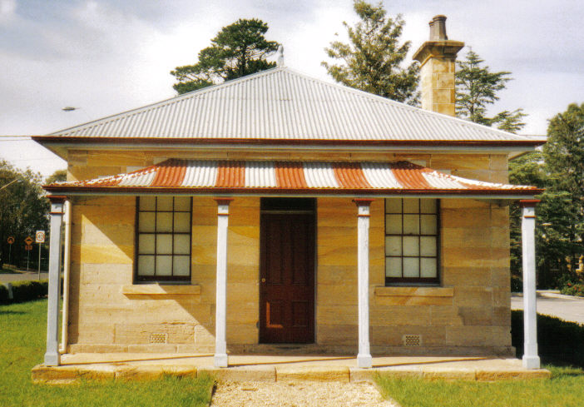
Postal address P.O. Box 38 Glenbrook NSW 2773

Contacts: Tim Miers 4739 2384
Doug Knowles 4751 3275
Meetings 3rd Wednesday monthly at 1.30 pm
(except Dec-Jan) Glenbook Guides Hall
cnr Hare & Moore Sts Glenbook

"Walks & Talks" 2014 Programme
Oct. Sat. 4th 9.30am: "Glenbrook Discovery"--Heritage Walk.
(Last walk for this season.)

ADULTS: $8.00ea. Children under 16yrs. Free: but must be accompanied by a parent or guardian. (No dogs please.) BOOKINGS are ESSENTIAL: Phone Doug. on 4751 3275. or Tim on 4739 2384 for details re meeting place, time and grade of walk. Good walking shoes are essential. Please bring a hat and drinking water.

