Pam’s Page

MT.SION ESTATE and WHAT THEY SAID IN 1926

By xxxxxxxxxxxxxxxxxxx

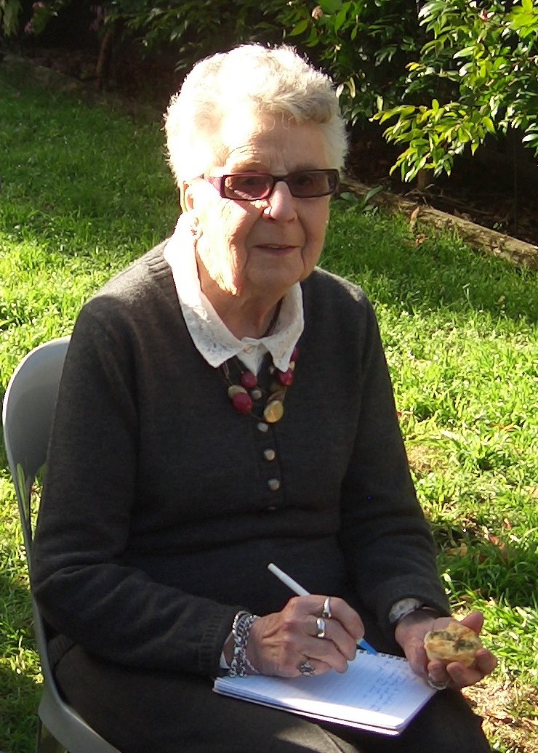

The name that “Mt Sion Estate” was selected by the original owner, Mr Barnett Levey, who had received a grant of land in xxx for the sum of £xxx. He chose this name as he considered the words of the “Sweet Singer of Israel” applicable to the charming area.

Our Blue Mountains, so well known by thousands of residents, have been called the scenic wonderland of Australia. That they are not better patronised and more thickly populated, is a matter of wonder to visitors. Only 40 to 50 miles from Sydney’s teeming population, were they situated in any other place in the world, the Mountains would be covered with gentleman’s residences of the better class. Development will surely come as Sydney’s suburbs move west.

Where can more beautiful sites for residences be found than in Glenbrook, While larger and more populous resorts have been popular, Glenbrook remains natures haven. There are numerous advantages which this estate offers to the home builder, and while previously the resorts have been a close preserve of the wealthier classes, the opening of Mt.Sion marks the commencement of a new era.

Mt.Sion possesses one of the most glorious climates in summer owing to it’s altitude of nearly 1000ft. above sea level , the occasional day may be warm, but the evening heralds a drop in temperature. The views from the estate present a vista of hills and valleys, suggesting that here one is really on the roof top of the world. Another pleasing feature of the estate is that the vendor has set aside 40 acres to form a public park.

Not the least of the attractions is the accessibility to the city, a little over an hour by either by rail or motor car. The railway service is fairly satisfactory and there are eight trains Sydney to Glenbrook weekdays from 3am to 10pm. The return service is moderately satisfactory, one can reside in Glenbrook leave home at 7.30am, be at work in Sydney by 9am. With the electrification of the railways, a complete change in passenger transportation is certain to result. Competent authorities state, that under this new development the travelling time from Glenbrook to the city would be under 40 minutes.

The town of Glenbrook has much to offer. All the usual postal facilities, also telegraph and telephone offices are available. The butcher, grocer, milkman, and other tradesmen call for and deliver orders. The School of Arts has a library and over 900 volumes, subscriptions exist for singles and families and free for returned soldiers. There is a fine hall with an excellent dancing floor for balls parties etc. There is also a good gymnasium.

The Public school has an attendance of over 60, an excellent tennis club, providing 4 courts for over 60 members and a commodious club rooms. Subscriptions are available for half year and yearly, and tournaments are held nearly every Holiday.

**POINTS TO REMEMBER**

1. Glenbrook is the 1st and nearest to Sydney of all the Blue Mountains railway stations.
2. The Mt.Sion Estate is a little over an hour by train or car to Sydney
3. The prospective high value of the land in Mt.Sion is beyond doubt.
4. Unsurpassed outlook of great scenic beauty.
5. The finest climate in Australia.
6. Pure crisp and inspiring mountain air.
7. A beautiful public park of over 40 acres in the very centre of the estate.

There are special weekend railway fares available, and on weekdays 1st class 4 shillings & 9 pence (50c) and 2nd class 3 shillings & 7 pence (35c) Cheap monthly excursions 1st class 6 shillings & 4 pence (65c) and 2nd class 4 shillings & 9 pence (50c).

The purchase money, interest rates, taxes, as well as all other charges including the cost of deeds on completion, may be paid by easy instalments of 5/- per month (50c) for each £10 ($20) of purchase money.

***EDITO****R:*-*The original grant to Barnett Levey was 616 acres, (refer to page 2 this newsletter) granted xxxxx for £xx and on todays map is approx., North to Mitchells Pass, East to Barnett St. South Levey St. and West to McDonalds. This article was part of a promotional advertisement 1926 for a portion this grant. The final section of this grant to be sold xxxxxx was that area now known as “Mt.Sion” between Mitchells Pass & Glenbrook Rd.*