Amendment April/may 2019

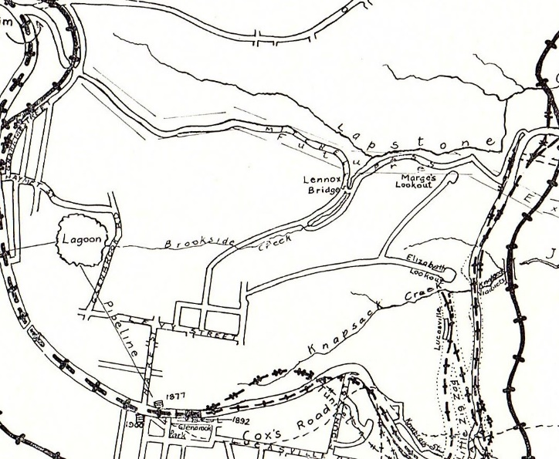

Pam’s Page April-May 2019 reported: *“With traffic now using Mitchells Pass, this opened up* *Glenbrook via what is now Glenbrook Rd.”.* This statement is partially correct, 2 tracks along side Brookside Creek were made from Lennox Bridge into Glenbrook via Hare St. {Refer to attached map published after 1913). Glenbrook Rd was built from the Lagoon to Mitchell’s Pass at a later date and became the main thoroughfare to Glenbrook from Emu Plains. The track from Lennox Bridge to High St. still exists today, and is a fire trail closed to public. In fact up to the development of Mt Sion Estate, when High St was connected to Olivet St. and the then track closed, it was still used. I can personally vouch for this as during 1950’s I often travelled to Emu Plains from Glenbrook via this track, in my Holden Sedan.

Railway Map post 1913