***ST ANDREW’S UNITING CHURCH GLENBROOK,* BRIEF HISTORY *(by Peter Berry)***

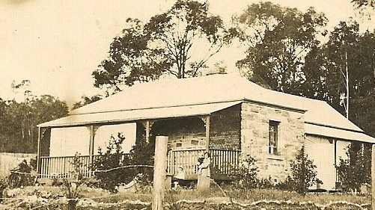 The origins of Glenbrook Uniting Church church go back as far as the early 1880s when, through research carried out by the late Ken Pickering, the Nepean Times in 1883 reported that the Presbyterian minister from Penrith/St Marys, the Rev Clausen used to come up to the tiny village of Glenbrook once a month on Friday evenings in his horse and buggy to visit a few Presbyterian families in the village.

**Mr W.Williams home "Wyuna" King** **St**

A little Presbyterian congregation formed over the following years and first formally met as such during an evening service in the village in 1927 with about a dozen people present. The services were held in the King Street homes of Mrs Gibb and Mr Williams. Both homes still exist. 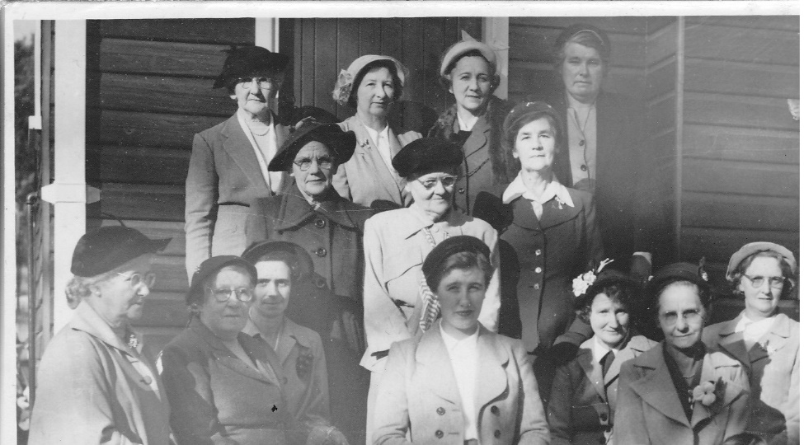 Other people there at the beginning were George and Jesse Bunyan who were pioneers of Glenbrook and whose daughter is Joan Peard who remains connected to the church to today. Services were held in private homes for some years but later the Glenbrook School of Arts was used for weekly worship. The Glenbrook congregation was then part of the Springwood Presbyterian parish. In 1951 a Women’s Guild was formed and set about raising money to buy a block of land. Key women involved were Mrs Pickering, Mrs Burfield and Mrs Bunyan. The ladies raised the necessary money for the purchase of the block of land on the corner of Lucasville Road and Green Street and a church was subsequently built by voluntary labour at a cost of £750 ($1500). Names of all the volunteers were buried in a bottle under the church which, as far as is known, remains there today. The church was formally opened on a cold Saturday afternoon on 12 June 1954.

**St Andrews Ladies 1954, Jesse Bunyan 2nd Left top row**

Margaret Elizabeth Williams was the first child baptised when the congregation met in the King Street home of Mrs Gibb. The same Margaret Elizabeth Williams was the first person married in the newly built Lucasville Road church.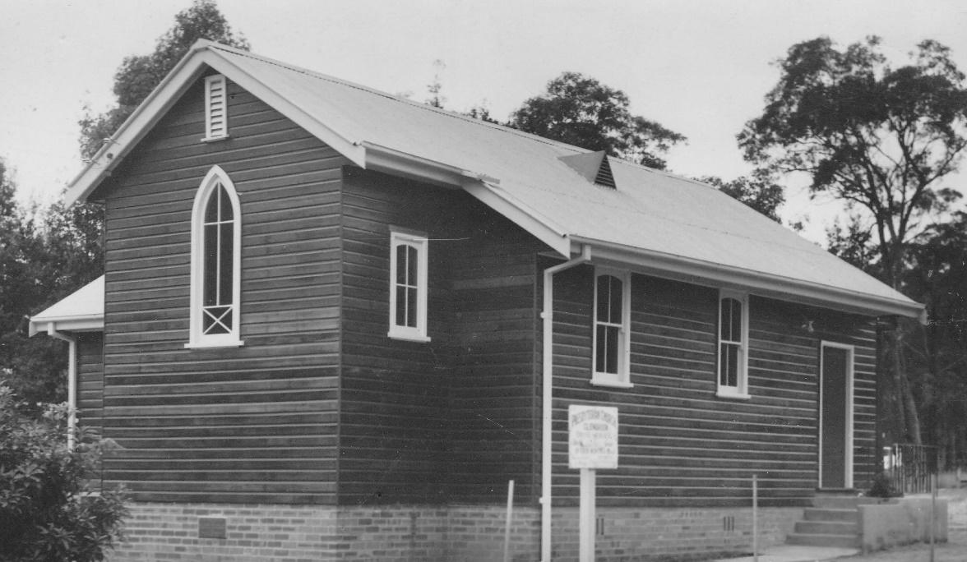

**St. Andrews Church 1954**

**St. Andrews Church 1954**

The church was later added to and improved several times and a hall built with major extensions being carried out in 1979. For a long while Glenbrook and Blaxland was a joint Presbyterian parish but when the Uniting Church came into being in 1977, Blaxland remained Presbyterian and Glenbrook became part of the new Uniting Church. Glenbrook was the only Presbyterian Church between Penrith and Lithgow to become part of the Uniting Church. Since the beginning of the Uniting Church, there have been 6 permanent ministers. – Rev. Michiel Groenewegen, Rev. Keith Esterbrook, Rev. Neil Smith, Rev. Elizabeth Orr, Rev. Susan Phalen and from April 2018 Rev Ellie Elia.

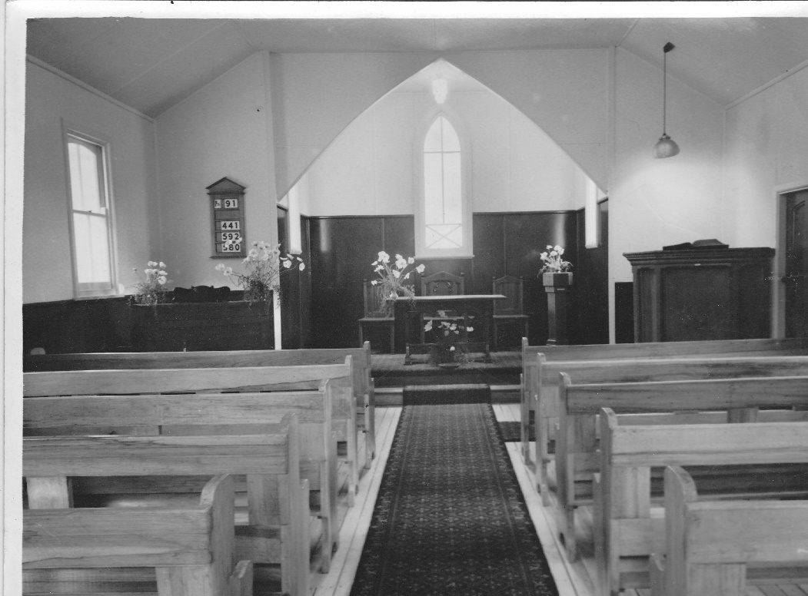

**St. Andrews Church 1954**