**GLENBROOK POINTS**

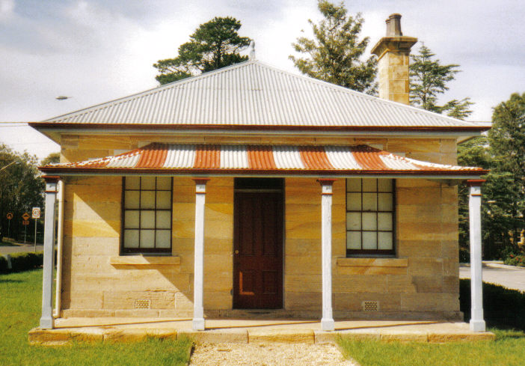**Newsletter of Glenbrook & District Historical Society Inc.**

**JUNE - JULY 2019**

**Postal address P.O. Box 38 Glenbrook NSW 2773**

**Contacts:** President: Denis Bainbridge Secretary: Neil McGlashan 4739 9864

**EDITOR** W.(Bill) Peard …. E-mail:- jpe13704@gmail.com

E-mail:- glenbrookdhs@gmail.com Facebook:- Glenbrook & District Historical Society Inc

**Meetings 3rd Wednesday monthly at 1.30 pm (except Dec-Jan)**

**Glenbrook Guides Hall cnr Hare & Moore Sts. Glenbrook**

"HISTORY WALKS" PROGRAMME for 2019.

**All on Saturdays: Walks led by Doug. Knowles & Team.**

**June 8th 1.30pm “Duck Hole--Glenbrook Creek.”** Old roadway construction and pump site for railway water supply to old Glenbrook Station.

**29th 1.30pm “The Mountains Murders.”** Captain Lee Weller’s

grave site and rock inscriptions.

**July 13th 9.00am “Faulconbridge Steam Sawmill Site.”** Engine remnants and other relics. Operated 1914-1925..

**Aug. 10th 9.00am “Bull’s Creek.”** Railway relics:- Stone dam and steam pump relics.

**31st 1.30pm “Lapstone Construction Railway.”**  1910-1913and east portal of Lapstone Hill Tunnel 1892.**.)**

**Sept. 7th 9.00am “Glenbrook Lagoon Precinct.”** Early campsite and railway dam

construction 1880 for water supply to the first Glenbrook Station.

**28th 9.00am “Glenbrook Heritage Walk.”** Historic sites, houses and West

Portal of Lapstone Hill Tunnel--1892.**(Last Walk for the year.)**

**Adults: $10 Accompanied Children under 16yrs. Free BOOKINGS are ESSENTIAL:** Phone Doug on **4751 3275**. Please allow the phone to ring longer than usual, for details re meeting place, time and grade of walk. Good walking shoes are essential. Please bring a hat and drinking water. (No dogs please.) **BAD WEATHER ON THE DAY:** Excessive wind or rain could cause cancellation due to hazardous conditions.

***Amendment Pams Page April/May, Glenbrook Village.*** It was reported that “the explorers camped here” (near Glenbrook oval). A small cairn was erected 1927, alongside new highway, to recognise this event. An investigation by the RAHS In 1937 showed that the first camp was nearer to Valley Heights. On economic grounds,1937, it was decided by the Council that it was cheaper to change the script to read “Passed nearby” rather than move the cairn to Valley Heights. The cairn still exists today, although moved a few times with road widening..

|  |
| --- |
| **Zora Cross 1890-1964**  Zora Cross 1919, photographer unknown,  *This is a summarised version of a new booklet on* ***Zora Cross*** *by G&DHS member Patricia Murnane. The full copy with all referencing is available for reading at the G&DHS Museum, Folder 10 File 27 or by email from Patricia Murnane –mickety@tpg.com.au* |
| ‘**I only know you, brother of my blood, Have gone; and many a friend, Trampled and broken in the Flanders mud, Found Youth’s most bitter end. God! You are not yet one with the kind dust Before new war-horns blow And sleek-limbed statesmen in their halls break trust To tell of other woe.**  These profound words were written by Zora Cross, resident of Glenbrook in 1921.  They compose Verse 6 her poem ‘Elegy On An Australian Schoolboy’ which had been written in response to the death of her brother Jack in WW1. |
| The 2019 March meeting of the *Glenbrook & District Historical Society* brought the pleasant surprise of a donation for the Museum from foundation member Tim Miers. It was an early edition of the trailblazing poetry book *Songs of Love and Life* (1917) by Zora Cross who resided in Glenbrook from 1919 until her death in 1964. *Songs of Love and Life* catapulted Zora Cross to fame in Australia and overseas, so much so, that Michael Sharkey noted that her name “was fashionably given to children born in subsequent years, and even bestowed upon a race horse” The ownership of this book by the historical society is a significant addition to the resources of the museum. |
| ***Who was Zora Bernice May Cross?***  **Born:** 18th October 1890 at Eagle Farm, Queensland.  **Parents:** Ernest William Cross (auctioneer originally from Sydney) and Mary Louisa Eliza Ann, nee Skyring, whose family was pioneer farming family in Queensland. While growing up on a dairy farm near Gympie, Zora was encouraged by her parents to write. Starting around the age of twelve, Zora was able to have many letters and stories published in the ‘Children’s Corner’ of *Town & Country Journal*’. |
| **Adult life:** Over her life, Zora was a schoolteacher, actor (stage), columnist, journalist, novelist, poet, children's author, speech teacher, theatre critic and more.  After studies at Sydney Teachers' College from 1909 to 1910 Zora taught for three years during which she married an actor, Stuart Smith and experienced the tragic event of her baby daughter’s death. She left Smith and continued to write journalism and poetry, while working as an actress and vaudeville performer. Among other publications and over the decades, Zora wrote poems, articles and serials in the *Bulletin, The Australian Women’s Mirror, The Sydney Morning Herald, the Mercury (Hobart), Sydney Mail, The Sun (Sydney),* and the *Brisbane Courier.* Dorothy Green describes Zora as having ‘immense courage and enterprise’ in the manner in which she found ways to support herself and her family. Zora wrote a number of novels over her life but none achieved the literary success of *Songs of Love and Life (1917)*. She also wrote a number of poetry books including *A Song of Mother Love* (1916)*, The Lilt of Life* (1918)and *The City of Riddle-Me-Ree* (1918). Zora made many, many contributions of poetry, short stories and serials to newspapers and magazines. Perkins describes Zora as a ‘working machine. As a lecturer at Sydney Teachers College, Zora produced one of the earliest books about literature of Australia, *An Introduction to Australian Literature*.  **Family:** After an earlier relationship and then a marriage to Stuart Smith in 1911, Zora partnered with David McKee Wright. From 1919 they resided in Glenbrook in what is now Wright Street. Unfortunately, David died of a heart attack on 5 February 1928 aged 58 years.  Over her life, Zora had 3 children, Ted, Davidina and April, and another who died at birth. Zora became a widow when she was 37 years old. Dorothy Green has commented elsewhere that ‘Wright's sudden death in 1928 left Zora in great financial difficulties. Her struggle to support her three children, mainly by freelance journalism, makes a painful story, though she remained cheerful, free of self-pity and simply got on with her work. Her younger daughter remembers her as 'a delightful and amusing parent, who never for one moment lost sight of her priority as a writer and a poetess'.  **Zora Cross**  **David McKee Wright** |
| ***What is Zora’s historical importance?***  ***In many ways Zora was a woman before her time*.**   * One can recognise in Zora some elements of the feminist movement of the 1960s and its development towards the contemporary feminist expression of the ‘Me Too’ Movement. Thus, she has been given the title of ‘proto-feminist’ by the *Old Queensland Poetry website.* Zora contributed to the world through her literary and journalistic skills for children and adults. She also contributed to the fledgling notion of rights of women and to many other social issues. Zora was a strong and talented woman who believed in her rights to self-determination. * Over five years from the late 1920s Zora wrote individual feature articles in the *Australian Woman’s Mirror* on the contributions of thirty-eight women poets, novelists and short story writers to Australian literature. These contributions are still recognised as important accounts of those women writers. * Zora’s childhood and later accounts of her family’s relationships with local tribal Aboriginal people are still valued.   ●Zora’s book *Daughters of the Seven Mile* (1924) showed ‘a then unusual interest in Queensland settings and some awareness of developing social and economic stresses in Australia’ *Writing was at the core of her being.*  ●She became part of the bohemian culture of the arts community and counted prominent literary figures Ethel Turner, Mary Gilmore and Eleanor Dark as friends.  ●Cross broke new ground for female writers in Australia because she dared to express intimate feelings of females across all their experiences. She received praise and criticism for this writing.  ●Zora’s contributions to other topics in poem form, such as the ‘Elegy on an Australian Schoolboy’ have better stood the test of time and Australia’s changing cultural understanding.  ●During the 1910s to at least the 1930s, Zora was one of Australia’s best-known authors. She had celebrity status which even lead to magazine profiles, akin to those that appear today in magazines. An introduction to a serial written by Zora for the Sydney Mail (Wednesday 12 August 1925, page 16) states that Zora is ‘probably one the busiest woman writer in Australia. Her work is done in Glenbrook, on the Blue Mountains, where she is an ardent grower of flowers and fruit, and where she absorbs much of the colour that makes her a vivid writer’  **Zora Cross later years**  *🡪*Zora’s poetry about war played a significant part in helping others to understand and express the human condition and suffering of war. Her critically acclaimed poem ‘Elegy On An Australian Schoolboy’ is one such example.  🡪Zora’s support for the Red Cross remained undiminished all her life.  🡪Zora was a woman who worked to support her children.  🡪She showed concern about the environment especially native flora.  🡪She argued for better inclusion of study of Australian literature for schools.  🡪She advocated about the adequacy of funding for the arts.  🡪During the period of preparations for celebrating the 150th Anniversary of Captain Phillip’s landing Zora advocated for the establishment of a National Theatre as one of the ways to mark the anniversary.  🡪Zora advocated for the preservation of Australian history. |
| **Death:** Zora died at Glenbrook of a heart attack on 23rd January 1964 aged 83 years. She was buried with Anglican rites at Emu Plains cemetery. She was survived by her son Ted, and her younger daughter April McKee (Wright) Hersey and her family in Glenbrook. |
| **Glenbrook can indeed celebrate having Zora Cross as one of its residents and take pride in her achievements and contributions to literature, society at large and to the community life of Glenbrook.** |

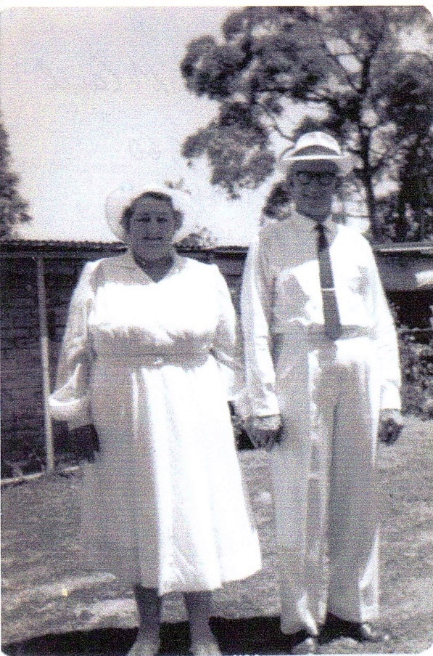**The Bakery**

**Nellie & Jim McCall & Family**

**By Joy Watters (nee McCall)**

Nellie & Jim McCall started the bakery in Mann St. Glenbrook in 1946 with Bob, Jimmy & Stan, sons from Jim’s first marriage. Nellie & Jim went on to have 6 children, Kenneth, Rae, Joy, John, June, & Keith. Over the years they bought out all bakeries from Glenbrook to Bullaburra and had a fleet of delivery vans that delivered door to door.

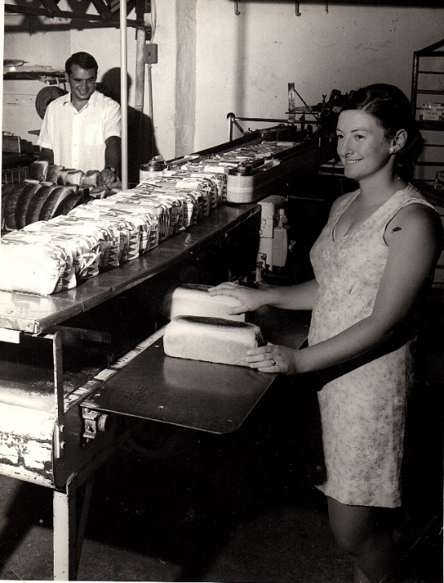 They were very involved in the village of Glenbrook, were foundation members of what is now Glenbrook Bowling Club, and Nellie was President of the womens bowls club and Jim was Treasurer for some years. Very sadly Jimmy was killed in a road accident age 21yrs whilst delivering bread. Kenneth died age 13 from a brain tumor.

**Nellie & Jim McCall**

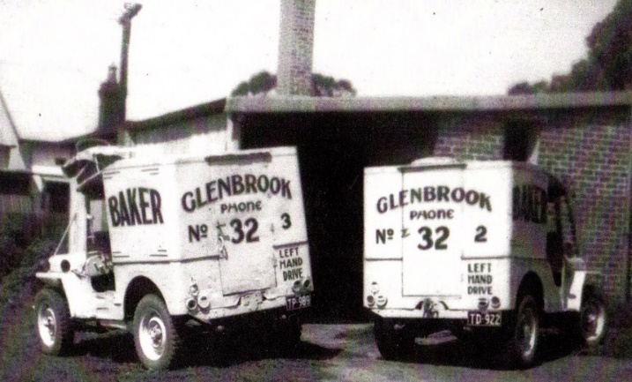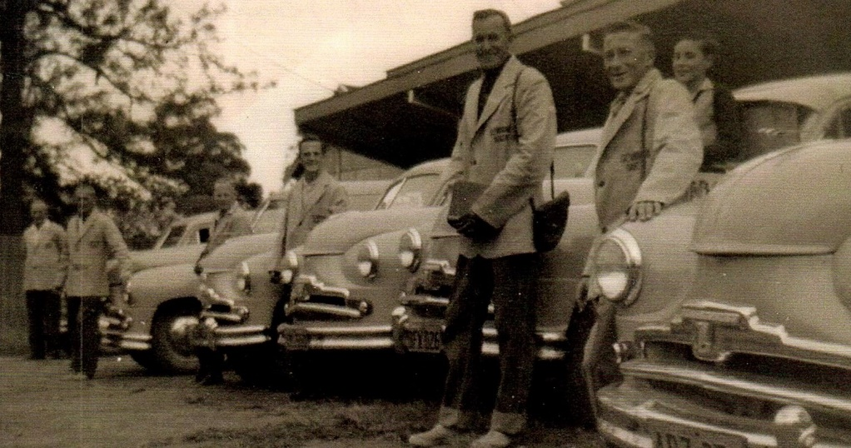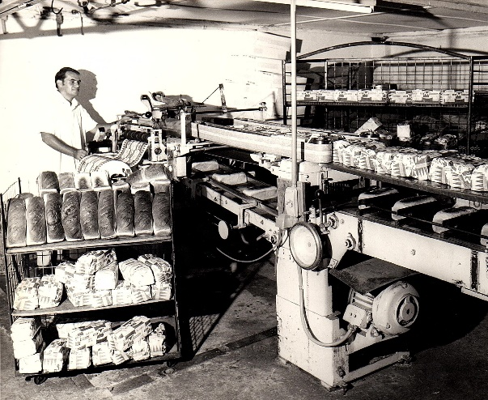 1965 Nellie & Jim moved away from Glenbrook and operated and worked in a small bakery & milk bar in Yeoval, a small country town in the West. Bob, the eldest son, operated the Glenbrook bakery with his sons. But in the early ’70’s the big bakeries had moved into the area and forced local bakeries out, so they sold out to Fielders and the Glenbrook bakery closed..

**Rowley & Pippa McCall slicing bread**

**Rowley McCall & bread slicer "The Monster"**

**First delivery vans**

**Some of the fleet of delivery vans with bread carters**

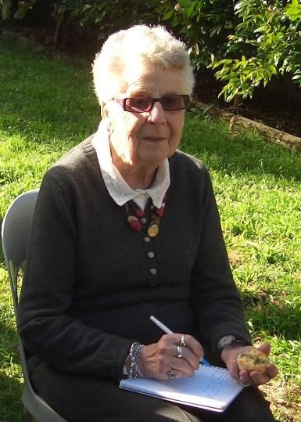 PAM’S PAGE

**THE GLENBROOK PIONEERS WALL**

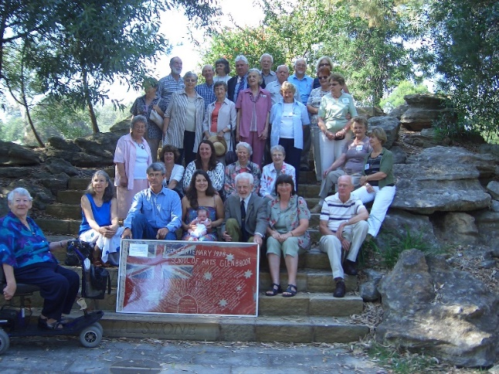

The Glenbrook pioneers wall was situated at the Glenbrook Visitors Information Centre and was officially opened on 20th March 2008.This was a project of the Glenbrook & District Historical Society and was quite a few years in the making. The purpose of this wall was to recognise the contribution that many of the older families made to the formation of the village.

**20th March 2008**

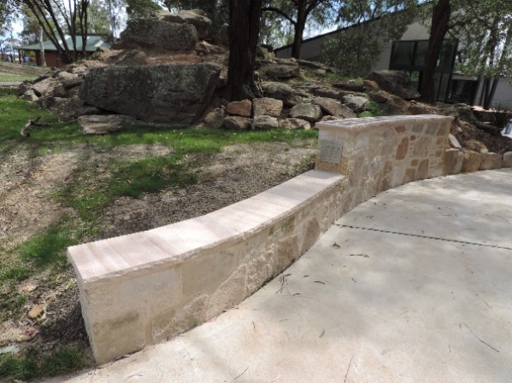 The criteria for the first selection was to be in residence prior to 1940, in fact the Hamment family came in 1881. The wall was to be constructed of stone with aluminium plates so as to remain in perpetuity, and also to be readily accessible to the public. The area selected was adjacent to the Glenbrook Visitors Information Centre, and with the assistance of the B.M.C.C. the project was completed in March 2008. Plaques were provided and paid for by the families of the early pioneers. More names were added to the wall in March 2014. In November 2018 a new wall was built to the East of the rebuilt Visitors Information Centre, and a further 16 names will be added.

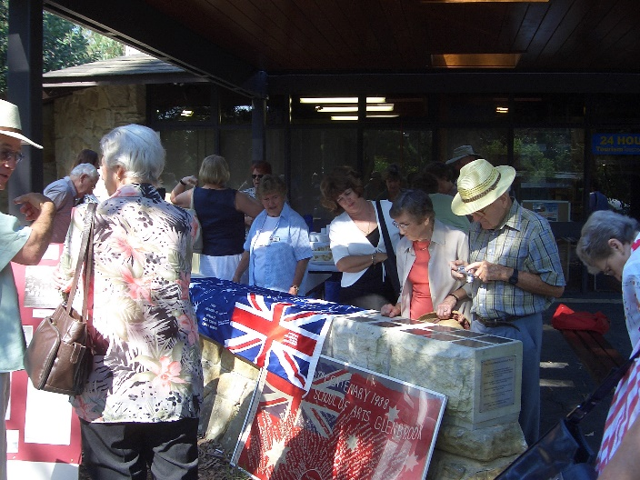 Two flags were displayed on the opening day of the first wall. These have historical interest, the red flag was a 150 years celebration flag (1770-1920). This was embroidered by Mrs Blundell & Mrs Latimer and the names listed all those families who had contributed funds to rebuild the School of Arts (now Community Centre). The original building had been destroyed by fire in 1926.

**New Pioneer Wall Nov 2018**

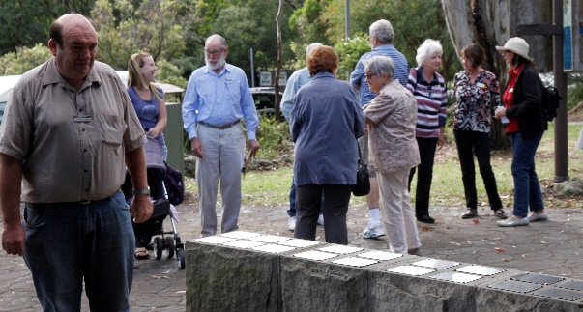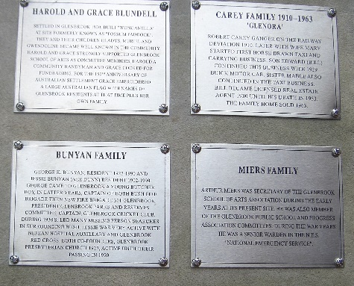 The blue flag was donated by Jackie Kelly., MP for Lindsay at the time, and was embroidered by Mrs Jenny Moore, 2000. This flag listed all families who had contributed funds towards production and publishing the book “Glenbrook and District - A History” by Nell Aston. Both these flags are on display in the Historical Societies Museum. The book is now on sale at the museum situated in grounds of old Public School Glenbrook, Park & Ross St. and through the Visitors Information Centre and also “Foothills Eco” 1a Ross St Glenbrook.

**March 2014**

**Some original plaques**

**Red & Blue Flags**

**Did You Know???** Som***e*** Trivia

 ● The new highway, Lapstone to Blaxland deviation, was officially opened in October 1926 by the Governor, Sir Dudley de Chair. It followed for the most part along the old Zig Zag railway track on the Southern side “*18 feet wide with 4 feet wide shoulders*”. Railway Pde in Blaxland was now the Great Western Highway and the original Bathurst Rd. was now Wilsons Way.

● Census figures in 1911 for the town of Blaxland numbered 88, but this probably included some of the railway workers. There were only five houses between what is now Station St & Bridge Rd., and a few in Hope & View Sts.



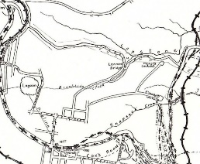 ● With opening of Mitchells Pass, the road into Glenbrook was via Glenbrook Rd.(blue line) but a second track was made from Lennox Bridge to Glenbrook via High St. (**refer to railway map** **1913, red line**). This track was only closed when Olivet St. was connected to High St & still exists today. It is now a fire trail closed to public in development of Mt Sion Estate, and was still used up to then. I can personally vouch for this as during 1950’s I often travelled to Emu Plains from Glenbrook via this track, in my Holden Sedan.



 ● In 1915, when severe bush fires were burning throughout the mountains, the now famous “Coo-ee march” began in Gilgandra. Volunteers willing to be recruited to the defence forces joined the route at towns along the 320 mile march to Sydney, passing through Blaxland in Wilsons Way and over Lennox Bridge in Glenbrook, to a reception in Penrith.

**Railway Map 1913 (coloured lines added)**

***From The Secretary’s Desk***

 (**i*) Meeting with Michael Keats, Bush Explorer, Author*** *– Michael is researching water supply to the steam engines in Glenbrook and he wanted to find out what we knew. He has a lot more information and expect will write a book with a chapter in it on this (ii)* ***Museum Status 2019:*** *Neil to complete form for Gay Hendriksen on where we want to go. He just sees us as a photography, documents and artefacts collection until we get more space. Gay will give us some ideas next month exactly where we want to go with the Museum*. *(ii****i) Joan Peard – Werrington House visit report****. Bill had afternoon tea at Werrington House, now owned by Peter Collins, former* [*Leader of the Opposition*](https://en.wikipedia.org/wiki/Leader_of_the_Opposition_(New_South_Wales)) *in NSW. Built for Mary King, the youngest daughter of Governor Philip King (the third Governor of NSW) and her husband Robert Copeland Lethbridge circa 1832. Werrington House currently sits on just over four and a half acres of its original 600 acre holding and comprises a two storey Georgian Style home offering outstanding original glasswork and joinery, along with all main rooms enjoying their own fireplace. It has wonderful military memorabilia. I recommend it as a place for us to visit. (iv* **) RAAF 1941 Plaque Clifton Avenue:**  Denis – I called for the fifth time and I finally found the owners at home out on their porch. They said more people have been stopping to have a look. Probably after the recent article in the Gazette. I explained what we are planning to do in conjunction with Council and they were amenable to it.

**GLENBROOK & DISTRICT HISTORICAL SOCIETY Inc**.

**OFFICE BEARERS 2018-2019 President: Denis Bainbridge Vice Pres: Doug Knowles & Joan Peard**

**Secretary: Neil McGlashen Treasurer: Anton Von Schulenburg**

**Committee: Pam Thompson Warren Page Ian Dingwall**

**Glenbrook & D.H. Society Museum is situated within the Old Glenbrook Infants School, Ross St. Entrance via Park or Ross Sts. Museum is open 1st & 3rd Saturdays 9am to 1pm Entrance Free**

APPLICATION for MEMBERSHIP of ASSOCIATION

*(Clause 3 (1)*

**GLENBROOK** & **DISTRICT HISTORICAL SOCIETY Inc.**

*(Incorporated under the Associations Incorporation Act, 2009.)*

***P.N: Would you please use a black pen and write firmly.***

I: ............................................................

[Full name of applicant:

**of:** ............................................................................................................

**[Address]**

**Phone:.....................** **Email: ...................................Occupation..............................**

# hereby apply to become a member of the above named Incorporated Association. In the event of my admission as a member, I agree to be bound by the Constitution of this Association.

**Signature of Applicant: ....................................Date: ..................**

Please enter your choice of annual fee from the separate price list.

$**.............** **plus joining fee: $5.00** = **Total** $**...............**

I give permission for my telephone number and email details to go on a list for members only use. Please tick if you agree

For insurance purposes, please indicate age category: [18 - 50yrs ..…] [51 - 70yrs .....] [71 – 85yrs..…] [86yrs + .....]

Please send this completed Application Form to:

Secretary

Glenbrook & District Historical Society Inc

**PO Box 38 Ph: 0420 660 388**

**GLENBROOK NSW 2773 Email:** [***glenbrookdhs@gmail.com***](mailto:glenbrookdhs@gmail.com)

Or: Bring with you to the next meeting: Every third Wednesday of the Month, (except December & January,) at 1.30pm at the Guide Hall, Cnr. Moore & Hare Streets.

*We look forward to seeing you at our next meeting or event:*

*From the Management Committee.*

***3/19.***