Pam's Column

THE GLENBROOK HORSE TROUGH

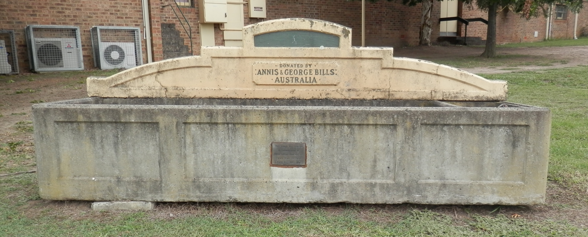
The concrete horse trough on the corner of Ross St. & the Great Western Highway is of standard design: they were constructed between1930-1940. The majority of the trough is waterarea. A cistern with an iron lid is at one end. A
terrazzo panel on the back of the trough bears the inscription: "Donated by Annis BILLS HORSE TROUGH GLENBROOK
and George Bills, Australia“. There is also a brass plaque attached to the lower front of the trough, saying: "Erected in the memory of those horses who did not return from the1st World War, 1914 – 1918."
Other troughs in the Blue Mountains are to be found at Medlow Bath, Wentworth Falls and Blackheath. Annis & George Bills had no children and were animal lovers who gave considerable sums of money to animal societies in Australia and the British Isles. When George died in 1927, he left an estate of 91,000 Pounds. After various bequests, the remainder of the estate was to be used to pay for horse troughs where ever they were
needed for the relief of horses throughout Australia and the British Isles. Building of the troughs provided employment in the depression years. About 700 troughs were placed in N.S.W. and Victoria and about 50 in the British Isles. Themajority of troughs of concrete, but a few were of granite: two of these are to be found in Scone N.S.W. and Hawthorn in Victoria.

A BILLS TROUGH PLAQUE ERECTED AT ELMORE VIC. READS:-
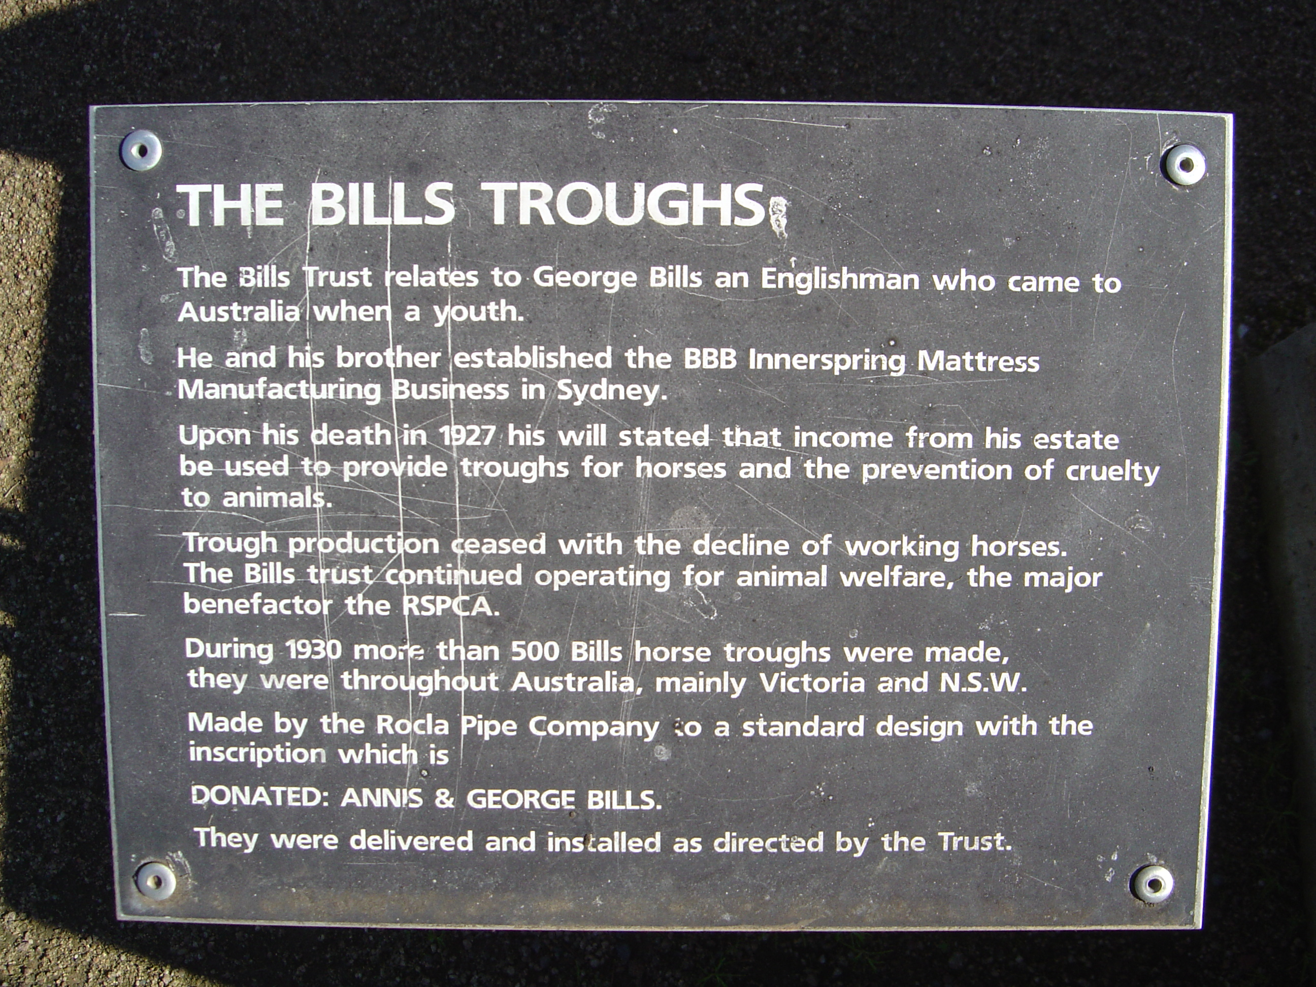
The Bills Trust relates to George Bills an Englishman who came to Australia when a youth. He and his brother established the BBB Inerspring Mattress Manufacuring Business in Sydney. Upon his
death in 1927 his will stated that income from
his estate be used to provide troughs for horses
and the prevention of cruelty to animals.
Trough production ceased with the decline of
working horses. The Bills Trust continued operating for animal welfare, the major benefactor the RSPCA. During 1930 more than 500 Bills horse troughs were made, they were throughout Australia, mainly Victoria and N.S.W. Made by the Rocla Pipe Company to a standard design
with the inscription which is:-DONATED : ANNIS & GEORGE BILLS. They were delivered and installed as directed by the Trust

