GLENBROOK POINTS
Newsletter of Glenbrook & District Historical Society Inc.
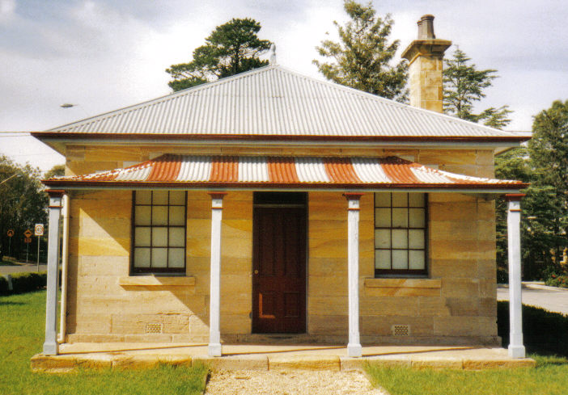
POINTSMAN'S COTTAGE
FEBRUARY MARCH '16
Postal address P.O. Box 38 Glenbrook NSW 2773
Contacts: Joan Peard 0414 605 482 or Neil McGlashan 4739 9864
Meetings 3rd Wednesday monthly at 1.30 pm (except Dec-Jan) Glenbrook Guides Hall
cnr Hare & Moore Sts Glenbrook
"History Walks" 2016 Programme ALL on SATURDAYS
Walks led by Doug Knowles & Frank Bowman
March 26th 9.00am "The Descent to the West" Mt. York: Three short return walks on the
three most historic roads to the West, Cox's Pass 1815, Lawsons Road 1822 and
the newest: Berghofer's Pass 1909 Includes morning tea: Special Walk: $12.00
April 9th 1.30pm "Bull 's Creek" Railway relics:-Stone dam and site.
23rd 1.30pm "Duck Hole--Glenbrook Creek." Old Roadway construction and pump
site for railway water supply.
May 14th 1.30pm "The Mountains Murders. Captain Lee Weller's grave site and rock
inscriptions
. June 4th 1.30pm "Lapstone Construction Railway" 1910--1913 and east portal of Lapstone tunnel 1892.
25th 1.30pm "Cox's Road." Walk along a section of this historic road following the ridge-top from
Linden to Woodford Trig.
July 9th 1.30pm "Dunn's Steam Sawmill Site" and earth dam. Brookside Creek, Lennox
Bridge and the old stone quarry.
30th 1.30pm "Glenbrook Lagoon Precinct." Early campsite and railway dam
construction 1880.
August 13th 9.00am "Faulconbridge steam sawmill site" Engine remnants and other relics operated
1914--1925. Long walk-steep climb: Allow 3 ½ to 4 hrs.

ADULTS: 8.00 ea. Children under 16yrs. Free-but must be accompanied by a parent or guardian. (No dogs please.) BOOKINGS are ESSENTIAL: Phone Doug. on 4751 3275 for details re meeting place, time and grade of walk. Good walking shoes are essential. Please bring a hat and drinking water. BAD WEATHER ON DAY: excessive wind & rain could cause cancellation due to hazedous conditions.
PAM'S PAGE

ANOTHER RAILWAY FATALITY

On the 1st February 1928 a fatal accident occured just 3 days after the collision of two trains on the Emu Plains section of the line. It appears that about 3.30 p.m. a young man named xxxx Bunyan had been employed to clear some of the trucks from the previous accident, when he slipped and fell onto the line, Some of the waggons were in motion at the time and the wheels ran over the poor fellow's leg, which was terribly mangled.
He was immediately attended by Dr Johnson of Penrith and was transported to the Sydney Infirmary which was reached between 6 & 7 o'clock that evening. He was placed in the accident ward under the care of Dr Marsden who found that he had a compound fracture of the thigh. He gradually worsened and succumbed to his wounds, about 2 hours after admissionm. Mr Bunyan was 27yrs, unmarried and a nephew of George E. Bunyan (Emu Plains)

From the Secretary's Desk
Mushroom tunell: Council has asked us to write a letter to the General Manager stating our concerns and possible recommendations for the tunnel. This has been done. Awaiting a reply from BMCC. A copy was also forwarded to Stuart Ayres office. Our concerns are:
1) Possible damage to the fabric of the Tunnel cause by flooding at the Eastern Portal.
2) The application by the Crown to fence the site to aid management of the clean up will possibly impact on the walking track used by residents of the Knapsack Street area. It is really the only safe way for walkers to access Glenbrook Village easily.
3) Commercial waste and abandoned vehicles and other assorted broken rusty machinery – this has been an issue for at least 17 years.
4) Weeds and rubbish compromising Knapsack/Tunnel Gully Creek,
5) Weed overgrowth outside Eastern Portal – Weeds also grow up through and around the abandoned vehicles and machinery outside the Western Portal.
6) Assorted tumbledown sheds and at least one dilapidated caravan.
The Society will get a Mobile telephone for the use of the Secretary and after this new brochures will be printed ready for Australia Day stall.
Joan spoke to Mark Greenhill on Monday Re: Welcome Wall there is a fault in the date put up as 1883 should have been 1885 carved in stone. Mark said he will personally see to it. Pam T. said a couple of letters are falling off .
Tim said it is very important that we need 2 people permanently there when the Museum is open. Will look at a roster system in the New Year. (Museum is open 1st &3rd Saturdays each month 9am – 1pm.)

GLENBROOK 'S PARKS & RESERVES
an historical perspective

On May 12th 1813, Gregory Blaxland, William Lawson & William C. Wentworth climbed Lapstone Hill, passed through what is now known as Glenbrook Oval. After the explorers came the road-builders, Lt. William Cox and his 30 handpicked, well inclined, hardy convicts, with eight soldiers as guards- overseers, began the first road across the Blue Mountains on July 18th 1814. It was completed in six months - a remarkable fee of engineering.

CAN ANYONE ASSIST????
EDITOR Bill Peard Have you a story of histrorical interest to tell? Have you lived in the district for a long period? Have you any old photographs, family or scenery? If you can assist, I would like to hear from you. No need to write the story, just give me the basic details, no need to send photographs, just e-mail copies with captions if known. All stories, documents and photos will be acknowledged when published .The photograph below comes from my personal collection. It is a Kodachrome slide and dated July 1956. This slide depicts the beginning of our 1st house in Moore St. looking South In the middle is the kindergarten which is mentioned in "Pams Page" Old photographs can reveal other interesting details viz in 1956 no oval, no bowling club and most streets are unsealed. Please send all Letters, Photos etc, as an attachment to e-mail address... jpe13704@gmail.com

GLENBROOK & DISTRICT HISTORICAL SOCIETY Inc.
OFFICE BEARERS 2015-2016
President Joan Peard 0414605482
Vice- Presidents Kevin Frappell Grant Holmes
Secretary /Treasurer Neil McGlashan Chief Historian Tim Miers
Committee Tim Miers Doug Knowles Pam Thompson

Glenbrook & D.H. Society Museum is situated within Old Glenbrook Infants School, Ross St. Entrance via Park or Ross Sts Museum is open every 1st & 3rd Saturdays
9 am to 1 pm. Entrance FREE
