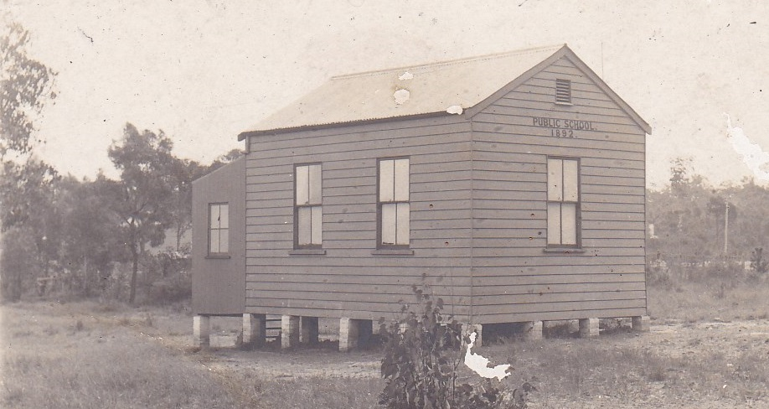

Glenbrook P.S. 1892 Green St.
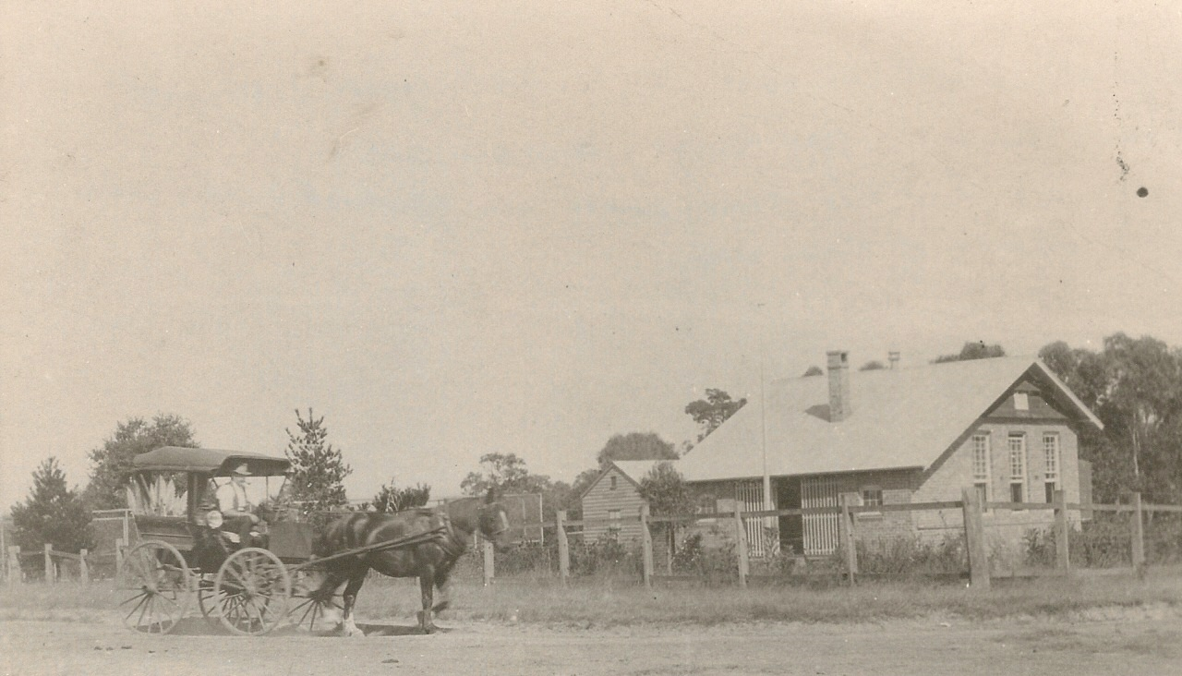
Glenbrook P.S. 1911 Ross St...1892 building in background
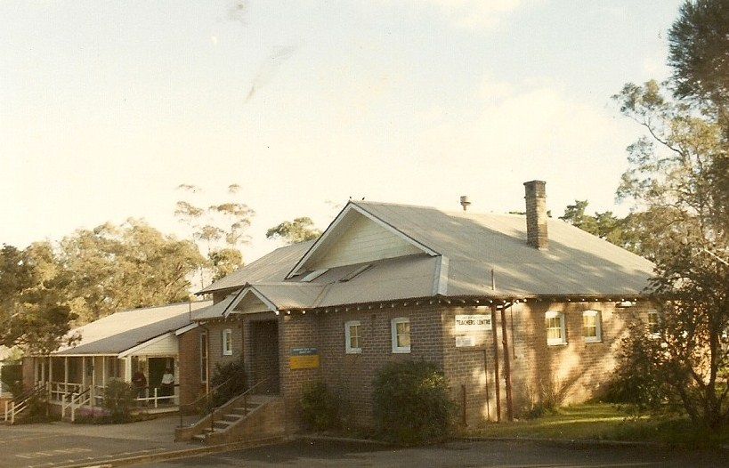
Glenbrook P.S. Ross St c1950‘s

