A BRIEF HISTORICAL OUTLINE
By Mr George K Bunyan (1904-1990)

The story traces the development of Glenbrookarks and reserves, rail, and road development from 1813 to 1985. The first crossing in 1813, by Blaxland, Wentworth & Lawson, passed this way. They camped at the swamp on the 12th May1813, which is now the SE corner of Glenbrook Oval. On route to this site, they would have passedthrough Glenbrook Park.
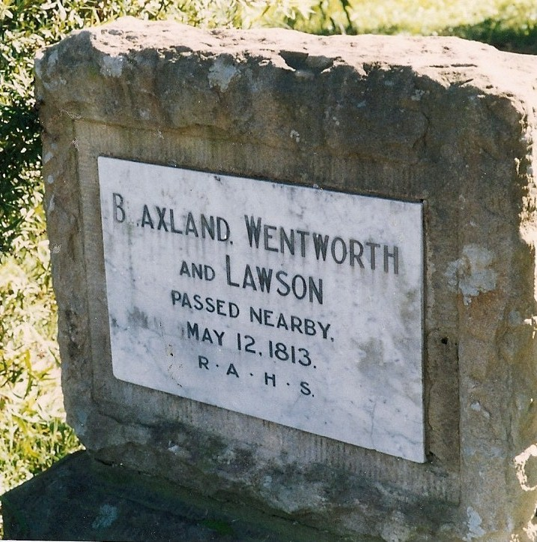
1815 1st.road over the Mountains was
surveyed and built by William Cox ,closely
following the explorer's trail but with
some easier grades. One possability is that
the road, about 20ft wide, tennis courts.
The other which seems more likely,
has the road traversing the park from the
corner at Lucasville Rd to where
Glenbrook Theatre now stands, thence to
Hare St and Glenbrook Lagoon where the
road building depot was located. Rock
cairns located at the R.A.A.F. Base and on
Lucasville Rd, near Clifton Ave, which
according to local lore, was left there by the 'explorers,' bear out exactly the second
route. It would seem more likely for these to have been erected by Cox and his road
-building team than by the explorers. In 1865 John Whitton built the ZigZag railway and
Lapstone Viaduct, (ie. The bridge across the gully on Lapstone Hill, now part of the old
Highway). A water tank was built in 1867, and water piped from Glenbrook Lagoon for
watering of the steam trains on their first stop on the mountains. The 'stop' was known as
"Watertank" and the three brick pillars which supported this water tank can still be seen
along the highway now in front of the Glenbrook Native Plant Reserve although
originally the tank was on the opposite side of the highway. By 1874 the stop became
"Wascoe Siding". (After John Wascoe, of Pilgrims Inn) The name was again changed
twice, 1878 to „Brookdale“ then 1879 to „Glenbrook“ which was later gazetted as a
village on 20th March 1875. Glenbrook Park
was proclaimed at the same time.
ROUTE OF 1st CROSSING THROUGH GLENBROOK
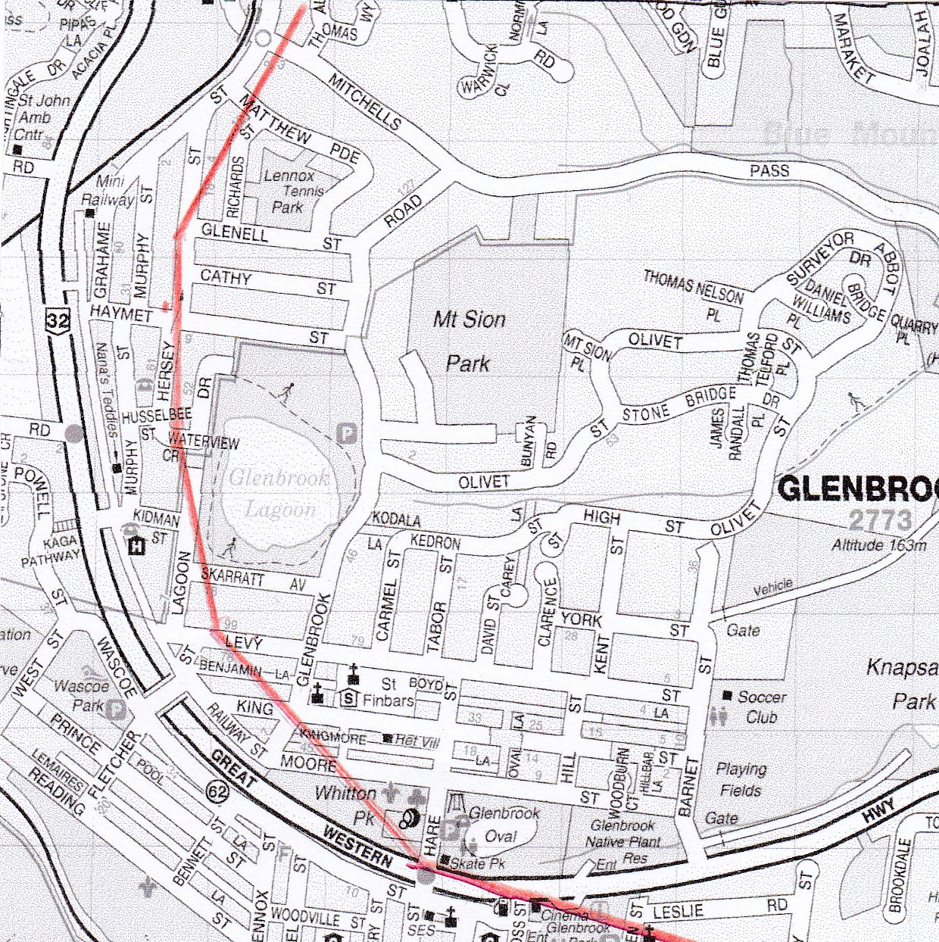
Reconstructed from Evan‘s field notes
Springwood Library During 1880‘s
stonemasons Mr. Ross & Mr John Dunn
were building sandstone residences in
the area. An 1886 railway guide shows
‘numerous country residences have
been erected in the area & will provide
a cool and quiet retreat for busy city
workers, it is well laid out and
the provision of reserves will
in time make this
place very attractive“.
Glenbrook Park & Oval were
dedicated in 1897 as „Reserve
for Public Recreation“. The first School of Arts opened on 17/11/1909. It was situated
in Glenbrook Park near Lucasville Rd. This was destroyed by fire in 1920‘s
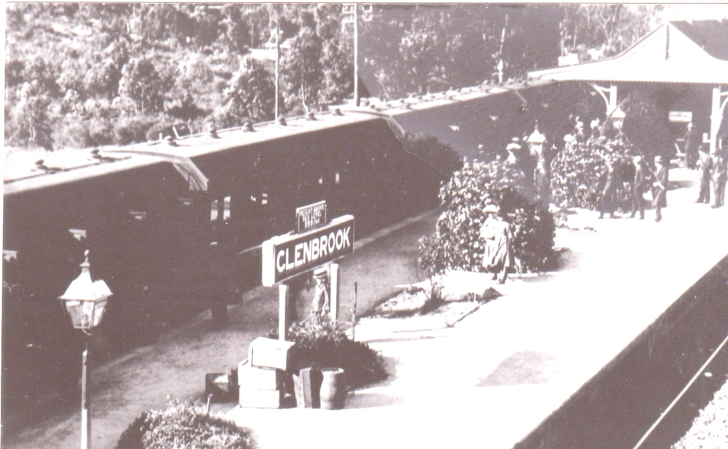
2nd RAILWAY STATION 1910
A brick railway station was
constructed in 1910, this was in
the centre of the dual railway
line now running alongside
Glenbrook Park. It was short
lived , as with the Glenbrook
Gorge deviation coming into
service in 1913, the station
was rebuilt on its present site. In this yearJohn Dunn, the Stonemason, built the
two stone pillars at the Hamment St. entrance to Glenbrook Park. Tennis courts
c1915 were constructed at Glenbrook Park by Colin Smith, a local identity, who
owned the first car and built a race-course near Lennox Park (From whence
material for the courts is said to have come.) Easter tournaments were held,
which were very popular. In 1926-27 the Main Roads Board chose the route of
the old railway line for the highway. (The old railway track had been taken up.)
This is still the route in use today, over the old viaduct, through the old railway
cuttings, and right over the site of the original railway station. The avenue of
Pin-Oaks, which lined the highway at Glenbrook were planted to commemorate
the opening of the highway by the Urban Area Committee: the forerunners of our
local Council. Those on the northern side of the highway are a little further out
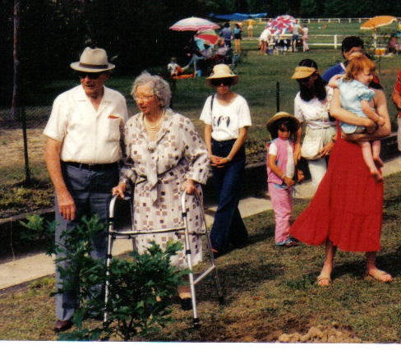
than their original position: having been replaced by older residents when the
highway was widened in 1980. GEORGE & JESSE BUNYAN
REPLACING A TREE 1985
(after highway widening)
Baby Health Centre opened in Glenbrook
Park, 27th July 1956. (now used by CWA) &
Whitton Park dedicated for public recreation 18th May 1956 (early maps shown as Glenbrook
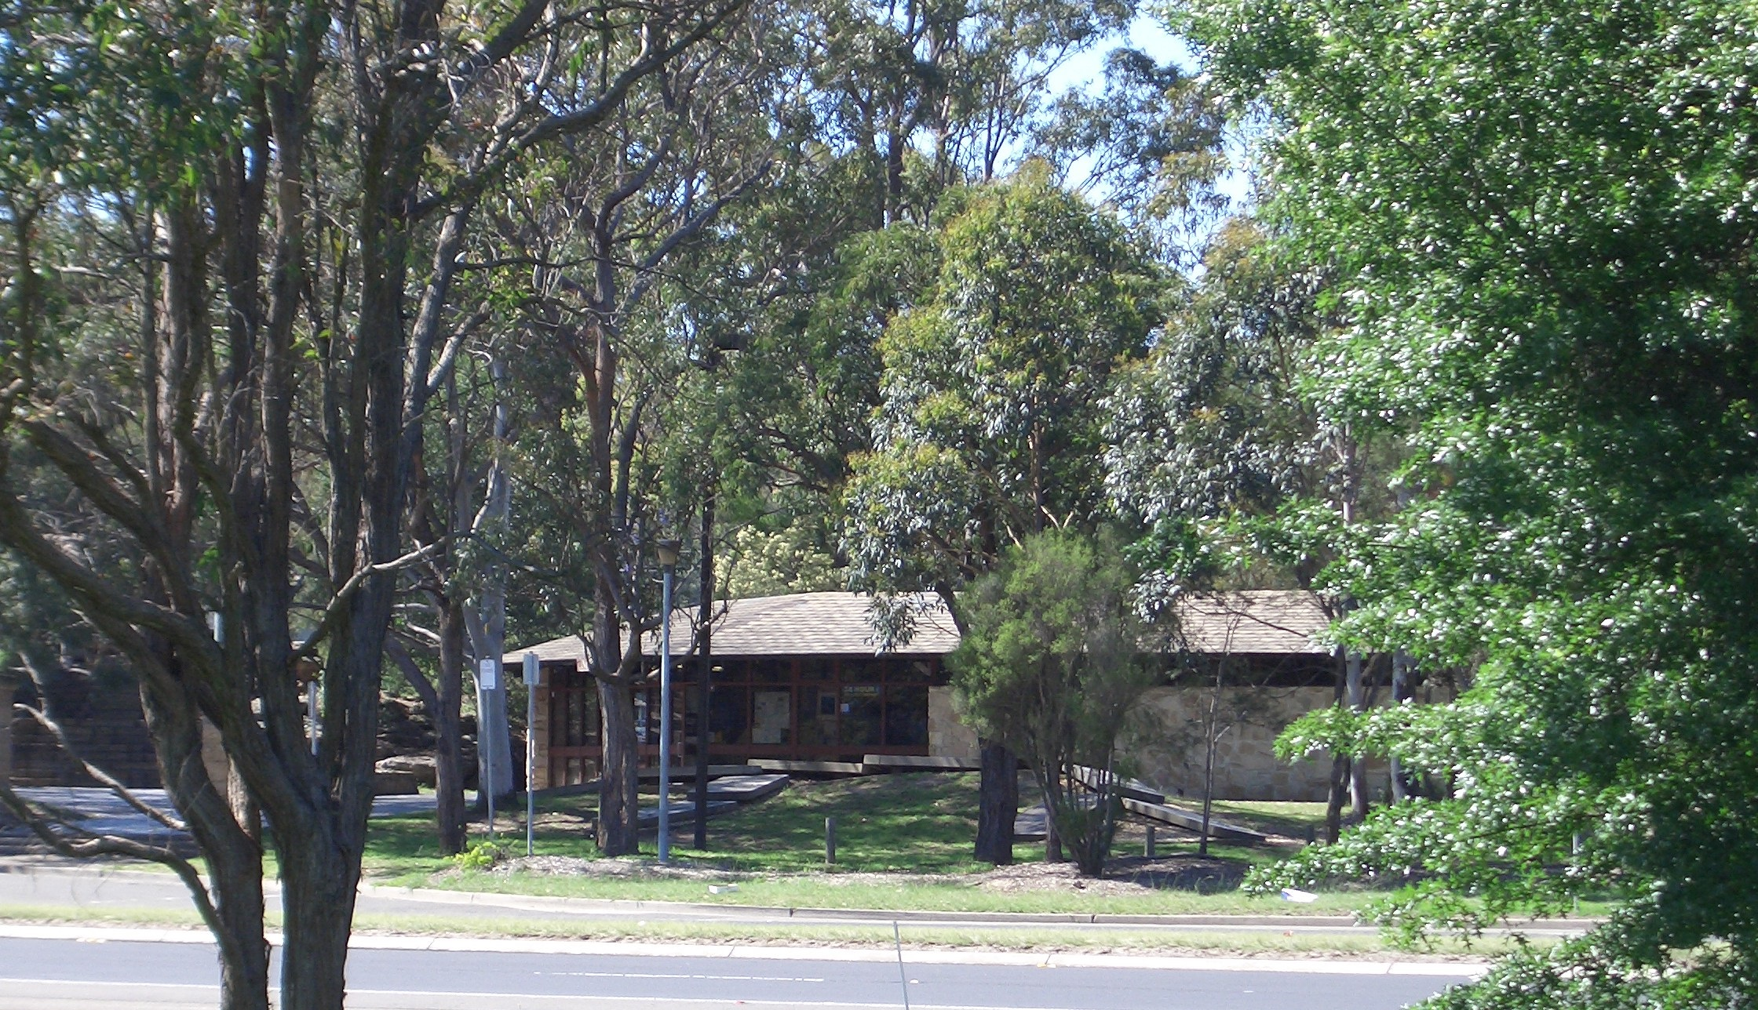
Gardens.) Hamment Street was incorporated into the area of Glenbrook Park. This was a little street running parallel to the Highway between Ross St & Green St It's name commemorated one of the first families to settle in Glenbrook, (c1860) . It is now the layby area where the Tourist Information Centre is located.
Perhaps the many relics of the past will be drawn together to form an interesting tourist package and Glenbrook will remain a village, well laid out with wide reserves a cool and quiet retreat for busy city workers, an antidote to city life (as reported in 1886).

1985 Tourist Information Centre opens.
EDITORS NOTE:- This is an edited version of an article written by George Bunyan. The original is in posession of his daughter, Joan Peard..He reports that the train station was „rebuit“. But both operated for about 6 months

GEORGE KEITH BUNYAN 1904-1990
By Joan Peard Daughter
My father was born at Emu Plains 1st son of
George E & Millard Bunyan. He, his father and his brother, opened their butchers shop in Ross St. Glenbrook c1922. He met and married Jesse Dunn April 1930. They lived the rest of their lives in Glenbrook, until their deaths in 1990. They were both very active in all village
activities, Church, Social, and Community. He was President of the 530A Parks & Reserves Committee, a voluntary organisation set up by BMCC to administer Parks etc. This story is a direct result of his involvement with this committee. After the BMCC
disbanded all these committees, dad wrote this story to present to a local meeting.

