GLENBROOK 301 NSW Fire Brigade 1953-1983
By Captain W (Bill) Peard (1963-1983)

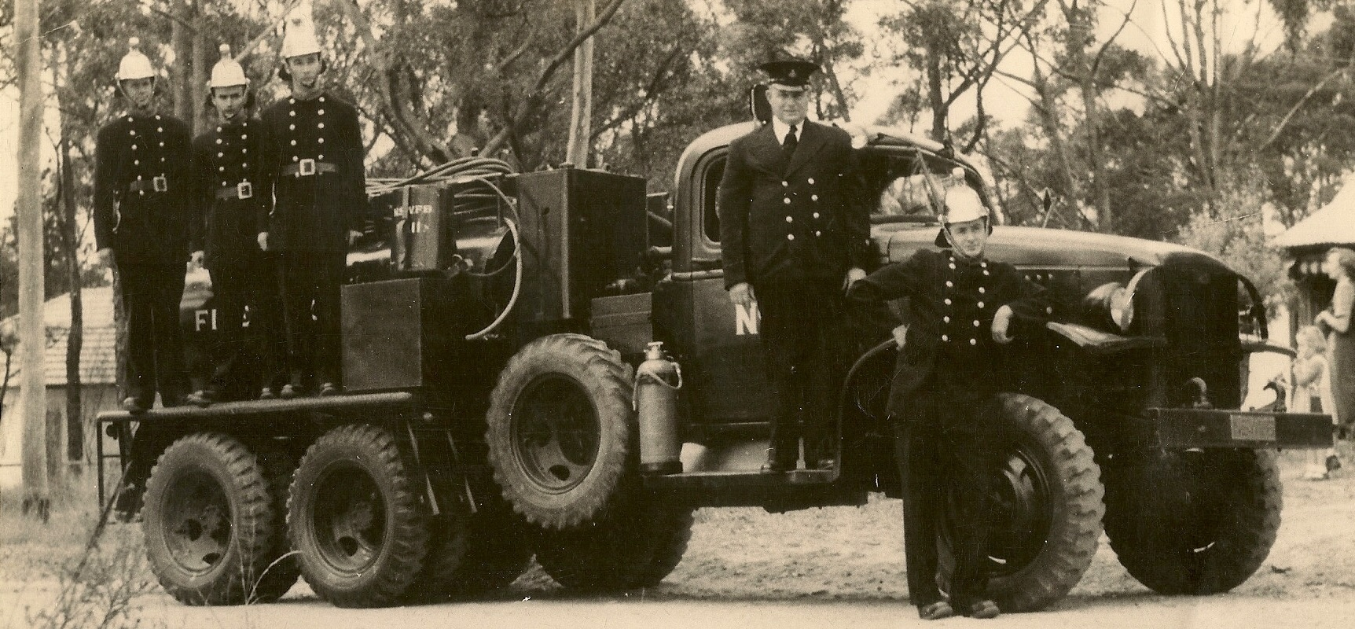
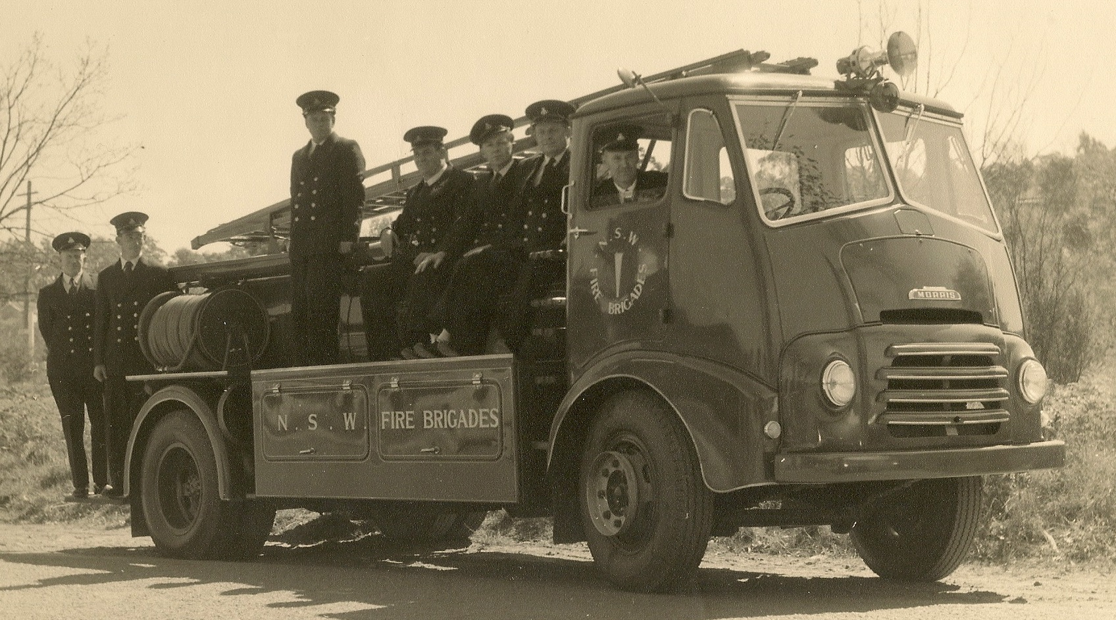
With the fire season now around the corner it is an interesting subject to examine how the protection, we now have in Glenbrook & surrounding areas, started. $1million of property & equipment did not appear overnight, in fact fire protection started from very basic beginnings, prior to 1953 a Bush Fire Brigade existed which was completely voluntary and funded by the local community, very little funds from govt. sources. After large bush fires in 1950-1953 and with the loss of property, the Board of Fire Commissioners decided to establish a NSWFB in the lower Mts., not only for bush control but property protection. Glenbrook was chosen as being the largest developed area, and situated about halfway from Penrith & Springwood Stations, also a BFB fire station already existed and was availble for use. In 1953 a crew consisting of Captain & 4 VF's were enrolled, supplied with one appliance and a small amount of equipment.The new fire station was now known as Glenbrook 301 Station under the control of Capt. George Bunyan, who had been Captain of BFB, who in turn was responsible to a District Officer, a permament fireman . The "appliance" (as fire trucks are known) illustrated in above photo was GMC ex- US Army decontamination unit. These had been purchased by the Board for use in bush areas, rebadged with NSWFB emblem, and issued to a few stations. They still were painted "Army Green". They were very good for bush fire, They were LHD, had a 4 speed manual gearbox with 4WD transmission, carried 2500L water and could deliver water from 2 lines of 25mm rubber hose, static or moving.They were very powerful and could climb steep hills,slowly. Their main problem was that for property protection, they carried no equipment whatsoever, nor any crew, just a driver + 1. The crew would follow behind in private cars with equipment. Fortunately this appliance was soon replaced, In 1955 a "Morris Composite" appliance was installed (see photo avove). These units were brand new, coloured red, made especially for bush/property areas as existed in Blue Mts & Central Coast. They were known as "Composite" .............. cont page 4

