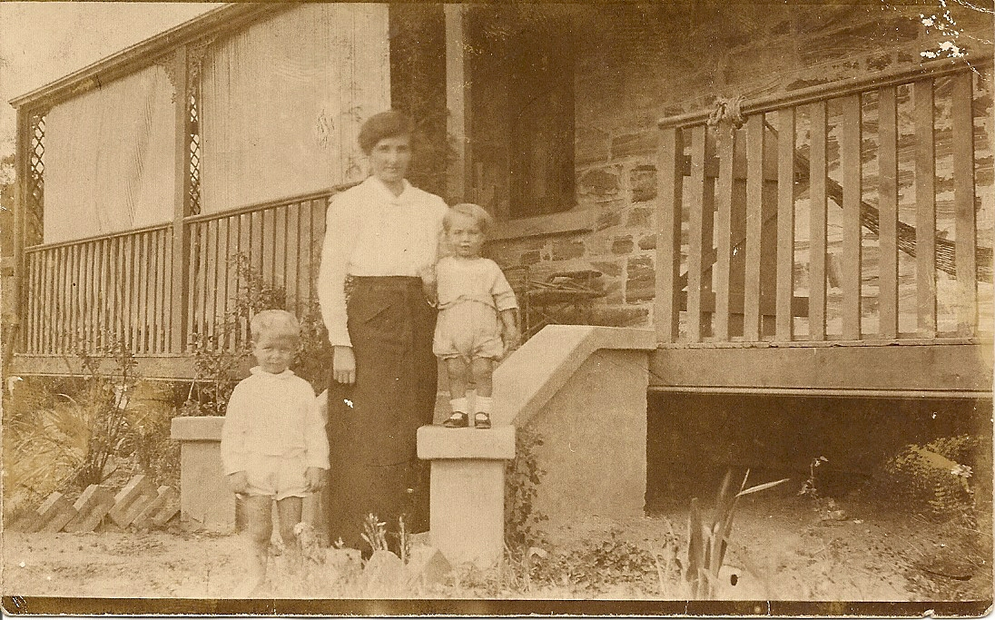

“WYUNA” KING ST GLENBROOK c 1917
Mrs Williams , Stuart & Eric
His brother Gordon was a POW in Changi,Singapore and was forced to work on the Burma Railway. At the end of the war Irene and Stuart lived briefly in Ashfield and their first child John was born in October 1945 Returning to Glenbrook they lived mostly at "Kelgoola," (now Ilford House) the O"Halloran family home. Two more sons were born, Ross in 1948 and Eric in 1950. Just after fourth son Peter was born in 1955 the family moved to a weatherboard cottage called "Dartmouth" at 60 Levy Street. Fifth son Tom was born in 1957. The house was renamed "Kelanoa" Down the track extensions were done to the house and a beautiful garden created. He was a member of the Glenbrook & District H S and a life member of the Glenbrook/Lapstone Rural Fire Brigade. Stuart lost his sweetheart Irene in 2005 after 63 years of marriage. People have commented to me what a gentleman Stuart was, very determined, seeing each day as a bonus. When Irene died he said, quote: "Now I have to build myself up." He succeeded, passing away only 4 weeks before his 97th birthday. At the time of his passing he was Glenbrook’s longest resident.
Stuart & Irene wedding 1943

