PAM'S PAGE
. GLENBROOK PRE-SCHOOL KINDERGARTEN
In 1945-6 Mrs Anne Potter, from Glenbrook general store & newsagency, and Mrs Knott commenced a pre-school kindergarten in the School of Arts building (now the Community Centre), Mrs Joyce Berry & Mrs Melvie Ide were to join them in 1951, when the Potter's sold their newsagency and left the village. On 10th February 1954 a meeting of the Kindergarten
Association was held in the home of treasurers Mr & Mrs Allen Llewellyn of Lucasville Rd.
The retiring President, Mrs Knott, said in her annual report “the Association has had a very successful year, their fundraing efforts had been assisted by the Springwood Players production of 'When we were married' which was a great success”. Another popular event had been provided by the children themselves who had performed some entertaing items for their parents at their Christmas party. The meeting was told that an area of land on the SE corner of Hare & Moore St. has been made available for their use .Mrs Knott thanked all saying that the membership had increased, indicating to the community the importance of a pre-school Kindergarten.
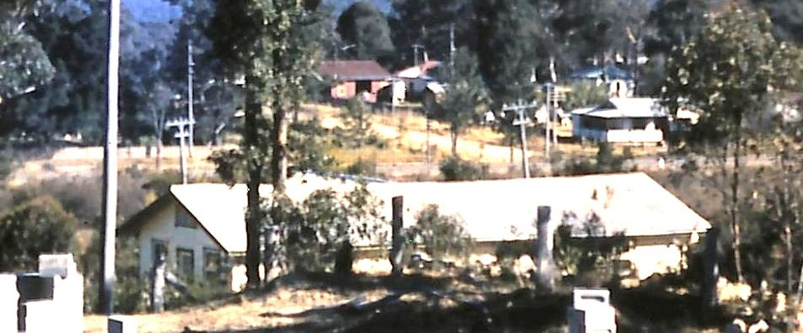 GLENBROOK KINDERGARTEN July 1956
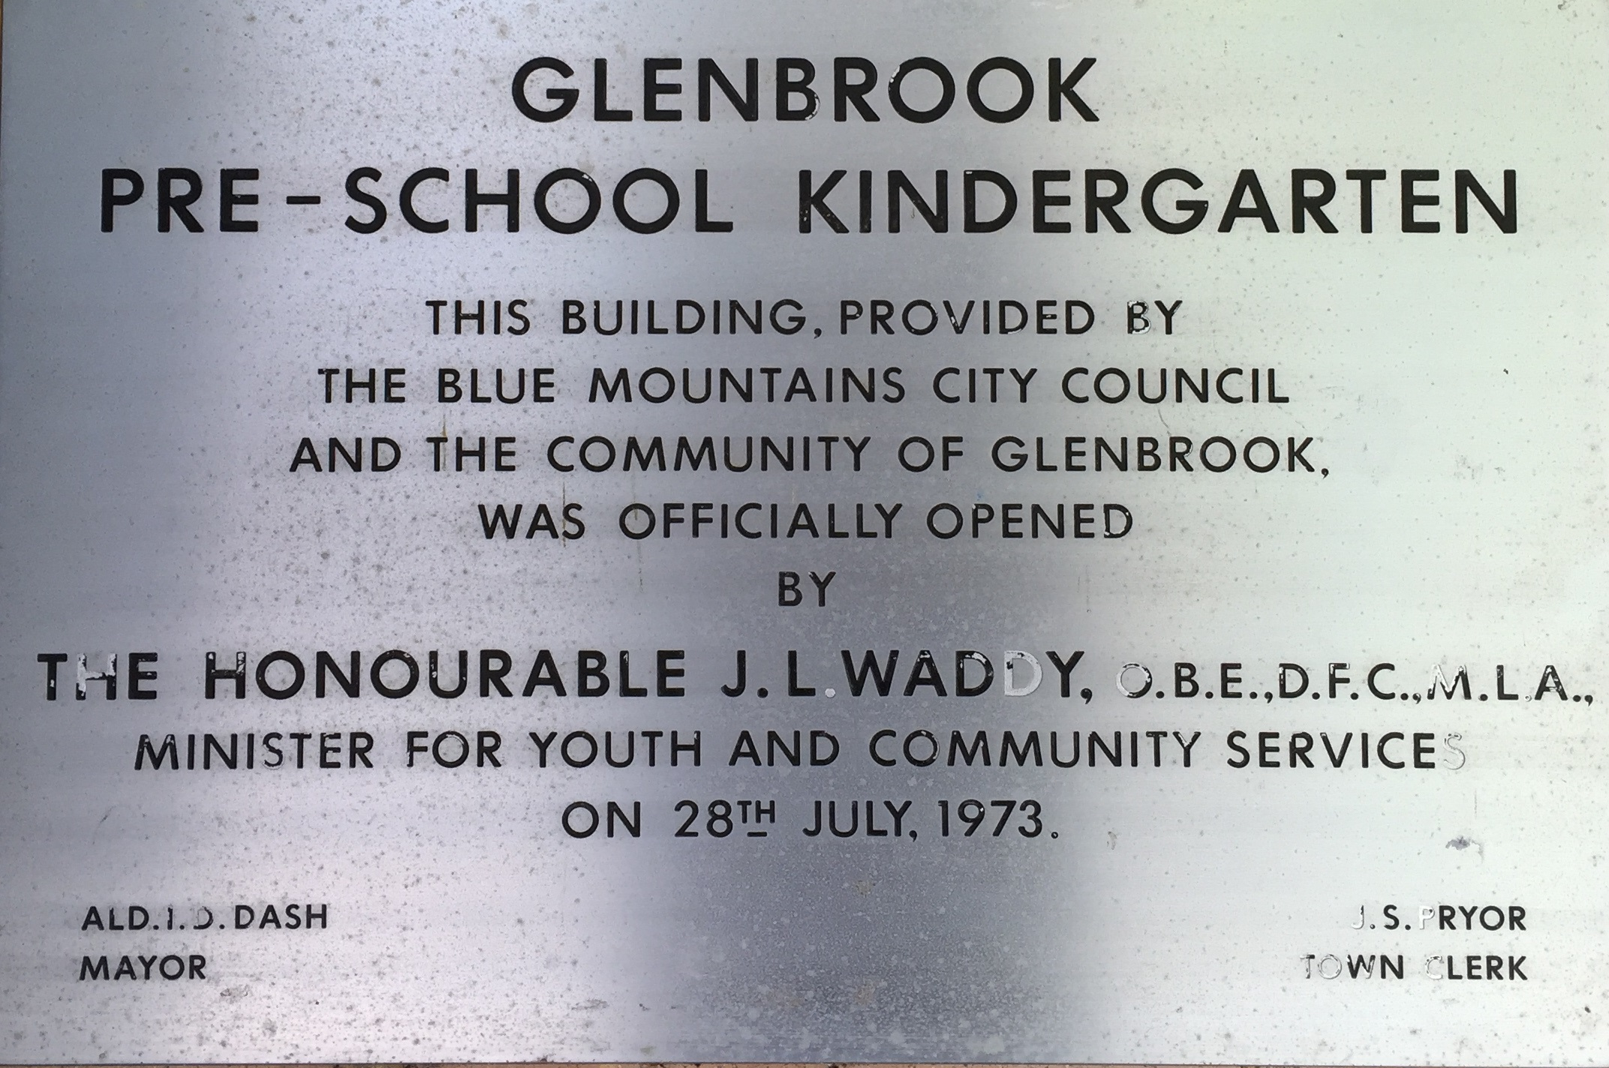
The incoming President, Mrs Avonia Wright, thanked Mrs Knott for all her hard work and said the Association would continue to raise funds to erect & equip it's own building, there are many children of kindergarten age in Glenbrook and numbers are growing yearly. c1955, a disused army building was purchased. and placed on the site & after much hard work by members of the Association the building was ready for the children. On 16th January 1956, my husband, Alan, and the President laid the cement slab for the toilet block. I can well remember the date, as it was the day my son was born.
The number of children attending was increasing with the attendance of children from the RAAF married quarters. A RAAF bus would collect the childen from the quarters and pick up & return others along the way.
A new site was aquired for the Pre-School Kindergarten and a beautiful new building and playgound was built in Dean St Glenbrook & officially opened on 28/7/1973.

