Pam’s Page
THE KNAPSACK VIADUCT.
Early train travellers crossing the Emu Plains had a wonderful view of seven classical white sandstone arches which were the Knapsack Viaduct and which became part of their ascent to the Blue Mountains. The recent construction of the viaduct: the like of which had not been seen in the colony in the early 1860's.The building of the viaduct and the Zig Zag railway were hailed as a landmark in early Australian engineering. The years that followed saw changes in the railway landscape and the role of the viaduct changed.In 1890 the Zig Zag was replaced by the first tunnel through the ridge which it had climbed. The viaduct remained in use until the second deviation came into being.It was opened in 1913 and a newer viaduct was buildt only 75 feet above the creek and was built of brick. Now the beautiful sandstone arches became part of the 20thcentury transport system.

The coming of the motor car required a new route up Lapstone Hill and in 1926, part of the old railway line leading to Blaxland was used and so the old viaduct became part of this route.With the coming of the M4, the route again changed and now the old viaduct was by-passed: not needed for the new road up Lapstone Hill.It has become some-what of a tourist attraction with a walking track passing over it.But it's beautiful arches remain a monument to early Australian engineering.
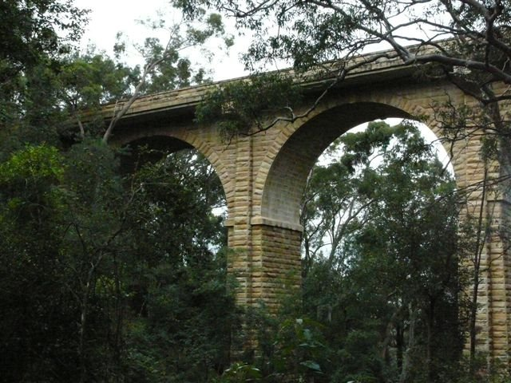
Photo courtesy Phillip Baker Glenbrook
Knapsack Bridge after conversion to road traffic Note added overhang

