Pam’s Page
ST. FINBARS HISTORY.

The first Catholic Parish was set up in Sydney in 1821 and in1839 Penrith became a Parish, of which Glenbrook was part. In Glenbrook, Mass was sometimes said in the School of Arts and in some private homes, including Mr. & Mrs. Woods‘ home in Brook Street, (now Woodville Road.)
The population slowly increased, especially as the railway construction neared Glenbrook. A permanent place of worship, and somewhere for the children to go to school was needed and so St.Finbars Church was built in Levy St. in 1912. This building still stands, recently refurbished, and is now used as a meeting room (Photo below 2014)
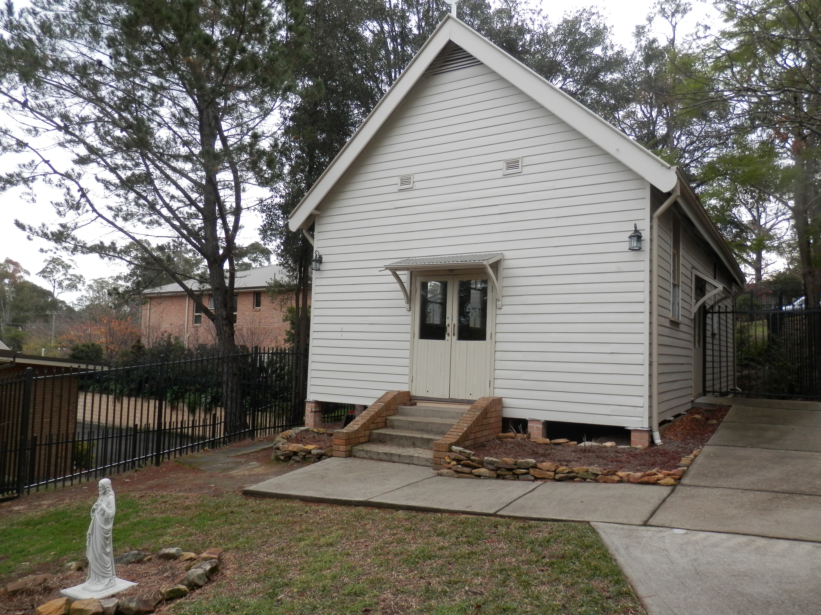
The Sisters of St.Joseph came to teach and lived in a small cottage on the corner of Glenbrook Road. & Levy St. When the railway line was finished in 1913, many families left. By 1919 there were less than 12 people worshipping. These few kept the church going until membership increased.
Father Leen was responsible for building the separate school in 1954 and the Sisters of St. Josephs again taught. They now lived in the Convent in Springwood and travelled down by Pearce's bus, picking up children along the way. The Sisters then marched the children up from the highway. By 1986 the remainder of the Sisters left, and the school was staffed by lay people. In the beginning St.Finbars was an infant's school only, but soon the Primary school was added.
In 1965 the Parish of Glenbrook came into being & in 1966 Father Fay became Parish Priest when the new church hall was opened. In 1978 the little wooden school burnt down, but by now the fine new buildings were being used. The Parish had seen great growth and the church and school buildings were a tribute to Father Fay. The beautiful new church, as it stands today, was built of sandstone blocks rescued when part of Sydney Hospital was demolished. This must also be a tribute to Father Fay. It contains a beautiful organ also rescued from a Sydney Church which was being demolished.
Pge 2

