Faulconbridge Sawmill Denis Bainbridge

The initial 60 acre Portion 53 land was purchase on July 15, 1909 by Henry Joyce. Further purchases were made for 70 acres Portion 54 on August 26, 1909 and Portion 55 382 of acres on September 28, 1911. Portion 55 bordered the end of Highland Road and to the north connected to Portions 53 and 54. Other land purchases must have been made as in the end there was 630 acres.

During 1913-14 a steam driven mill was built in the Linden Creek valley on a small tributary to Linden Creek . A 900 metre long one metre gauge tramway incline track was built using 4x2 inch hardwood rails fixed to rough bush sleepers with some on a raised track bed over the difficult terrain. When you see the remains of the boiler today it is hard to imagine how it was transported to the valley floor as it is estimated to weigh over 7-8 tons. The weight of the steam engine is unknown as the only remains are a 18 inch throw crankshaft. A steam winding engine was installed at the top of the tramway incline to raise the carriage while they would have been lowered under a brake. There is evidence of foundations for this engine at the top of the incline. When you consider the seven strand 1.5 inch diameter steel cable remains found in the valley was the cable used in this winder the size of the winding drum required was a large piece of equipment.

It is difficult to determine the layout of the sawmill plant on the valley floor as the area is rough and there is little left work out the possible configuration. How they moved the logs around is difficult to imagine. The remains we have now are;

An approximated 60 HP Colonial boiler missing end sections installed in stone wall foundations, the boiler firebox door frame, a section of water or steam pipe, a large diameter thin wall steel section which has been claimed as a flywheel which looks like the brake band and operating levers.. Some steel mechanical parts use unknown, a large 18 inch throw crank shaft buried vertically in the ground and some stone foundations. Away from this plant laying in the creek are a two sets of trolley one metre gauge cast iron wheels with steel spokes and sections of the 1.5 inch steel cable.

The Colonial style boiler was popular for use in timber mills near rivers. They were good steamers using wood fuel. Using the reverse flow design they were compact, easy to clean and maintain. They usually operated at a pressure between 90-100 PSI.

The boiler at this site is 12 feet long, 6 feet diameter with 48 4 inch fire tubes. Some fire tubes have been sealed due to steam leaks. The boiler is mounted between sandstone block walls with its brick firebox underneath. By checking the diagram below we can see the housings on the ends are missing one being the baffle that directs the flue gas into the fire tubes where it exits up the chimney. The steam generated flows into the header on top of the boiler. Feed water is injected into the boiler via the pipe on the bottom of the boiler. This a fairly large boiler of this type and would require a lot of wood and water to keep operating. It is estimated that there is 950 square feet of surface heating area which would evaporate around 3800 lbs (380 gallons) of water per hour generating 60 HP for a boiler in peak condition. I suspect that this boiler wouldn’t in peak condition as several fire tubes had failed and had to be sealed.

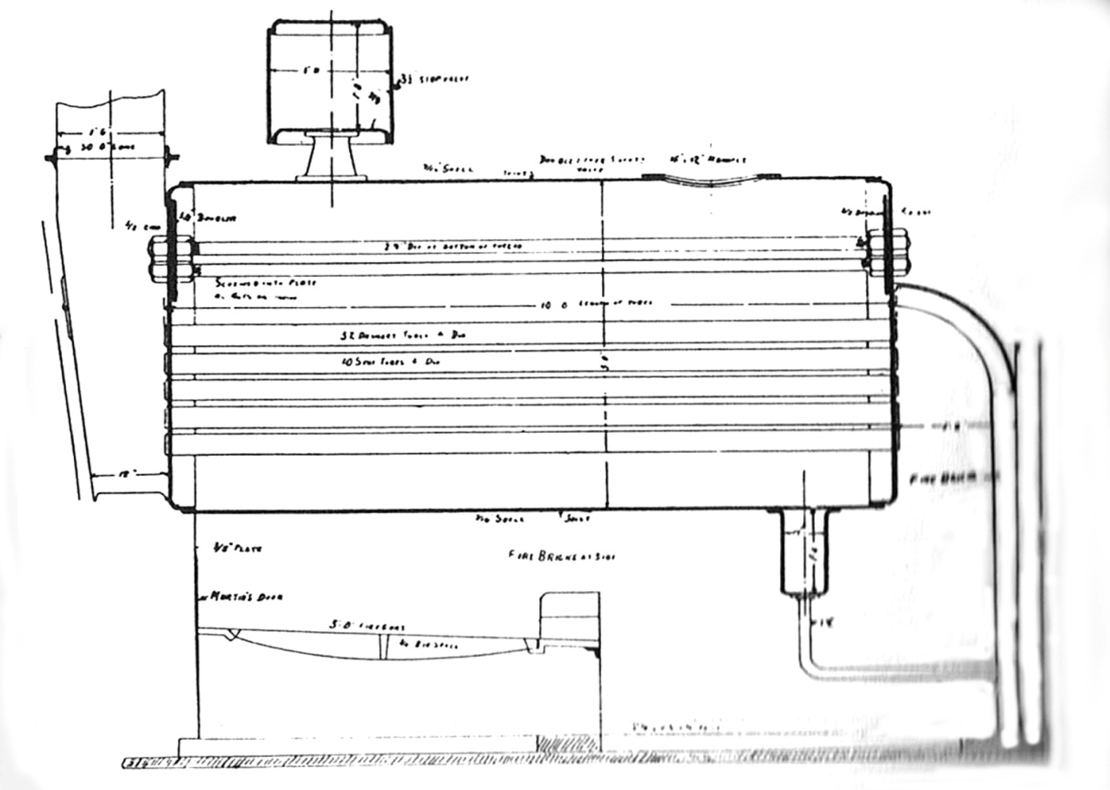

Typical Colonial Boiler Outline

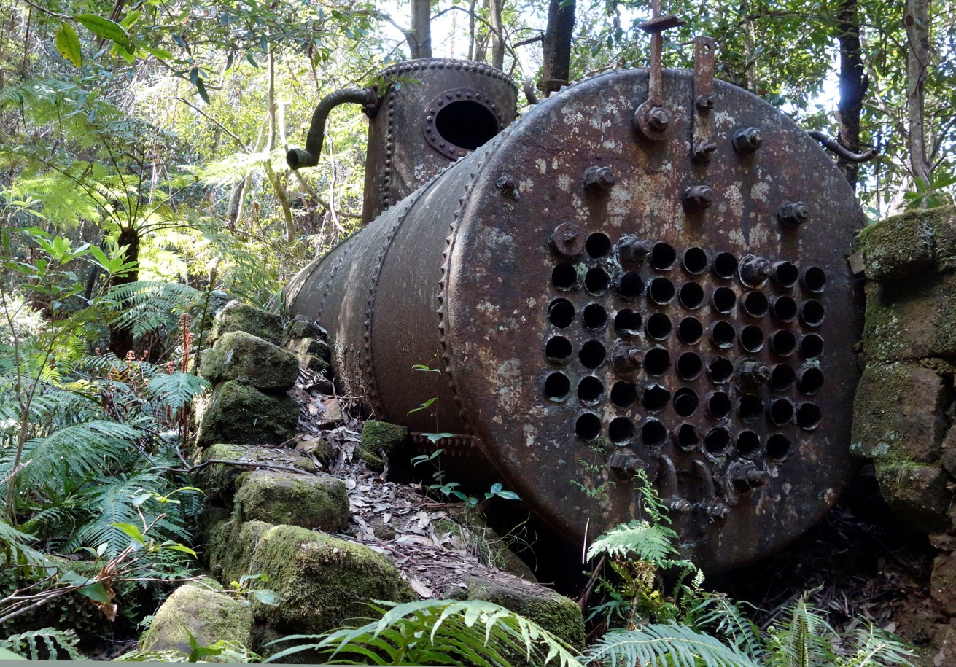

Boiler on Site. Chimney Housing and Firebox Door Missing

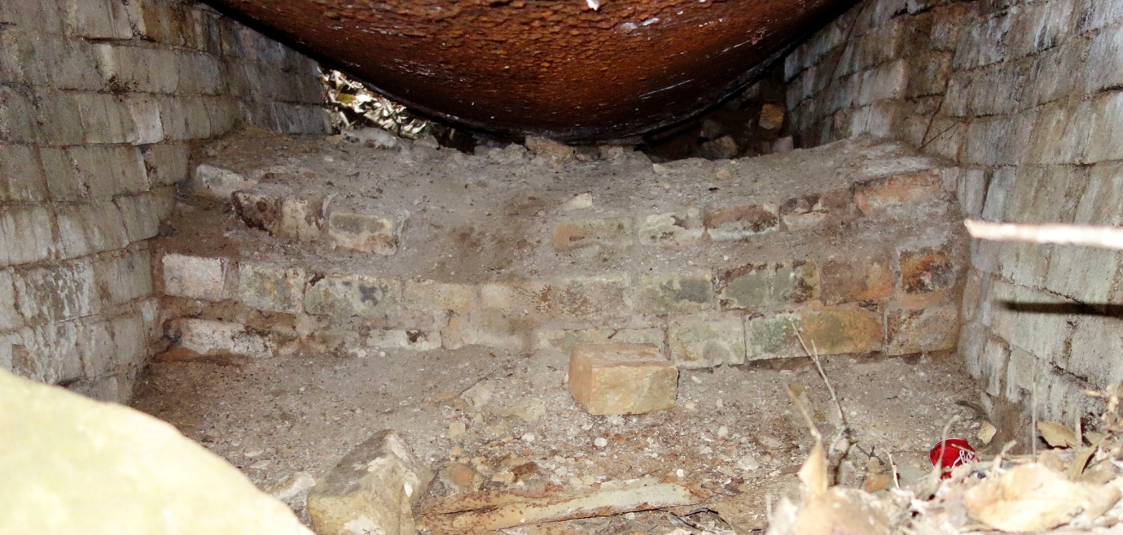

Firebox lined with Fire Bricks

It appears to be missing a grate assembly fitted to this boiler. The effect of the fire on the boiler shell can be seen.

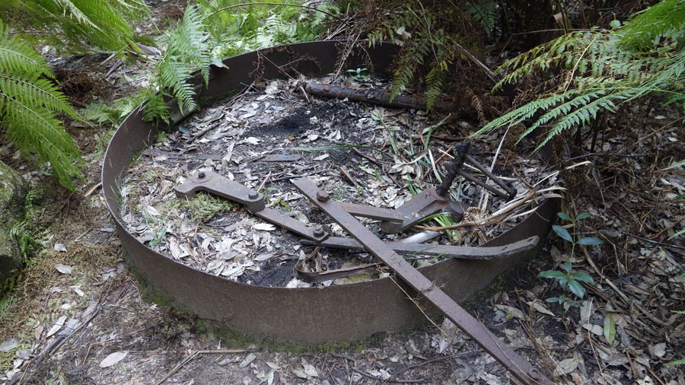

Unknown Parts

The parts in the photograph above have been previously described as a flywheel which isn’t correct. When researching machinery used in the early 1900’s it appears to be a brake band as used in snap brakes and its operating lever assembly. The band fitted around a large wheel on a winder for example and by pulling on the brake lever the band tightened on the wheel to slow its motion. This could have been used on the incline winder or similar to control the speed of the trolley on decent.

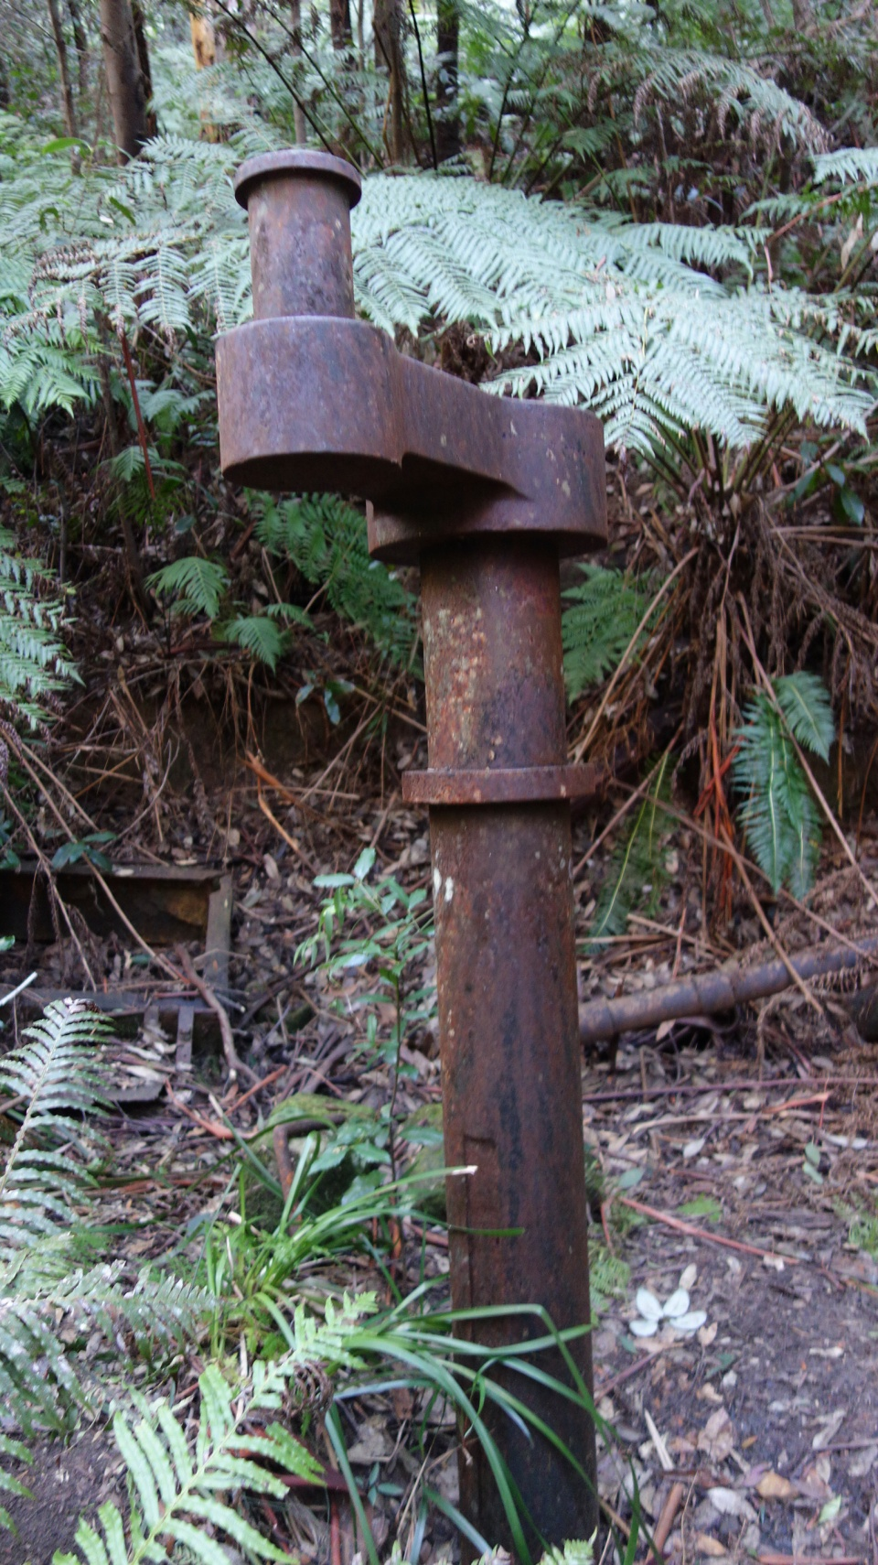

Other Items

Located near the boiler is a large steam engine 18 inch throw crank shaft buried in the ground. Why this item was left in this way is a mystery. It would have been from a large engine and one suspects that it is possible that it may be connected to a flywheel which is buried. In the background on the left can be seen the frame for the firebox door while on the left is some of the steam or water piping laying about the site.

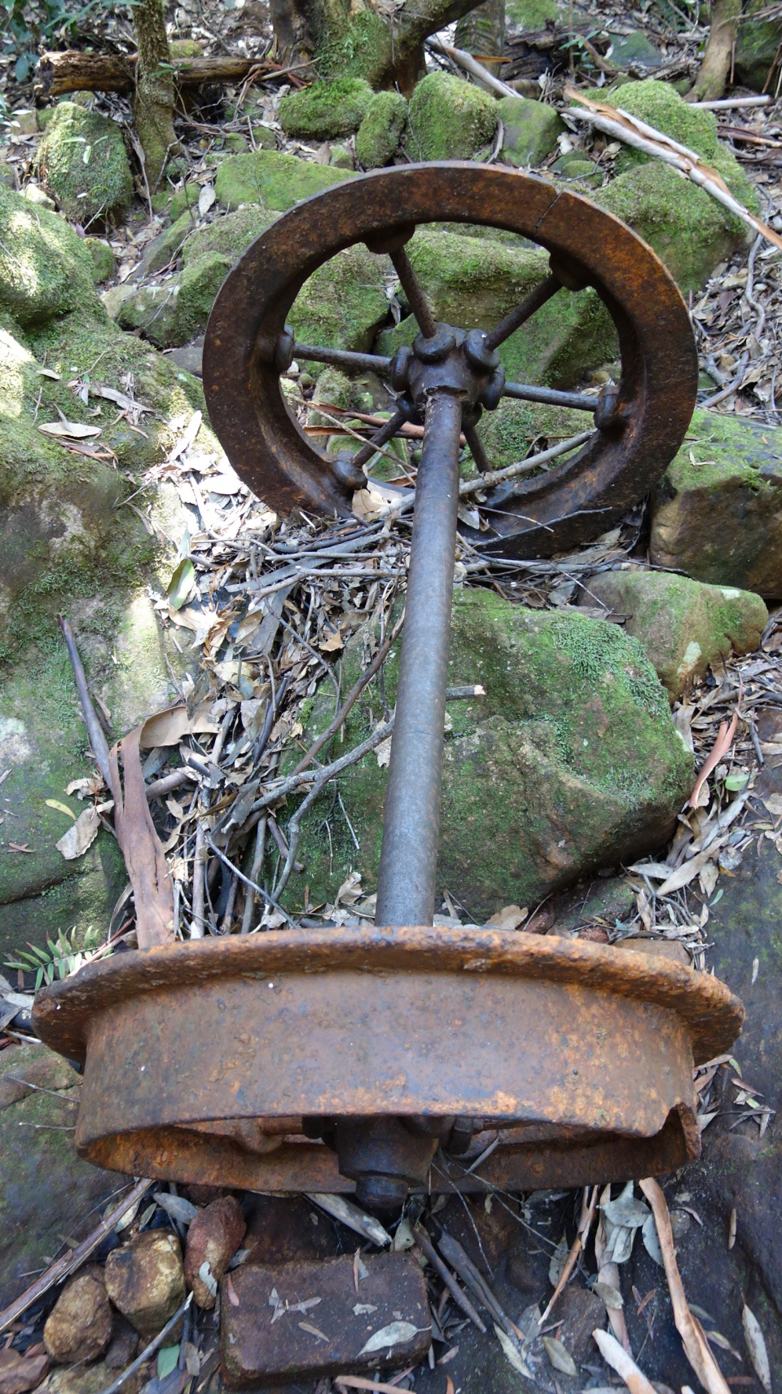

Carriage Wheel Set

This is one of the two sets of carriage wheels on the site. One is located in the creek while the one above is on the side of the creek. The wheels are one metre gauge which suggests a European origin. They are constructed with cast iron hubs and rims with steel spokes. Their solid construction suggests a heavy duty operation capability. If as suggested the boiler and sawmill plant where lowered on the incline then would require very heavy duty equipment indeed for the track, carriage and winding machinery to control the decent.

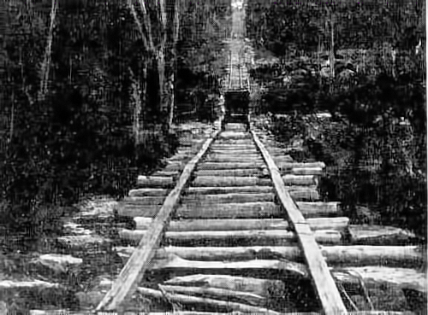

Incline Photograph

This cleaned up photograph published in the Blue Mountains Gazette August 31, 1916 in an inaccurate article about the sawmill with source unknown could be the incline for this sawmill. It has 4x2 inch hardwood rails on rough bush sleepers. This photograph would have been taken from the bottom. The resolution is poor so we cannot have a good look at the carriage and its wheels. One can only imagine the amount of work and capital cost to install the sawmill and incline.

The sketch map below was published in the Springwood Historical Society Bulletin No. 40 January 1983 in an article “The Faulconbridge Sawmill” written by S. J. Bently. The only question about this map is the turn in the tramway track at the bottom. This would be difficult with a long cable driven by a winding engine at the top of the track.

The final 1922 photograph from the Blue Mountains Collection is the unloading of railway sleepers carried from the sawmill by horse and dray to Faulconbridge Station to be loaded into railway trucks for delivery to their final destination.

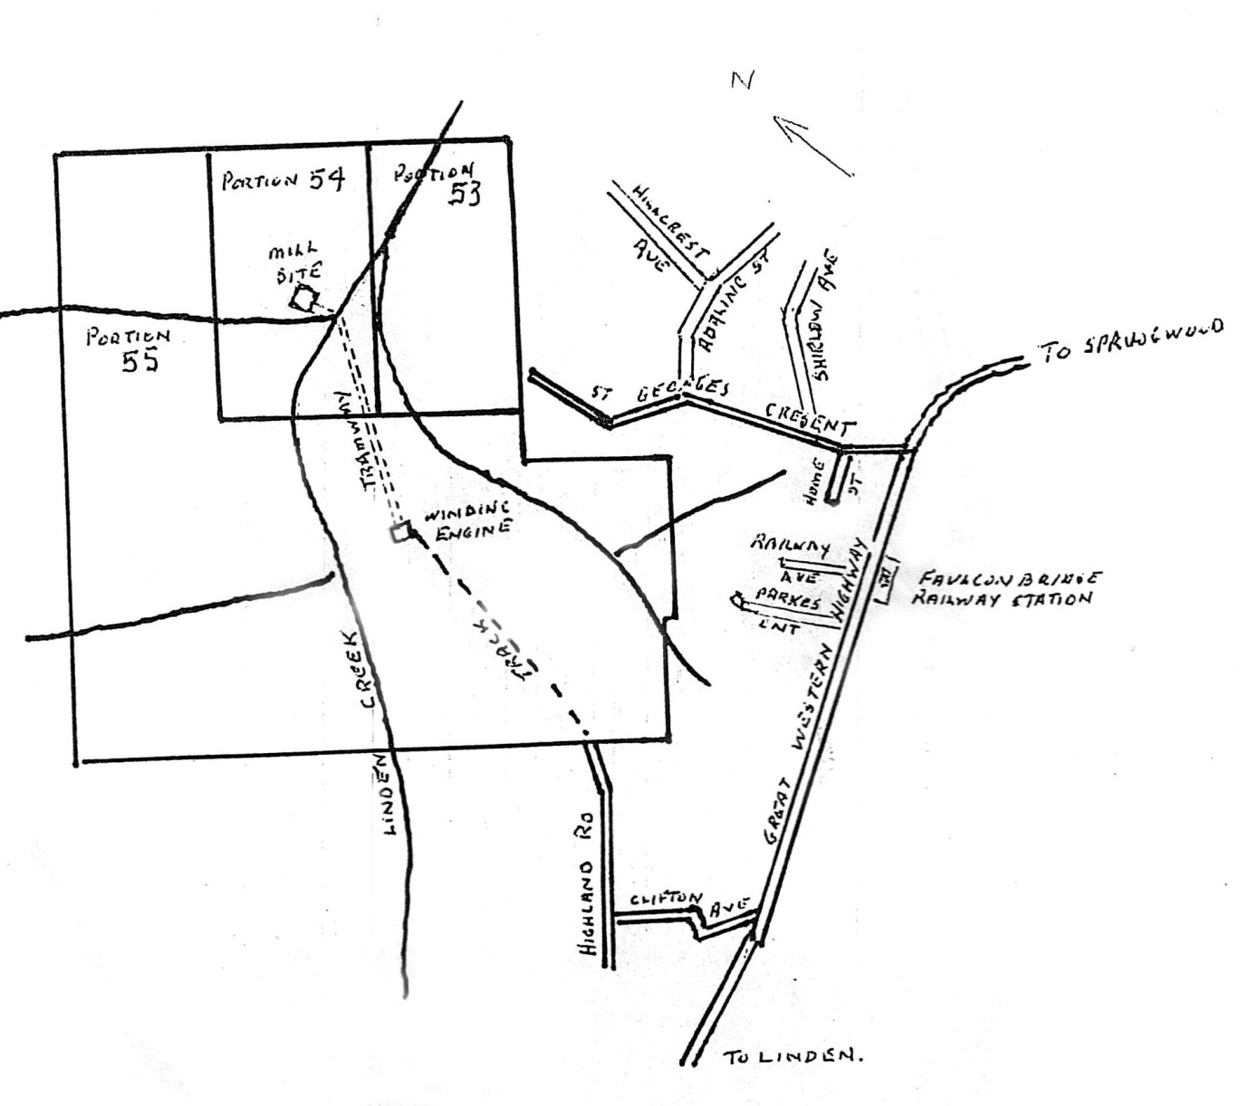

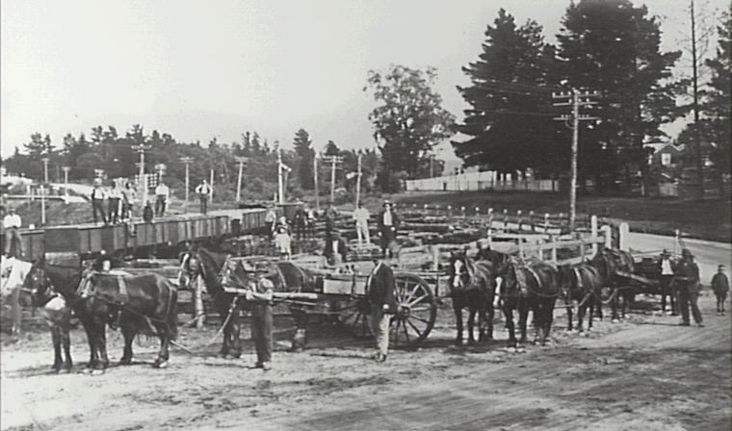

The question now is how successful this business was for its owners and the answer is probably it was a poor investment. There were four ownership change over the life of the mill and as shown below there were court cases over payment problems.

Henry Joyce who obtained the land in 1909 and built he infrastructure in 1914 soon ran into financial problems with the quality and access of the timber and as suggested the high water requirement of the boiler. He became insolvent and to repay debts passed the mill on to Augustus Wilson. The date of this transfer is not known.

The next owner was Charles Snell. The Springwood Historical article states that Wilson sold to Snell in 1920 for P1600, however this isn’t possibly true as Newspaper article listed below suggests that Snell sold it to Francis James Searle, Lawrence, George Moncrieff Sawmillers from Faulconbridge and John Wallace Easson of Hardwoods Ltd at Woolwich for P4000. It may have been an arrangement where Hardwoods Ltd acted as guarantee for the purchasers. There must have been cash problems as the court cases below indicate that promissory notes were not paid in time. From the newspaper reports we can find Snell had many problems getting paid.

The Blue Mountains Echo reported on 8/10/1920 that the sawmill had changed hands for a substantial sum ( later reported to be P4000). The sale was handled by Messrs Molvin and Dawson. It is assumed that the vendor was Charles Snell and the purchaser was Hardwoods Limited.

The next year on 19/9/1921 it was reported that in the District Court Charles Frederick Snell timber merchant of 20 Castlereagh Street Sydney sued Francis James Searle of Faulconbridge, Lawrence George Moncrieff of Faulconbridge sawmillers, John Wallace Easson of Woolwich merchant and Hardwoods Ltd of Woolwich for the recovery of P292/11/1 alleged to be the amount of promissory notes made by the defendants Searle and Moncrieff in favour of Charles Snell and endorsed by the defendants Easson and Hardwoods Ltd. Judgement had already been made against the defendants Searle and Moncrieff, however, Easson and Hardwoods were disputing the notice given about the dishonour. The verdict is unknown.

In the SMH dated April 1, 1922 in the “For Sale” advertisements:

“Complete Firewood Sawmill Plant etc, with rights to bush thickly timbered 50 miles from Sydney. Apply Watkinson Bros, George and Hay Streets Sydney.”

It is not known if it was the Faulconbridge Sawmill, however, it is probable that it was indeed as the timeline and description is very close. It is obvious that financial problems were in play and perhaps the current owner(s) wanted to dispose their interest in the sawmill. The following court case followed over failed payments

Another No. 1 Jury Court case was reported by the SMH on 24/6/1922 before Justice Ferguson without a jury. The case was ‘Sale of Faulconbridge Sawmill” Snell v Easson.

C harles Frederick Snell bought the case against John Wallace Easson Managing Director of Hardwoods Ltd to recover P1088/7/0 upon a deed executed on September 15 1920 by which the defendant covenanted to fulfil certain conditions prescribed by another deed dated September 10, 1920. It stated that the on the behalf of Snell that this September 10 deed that if a default was made by certain purchasers from Snell in carrying out their contract Hardwoods Ltd would in a certain time pay P1000 or the purchase balance of the purchase money due on the date mentioned by Snell being in possession of the Faulconbridge Sawmil together with 612 acres of land contracted to sell to Searle and Moncrieff for P4000. The contract provided that payment should be made by monthly payments of P103/6/8. On September 15 an agreement was made between Searle, Moncrieff and Hardwoods Ltd and the Snell that by which Hardwoods Ltd upon any payment default over seven days would upon notice to them would within another seven days P1000 on the purchase money or take over the benefits and liabilities of the purchasers. The payments were irregular and in the following may P108/6/8 under the deed in addition to a sum of P116/13/4. To meet these arrears a cheque for P108/6/8 was paid leaving the other amount still owing and a further agreement where the P116/16/4 and some other monies that were due to Snell by Searle and Moncrieff were secured by separate promissory notes two of which were in question in the present action. The June instalment was missed and although notice was given to Searle and Moncrieff and within the prescribed period Hardwoods Ltd and Easson the P1000 was not paid.

In his pleadings the defendant alleged the property subject to the agreement was not Searles and he had no title to it. Searle replied that he did have title and if there had been any problem Searle and Moncrieff could have rescinded the contract which they didn’t. The dwefendants tried to say that the promissory note issue was before the District Court and not subject to this court. The judge dismissed this argument and found for the plaintiff on the promissory notes valued at P88/7/6 each with P4/0/0 interest. He found the notice of default on the June payment did not reach hardwoods Ltd as set out in the agreement and entered a verdict for the defendant on the P1000 claim.

As can be seen from these court cases that the purchasers were in financial problems they had tried to sell the sawmill see advertisement below.

The Springwood Historical article states that for a short time the top engine was used to cut firewood timber for a Katoomba fuel merchant. It is not known when the valley operations cease and some of the equipment removed leaving the boiler which would be too heavy to raise up the incline. Also no dates are known when the top machinery was removed.

The land was resumed in 1928 and placed in the Faulconbridge Park which was later The Blue Mountains National Park.