GLENBROOK BUS SHELTER
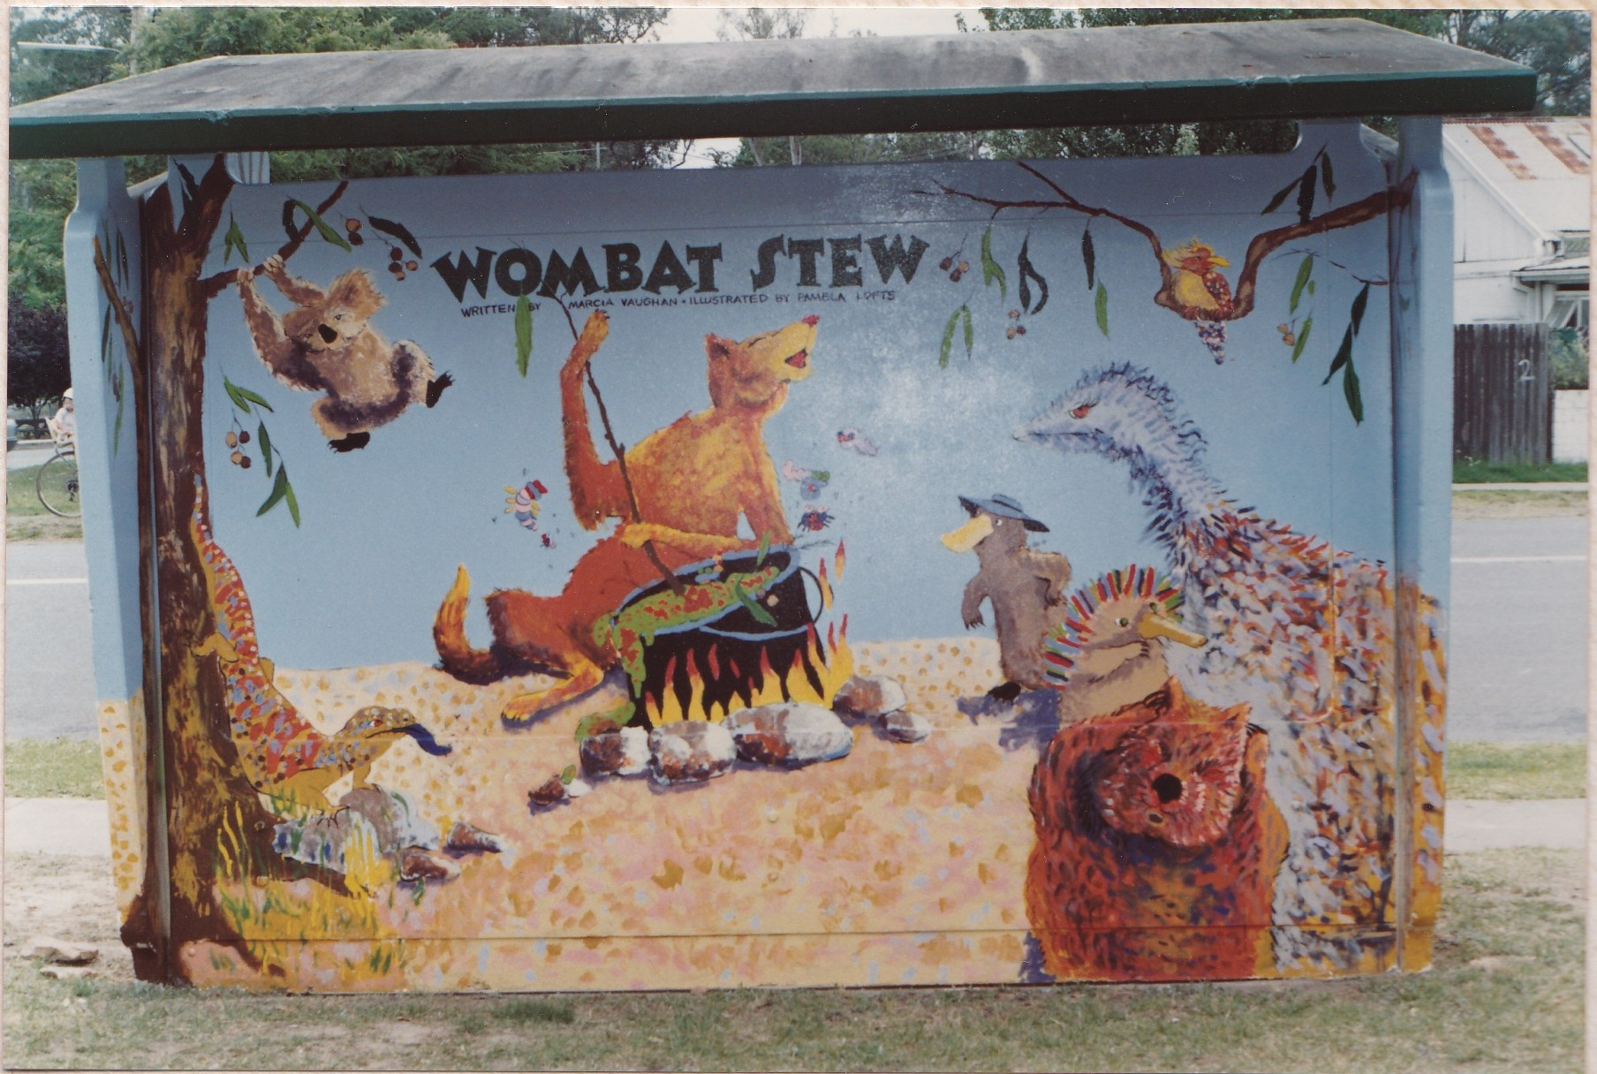
Recently a car ran off the road and collided with a bus shelter, severely damaging the car, but with minor damage to the concrete bus shelter. On removing the car the shed was further
damaged. Within a few days the Council
removed the damaged shed simply by
crushing the concrete and carting the
rubble to the tip. Not an exiting story, but
the shed in question was of historic value
to Glenbrook, situated in Ross St at the
Community centre. The shelter shed was
painted by students from Glenbrook MURAL FROM REAR
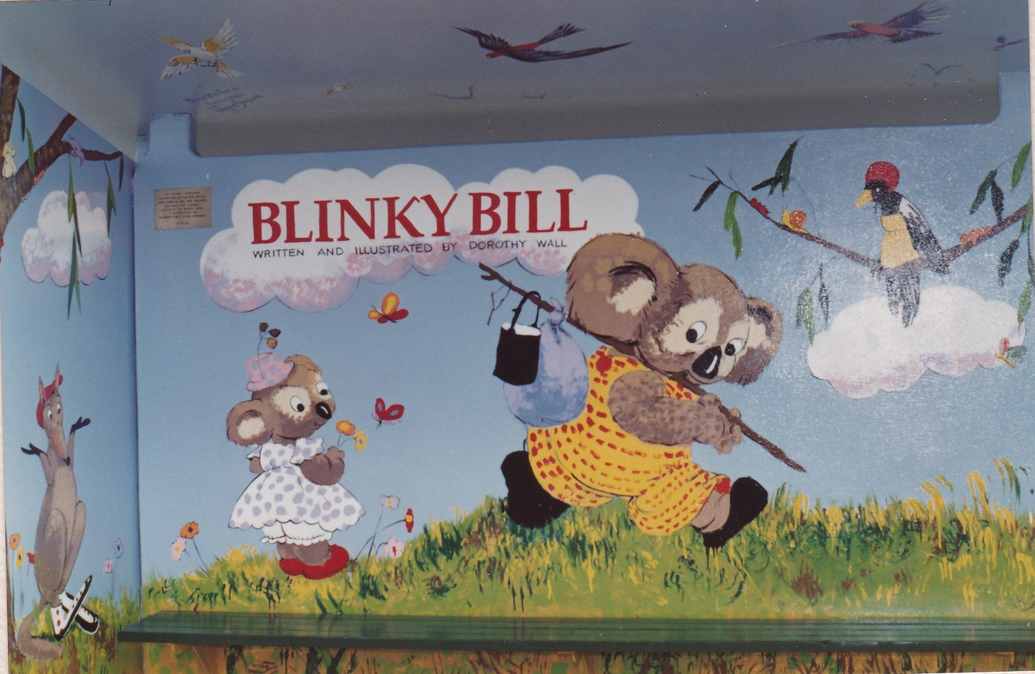
Primary School as part of their 100 years
school celebration 1992. The artist was
Sue Gasser .
Joan Peard and others considered this
to be an act of vandalism and Joan
contacted Mayor Mark Greenhill.
The Mayor was unaware of this event
and promised to "look into it and ring you
back". Within a few days the Mayor said
he wouild recommend to Council that the MURAL FROM FRONT
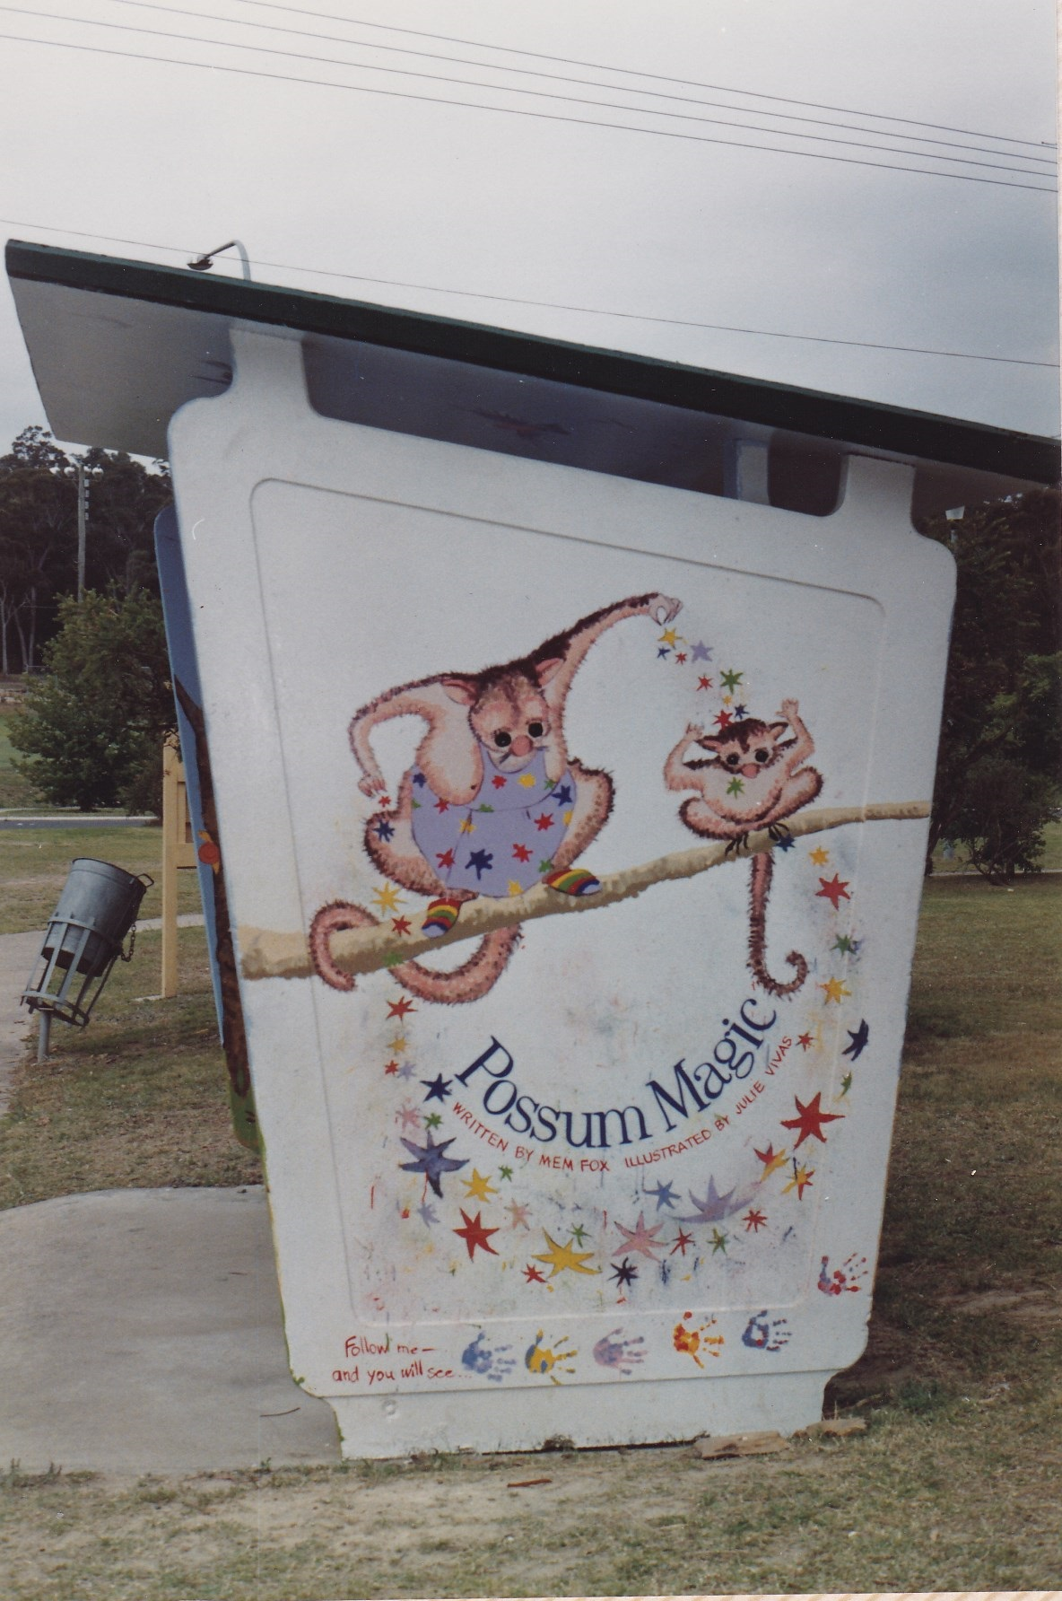
shelter shed be replaced and restored to it's
former glory. More recently the Mayor contacted
Joan to report that a similar concrete shed was
available and the murals restored. Fortunatley our
Mayor has an interest in local history, which is
more to be said than those who authorised the sheds
removal, and he is always available & listens.
We have 3 photographs of the original, but the
outside mural of the northern wall and inside of
southern wall are still missing. If any member can
help, please e-mail me copies of their photos. We
cannot rest on our laurels until the shed is replaced SOUTH WALL
and restored. Nothing short of this is satisfactory.
EDITOR e-mail jpe13704@gmail.com

