From pge 3 .....as they served both as a "water tanker" & 'pumping" appliance. They were powered with a 4cyl Morris truck moter, 4 speed manual transmission with a pumping unit on the rear. They had all the features of the GMC tanker plus carried all the required station equipment in use in those days. They were made to operate in bush or with property. Their main drawback was that the crew were carried on the back exposed to the elements. A bit uncomfortable on a winters night!! no problem travelling east to Penrith , had many hours pumpimg water, in fact at one fire involving a factory in Penrith the Morris pumped for over 4 hours continously. It finished it's life at the Penrith Museum of Fire.
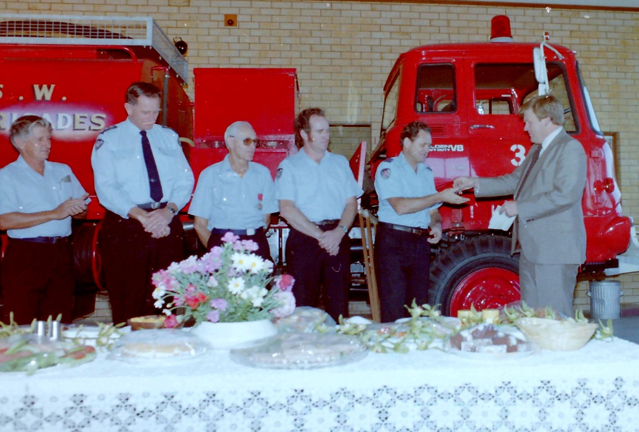
I joined the Brigade 1960 and was appointed Captain when Capt George Bunyan retired in 1969. At that stage we still operated in the original station in Wascoe St (now site of Anglican Church) with the "Morris" and little space to move. A new 2 bay station was built (mid '70s) on cnr Wascoe & Lennox Sts. (still in use today). We soon were allocated a new & 2nd. appliance, the latest International water tanker. This was a powerful unit, made to carry 2500L water plus equipment, and a 4 speed auto. gearbox. The photo at left shows Mr Peter Anderson, the local MP & Police Minister, handing me the keys. With a 2nd appliance I was now able to increase our crew to Capt & 12 VFs.The Board considered Glenbrook to be an important cog in fire prevention in the Mountains and in the late '70s we were allocated a 3rd appliance and allowed to increase crew to Capt & 16 VFs.
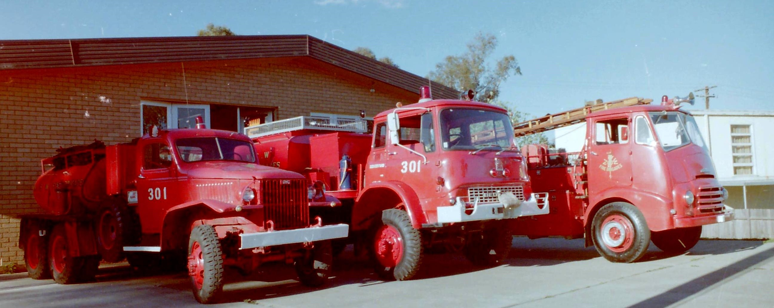
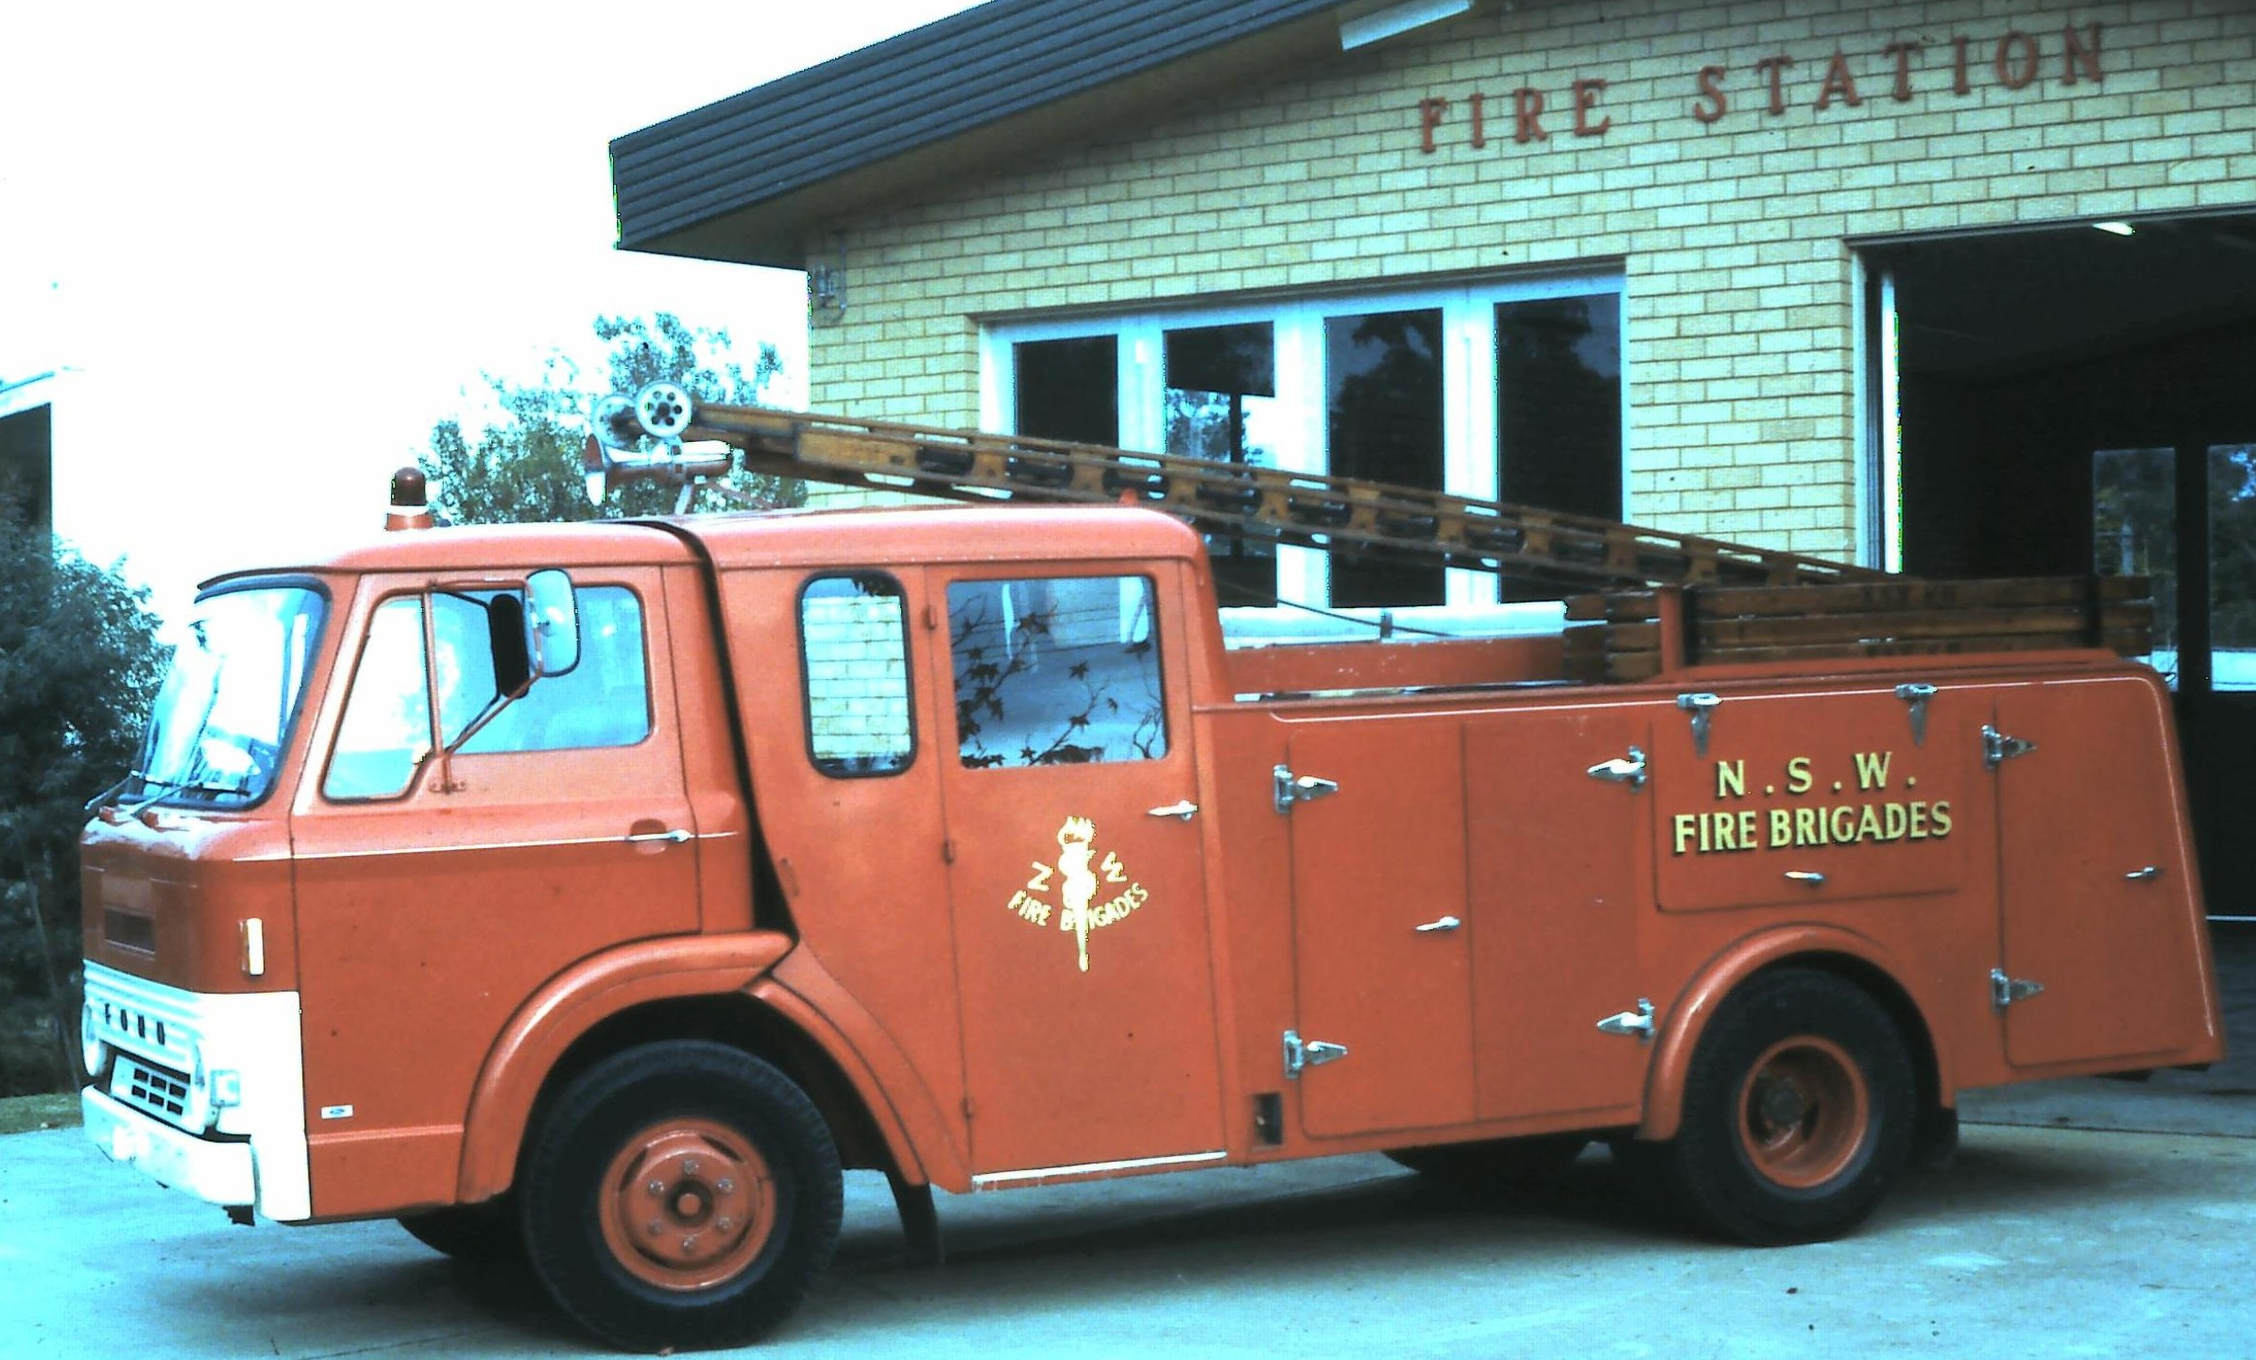
The 3rd appliance was again a GMC water tanker, now painted red, but not the original unit. It was to be used as a backup tanker throughout the mountains, both for NSWFB & RFS (previously known as BFB). In the major fires of 1979 the GMC was used extensively, and at one stage operated for 3 days at Mt.Wilson with RFS. The photo left shows the 3 appliances stationed at 301 Glenbrook, GMC Water Tanker, International Water Tanker & Morris Composit. In 1979 the GMC was returned to HQ and not replaced.
As previously mentioned the Morris was retired in 1980. This unit was replaced with a second hand unit from a City station (see photo left), a Ford, commonly in use at that time, These units were called "Pumpers", sat 6 crew in cabins, carried all equipment plus 300L water with one 25mm rubber hose. The water pumps were at the rear & had to remain static to operate. When I retired in 1983 the station housed 2 appliances, a "Pumper" & a "Tanker". Today it is still a 2 appliance station but with more modern appliances and equipment All Photos from my collection Editor Bill Peard

