Skarratt Family Notes

The Skarratt family tree is a complicated one as there were a lot of children and the same names were often passed down. The family moved from London to Kington Herefordshire and many later migrated to Australia.

Will start our tree with

Thomas Carleton Skarratt married Elizabeth Ball

Born: 1776 1802 Born:

Dead: 1838 Dead:

All Children born in Kington

Thomas Carleton 1803 – 1809

Elizabeth Carleton married Walter Hall

Born: 1804 1828 Born: 1803

Dead 1862 Dead:

Migrated to Australia in 1853

Ann Carleton 1807 – 1842 Spinster

Henry Carleton married Sarah Evens

Born: 1809 1833 Born: 1824

Dead: 1888 Dead: 1885

Kington and Ludlow

Charlotte Carleton 1811 – 1872 Spinster

Thomas Carleton 1813 – 1814

William Carleton 1815 – 1815

Hester Carleton married Joseph Brothwood

Born: 1816 1854 Born: 1820

Death: 1889 Dead:

Migrated to Australia in 1887

Thomas W Carleton married Elizabeth Stephens

Born: 1818 1857 Born: 1824

Dead: 1909 Dead 1885

**William Carleton married Frances Mary Weale**

**Born: 1821 1853 Born: 1831**

**Dead: 1896 Dead; 1911**

**Migrated to Australia 1874**

**This is the branch that is the most interest to us.**

Charles Carleton married Mary Wren

Born: 1824 1854 Born: 1836

Dead: 1900 Dead: 901

Migrated to Australia 1852.

**William Carleton married Frances Mary Weale**

**Born: 1821 1853 Born: 1831**

**Died: 1896 Died; 1911 Mountside Glenbrook**

Children of William Carleton and Frances Mary Skarratt born in Kington who migrated to Australia.

Frances Elizabeth

**Thomas Carleton** married -1 Unknown

Born: 1857 married -2 Esther Caroline Page

1907 Born: 1861

Died: 1927 Picton Died: 1938 Lakesland

In 1906 lived at Ulinbawn Glenbrook. His occupation was listed as an “Assayer” we assume at his cousin’s Mt Morgan mine. He married Esther Page a barmaid at the hotel where he was the publican.

Carleton Walter married Christina Simpson

Born: 1867 Born: 1872 St George NSW

Died” 17/2/1943 Died: 17/2/1943 Rockdale

Children

Doris Carleton Skarratt

Born: 26/8/1898

Death: 1/10/1969 Peakhurst

Reme Alice Carleton Skarratt

Born: 1902 Marrickville

Death: 7/5/1993 Canberra

Walter Weale Skarratt

Born: 1907 Rockdale

Death: 12/6/1952

Kenneth Baun Skarratt

Born: 1910

Death: 3/1/1982

Charlotte Eleanor

Born: 1870

Death: 23/11/1938 Sydney

**Donald Frederick Skarratt**  married Elizabeth Norris

Born: 23/5/1873 1914 Born:

Death: 10/8/1948 Mountside Windsor Death: Mountside

Arrived in Sydney Australia: 28/4/1874

Children

Donald Walter married Mollie Crowther

Born: 18/5/1915 10/1939 Born:

Death: 1977 Concord Repat Hospital Death:

Children

Two sons

**Eric Norris**  married Helen Baldwin

Born: 10/3/1919 Born:

Death: 6/8/2000

Children

John:

Born; 1947

The Late Mr. Donald. F.Skarratt

After an illness of about twelve months duration, Mr. Donald Frederick  Skarratt, a gentleman widely known and esteemed in the Nepean and Lower Mountain districts, died at his home, "Mountside", Glenbrook, on 10th August 1948 at the age of 76 years, Mr. Skarratt was born at Kington, Herefordshire, England, the son of William and Mary Skarratt, with whom he came to Australia when he was six months old. They were early residents of the Strathfleld-Burwood district.

In his youthful days Mr, Skarratt went to Queensland and worked on the Claverton Downs Station, to gain colonial experience. In 1905 he bought "Mountside", Glenbrook, from the late Mr. Colin Smith, where he continued to reside for the rest of his days.

He proved himself a public-spirited gentleman, giving much of his time and talents to district advancement, in proof of which it may be mentioned that he was for 21 years a Councillor of Blue Mountains Shire Council. He took a keen interest in Shire matters and in any movements for local progress.

He was married in St. Matthew's Church, Windsor, in 1914, to Elizabeth Norris, daughter of the late William and Jane Norris, of Roma, Queensland, by the late Rev. Norman Jenkyn, Rector.

Deceased is survived by Mrs. Skarratt and by two sons-Donald (Narromine) and Eric (Glenbrook). He leaves no brother or sister, being the last of a family of eight. The late Mr. Walter Russell Hall, well-known in Queensland gold mining circles, was a cousin of Mr. Skarratt.

A largely-attended cremation took place at Northern Suburbs Crematorium on 11th inst., the service being conducted by Bishop Wilton, a friend of the deceased. Numerous wreaths bore testimony to the very high regard in which Mr. Don Skarratt was held and the sympathy felt for the bereaved.

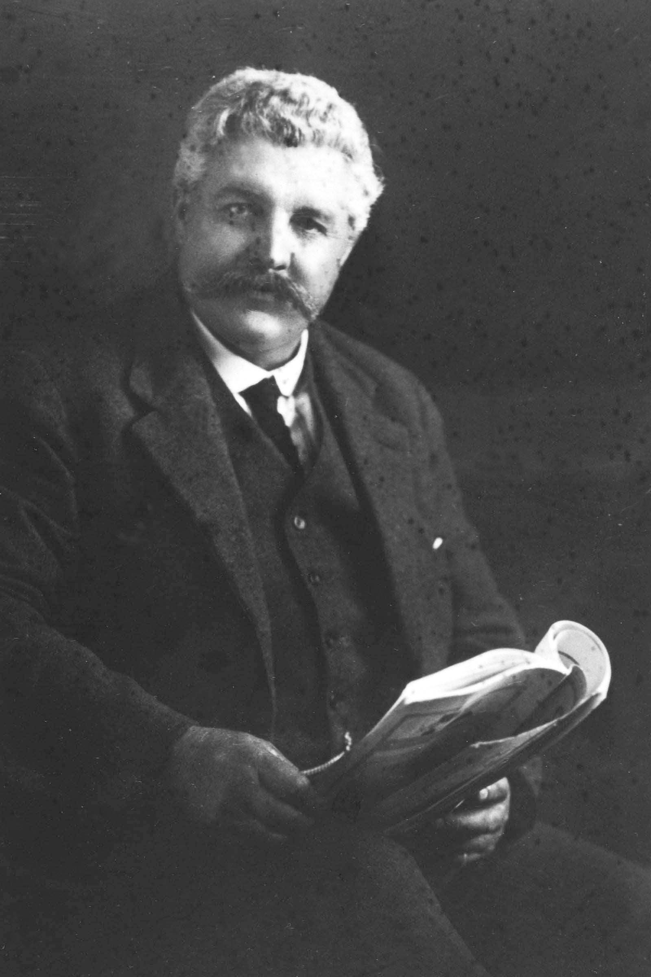

Donald F Skarratt

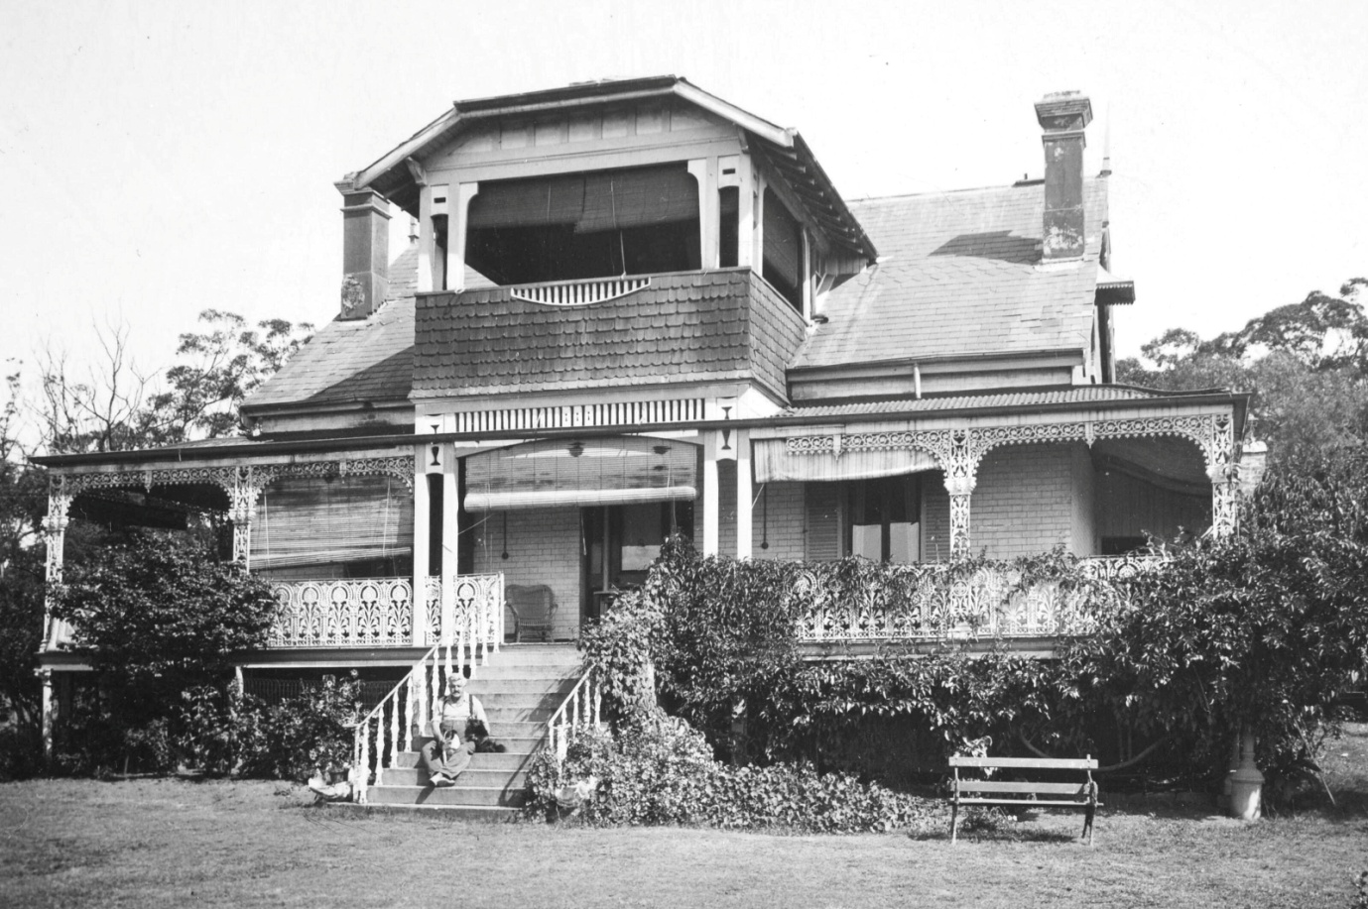

Donald Skarratt at Mountside before the fire.

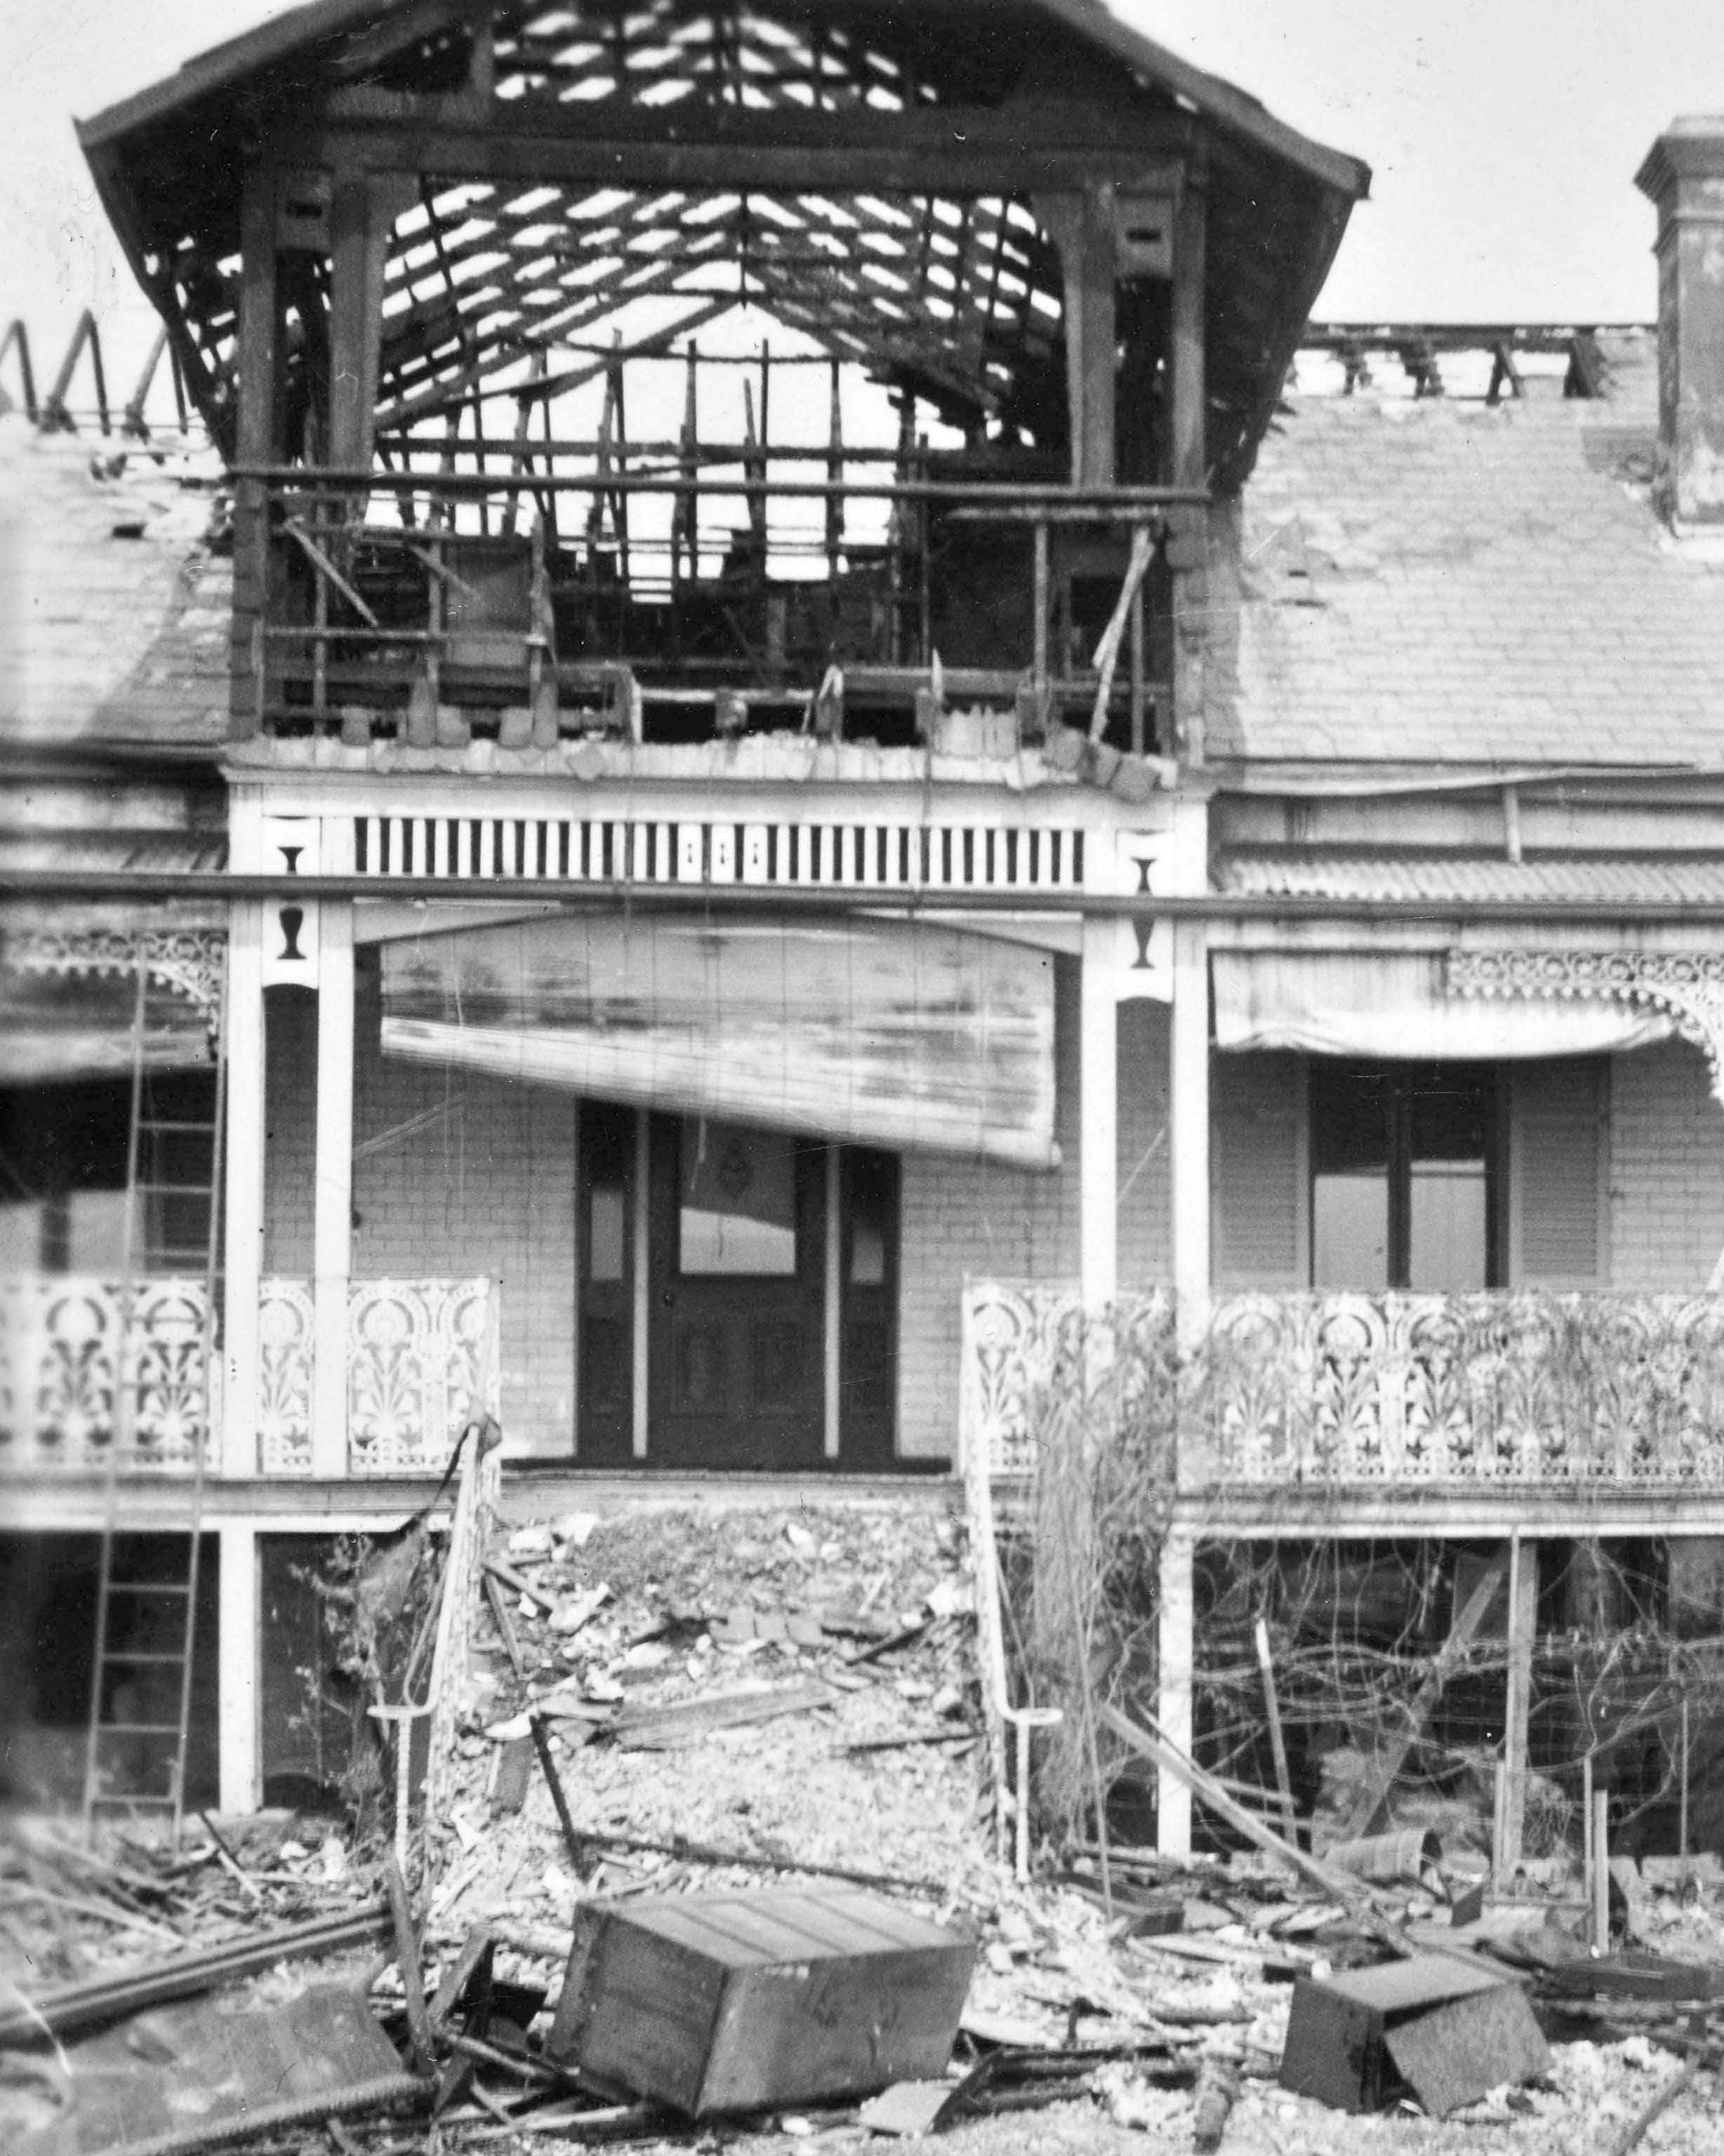

Mountside after fire

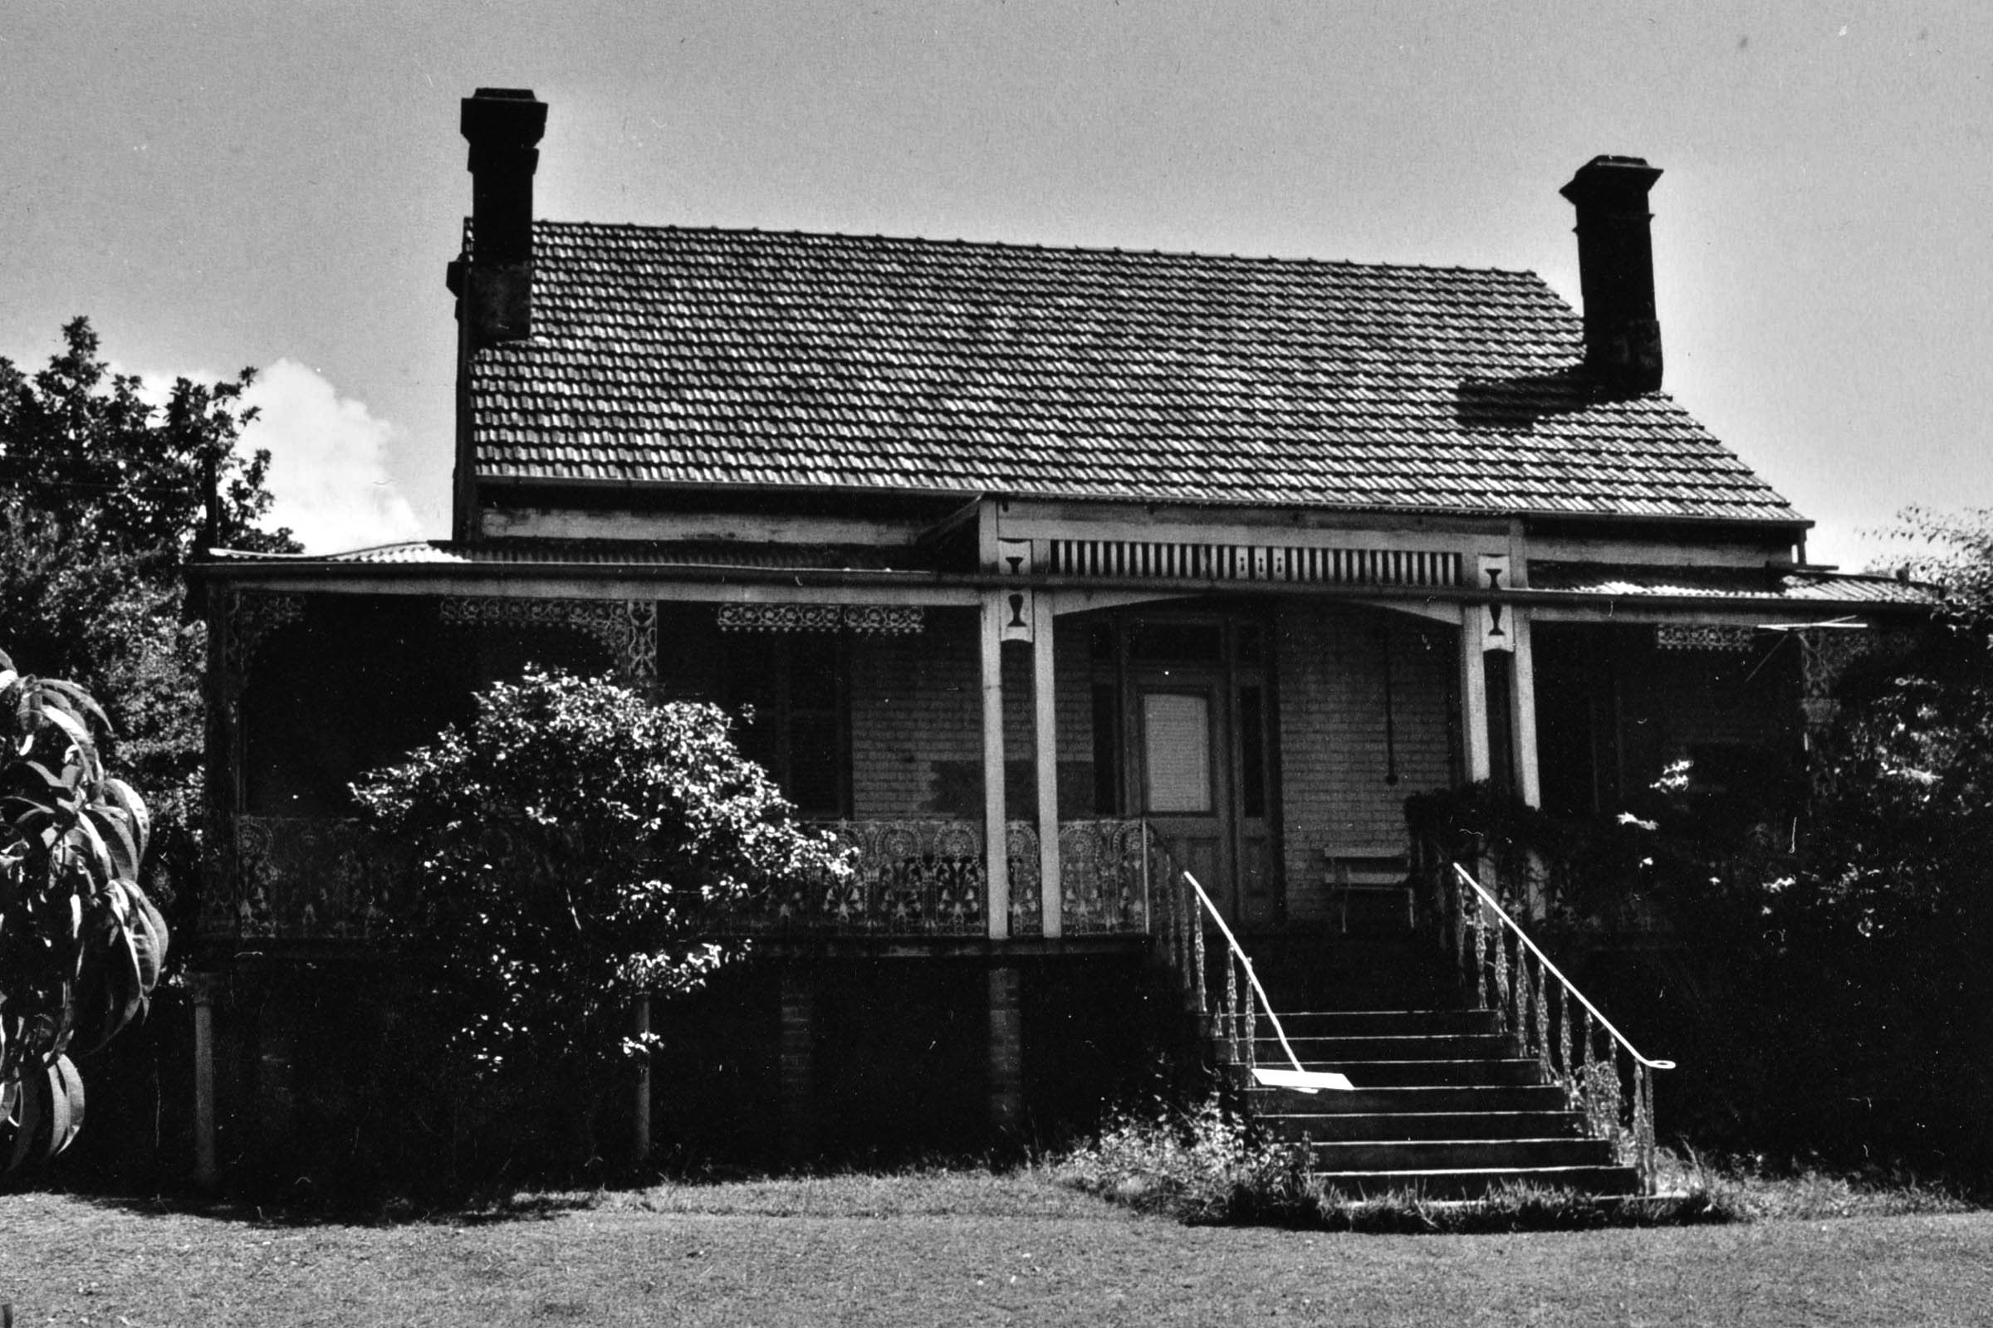

Mountside after repairs

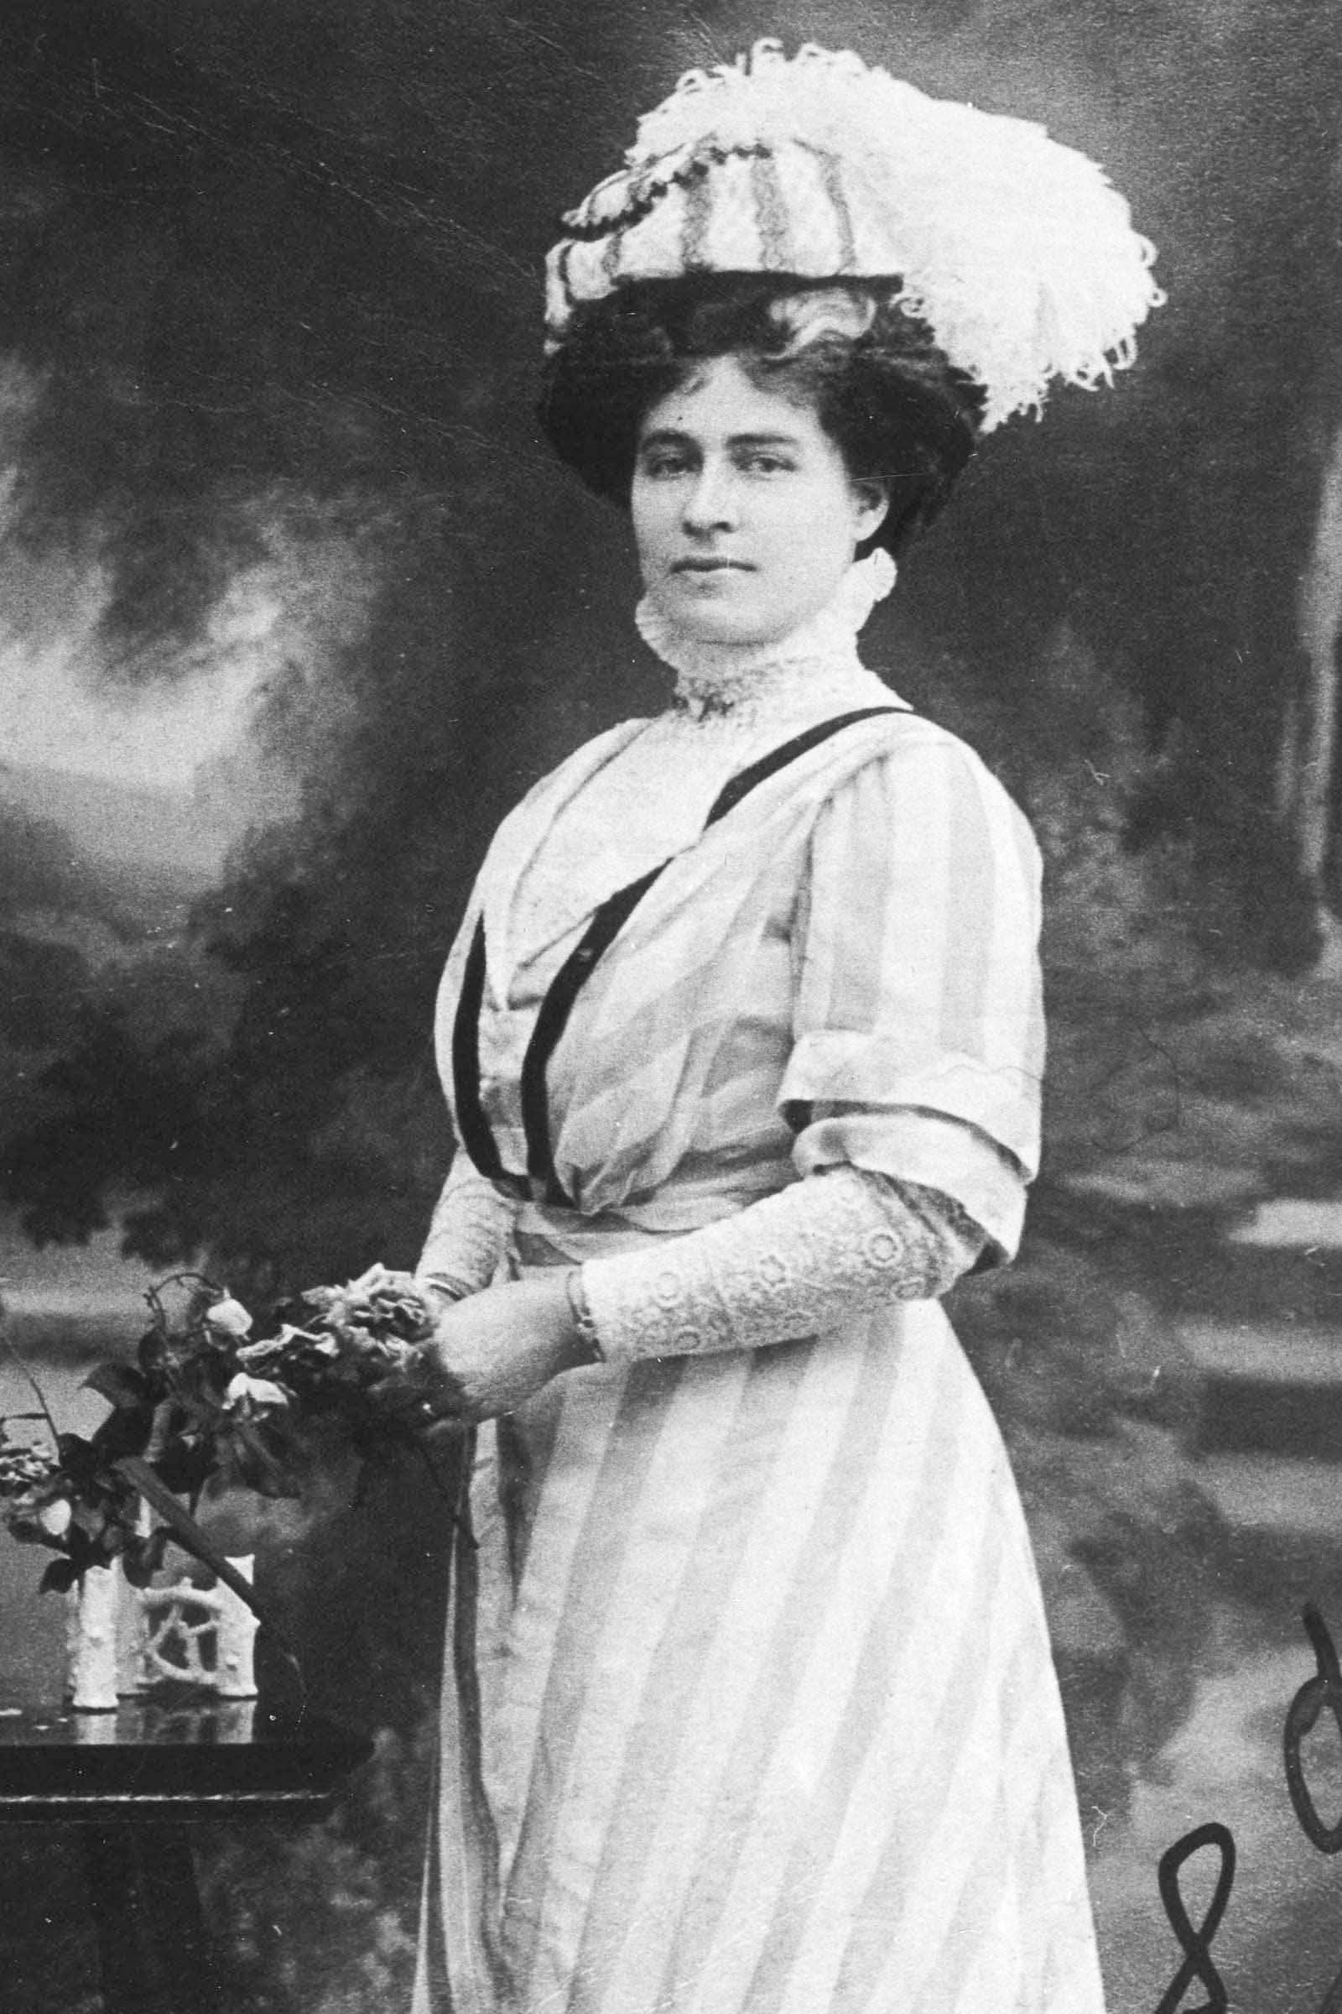

Elizabeth Skarratt

Donald Walter Skarratt, Narromine Son

Born in Ashfield on May 18 1915.

Purchased Ugumijil we think in the Parish of Momo in the Tomingley District on the 8/4/1938 from Florence and Bede William Augustine for 9,813 Pounds and 10 shillings.

The property was sold on the 30/11/1966 to William Thomas Wilton for $100,000

The property has been described as being “down south in the hills” and was for grazing only.

A local describes him as keeping to himself but drove a nice car.

Newspaper clips on his 1939 marriage..

Admired the Photo HIS FUTURE BRIDE (Nepean Times October 5, 1939.

At the home of Mrs C. H. Gurner, of Picton, several years ago, Mr Donald Skarratt, of Narromine, son of Mr and Mrs D, Skarratt, of .' Mountside," Glenbrook, saw the photo of a school glrl

and was impressed by her beauty. He remarked that he must meet her when she grew up.

The girl was Miss Mollie Crowther,Mrs Gurner's niece, and was then living in Valparaiso, Chile. A year ago she came to Sydney, her photograph appeared in the Sydney Press on her arrival, and was recognised bv Mr Skarratt. He was introduced to her shortly afterwards, and on Saturday

Night thev were married at St. Mark's Church, Darling Point.

The bride, who was born in Peru, comes of an old Australian pioneering family. Her great-grandfather, Dr. J.M. Walker, was the first doctor in the Camden district, she is the youngest

daughter of Mr and Mrs P. Russell Crowther, who are at present living witli Mrs Crowther's sister, Mrs H. A. Walker,of Woodburn Park, Lakesland.

With her cream satin classical gown, the bride wore an antique bracelet which belonged to her grandmother,Lady Cassells, of Melbourne, and her tulle veil was worn by her aunt, Mrs

Gurner. She carried a sheaf of azalias and orchids, and wore a coronet of orange blossom.

Bishcn E. N. Wilton, assisted by Canon R. W. A. Barder, performed the ceremonv. Miss Crowther was at tended by Miss Pat Bennett and a flower girl, Sally Gurner. Mr Brian Broadbent, of Orange, was best man, and the reception was held at. Elizabeth Bay House.

The bride and bridegroom will make their home at Narromine.

He was a member of the CMF (N4124) when he joined the AIF in July 21, 1941 at Seymour Victoria (NX114275). As a warrant Officer he served with the Army School of mechanisation, Seymour, Victoria, and later with the land HQ, Port Moresby. He was discharged in January 1946.

He died in Concord Repatriation Hospital in 1977 two weeks after being severely burnt after his house caught fire we believe by arson.

More information available about his life is available..

**Eric Norris Skarratt** Glenbrook (Architect)

Born on March 16, 1919. He lived at Glenbrook

12/1/1939

Technical Examinations

Among successes al the recent Technical College examinations were the followlng-Architecture, Diploma

Course. Stage II.. Eric N, Skarratt;

Newcastle and District Mechanical Engiineering,, Diploma, stage III., Clinton J. Blessing.

He joined the AIF in 1942 (NX149495) as a Lieutenant with the 5th Australian Army Troops Company, Royal Australian Engineers. He served in New Guinea at Milne Bay and on Bougainville from 1943 to 1945.

25/5/1949

Mr. ERIC SKARRATT, ot Glenbrook, has been appointed consulting architect to Penrith Council.

Married Helen Baldwin (Artist). Blaney.

Son: John B: 1947

Eric died on August 6, 2000.

Helen Baldwin

Australian Womens Weekly 26/5/1951

New South Wales artist Helen Baldwin (Mrs. Eric Skarratt).

MEASURING 27 inches by 14 inches, it shows the party being farewelled by friends in period costume at the gates of Government House, Sydney, their boat mounted on a dray.

The picture is worked in coloured wools and silks in petit-point and gros-point, varieties of

satin-stitch. Flesh tones and other fine detail

arc in petit-point, 400 stitches to the square inch, and the remainder in gros-point, 100 stitches to

the square inch.

Similar to tapestry in effect, it will be included in an exhibition which Miss Baldwin hopes to hold in Sydney later this year. It took six weeks to complete..Miss Baldwin classes her work as pictorial embroidery. She points out that tapestry is woven on a loom, the design being part of the process of making the cloth.

Her embroidery is more in the tradition of the historical Bayeux tapestry. The result is as far from the ordinary conception of embroidery as could be imagined. From a few paces off, Helen Baldwin's embroidery has all the appearance and liveliness of water-colour or oil-paintings.

The sewing technique is also far removed from that of the famous Bayeux tapestry, the actual stitchery of which is somewhat crude. "A newspaper photograph gave me the basic idea for the picture," said Miss Baldwin. "Then I had to sketch it out on a larger scale in water-colours, and rearrange it slightly to show the faces.

"They didn't come out clearly in the newspaper reproductions, so I had to use my imagination a bit. I prefer to work from living models if I can." When Miss Baldwin had finished her sketch and worked out the colour-scheme, her next job was to draw the picture in ink on embroidery canvas. "That's always the most monotonous part of the job," she said. "After that, it's a matter of 'painting with the needle'." After doing this type of needlework for about 10 years, Miss Baldwin has the appreciation of a small but expanding circle of art collectors here.

Some of her "pictures" will be shown shortly at Charleston, U.S.A. They are examples

taken to America recently by art collector

HELEN BALDWIN (Mrs. E. N. Skarratt), who uses wools and silks instead of paints to create

her embroidery pictures. Dr. Richard Siau, husband of Norman Lindsay's daughter Helen.

Dr. Siau was enthusiastic about Miss Baldwin's work.

Critics say her figures are especially good. Expressions on faces and the reproduction of flesh tones have been described as unique in this type of embroidery.

Miss Baldwin, who taught herself her craft, was born in Blayney, N.S.W. Now in her early thirties,

she says she's been drawing and painting for as long as she can remember. After an art course at Sydney Technical College, she did commercial work for a while, wrote and illustrated children's books, then married architect Eric Skarratt.

Since then, at her home in Glenbrook, on the Blue Mountains, she has concentrated mainly on embroidery, because, she says, "It's thc kind of job you can pick up in odd minutes at home. I like to brood about oil paInting and water-colour, and a housewife never seems to have any long stretches of time without being interrupted." Helen Baldwin finds her time fully occupied

running a home (she's a masterly cook), looking after a garden, and caring for her husband

and five-year-old son John.

One of her most successful portraits is an amazing and delicate likeness of young John,

in petit-point about 1000 stitches to the square inch.