Skarratt Family Notes

Newspaper Clips

Donald Frederick Skarratt 23/5/1873 -10/8/1948

Born: 23/5/1873, Kington Herefordshire

Arrived in Sydney Australia: 28/4/1874

Married: Elizabeth Norris in 1914 at Windsor

Death: 10/8/1948 Glenbrook

The Late Mr. Donald. F.Skarratt

After an illness of about twelve months duration, Mr. Donald Frederick  Skarratt, a gentleman widely known and esteemed in the Nepean and Lower Mountain districts, died at his home, "Mountside", Glenbrook, on 10th August 1948 at the age of 76 years, Mr. Skarratt was born at Kington, Herefordshire, England, the son of William and Mary Skarratt, with whom he came to Australia when he was six months old. They were early residents of the Strathfleld-Burwood district.

In his youthful days Mr, Skarratt went to Queensland and worked on the Claverton Downs Station, to gain colonial experience. In 1905 he bought "Mountside", Glenbrook, from the late Mr. Colin Smith, where he continued to reside for the rest of his days.

He proved himself a public-spirited gentleman, giving much of his time and talents to district advancement, in proof of which it may be mentioned that he was for 21 years a Councillor of Blue Mountains Shire Council. He took a keen interest in Shire matters and in any movements for local progress.

He was married in St. Matthew's Church, Windsor, in 1914, to Elizabeth Norris, daughter of the late William and Jane Norris, of Roma, Queensland, by the late Rev. Norman Jenkyn, Rector.

Deceased is survived by Mrs. Skarratt and by two sons-Donald (Narromine) and Eric (Glenbrook). He leaves no brother or sister, being the last of a family of eight. The late Mr. Walter Russell Hall, well-known in Queensland gold mining circles, was a cousin of Mr. Skarratt.

A largely-attended cremation took place at Northern Suburbs Crematorium on 11th inst., the service being conducted by Bishop Wilton, a friend of the deceased. Numerous wreaths bore testimony to the very high regard in which Mr. Don Skarratt was held and the sympathy felt for the bereaved.

In 1906 Elizabeth Norris was living at Ulinbawn and her occupation was listed as “lady help”. Elizabeth married Donald Skarratt in 1914 at Windsor.

His occupation at one stage was listed as “trainer”

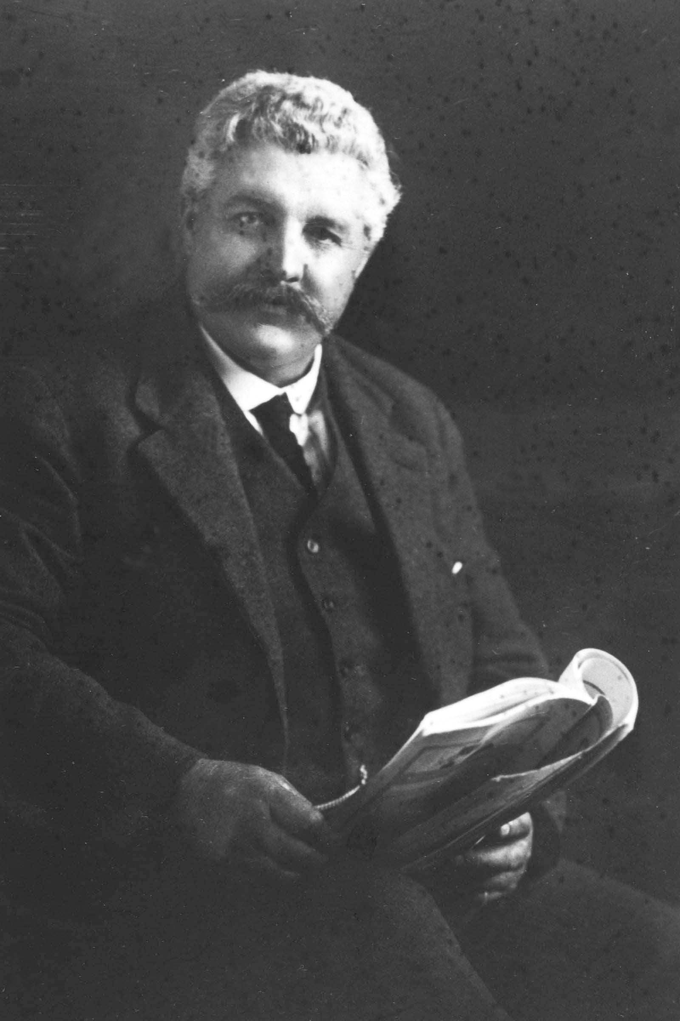

Donald F Skarratt

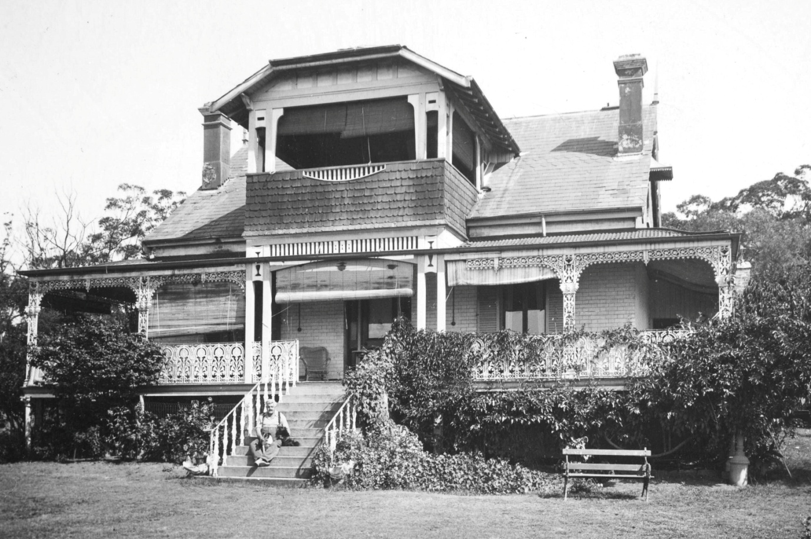

Donald at Mountside before the fire

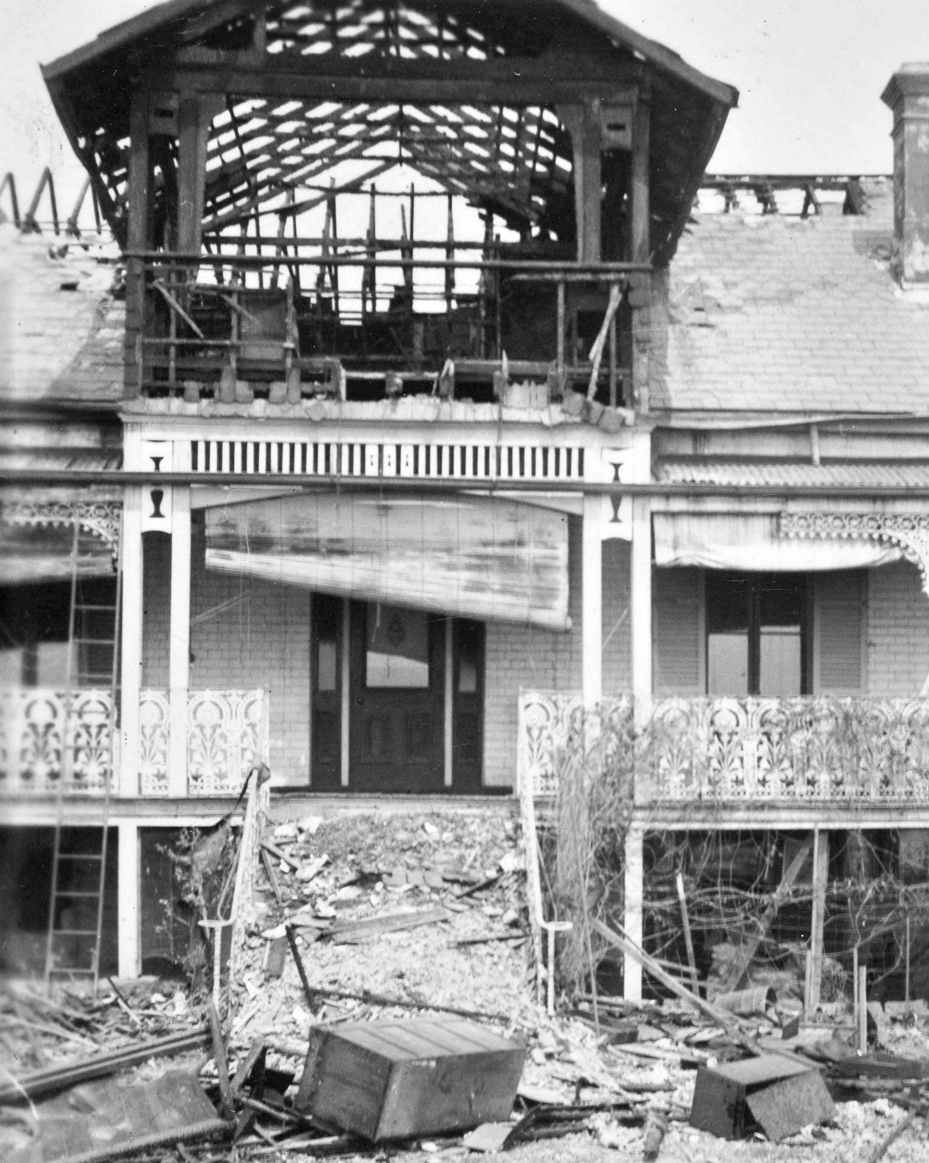

Mountside after the fire

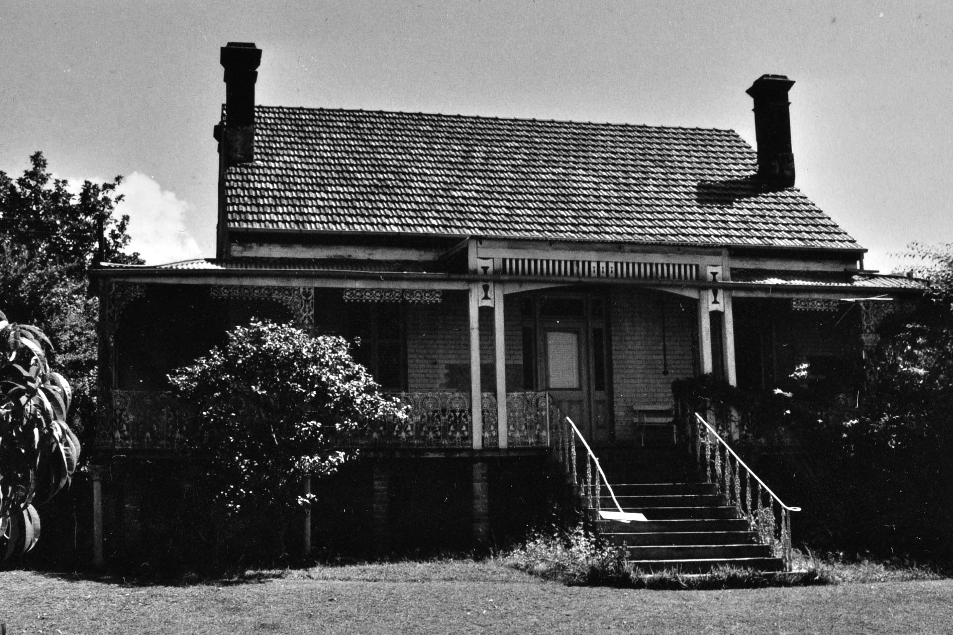

Mountsisde as rebuilt after the fire

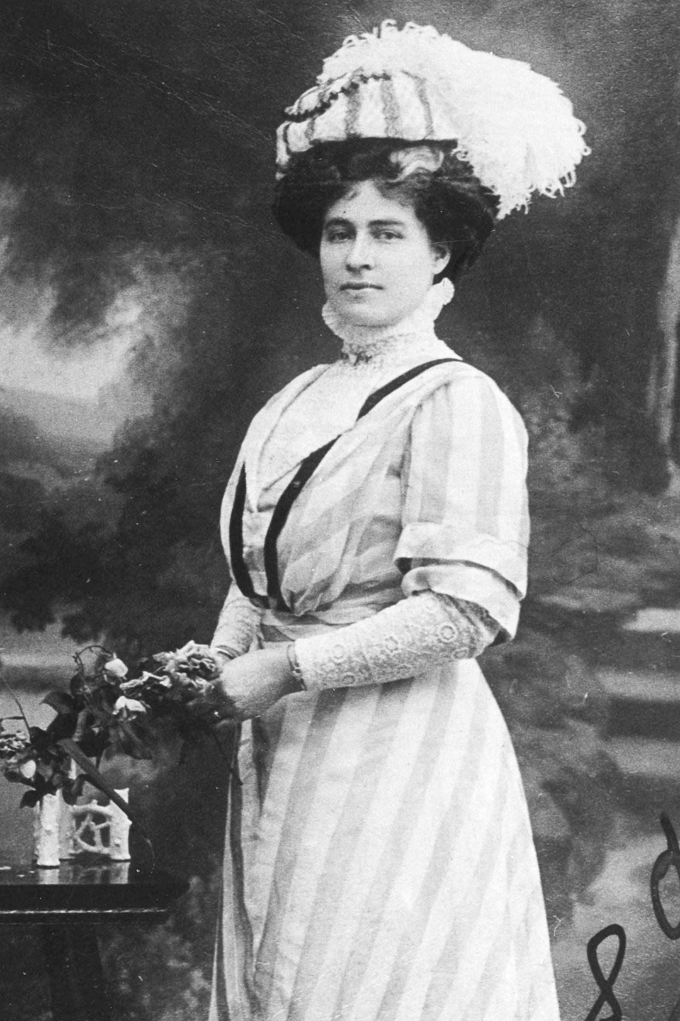

Donald Walter Skarratt, Narromine Son

Born in Ashfield on May 18 1915.

Purchased Ugumijil we think in the Parish of Momo in the Tomingley District on the 8/4/1938 from Florence and Bede William Augustine for 9,813 Pounds and 10 shillings.

The property was sold on the 30/11/1966 to William Thomas Wilton for $100,000

The property has been described as being “down south in the hills” and was for grazing only.

A local describes him as keeping to himself but drove a nice car.

Newspaper clips on his 1939 marriage..

Admired the Photo HIS FUTURE BRIDE (Nepean Times October 5, 1939.

At the home of Mrs C. H. Gurner, of Picton, several years ago, Mr Donald Skarratt, of Narromine, son of Mr and Mrs D, Skarratt, of .' Mountside," Glenbrook, saw the photo of a school glrl

and was impressed by her beauty. He remarked that he must meet her when she grew up.

The girl was Miss Mollie Crowther,Mrs Gurner's niece, and was then living in Valparaiso, Chile. A year ago she came to Sydney, her photograph appeared in the Sydney Press on her arrival, and was recognised bv Mr Skarratt. He was introduced to her shortly afterwards, and on Saturday

Night thev were married at St. Mark's Church, Darling Point.

The bride, who was born in Peru, comes of an old Australian pioneering family. Her great-grandfather, Dr. J.M. Walker, was the first doctor in the Camden district, she is the youngest

daughter of Mr and Mrs P. Russell Crowther, who are at present living witli Mrs Crowther's sister, Mrs H. A. Walker,of Woodburn Park, Lakesland.

With her cream satin classical gown, the bride wore an antique bracelet which belonged to her grandmother,Lady Cassells, of Melbourne, and her tulle veil was worn by her aunt, Mrs

Gurner. She carried a sheaf of azalias and orchids, and wore a coronet of orange blossom.

Bishcn E. N. Wilton, assisted by Canon R. W. A. Barder, performed the ceremonv. Miss Crowther was at tended by Miss Pat Bennett and a flower girl, Sally Gurner. Mr Brian Broadbent, of Orange, was best man, and the reception was held at. Elizabeth Bay House.

The bride and bridegroom will make their home at Narromine.

He was a member of the CMF (N4124) when he joined the AIF in July 21, 1941 at Seymour Victoria (NX114275). As a warrant Officer he served with the Army School of Mechanisation, Seymour, Victoria, and later with the land HQ, Port Moresby. He was discharged in January 1946.

He died in Concord Repatriation Hospital in 1977.

Eric Norris Skarratt Glenbrook (Architect)

Born on March 16, 1919. He lived at Glenbrook

12/1/1939

Technical Examinations

Among successes al the recent Technical College examinations were the followlng-Architecture, Diploma

Course. Stage II.. Eric N, Skarratt;

Newcastle and District Mechanical Engiineering,, Diploma, stage III., Clinton J. Blessing.

He joined the AIF in 1942 (NX149495) as a Lieutenant with the 5th Australian Army Troops Company, Royal Australian Engineers. He served in New Guinea at Milne Bay and on Bougainville from 1943 to 1945.

25/5/1949

Mr. ERIC SKARRATT, ot Glenbrook, has been appointed consulting architect to Penrith Council.

Married Helen Baldwin (Artist). Blaney.

Son: John B: 1947

Eric died on August 6, 2000.

Helen Baldwin

Australian Womens Weekly 26/5/1951

New South Wales artist Helen Baldwin (Mrs. Eric Skarratt).

MEASURING 27 inches by 14 inches, it shows the party being farewelled by friends in period costume at the gates of Government House, Sydney, their boat mounted on a dray.

The picture is worked in coloured wools and silks in petit-point and gros-point, varieties of

satin-stitch. Flesh tones and other fine detail

arc in petit-point, 400 stitches to the square inch, and the remainder in gros-point, 100 stitches to

the square inch.

Similar to tapestry in effect, it will be included in an exhibition which Miss Baldwin hopes to hold in Sydney later this year. It took six weeks to complete..Miss Baldwin classes her work as pictorial embroidery. She points out that tapestry is woven on a loom, the design being part of the process of making the cloth.

Her embroidery is more in the tradition of the historical Bayeux tapestry. The result is as far from the ordinary conception of embroidery as could be imagined. From a few paces off, Helen Baldwin's embroidery has all the appearance and liveliness of water-colour or oil-paintings.

The sewing technique is also far removed from that of the famous Bayeux tapestry, the actual stitchery of which is somewhat crude. "A newspaper photograph gave me the basic idea for the picture," said Miss Baldwin. "Then I had to sketch it out on a larger scale in water-colours, and rearrange it slightly to show the faces.

"They didn't come out clearly in the newspaper reproductions, so I had to use my imagination a bit. I prefer to work from living models if I can." When Miss Baldwin had finished her sketch and worked out the colour-scheme, her next job was to draw the picture in ink on embroidery canvas. "That's always the most monotonous part of the job," she said. "After that, it's a matter of 'painting with the needle'." After doing this type of needlework for about 10 years, Miss Baldwin has the appreciation of a small but expanding circle of art collectors here.

Some of her "pictures" will be shown shortly at Charleston, U.S.A. They are examples

taken to America recently by art collector

HELEN BALDWIN (Mrs. E. N. Skarratt), who uses wools and silks instead of paints to create

her embroidery pictures. Dr. Richard Siau, husband of Norman Lindsay's daughter Helen.

Dr. Siau was enthusiastic about Miss Baldwin's work.

Critics say her figures are especially good. Expressions on faces and the reproduction of flesh tones have been described as unique in this type of embroidery.

Miss Baldwin, who taught herself her craft, was born in Blayney, N.S.W. Now in her early thirties,

she says she's been drawing and painting for as long as she can remember. After an art course at Sydney Technical College, she did commercial work for a while, wrote and illustrated children's books, then married architect Eric Skarratt.

Since then, at her home in Glenbrook, on the Blue Mountains, she has concentrated mainly on embroidery, because, she says, "It's the kind of job you can pick up in odd minutes at home. I like to brood about oil paInting and water-colour, and a housewife never seems to have any long stretches of time without being interrupted." Helen Baldwin finds her time fully occupied

running a home (she's a masterly cook), looking after a garden, and caring for her husband

and five-year-old son John.

One of her most successful portraits is an amazing and delicate likeness of young John,

in petit-point about 1000 stitches to the square inch.

Thomas Carleton Skarratt.

The oldest son of William Carleton and Francis Mary Fannie (nee Weale) Skarratt born in Kington Herefordshire in 1853. He migrated with the rest of the family to Australia in 1874. He was listed in the 1906 Electoral Roll as living at Ulinbawn with occupation as assayer probably at the Mt Morgan mine.

There is no record of his first wife at the moment. His second wife in 1907 was Esther Caroline Page who was born in Binalong in 1860. It was said she was a barmaid in an unknown hotel where Thomas was the publican. A family member did own the Royal Hotel in George Street Sydney

They lived at Lakesland near Thirlemere. Thomas died on October 31, 1929 aged 72 years at Picton. His occupation was shown as “Gentleman”

His estate (File 48441} was calculated at 17,450 pounds 2 shillings and 9 pence