GLENBROOK POINTS

Newsletter of Glenbrook & District
Historical Society Inc.

Oct-Nov 2012
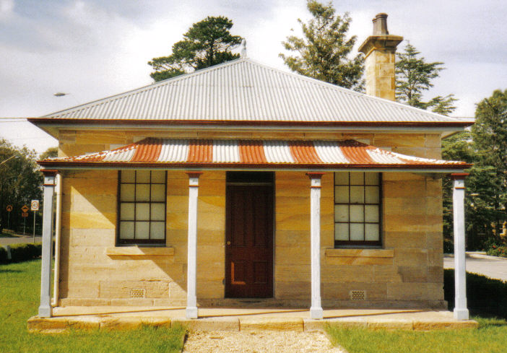
Postal address P.O. Box 38 Glenbrook NSW 2773

Contacts: Tim Miers 4739 2384
Doug Knowles 4751 3275

Meetings 3rd Wednesday monthly at 1.30 pm
(except Dec-Jan) Glenbrook Guides Hall
cnr Hare & Moore Streets Glenbrook

WALKS & TALKS: From Oct 2012.
OCTOBER: Saturday 27th: 9.30am Glenbrook Discovery - "Heritage Walk.' (Last walk for this season.)
MARCH Saturday 16th. 2013 at 9.30am: Duck Hole--Glenbrook Creek, Old Roadway Construction and Railway Pump Site.
Adults: $5.00ea. Children under 16yrs. free, but must be accompanied by a parent or guardian. (No dogs please.) Bookings are essential: Phone Doug. on 4751 3275 (Please allow the phone to ring long), or Tim on 4739 2384 for details

