Page 4 Items of interest

Our September meeting will be the A.G.M. and all executive positions will be open for election.Nomination forms are available from Secretary Shirly Konza. Please bring a plate for afternoon tea.

Register now for Histroy Conferance at Carrington Hotel 27/10/12..... $45 per p. Registration forms now available.

BMCC Elections.... All Ward 4 nominees have been invited to address our next meeting.. Aug 15th

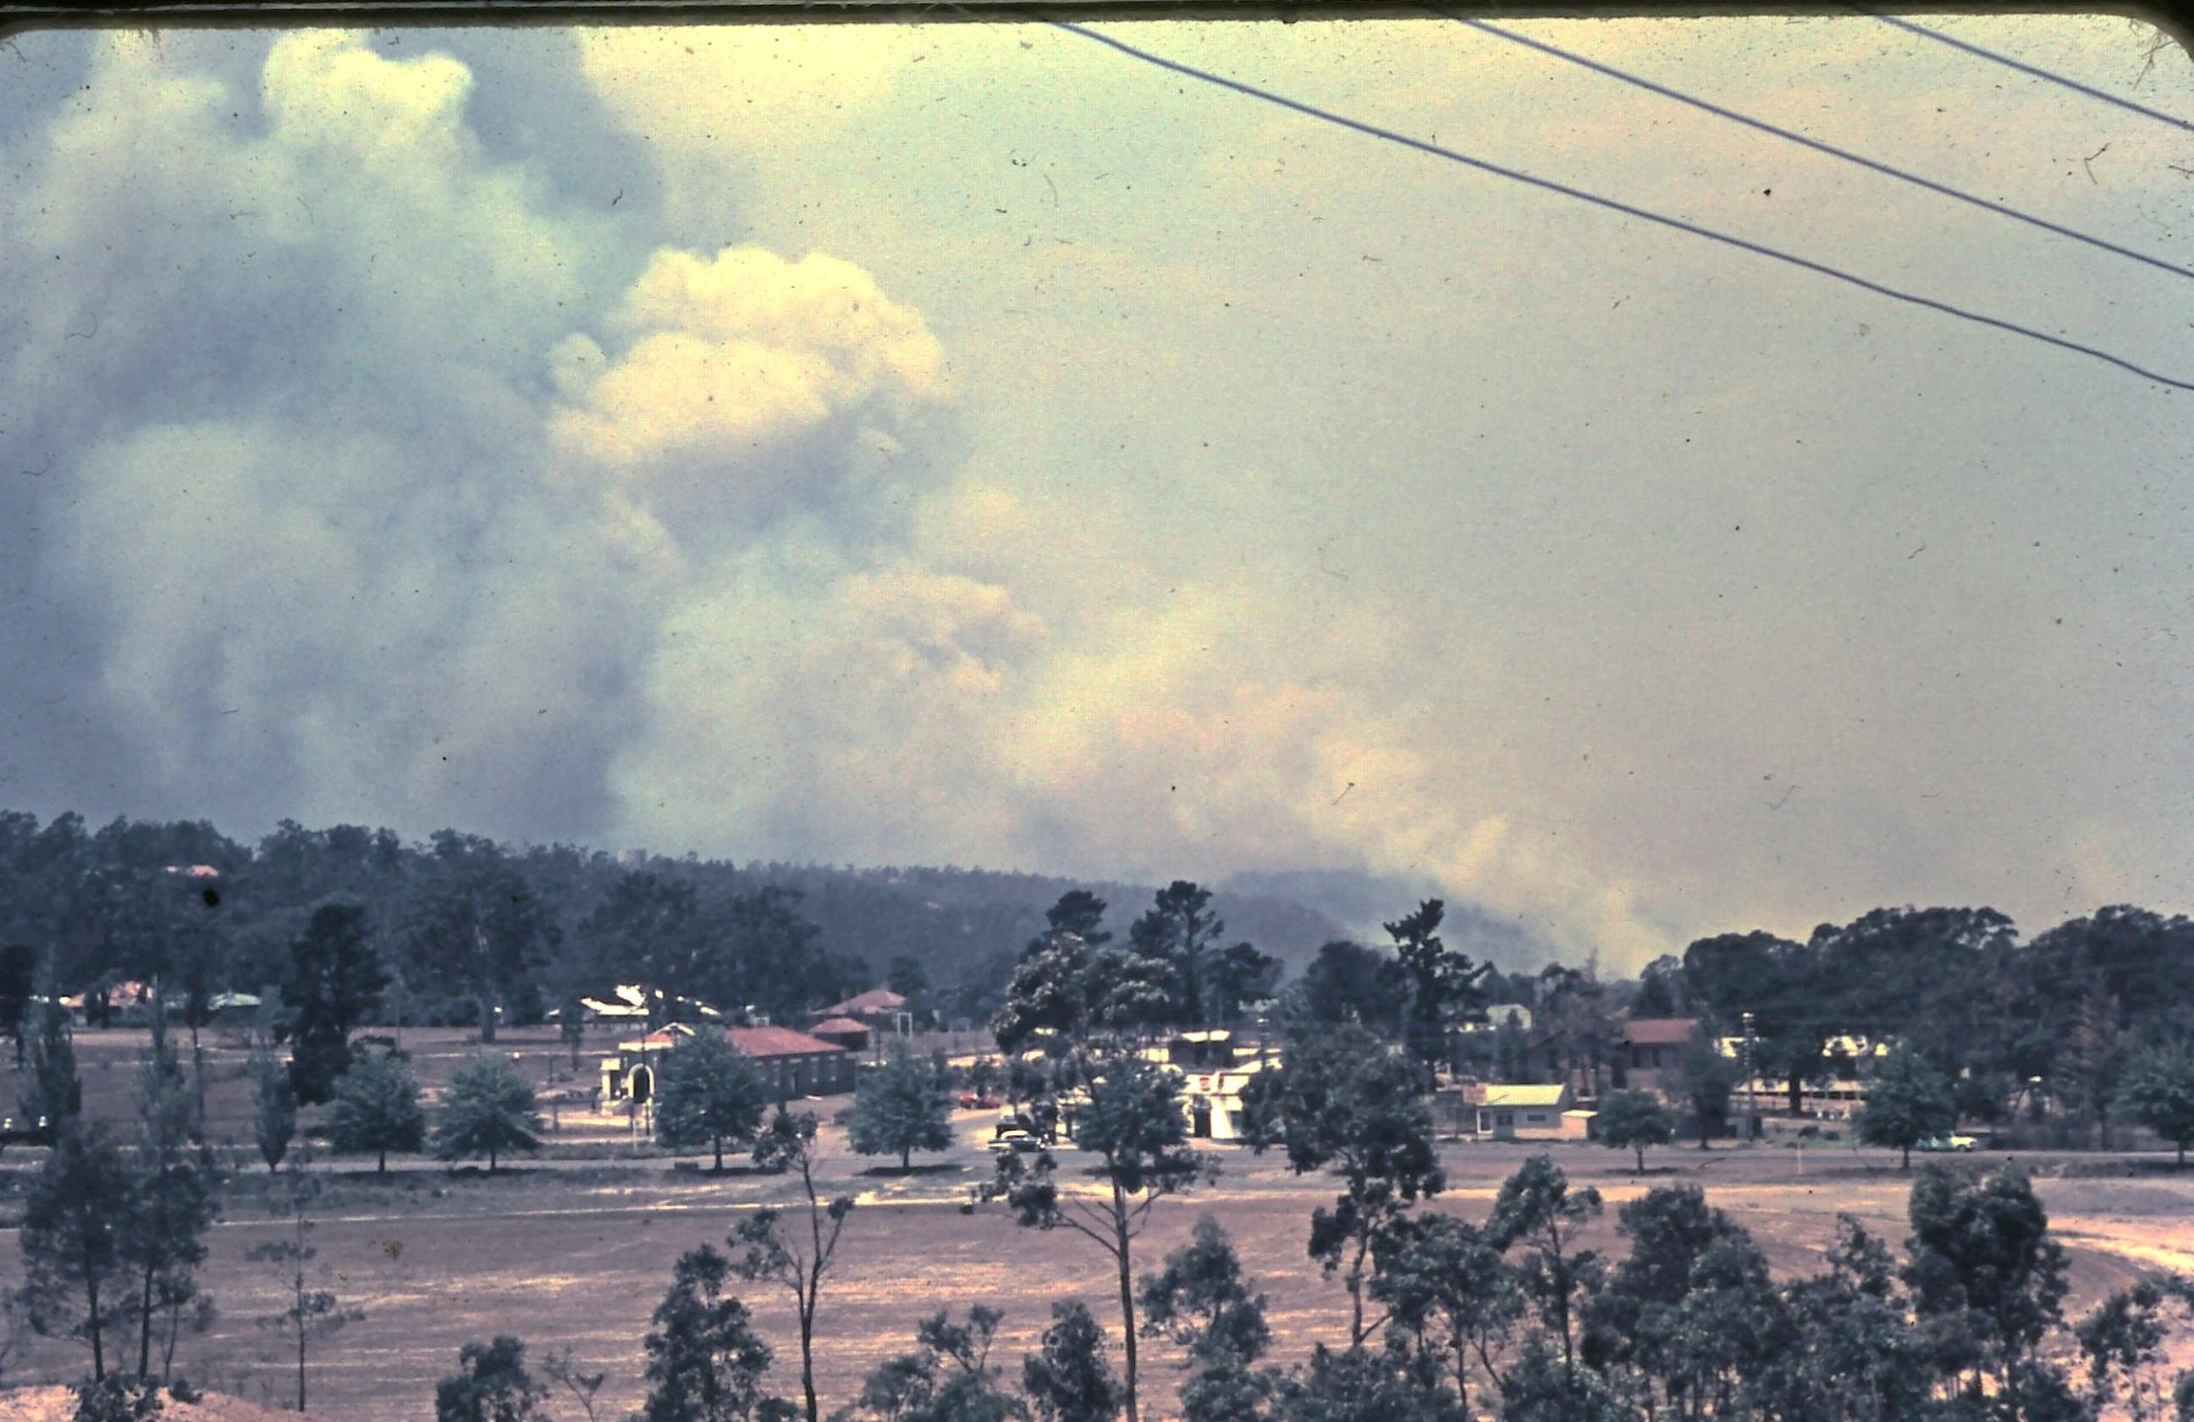

Glenbrook Dec 1957
Anyone with any memories of this day, would you like to put pen to paper and give us your memories.... Fax or e-mail to Mary K or editor e-mail only jpe13704@gmail.com

STOP PRESS Mr Stuart Williams of Levy St Glenbrook died Thursday 9th age 96yrs.. funeral details not yet available. Stuart lived in glenbrook all his life and was a member of the Society. Our sympathy goes to the family. A page wll be devoted to his life next issue.

