Cont... Page 4
It came to my notice that someone wants to move the War Memorial from Blaxland to Glenbrook. I don't know that it has ever been moved before but I knew that it had not been moved twice. That is one thing that Tim (Miers,) Doug (Knowles,) and I agreed on. I made some calls to my older brothers and sisters and Beryl. Beryl Madden is the great-great granddaughter of Joshua Hargraves one of the very first land owners and residents of Blaxland. Beryl saw the ad in the paper and wanted to come to the meeting. For a start, I am telling people that the memorial is still in the park
where it was put: it's the road that has been changed. The road that goes between the monument and the park was put there sometime in the last 15yrs or so. It used to exit at Ridge Road and that little bit of paved road which goes up to the lights: that was the access to the Park which was well used all my life up until about then. After it was cut off, it hasn't been used because no-one can drive to it: you can walk to it. My view is that the monument should stay in Baxland .I want to talk a little more now about Barbara (Higginson) because she was very interested in the War Memorial and she looked into the Campbell family. The Campbell family came after the Hargraves. (Beryl now lives in Warrimoo.) Then came the Calvers of Blaxland who were there for many, many years. The Campbells came very early and they came from the Southern Highlands. They were fairly wealthy and lovely people.They had a daughter and a son. It was the son, Harold, who was killed in the first world war. These people were very generous and they gave a lot to Blaxland: socially, they would have fetes at their home for the Red Cross and raise money. They gave a lot of land for the Church of England in Taringa Street, because at that stage the church was further down near where the Pilgrim Inn was. But they gave this land for future church service. They also gave the block of land next door to their home, which would have been where IGA supermarket is now, for a Scout hall. That is the land that has been, just recently, made into a children's park which was named after the host of the Pilgrim Inn, Outtrimm, If the monument is moved, it should go to Outtrimm Park. Barbara thought that the park should be named "War Memorial Park." Council agreed that it could be called this. They put a notice on it with this name but they didn't do anything with the park: you still couldn't get to it. About 12 months ago, I noticed that the sign was looking a bit daggy, and hadn't been mowed around. They did look after it for awhile. Those little sheds were built by my father. They are now ruined. Council has taken the sign down, as they could not look after it, so it is no longer named "War Memorial Park

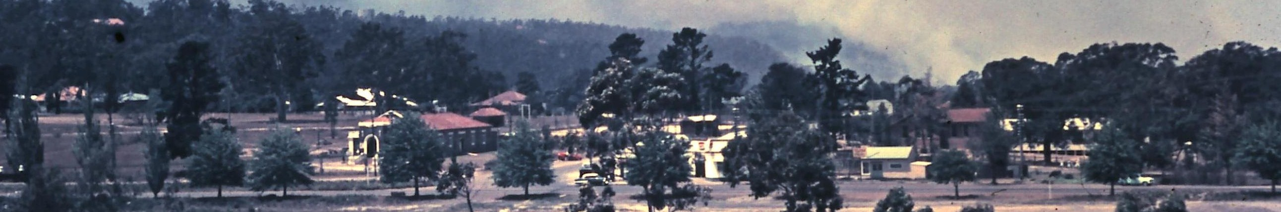
G.W.Highway Glenbrook c1955...Note Lapstone road bar on highway.... How many
cars can you see in this photo?

FROM THE EDITOR.... Let me know if you have an e-mail address. I can e-mail you this newsletter before each meeting (saves postage). Also if you want to publish any photos or documents just send me an e-mail with attachments..... my e-mail is jpe13704@gmail.com
e-mail address is jpe13704@gmail.com

