General Meeting 18th Sept.2013.
1. PLAQUES for PIONEER WALL: the following Families have subscribed to commemorative plaques which are to be made and attached to the wall.
(a) McKENZIE FAMILY: by Edna Nicholls, Glenbrook.
(b) GLOSSOP FAMILY: by Mabel Glossop, Glenbrook
(c) WRIGHT/HERSEY: by April Hersey, Glenbrook
(d) FREE FAMILY: by Maureen Williams, Warrimoo.
(e) JACKSON FAMILY: by Joy Brown, (nee Jackson) Glenbrook.
(f) WHITTON FAMILY: by Neil Whitton, Glenbrook
(g) HUNTER (Nurse) FAMILY: by G & DHS Inc.
2. At last we have actually moved in to the school room. The Community Use Agreement from the Dept. of Education was signed on 13th August, 2013.We have been assured by Tamara and Phoebe, NSW Museums and Galleries, that we can call our display a Museum. Lynn Collins, Museums Adviser to BMCC has also been very helpful.
We will need as much help as possible in setting up the Museum, and members are welcome to join us for this ongoing workshop. Workshops will be, for the time being, the third Saturday of each month., 2.00pm to approx..4.00pm. Please phone Doug. or Mary on 4751 3275 (Let the phone ring long) to confirm.
3. Election of Offices .. Executive Officers:
President: Doug. Knowles, Vice President: Kevin Frappell, Secretary: Mary Knowles, Treasurer: Neil McGlashan.
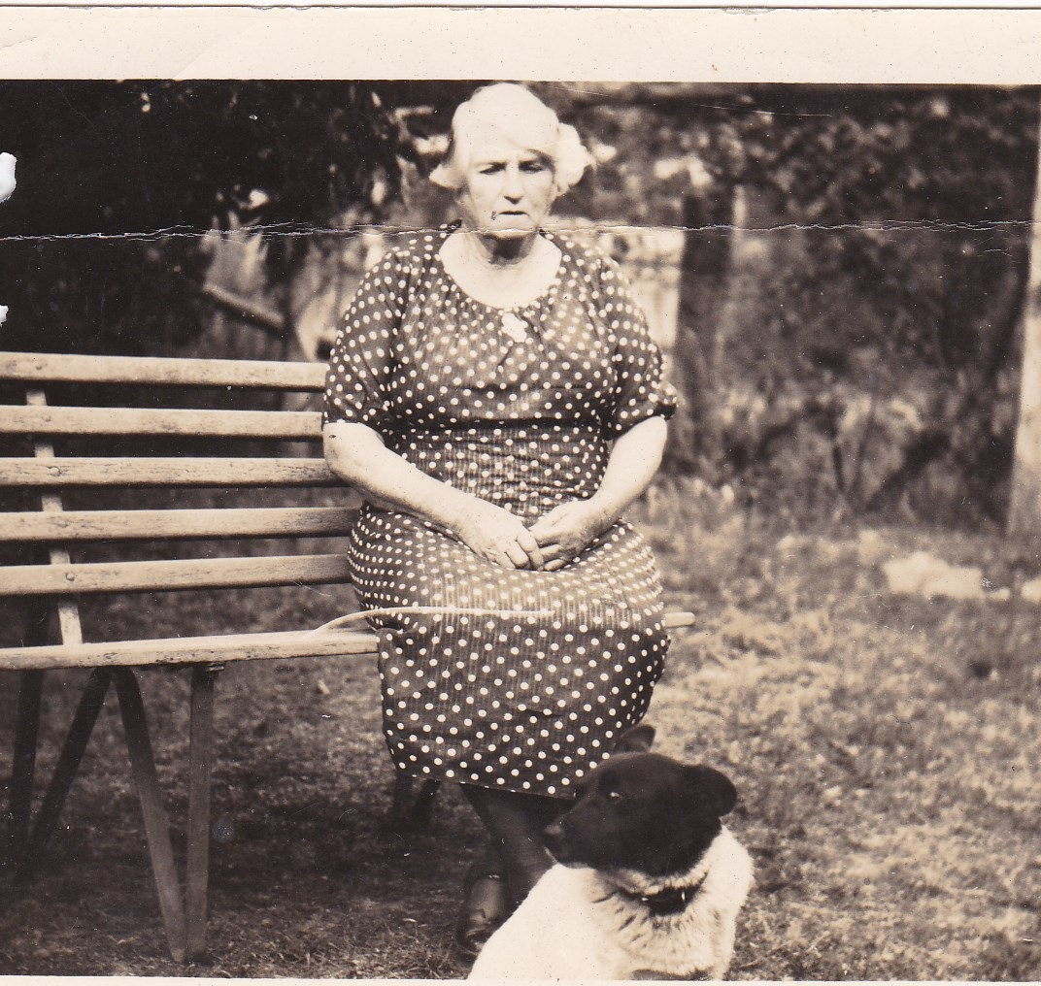
Other Committee Members: Tim Miers, Chief Historian, Pam Thompson and Joan Peard. Publicity Officer: Anne Peters, Catering Officers: Maureen Halford and Pam Thompson, Activities Officer: Mary Knowles.

Nurse Selina Hunter Glenbrook c 1930‘s

