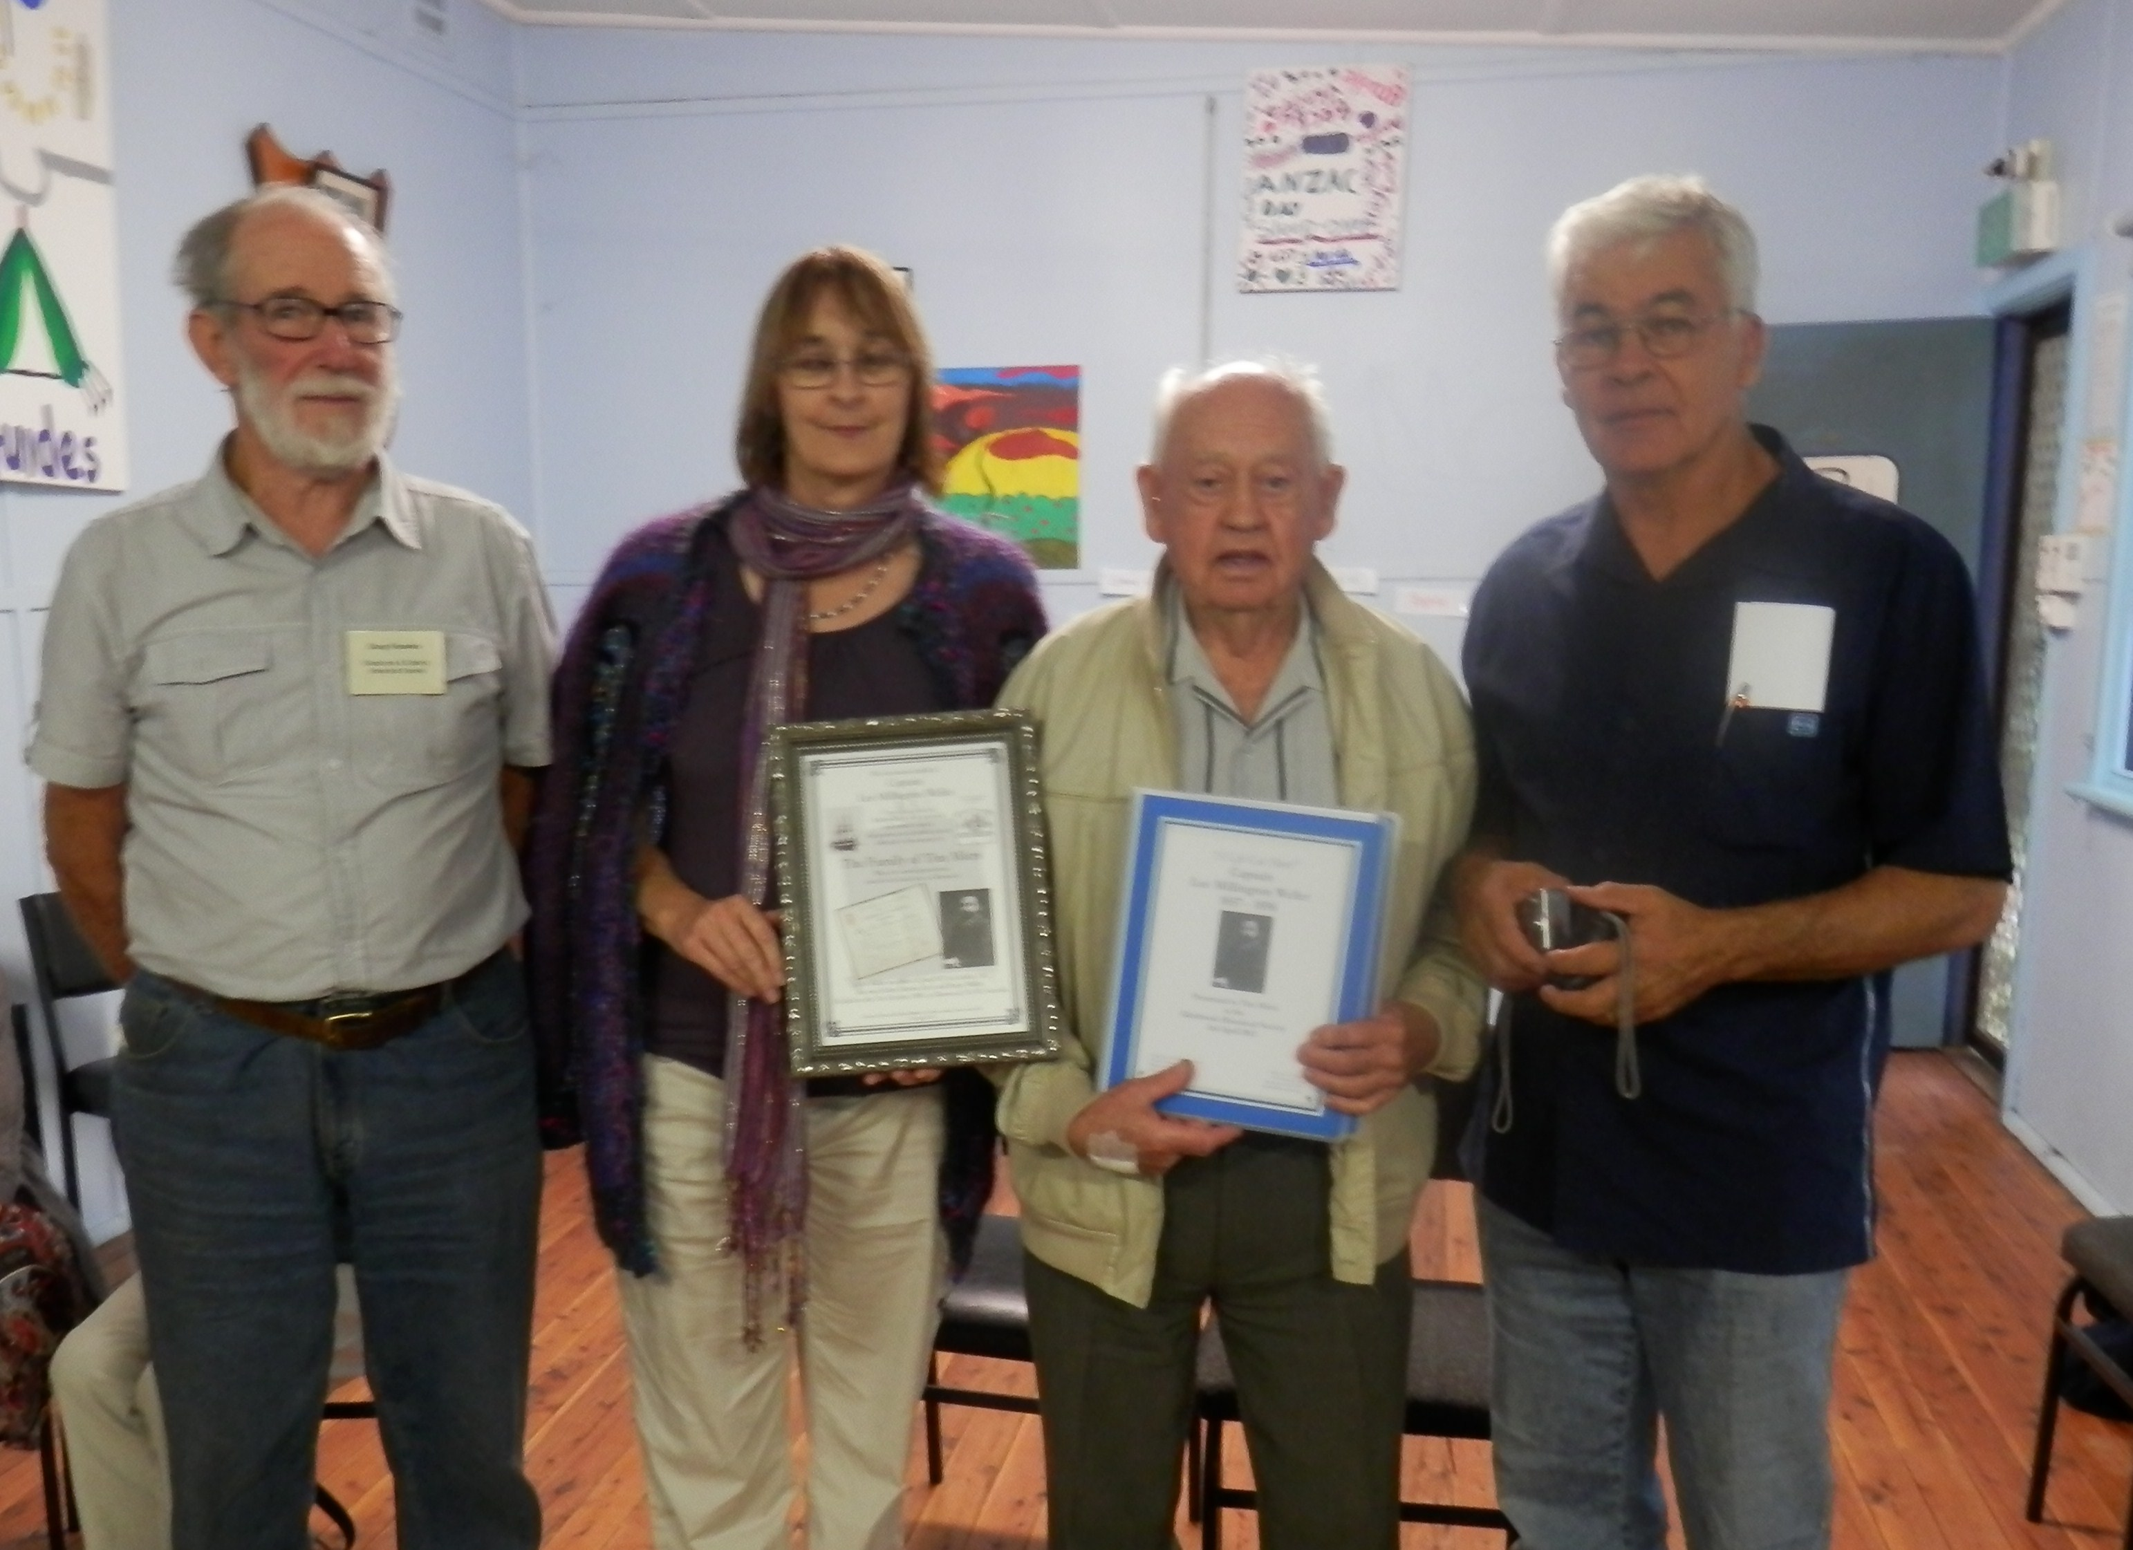

Doug Robin Tim Peter
Presentation of Book & Plaque to Tim Miers Wed 3rd April ‘13

From page 3
Peter Hibbert (Robin’s brother) then addressed the meeting
His research centered around the life of Lee from the time he entered the Maritime Academy, age 14, until his graduation as a Captain. History records that he was a top scholar and received many commissions as a Captain. Peter remarked that we will never know to what heights he may have attained in the young colony of Sydney if it had not been for his untimely demise. All present were deeply impressed with depth of research which Robin & Peter had presented.
Ed note: For those members & non members who are not familiar with the rest of this saga, Frank Butler and his victims, can find a full report in a book “Glenbrook & District A History” Chapter V “The Weller Murder” written by Nell Aston. Book is available $25 from The Society or “The Brook” Gifts and Crafts Co-Op Glenbrook. 4739 9511
.......................................................................................

At our June meeting Kate Matthew will be our guest speaker. Kate is an historian researching the “Old Lapstone Hotel”

