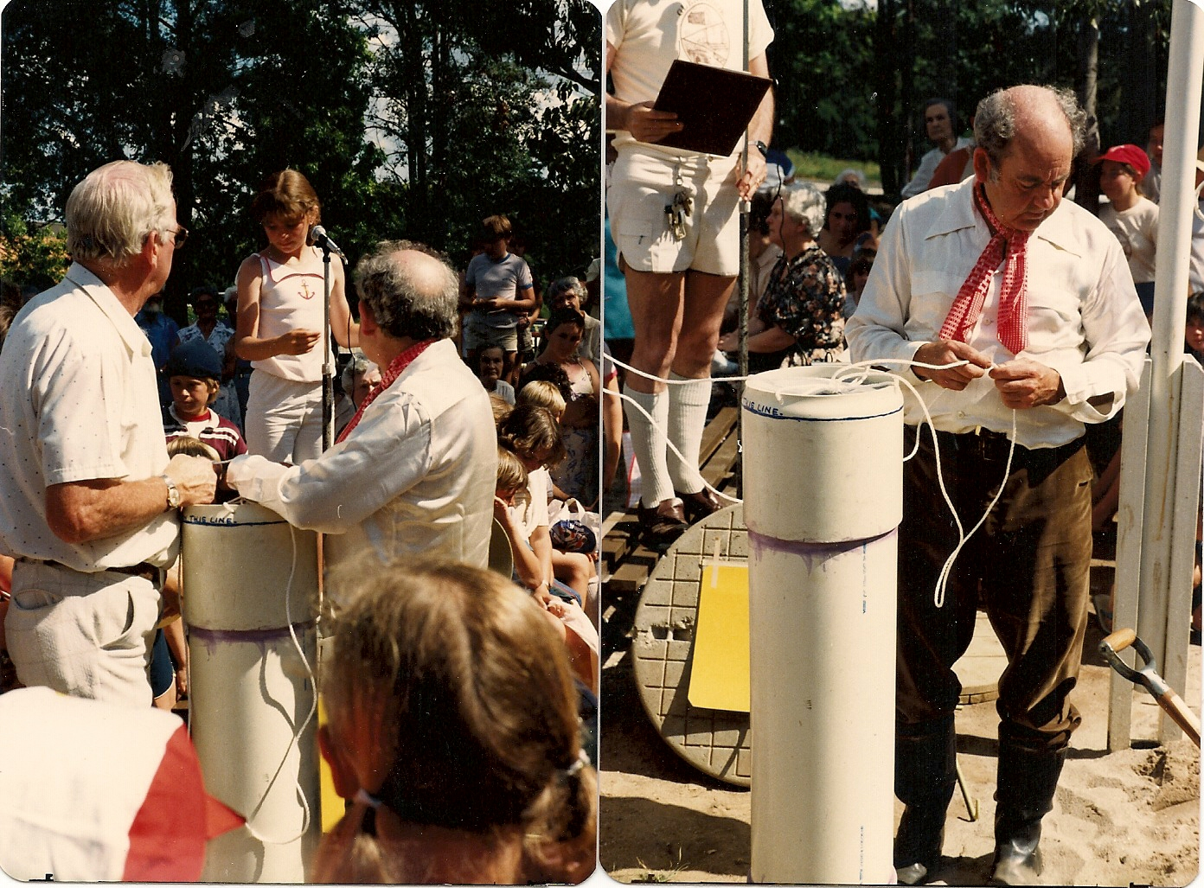

Tim Miers preparing first capsule at 1992 centenary celebrations Glenbrook Infants School

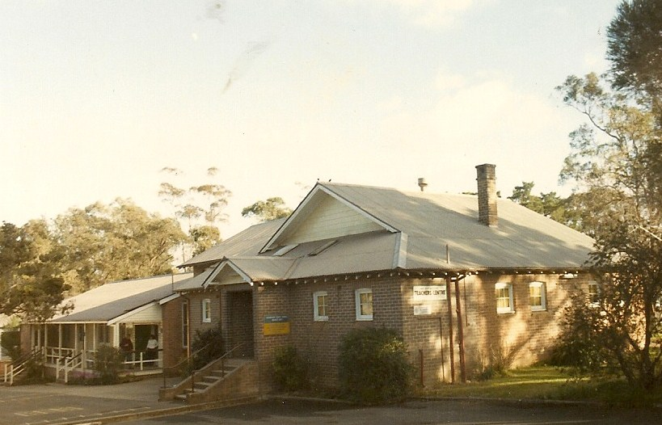

Glenbrook Infants School 1992

