Pam’s Page THE INNS AT EMU PLAINS.
Once the road over the mountains to the goldfields was opened and a regular coach service was started, inns began to spring up: indeed there were six or seven between the Nepean River and the foot of the Lapstone Hill.
These were Emu Inn, Union Inn, the Carrier Arms, the Mountaineer, the Arms of Australia and the Australian Arms. The Emu Inn was licensed to a Harry Hall in 1836: it stood to the west of a building known as the Assembly Hall. This later became a General Store and in the 1940's, was run by the Hutchinson family. It then became a bakery and now stands on the corner of the Great Western Highway and Russell Street, adjacent to the Caltex Service Station The Union Inn was on the southern side of the G.W.H just past River Road and is now completely derelict. A fact that must have been very confusing were the two inns of similar names, quite close to each other on the same road. The Arms of Australia was licensed in 1841 and is now a very interesting museum displaying local memorabilia. It was purchased by the Penrith Council in 1969 when it was almost derelict and restored to be used as a museum. The Australia Arms sits today beside the traffic lights at the intersection of the Great Western Highway and Old Bathurst Road. For many years it was the Emu Plains Post Office. It fell into disrepair and many years ago it was restored and looked wonderful: and yet, once again, it is unused, windows boarded up watching the traffic going by and waiting for what? Behind it stands what must be the only slab shed left in the area. apart from the name, nothing much is known of the other inns. Just along from the museum stands a large old sandstone cottage once known as "Mortimer's Residence." While it was never an inn, it has stood for many years and was once used as a grocery shop. I can remember it being run by a Mrs. Gow. There have been many historical houses in Emu Plains: some of them still standing. But sadly, as has been the case in our area, many of these have disappeared.
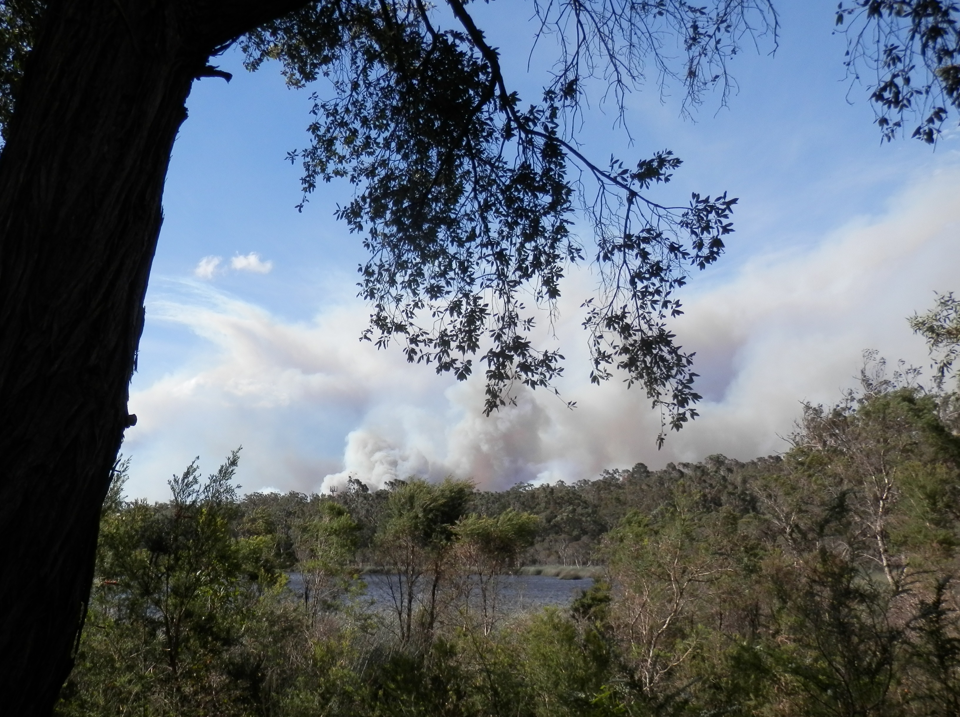

Glenbrook Lagoon looking North
Thursday 4 p.m. 17/10/13

