GLENBROOK POINTS

Newsletter of Glenbrook & District
Historical Society Inc.

APR – MAY 13
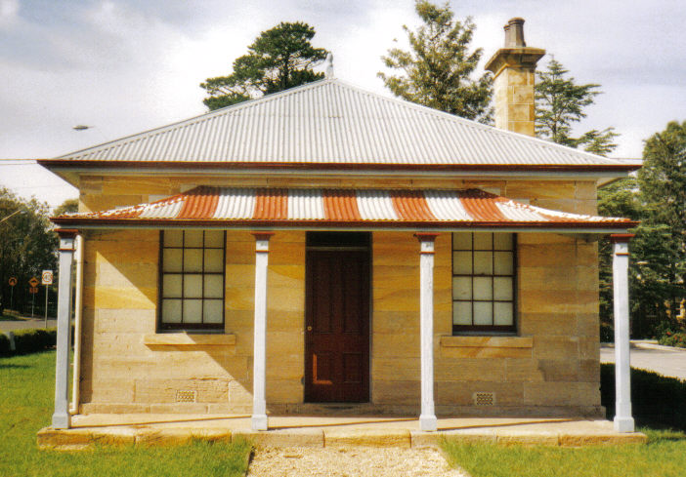
Postal address P.O. Box 38 Glenbrook NSW 2773

Contacts: Tim Miers 4739 2384
Doug Knowles 4751 3275

Meetings 3rd Wednesday monthly at 1.30 pm
(except Dec-Jan) Glenbrook Guides Hall
cnr Hare & Moore Streets Glenbrook

WALKS & TALKS: From May 11th
May, Saturday 11th at 1.30pm: This short guided walk takes us through Glenbrook, following as closely as possible, in the footsteps of Blaxland, Wentworth & Lawson through the village and finishing at the Glenbrook Lagoon for Afternoon Tea. A map will be available on the day, showing transport routes from 1813, and other relevant features. June, Saturday 8th at 1.30pm: "Cox's Road." Walk along a section of this historic road following the ridge-top from Linden to Woodford Adults: $5.00ea. Children under 16yrs. free, but must be accompanied by a parent or guardian. (No dogs please.) Bookings are essential: phone Doug. on 4751 3275 (Please allow the phone to ring long), or Tim on 4739 2384 for details

