GLENBROOK POINTS

Newsletter of Glenbrook & District
Historical Society Inc.

June July 13
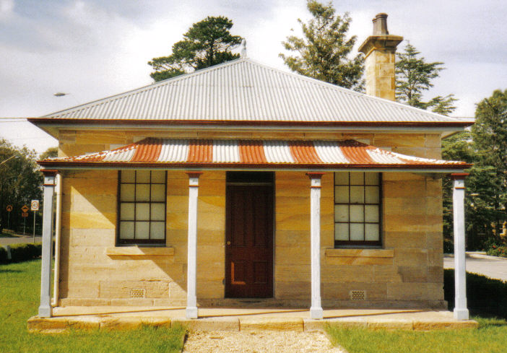
Postal address P.O. Box 38 Glenbrook NSW 2773

Contacts: Tim Miers 4739 2384
Doug Knowles 4751 3275

Meetings 3rd Wednesday monthly at 1.30 pm
(except Dec-Jan) Glenbrook Guides Hall
cnr Hare & Moore Streets Glenbrook

WALKS & TALKS: From June 29th
June, Saturday 29th at 1.30pm: "The Mountain Murders:" Lee Weller's Grave site and rock inscriptions.
July, Saturday 20th at 1.30pm: "Glenbrook Lagoon Precinct." Early campsite and railway dam construction 1880.
August, Saturday 10th at 1.30pm: "Cattle Rustler's Yard," campsite and caves.August, Saturday 31st at 1.30pm: "Lapstone Construction Railway 1910" and East Portal of Lapstone Tunnel 1892.
Adults: $5.00ea. Children under 16yrs. free, but must be accompanied by a parent or guardian. (No dogs please.) Bookings are essential: phone Doug. on 4751 3275 (Please allow the phone to ring long), or Tim on 4739 2384 for details

