GLENBROOK POINTS

Newsletter of Glenbrook & District
Historical Society Inc.

Oct Nov 13
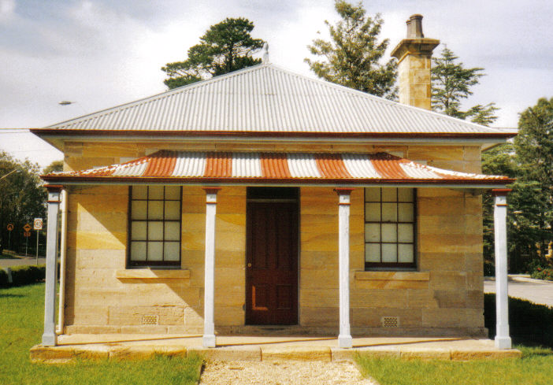
Postal address P.O. Box 38 Glenbrook NSW 2773

Contacts: Tim Miers 4739 2384
Doug Knowles 4751 3275
Meetings 3rd Wednesday monthly at 1.30 pm
(except Dec-Jan) Glenbook Guides Hall
cnr Hare & Moore Sts Glenbook
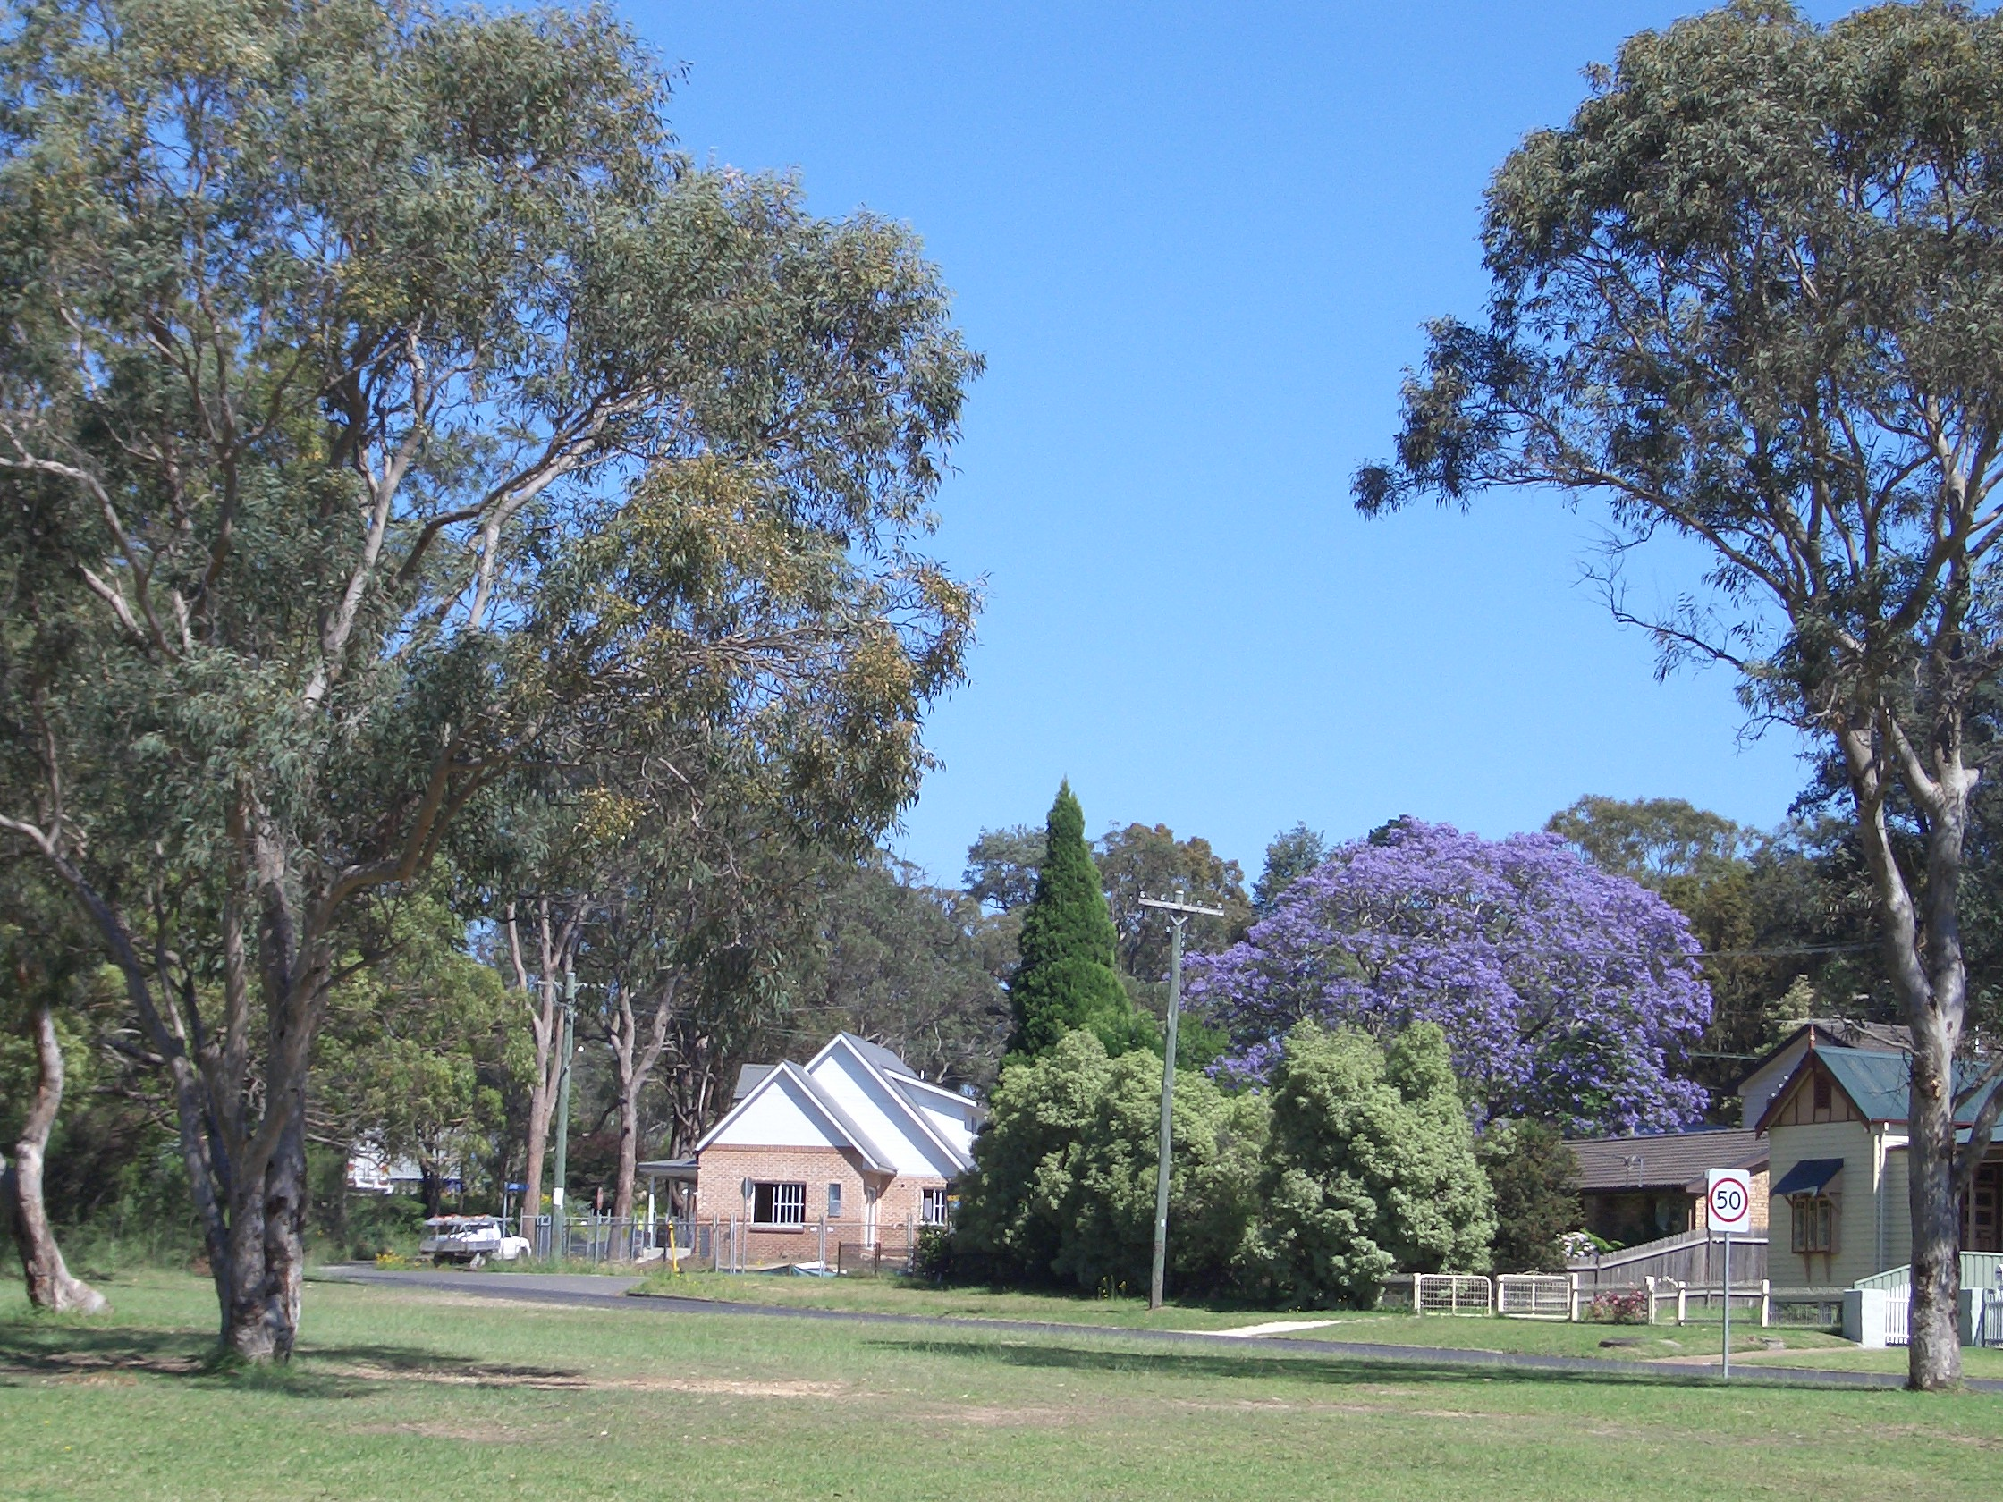

Moore St Whitton Park
Jacaranda are now in blossom throughout Glenbrook

