Pam’s Page
The Native Plant Reserve.
This reserve is situated on land set aside from development in 1816. It has scientific importance because of the endangered Boronia which grew in the area. The land running beside the Great Western Highway is rich in native flora the Boronia, are species of Banksia, Eriostemon and some forms of Melaleuca.
The two hectares of the present reserve are part of two much larger reserves which was originally set aside in 1897 for railway purposes. This also included the present oval. The reserve was originally next to the railway line, but this section of the track was closed in 1913 and in 1926, the Great Western Highway was altered to run along the line of the old railway. So the reserve has been beside the Highway for some 75 years.
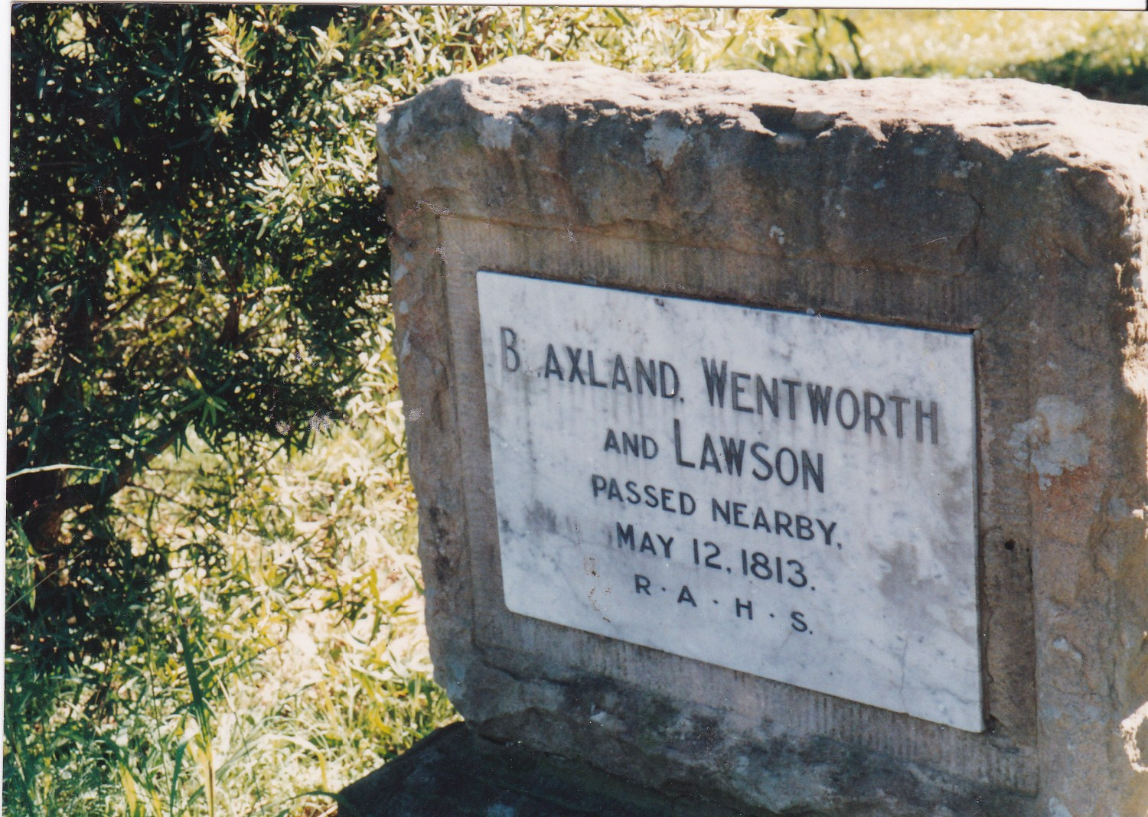
Several memorials have been erected next to the reserve. These include the Garlick Parade sign, and the memorial to Blaxland, Wentworth, and Lawson who passed near here. Also one dedicated to the opening of the highway. The plaque from this was stolen and it has taken many years for the Historical Society to find out the wording and we are having the memorial repaired and restored in the near future. Also included are the brick tank stand piers. These held the water tank which was used to water the Blue Mountains crossing trains and was originally situated memorial
on the Southern side of the Highway.
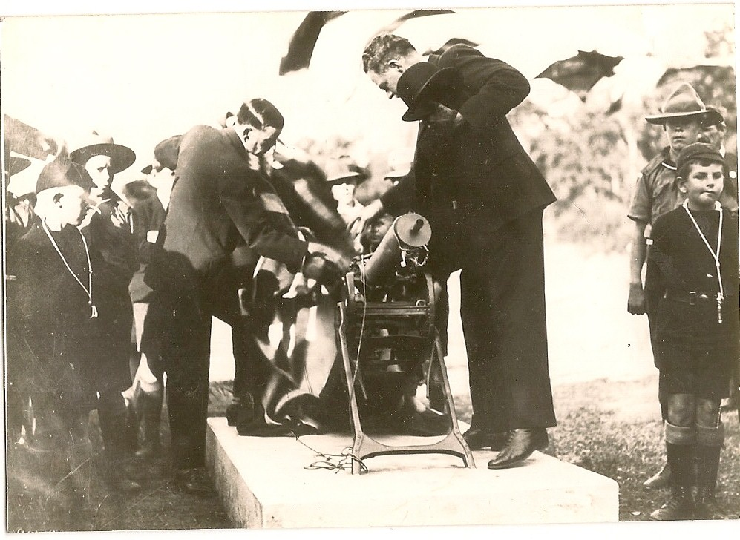
Unfortunately, we cannot replace the gun that sat here from the end of WWI, until sometime during WWII.

Glenbrook Scout Group at
ceremony opening highway 1926
Gun was removed during WWll

