Pam’s Page

In the early 1920's, a Captain Charles Smith, who lived in Darlinghurst, decided he would like a mountain residence. He bought land on top of Lapstone Hill with a partly built house on it: finished it, and called it "Logie." Over the years "Logie" altered and extended. It became the Lapstone Hotel in the late 1920's and in turn, was purchased in the1940's to become the R.A.A.F. Base.
The early history of the R.A.A.F. began with the formation of Eastern Area Headquarters at Edgecliff in Sydney in 1942. At the end of the war, the Headquarters were re-located to Bradfield Park. However, it proved to be unsuitable for a permanent location for an Area Headquarters. In 1949, the Lapstone Hotel was purchased by the R.A.A.F. for use as Eastern Area Headquarters. It was a 2 storied 'U' shaped building of 57 bedrooms together with a dining-room and kitchen, ballrooms and several reception rooms. Also, there were a number of outbuildings, a swimming pool, small golf course and an extensive garden. The property was considered suitable and the premises were occupied by the R.A.A.F. in 1950. Between 1949 and 1954, additional land was purchased nearby to allow Married Quarters to be built for Officers and other ranks.
1953, Eastern Area Headquarters was re-formed as 'Headquarters Home Command' and later on became 'Operational Command.' Three separate elements were based at R.A.A.F. Glenbrook. Many R.A.A.F. members and their families lived in the Lower Blue Mountains. The Officers lived and had their dining-room and Mess in the main building. Snr. N.C.O.s and Airmen lived in a R.A.A.F. camp in Penrith roughly where the Westfield Plaza and the Joan Sutherland Centre is to-day. They were bussed to Glenbrook each morning for work: returned to Penrith for lunch: taken back to Glenbrook for the afternoon and then back to Penrith at the end of the day.
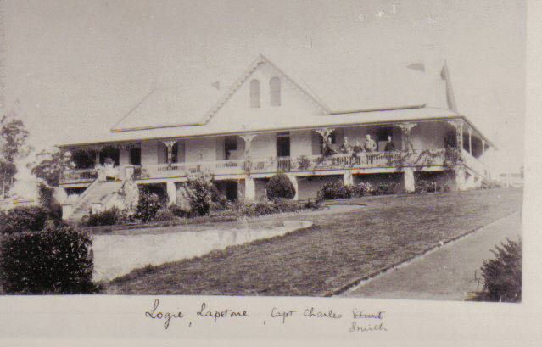
Sometime later quarters were m built for the other ranks " Briarcliffe", a large s sandstone cottage adjacent to t the Base, was purchased in 1 1953. It is the official home o of the Air Officer C Commanding Operational C Command.
"B Briarcliffe" was built in 1 1923 by Mr. John. C. Dunn o of Glenbrook. It is built f from sandstone quarried on t „LOGIE“ c 1920 the property.
These are my memories of the Base in the 1950's and 1960's: also in 1970 when my family returned to Glenbrook from a posting in Washington D.C U.S.A.
There are no married quarters anymore . Personnel either purchase their own homes or live in rental properties.There doesn't seem to be the contact between the service personnel and the local community which was really enjoyed in years gone by.

Pge 2

