Pam’s Page

AN EXCITING HAPPENING
IN THE DAY OF THE LIFE OF A YOUNG GIRL By Mary Watts.

The warning sound, slight as it was, was the first indication of an exciting happening-- about to happen in Euroka Road Glenbrook.
'The happening' started in the bush at and around the Euroka Clearing very early in the morning. The sounds that I heard,stamping, shuffling and thumping, was interspersed by impatient bellowing and, whips cracking, announced the imminent arrival and passing of what appeared to be, to a 6yr. girl of the time, all the cattle in the world.
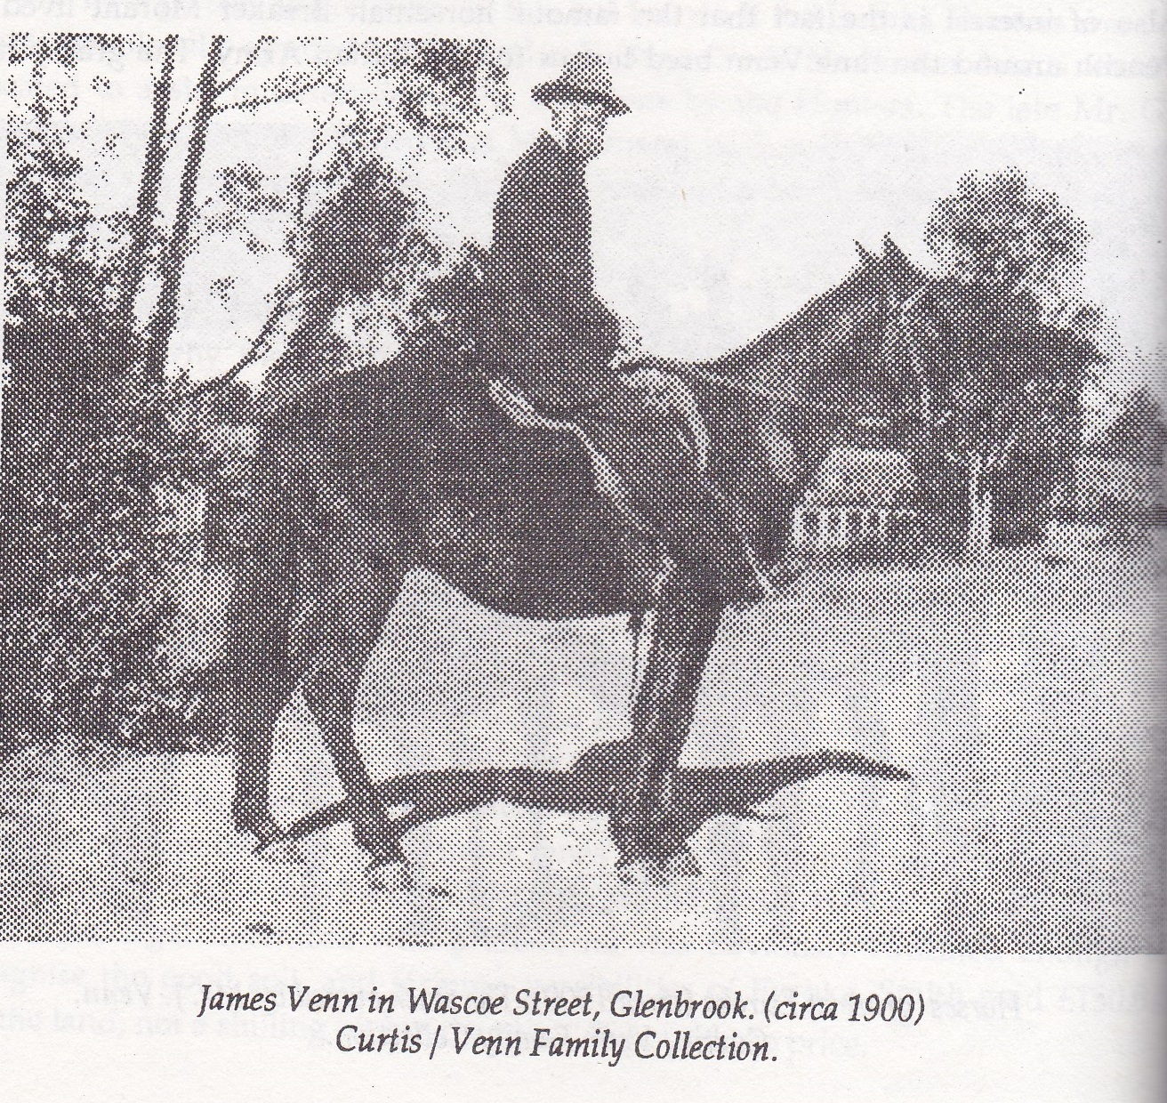
I stood at about 3 ft. 6 inches, just under the top rail of our pipe-and-wire-mesh gate which had a privet clipped hedge either side of it. Their horns were huge, about 3 ft. wide. At least that was what they seemed to be and when they suddenly appeared in the gateway, tossing those horns from side to side, we would all run, terrified, into our home and firmly shut the door. We would emerge just as the last of the cattle drive went by causing storms of dust on the-then unsealed, Euroka Road. They were held in Glenbrook Park which had a fence all round in those days. From there, we can only guess, they were taken to the sale yards?
This 'phenomenon' happened at least once a year (to my recollection.) Cattle were a rare sight in Glenbrook and still are. EDITOR NOTE:- *James Venn , a dairy farmer in Glenbrook, bought Euroka in 1922 and sold again in 1924. It is reported that James grazed stock on the site prior to 1922. Jack Venn (son) grazed cattle on the Euroka site until 1954, when the lease was terminated. Euroka was then incorporated into the Blue Mountains National Park. The Euroka Clearing is 4 Kilometers south of Glenbrook and is accessible by 'Fire Trail.'

*Acknowledgements to Bruce Cameron „A History of the Blue Labyrinth“ 1st edition 1992

