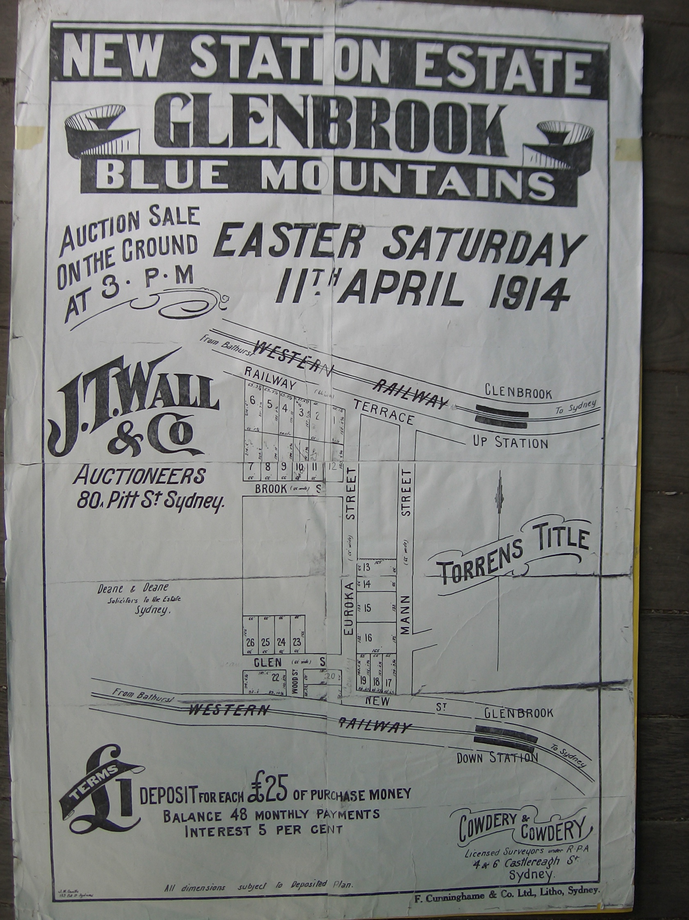
A LITTLE RAILWAY HISTORY

In 1914, as this poster shows, the railway was still operating on what is now known as the old railway line. In fact for some years the Northern line operated as the line to Sydney, in railway nomenclature "the up line" and the Southern line was the line to the West, in railway terms "the down line"
The lines were single track and joined just East of Blaxland Station

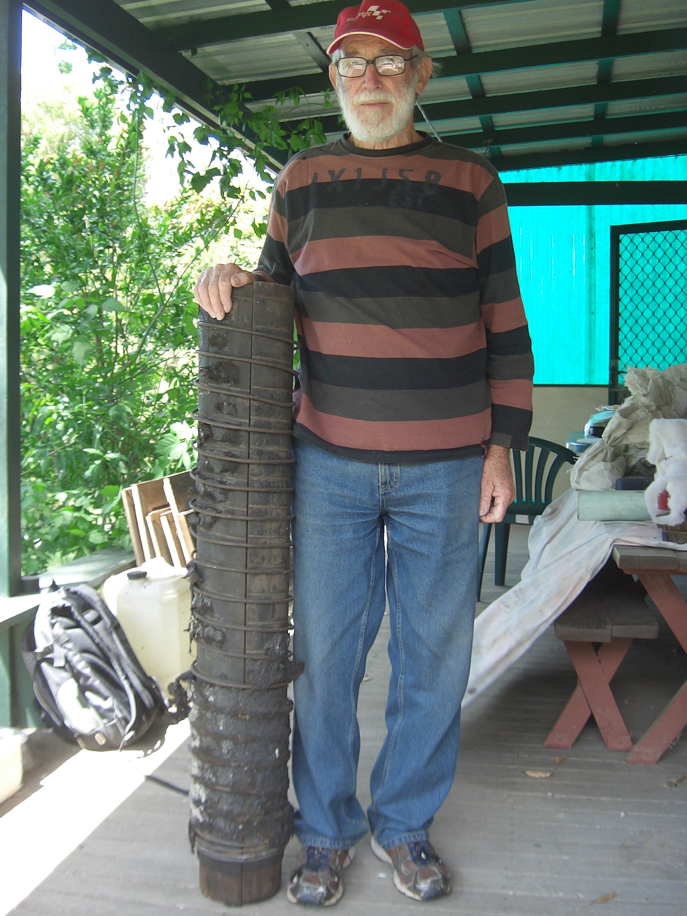
Water tanks were situated towards Eastern end of Glenbrook Park and water was gravity fed through wooden pipes from Glenbrook lagoon. Pres Doug is shown holding an original water pipe, now on display in the museum.

The museum is open on 3rd Saturday each month
9am to 1pm. Entry is free.
Any members interest in assisting in the operation of the museum are asked to contact Pres Doug. Your assistance would be helpful, he needs more assistance.

