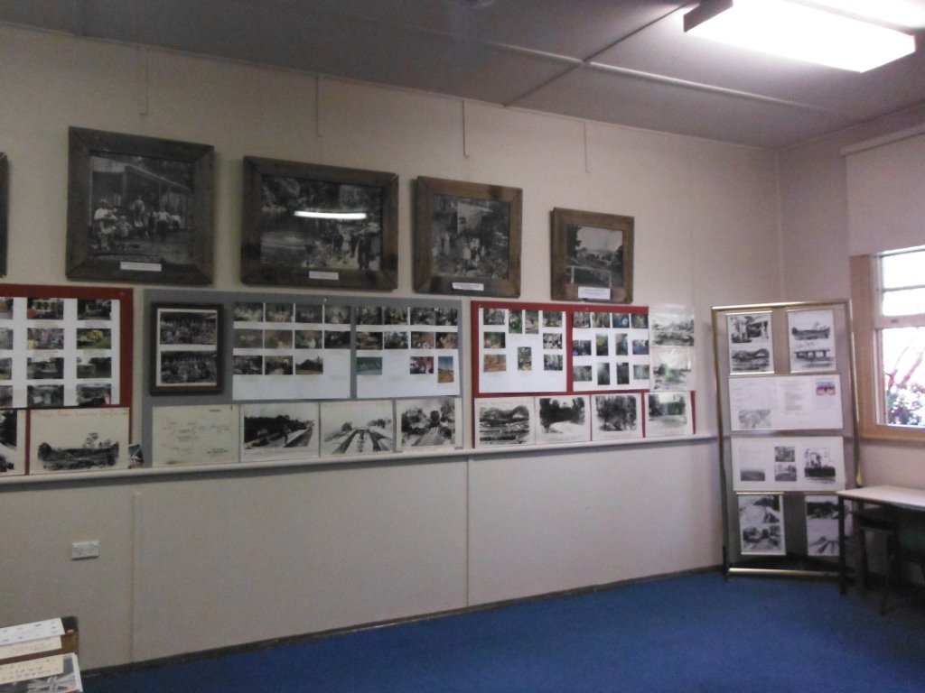
"Our Museum is now open and fully operational" reports Pres Doug who also thanked Dennis Bainbridge and David Paye for their assistance on the 1st & 3rd Saturdays. At this stage the Museum is only open to the public on two days per month and we need more photographs and historical documents to display, or to provide information for those seeking it. What do you have to help in this regard? Please bring it along. You can also send information direct to Newsletter Editor via E-mail.at jpe13704@ gmail.com Scan all documents MUSEUM DISPLAY and photographs and send as an attachment and add details for our records. If you have any stories of historical nature, I would love to see and publish them. It is also a good opportunity to have a chat and sell a book or two. Don't forget we have "Comrade in Ams, 1914--18" at $5.00ea and this year is WWI Centenary. Heritage Advisory Committee: Currently there is two vacancies on this BMCC Committee. This group meets about 4 or 6 times per year, and provides information and advice to assist Council's decisions. I feel sure any member nominating would receive a good letter of support from G&D H. Soc. If you are interested, contact the Secretary promptly.

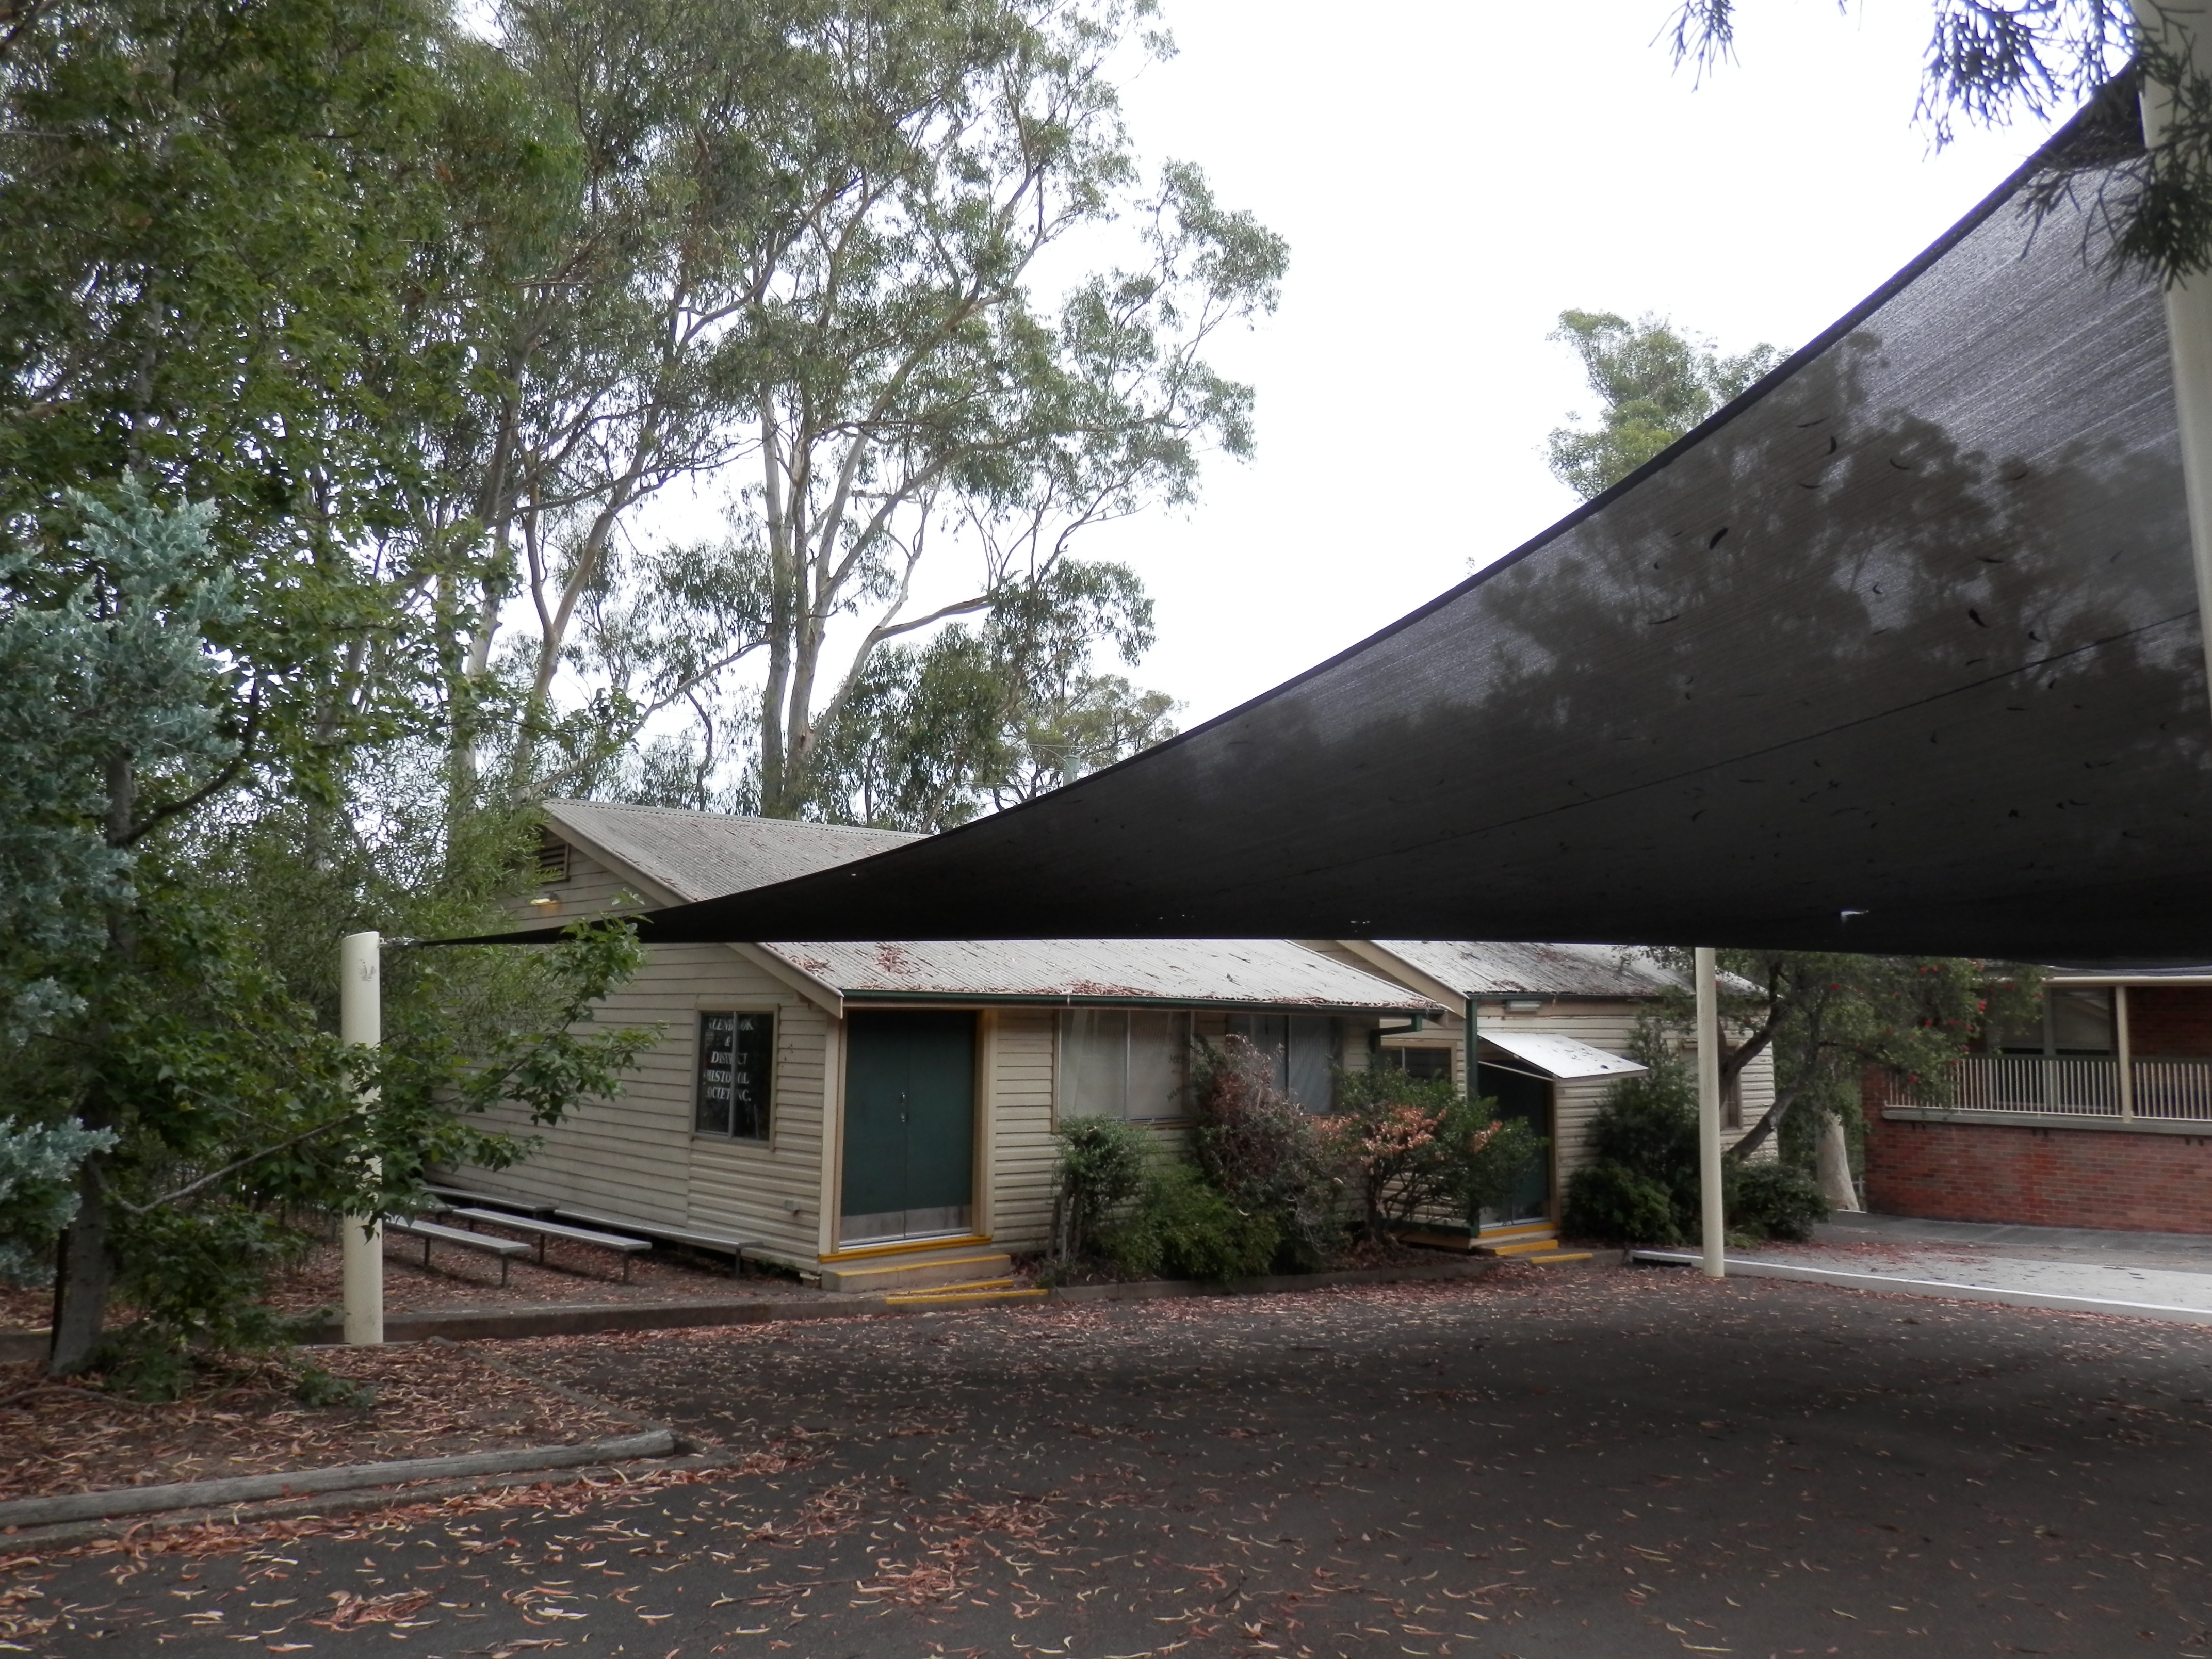
The School site is still owned by the NSW Dept of Ed. and is now an anexe to Springwood High School which has established a school for students ( yrs 7 to 12) with learning disabilities resulting from anxiety or depression & who find themselves unable to attended regualar schooling. There will be a limit of 21 students at any one time, with a current enrolement of 7. The 2 classrooms facing Raymond Rd will be used and one is already refurbished . All other facilities are in use. RotaryClub of Lower Blue Mts. will still host the markets and the Historical Society will have the use of one classroom as a museum. MUSEUM via SCHOOL GROUNDS

