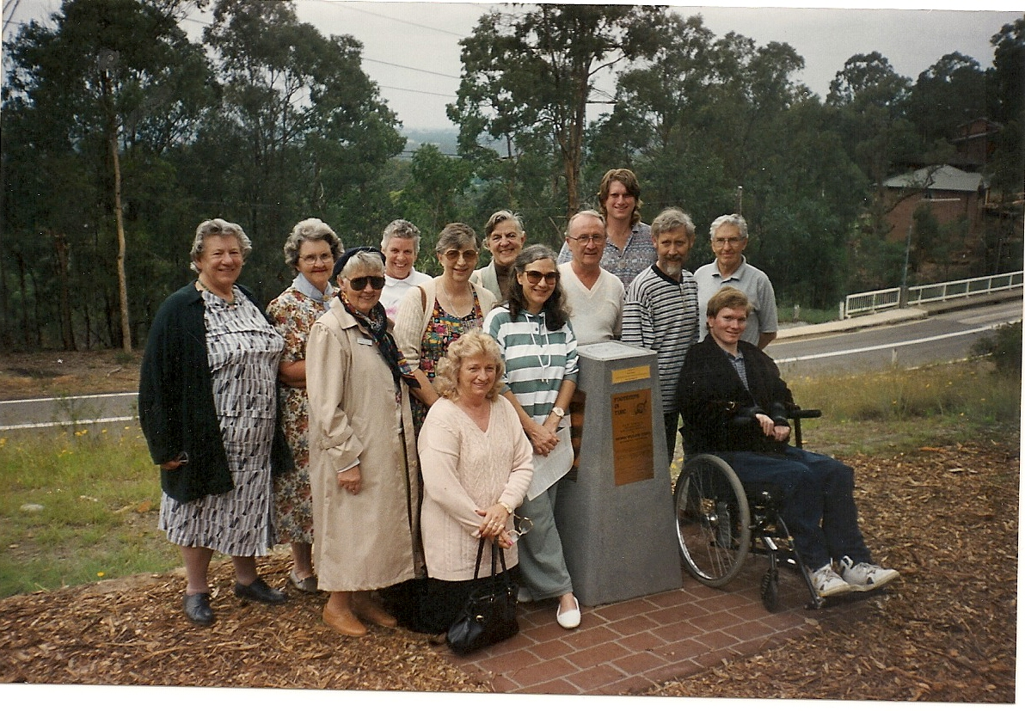
Quiz of the Month.... Can you name the venue and the people in these photographs.. No prize for correct answers! E-mail to jpe13704@gmail.com
