GLENBROOK POINTS

Newsletter of Glenbrook & District
Historical Society Inc.

April - May '14
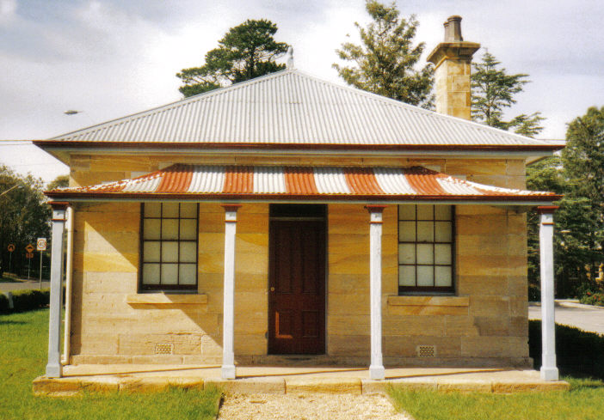
Postal address P.O. Box 38 Glenbrook NSW 2773

Contacts: Tim Miers 4739 2384
Doug Knowles 4751 3275
Meetings 3rd Wednesday monthly at 1.30 pm
(except Dec-Jan) Glenbook Guides Hall
cnr Hare & Moore Sts Glenbook
"Walks & Talks" 2014 Programme
April Sat. 26th 1.30pm "Eastern Zig Zag Railway 1866, Knapsack Viaduct and Old mine shaft.
May: Sat. 10th 1.30pm "Bull's Creek," Stone dam and old Railway Pump site. Sat. 31st 1.30pm "Glenbrook Lagoon Precinct." Early campsite and railway dam construction1880.
June: Sat. 21st 1.30pm "The Mountain Murders." Lee Weller's grave site and rock inscriptions.
ADULTS: $8.00ea. Children under 16yrs. Free: but must be accompanied by a parent or guardian. (No dogs please.) BOOKINGS are ESSENTIAL: Phone Doug. on 4751 3275. or Tim on 4739 2384 for details re meeting place, time and grade of walk. Good walking shoes are essential. Please bring a hat and drinking water.

