GLENBROOK POINTS

Newsletter of Glenbrook & District
Historical Society Inc.

JUNE JULY '14
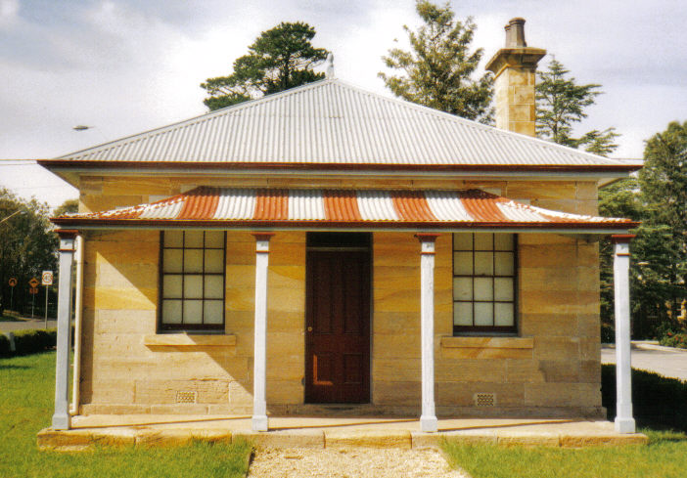
Postal address P.O. Box 38 Glenbrook NSW 2773

Contacts: Tim Miers 4739 2384
Doug Knowles 4751 3275
Meetings 3rd Wednesday monthly at 1.30 pm
(except Dec-Jan) Glenbook Guides Hall
cnr Hare & Moore Sts Glenbook
"Walks & Talks" 2014 Programme
June: Sat. 21st 1.30pm "The Mountain Murders." Lee Weller's grave site and rock inscriptions.
July: Sat. 12th 1.30pm :"Dunn's Sawmill Site" and earth dam, Brookside Creek, Lennox Bridge and old Stone Quarry.
Aug: Sat. 2nd 1.30pm "Cox's Road." Walk along a section of this historic road following the ridge-top from Linden to Woodford Trig.Sat. 23rd 1.30pm "Duck Hole-Glenbrook Creek.” Old Roadway Construction and Railway Pump site.
ADULTS: $8.00ea. Children under 16yrs. Free: but must be accompanied by a parent or guardian. (No dogs please.) BOOKINGS are ESSENTIAL: Phone Doug. on 4751 3275. or Tim on 4739 2384 for details re meeting place, time and grade of walk. Good walking shoes are essential. Please bring a hat and drinking water.

