**GLENBROOK POINTS**

**Newsletter of Glenbrook & District Historical Society Inc.**

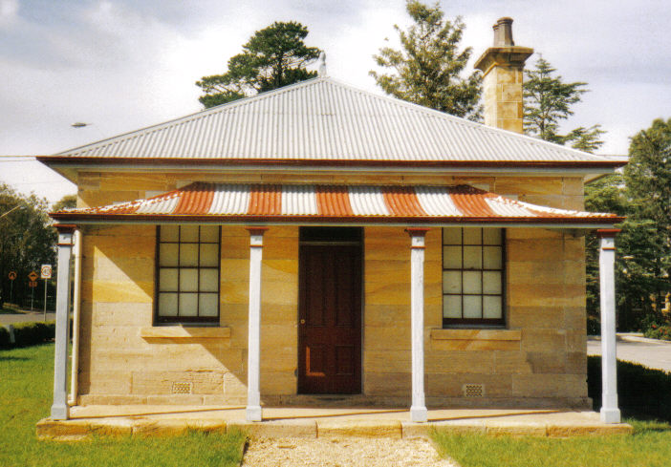

**POINTSMAN'S COTTAGE**

**AUG SEPT '16**

**Postal address P.O. Box 38 Glenbrook NSW 2773**

**Contacts:**  President Joan Peard 0414 605 482 or Secretary Neil McGlashan 4739 9864

**Meetings 3rd Wednesday monthly at 1.30 pm (except Dec-Jan) Glenbrook Guides Hall**

**cnr Hare & Moore Sts Glenbrook**

**"History Walks" 2016 Programme ALL on SATURDAYS**

**Walks led by Doug Knowles & Frank Bowman**

A**ugust 13th 9.00am "Faulconbridge steam sawmill site" Engine remnants and other relics operated**

**1914--1925. Long walk-steep climb: Allow 3 ½ to 4 hrs.**

**September 10th 9.00am** "**Glenbrook Discovery Heritage Walk" Historic sites, houses and West Portal**

**of Lapstone Tunnel--1892. (Last Walk for the year.)**

*ADULTS : 8.00 ea. Children under 16yrs. Free-but must be accompanied by a parent or guardian. (No dogs please.) BOOKINGS are ESSENTIAL: Phone Doug. on 4751 3275 for details re meeting place, time and grade of walk. Good walking shoes are essential. Please bring a hat and drinking water. BAD WEATHER ON DAY: excessive wind & rain could cause cancellation due to hazedous conditions.*

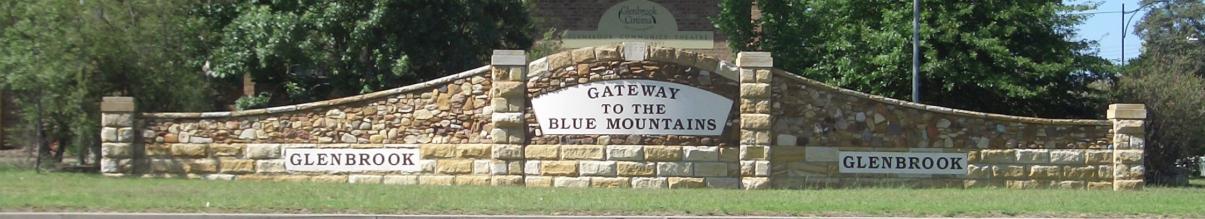

***PAM'S PAGE***

**ROYAL AUSTRALIAN AIR FORCE GLENBROOK**

The early history of the R.A.A.F. Glenbrook starts with the formation of Eastern Artea Headquarters at EDgcliffe Sydney, May 1942. At the end of WWll the headquarters werer located to Bradfield Park Sydney, however it was not a suitable site for the permanent location of Area Headquarters

In 1949 the Lapstone Hotel was offered to the R.A.A.F. to be used as Easter Artea Headquarters. It was a ywo strory, U shaped building with 57 bedrooms, together with kitchen facilities and dining room situated on Lapstone Hill. There werer also sporting recreational areas which included a swimming pool and 9 hole golf course with practice putting green. In the garden area was a 100+ year old Morten Bay tree which was christened the Yum-Yum tree by the R.A.A.F. boys. It was under this tree that Xmas drinks were served and wonderful Xmas parties held for the members children.Unfortunately the tree was struck by lioghtning during a storm and had to be removered

In all there was appeoximately 40,000 sq.ft. of floor space on 29 acrea of land. The property was condidered suitable and the site acquired on 1st September 1949, the R.A.A.F. moved in in 1950. The total price is reported as being 200 Pounds ($400). Between 1949 & 1950 additional land was purchased near the Headquarters at Glenbrook to provide for homr sites for Marrieed Quarters, so that the total area now occupied about 70 acres.

Eastern Area Headquarters was reformed as Headquarters Home Command in 1953 and some years later became Operational Command.

I with my family spent many happy years in Married Quarters in Mount bSt Glenbrook. All these married quarters are noew owned by civliians.

**100 YEARS of RETAILING in GLENBROOK**

**18XX TO 19XX**

***This is a reprint of an article written by myself (Editor) for a magazine published by Glenbrook Chamber of Commerce to promote their 19xxx Spring Festival.***

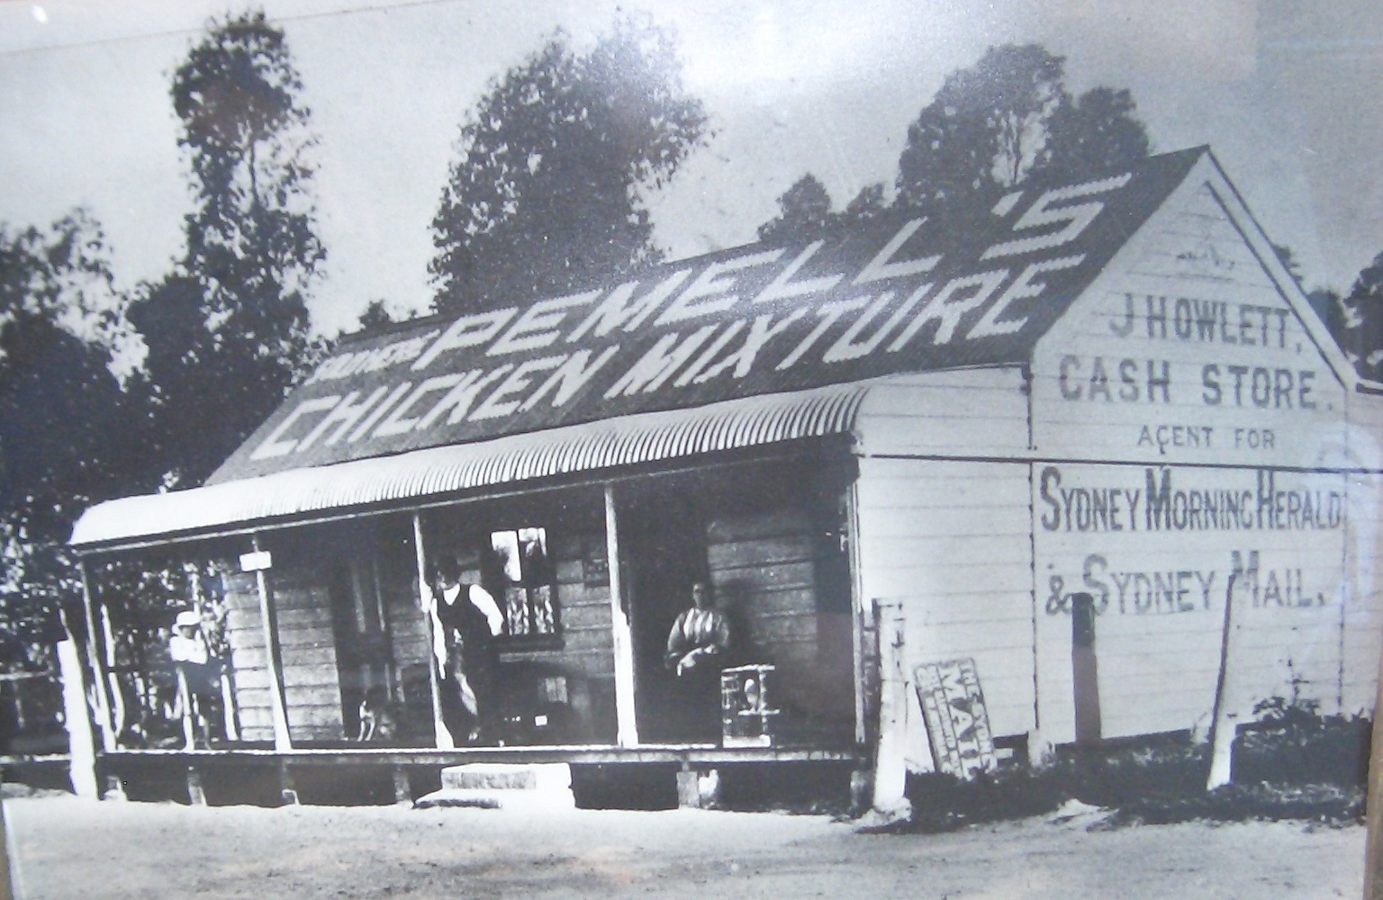In the days before town planning stores often opened adjacent to or forming part of a residence. Early store in Glenbrook opened in this manner up to the post war era and until the town plan was established by the B.M.C.C. Howletts store was probably on of the first to open in Glenbrook, operating in Wascoe St from the late 1800's until the early 1920's. It was later at one stage a butcher then a bakery. The bakery was moved by Jack Cattell to Mann St. The old wooden building was turned into a residence for the McCann family then demolished and Mr & Mrs Skarrett's residence now stands on this site.

Howletts operated a second general store from about 1913, on the corner of Glen & Burfitt St. This store was later converted into a farrier by Jim Moore. Mrs McCleave's residence now stands on this site today.

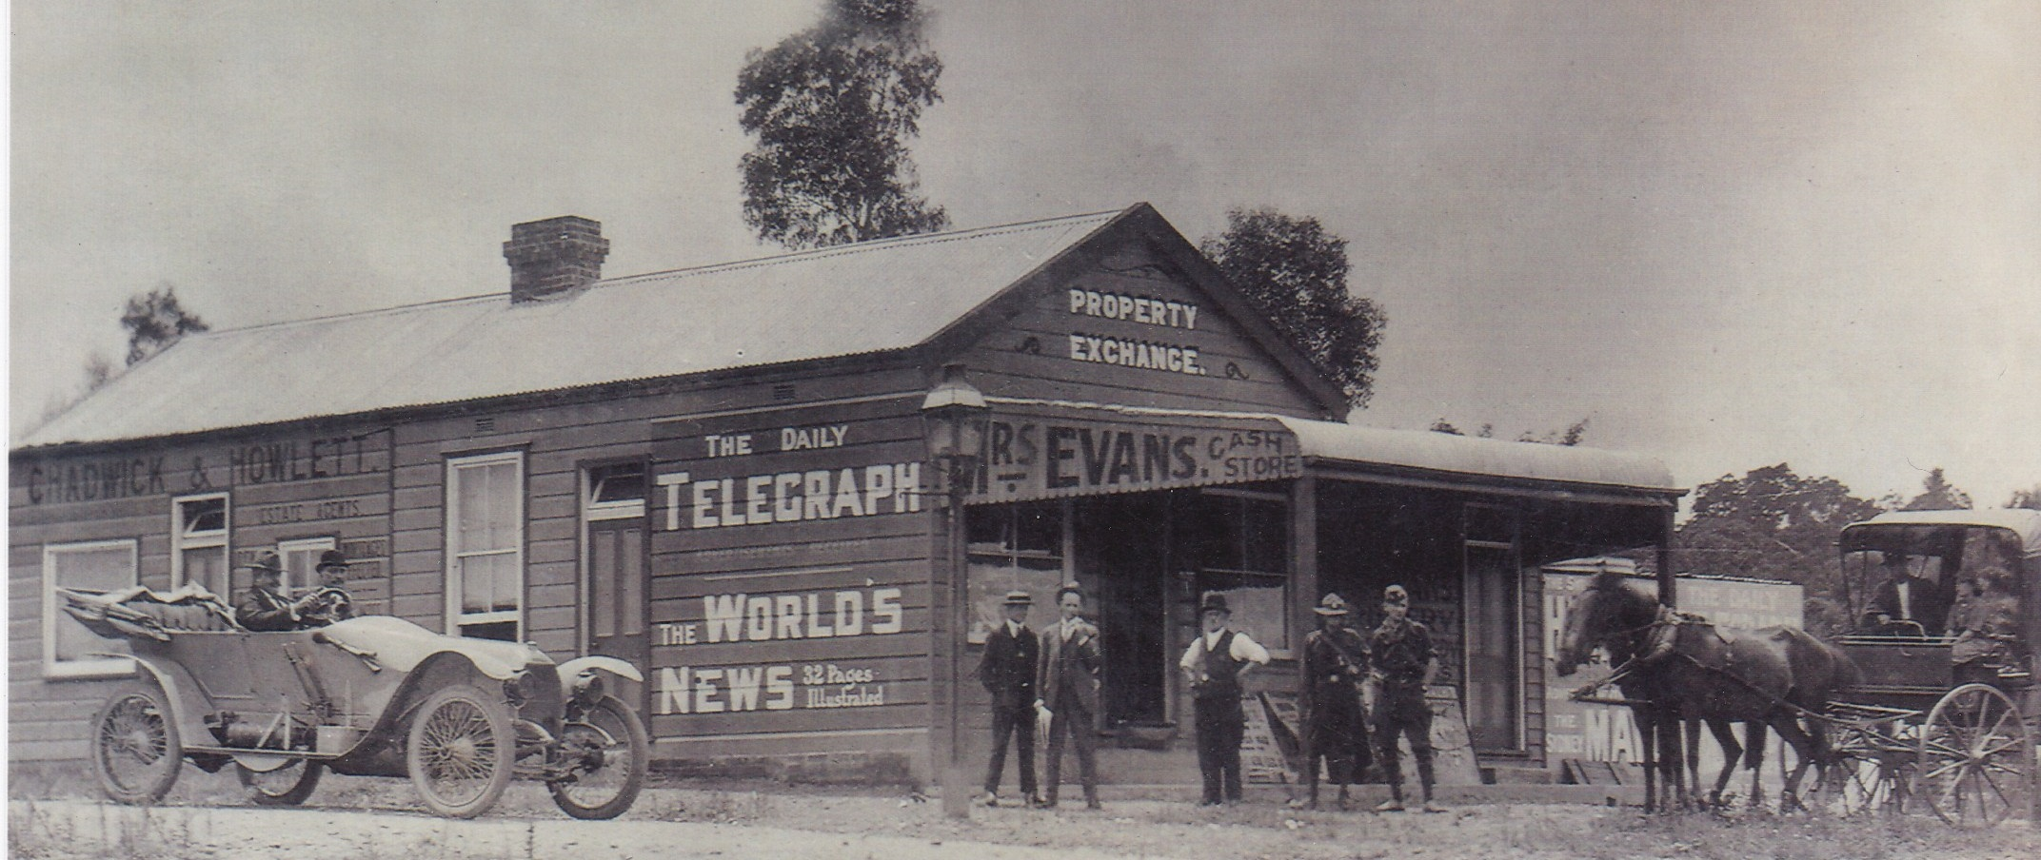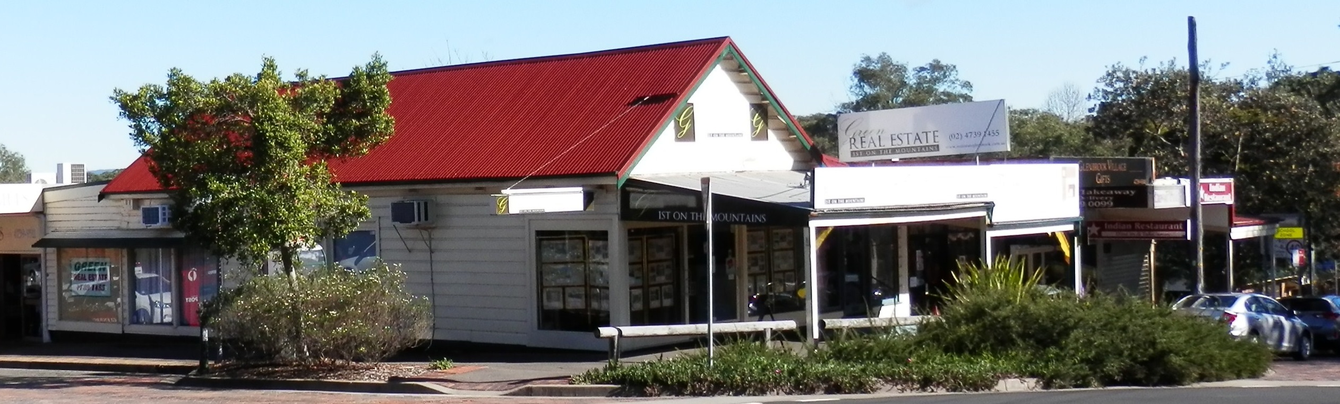The building on the corner of Park & Ross St., now occupied by Greens Real Estate, has had a checkered history. Originally built by Ted & Bill Brownlow in the early 1900's as a produce and general store and operated as such for about 30yrs. The post war era saw many and varied tenants. Bill Watts operated a joinery shop, Jim Woods a newsagency, and at one stage, 1960's, Mrs John Green ran a haberdashery, with a doctors surgery, Dr Peter Bell, and a dentists surgery, Victor Humphries. The doctor & dentist moved out and John Green, who at this time had the Glenbrook Taxi service, converted the building to a real estate agency and thus was the beginning of Greens Real Estate. Robin Hine (nee Lemon) occupied the part of the building facing Ross St., as a haberdashery. This building still stands today, haberdashery gone and the estate agency occupying most of the\building. Joan & Des Annabel, the new owners, have recently added two more shops facing Park St.

In 1926 Bill Brownlow built Macquarie Stores & residence in Wascoe St. This was the last of the old style general stores to continue trading, eventually succumbing to modern marketing and self service. Macquarie Stores closed in 1981. The shop and residence still stand but are now a modern real estate agency “The Professionals”

In the mid 1930's , Mr Miles built a large brick shop adjacent to his residence in Park St.This store

was for many years the major shop in Glenbrook, selling basically everything. In 1937 Alan Potter bought the business & residence for 1700 pounds ($3400) adding newspapers to his stock in trade. Later he built another store between the shop and residence, this was to become a newsagency selling fruit, veges and drinks with the lager shop retaining hardware & groceries. Jim Wood acquired the newsagency and moved to the Ross/Park St site, the smaller store now became a greengrocer, and indeed still is such , run by Len Clark, although altered and enlarged. Mrs Lemon bought and traded in the larger building from 1956 to 1973, but like Macquarie Stores, suffered from changing trading patterns and sold the store to Joan & Des Annabel. The store reopened a few months later as “The Jig- Saw” TOY & BOOK Centre, which is owned and operated by Mrs Joan Peard, the building was extended and refitted and now sells gifts & souvenirs.

Raymond Galleries in Raymond St. is another old store. Opened in c1915 by Miss Moore, who was the postmistress, and managed by Miss Jesse Dunn (now Mrs Jesse Bunyan) as a haberdashery, fine soaps and perfumes. In 1964, Dr Jock Robinson used these premises as a surgery until moving to his present site in Park St. The shop still stands and now part of the Blue Mountains Creative Art Centre.

As mentioned earlier, a bakery operated in Mann St. the McCall family operated this for many years, but was eventually closed and demolished, a dwelling stands on this site today. Also in Mann St. in 1930, Mr Carey, who ran the taxis as did his father before him, converted a garage into a real estate office. After his death the building became Glenbrook's firstt Pharmacy. And his son Alan immediately moved the Pharmacy to his new shop in Ross St. where the Pharmacy is today. Mrs Morrison used this office from 1971 to 1973 as a toy & book store which she called “The Jig-Saw”. As mentioned earlier at this business moved to Park St and was sold to Joan Peard.

In 1923 a butcher's shop was built in Ross St by Mr Geroge E. Bunyan with his son George K Bunyan, and 1930 a residence was built at the rear. Mr & Mrs George K Bunyan lived in the residence and ran the shop. Prior to 1923 fresh meat was delivered from Mr E Bunyan's shop at Emu Plains to Glenbrook , and indeed as far as Warrimoo, (by horse up Mitchells Pass). The business and residence was sold to Mr Pat Roots, 1945, who operated on this site up to 1980 when the business was changed to a real estate agency, by Bruce Huxtable. Mr & Mrs Roots still live in the Ross St. residence and Mr & Mrs K. Bunyan still reside in Glenbrook.

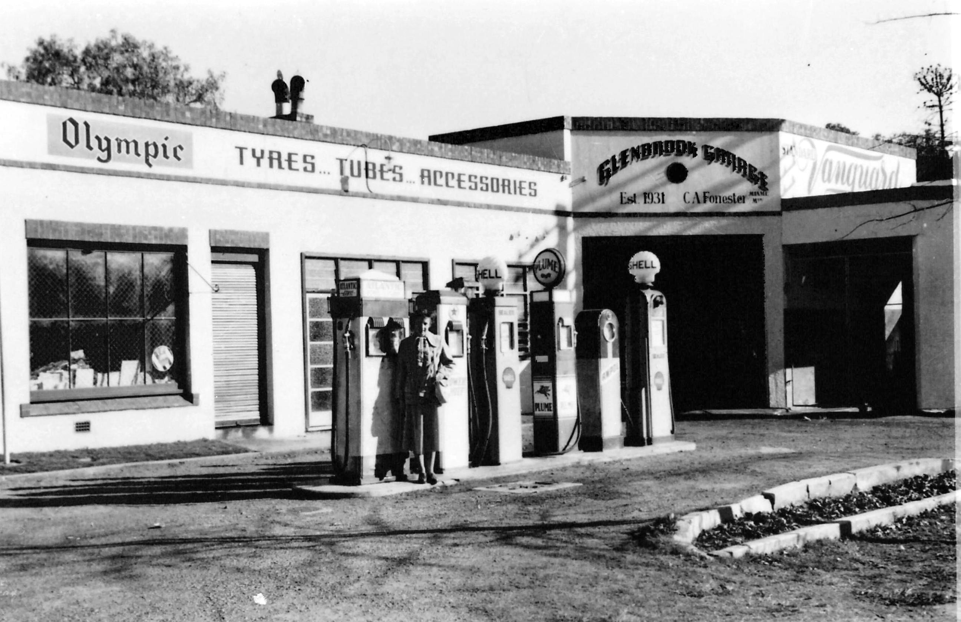The original Post Office, opened c 1900, was in a residence in Raymond St. with Miss Moore as the Postmistress. Don Hodgess bought and moved the post office to its present site in Ross St. Later the building was extended and sold to Australia Post, now an official post office.

The garage, originally was the Pointsman's cottage site and remained so up to 1927, although the rail line was diverted in 1913. In 1927 Mr Charlie Forrester occupied the residence and opened a garage in the front, which was now the Great Western Highway. The front verandah was closed and became an office and storeroom. Ampol later enlarged the site to what it is today and the small office became a milk bar serving passing motorists. The original stone cottage stands today and up to recent times was occupied as such.

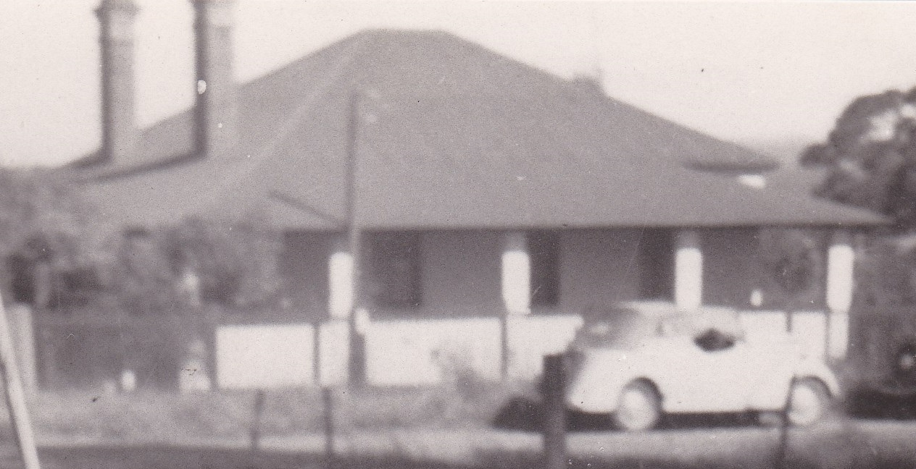One of the earliest residences in Glenbrook was built c1860 on the corner of Park St. & Euroka Rd. Mr & Mrs Hamment were the first occupants. This residence was demolished 1960's and a Dr's surgery & a shop erected. Dr Jock Robinson moved his surgery to this site and Mr Bill Peard opened the second Pharmacy, 1969. Later shops were to be built from the Pharmacy through to the greengrocery, all of which have been continuously occupied. Today, the only original tennents are the Doctor and the

self service store.

At the other end of the block, corner of Park & Ross St, stood another old residence. This was built c1900 and was occupied by Mr & Mrs Jack Hunter. After their death, Miss Ruby Hunter lived alone until her passing in1974. The site was sold to the Commonwealth Bank and the house demolished, but the bank did not proceed to build and the site remained vacant for many years. Recently the bank sold and eight shops were erected on the site.

Corner of Ross & Cross Sts .now a solicitor's office, was originally a dress shop run by Mrs Breakspear, later Mrs Ryan sold cakes and served tea. The shop had many varied tennents and was closed for long periods, although the residence remained continuously occupied by the Breakspear family. There were a few stores open around the village during the post war period, which were attached to house. No evidence of the shops exist today. Mr Parton opened a general store on the corner of Kedron and Carmel Sts mid 1940''s The “Lagoon Store” traded up to a few years ago. Mrs Merryweather, in the last residence in Emu Rd. served Devonshire Teas and drinks up to the early 1960's. Charlie Mansfield operated a gents Hairdressing saloon in Euroka Rd., which he worked himself, the building still exists but no retail activity on the site

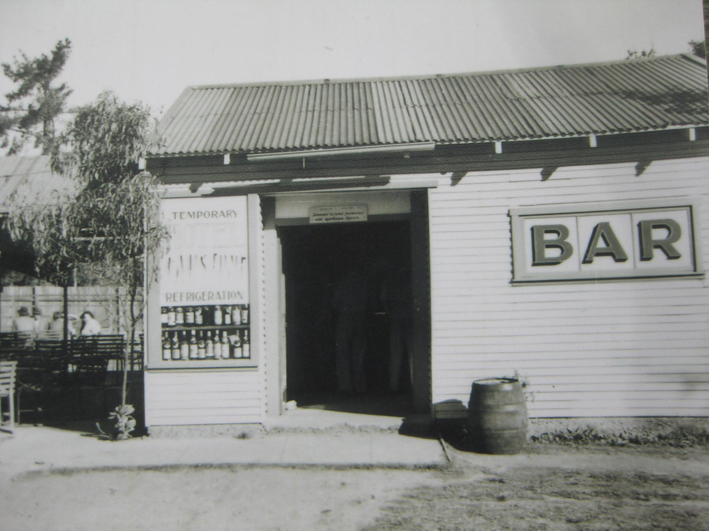One short lived but very popular building was the temporary road bar, built on the highway, adjacent to the old garage, after the closure of the Lapstone Hotel. This bar catered for the local residents (no clubs in those days) and and passing motorists. The road bar closed when the New Lapstone Hotel opened.

**EDITOR**: *Some minor editing has been made to the original article, addresses identified and dates corrected, but the article still has to read in the same time frame viz 19xxx*

**From the Secretarys Desk**

**REPORTS: i) Re the mushroom tunnel:** Doug: On 26th May, we met at the Visitors Centre and myself & Neil met the 2 people from Dept. of Lands with others. The time taken to terminate the leasewas longer than everyone had hoped because the lesee was in breach of all sorts of conditions and the Dept of Justice had to got through all sorts of notifications**:** this takes ages. If you go down there you will see a fenced off area. The walking tracks are still maintained. The Dept.of Lands is very anxious to complete the clean-up before 30th June. The clean-up is of monumental proportions: There are buildings there in derelict condition with asbestos. There is heaps of old machinery of every conceivable description: fork-lift pallets and crates. there is steel racking and trolleys: plastic crates: wooden crates: steel crates: old air conditioning systems: there are diesel engines: there are excavators: Steel is recyclable.

We then inspected the inside of the tunnel. First problem is finance. The contract is for the external clean-up only. The interior poses special problems: No lighting, no ventilation, You have to use electric fork-lifts and miner’s lamps etc. to see what you are doing. Huge cost involved there. The abandoned debris inside the tunnel—There are many of those one-cubic-meter carry bags that you pick up with forklift trucks. Inside there are pumps, air conditioning systems, steel sheeting with steel racking. Some is fixed to the walls: Trolleys: air-ducting in steel: Polythene, PVC pipe and also pvc conduits fixed to the walls and the apex of the roof.

There is no finance allocated for next financial year to do this. There will possibly be finance in the year 2017/2018. Access to the tunnel will not happen soon. Securing the tunnel at both ends is a primary factor and security will be done to allow people to see in, there will be a grill The present gates obscure the elegant episode stone & brick portal which is heritage listed. So the new security gates will be mounted inside the tunnel a meter or so and will not obscure the face of the portal and all the fancy brick and stone work.

The baffle walls at East end in brick, were put in during WW2. The brickwork is now considered an artifact. No one seemed to know the original purpose. Access to the inside of the tunnel will not happen soon. Access to the surrounds of the tunnel will be done shortly. A really good satellite photo is in the museum You can really appreciate the monumental amount of rubbish left around the place.

Valley Hts. Loco Museum have grandiose ideas about setting up a transport heritage walking track on the eastern face of the hill. They said they don’t have any money or staff to do anything. The Conservation Group were concerned with re-vegetation. The Dept. of Lands people said that The Soil Conservation Service of NSW. does that. They are the experts.

**ii) Bill’s Horse Trough: Joan** received an email from Mark (Patrick) Williams to say that it was going to go through the park planning committee. A phone call to Elizabeth Dudley-Bestow revealed that Council has already decided that we are going to move it into the Park. It is in a dangerous position. They are going to put it somewhere between the children’s play area and near a garden. More people will have access to it to read about it etc.

**iii) Glenbrook Gateway Monument:** . The Glenbrook and District Historical Society believe that the date inscribed in the keystone at the top of the arch should read 1885, not 1883 as inscribed. The understanding of the Glenbrook and District Historical Society is that this date is to reflect the year in which Glenbrook was gazetted as a town.Currently, the date is presented on the monument with no interpretation as to its significance. An inspection of the monument shows that the stone could be removed relatively easily. A stonemason would be required to make the necessary works to remove, correct and replace the stone.Currently, Council does not have an identified budget to undertake any works as outlined above. This work would need to be prioritised and assessed against other works required on Cultural and Physical Assets across the city.

**a CAN ANYONE ASSIST ??**

**EDI lond periodsTOR Bill Peard**   *Once again a member has supplied an article for the newsletter, thanks to Elizabeth. Last edition we had an interesting article thanks to David. Have you a story of histrorical interest to tell? Have you lived in the district for a long period? Have you any old photographs, family or scenery? If you can assist, I would like to hear from you. No need to write the story, just give me the basic details, no need to send photographs, just e-mail copies with captions if known, or leave at the museum. All stories, documents and photos will be acknowledged when published . Please send all Letters, Photos etc, as an attachment to e-mail address... jpe13704@gmail.com or gdhs@gmail.com*

**GLENBROOK & DISTRICT HISTORICAL SOCIETY Inc.**

**OFFICE BEARERS 2015-2016**

**President Joan Peard 0414605482**

**Vice- Presidents Kevin Frappell Grant Holmes**

**Secretary /Treasurer Neil McGlashan Chief Historian Tim Miers**

**Committee Tim Miers Doug Knowles Pam Thompson**

**Glenbrook & D.H. Society Museum is situated within Old Glenbrook Infants School, Ross St. Entrance via Park or Ross Sts Museum is open 1st & 3rd Saturdays**

**9 am to 1.30 pm. Entrance FREE**

