**GLENBROOK VOLUNTARY BUSH FIRE BRIGADE**.

By Doug Knowles Past Pres. Glenbrook & District Historical Society***.***

By about 1940 or so, a group of local residents, George Bunyan as Captain, organised themselves to help the locals with hazard-reduction burning. About 1941 or so, the group was issued with a trailer-mounted pump, powered by a 4 cylinder petrol engine.This was fine if the fire was approaching the lagoon, but there was no town water-supply and they didn’t have a tanker-truck.Town water progressively arrived at about 1942. So, to organise a hazard-reduction burn, you ask Stan Edwards to put the tank on his truck.Then he drives to George Bunyan’s to couple-up the trailer pump. Then, drive to the lagoon to fill the tank, then they are ready to start. As you can appreciate, this set-up is not capable of a quick response ! Blue Mountains Shire Council was supportive and helpful in providing a fire-siren (on a pole, in Ross Street) and also £25 cash to be used to buy tools and equipment.

About 1949, the group decided to ask the Board of Fire Commissioners to set up a fire station and tanker in Glenbrook.The reply was a definite ‘no,’ so the group decided to be independent and do it themselves. First step was to raise the necessary cash for building materials.The Shire Council made a block of land available in Wascoe Street for a Fire Station. Letters were sent to all residents asking for cash donations to support this project.

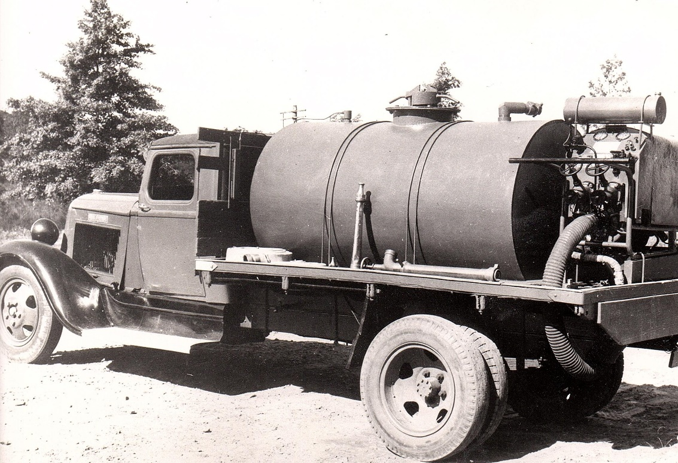 The group now had funds, but not enough to complete the project......should they start? or should they wait until there was enough cash to complete the project.? They decided to start, while interest was keen, funds in hand would provide steel mesh for concrete footings and sufficient for purchase of sand, cement and gravel to get the job to floor level. Voluntary labour will dig trenches, position the steel work, mix and finish concrete floor. No Readymix’ concrete in those days.

**1936 Dodge Truck , Water Tank & Pump**

With the project completed to floor level, they then asked the locals to provide the cash to finish the project. All members**/**volunteers did a door-knock for funds. This yielded enough cash to complete the fire station and set up a fire tanker truck. I remember my father Melton Knowles, saying...”Very successful**:** those who previously gave 10 Bob, gave 10 Quid.” ! A donation of £10 in 1950 is a substantial sum, and is equivalent in 2018 purchasing power, to about $650

Melton Knowles was regarded as Chief Architect/Engineer/Carpenter and Clerk of Works. Fred Cole and Frank Morris were in charge of the brick-laying team. A tank and the pump were set up on a 2 ½ ton,1936 Dodge truck. With lots of help from the workshop team at the Colonial Sugar Company at Pyrmont, lots of clamps, brackets, fittings and adaptor pieces were made at Pyrmont and assembled at Glenbrook.

So now, Glenbrook Village had a proper fire-fighting tanker truck. Yes, a Fire Engine!! and all provided by local subscription and voluntary labour. A display in our Museum at Glenbrook has photos of this Fire Station, tanker and crew with their names listed. 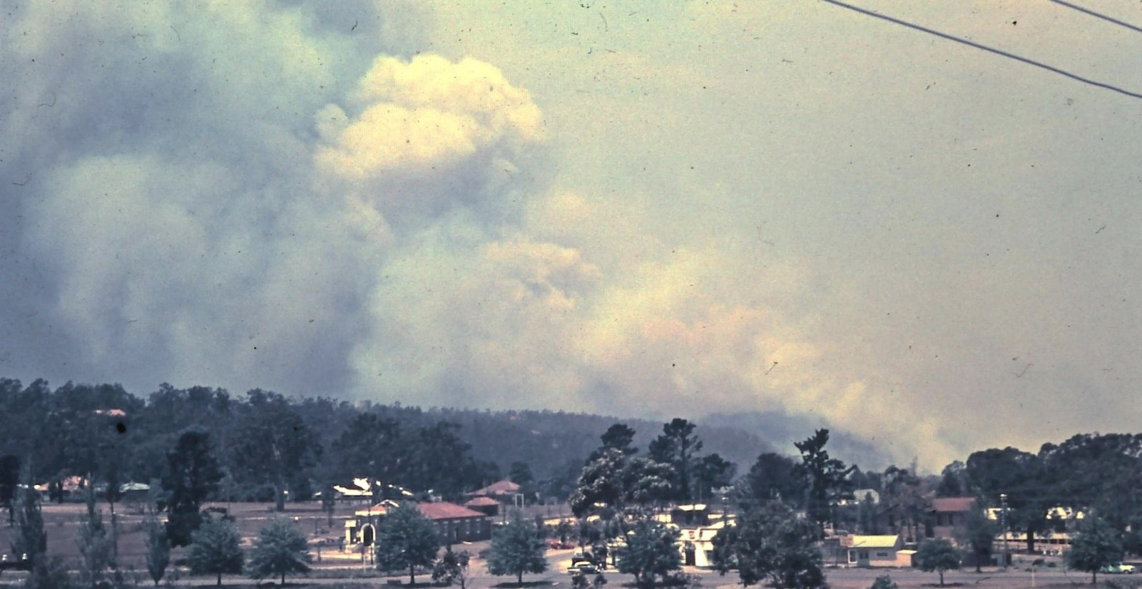

**Glenbrook Fire from Moore St**.

The first big test for crew and tanker occurred on the 6th December, 1951. An unstoppable bush fire swept through. Only 5 houses were lost in Glenbrook. Blaxland lost about 10, Warrimoo even more. So, the village tanker truck and volunteer crew well-and-truly proved their worth.

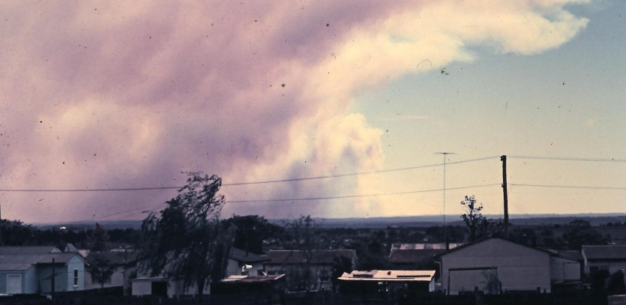 Later on, following much development in the village, in the mid to late 1950’s, the Board of Fire Commissioners decided to provide a modern fire engine and extend the fire station so that it will fit in, and even pay the crew. With George Bunyan remaining as Captain, this suited everybody.The Glenbrook fire engine built by the voluntary crew was transferred to Castlereagh Bush Fire Brigade.

**Fires From St.Marys**

***This information is compiled from Museum exhibits, and memory, by Doug Knowles for the Glenbrook & District Historical Society’s 25th anniversary*. *Photos G&DHS Collection***